**Demographic Information**

*Circle Your Response*

**What is your gender?**

Female

Male

Refused

**How do you normally identify your race?** (select all that apply)

American Indian or Alaska Native

Asian

Black or African American

Native Hawaiian or other Pacific Islander

White

Unknown

Refused

**What is your ethnicity?**

Hispanic or Latino

Not Hispanic or Latino

Unknown

Refused

**What is your marital status?**

Married

Living with a partner in a marriage-like relationship

Widowed

Divorced

Separated

Never married

Unknown

Refused

**Highest Level of Education Obtained** (select the one with which you MOST CLOSELY identify)

Some high school or less

High School/ GED

Associates Degree or Some College

Bachelor's Degree

Master's Degree or other Advanced Degree

Refused

**“I feel prepared for my palliative care appointment”**

(Circle your response)

1. Strongly Disagree
2. Disagree
3. Neither Disagree nor Agree
4. Agree
5. Strongly Agree

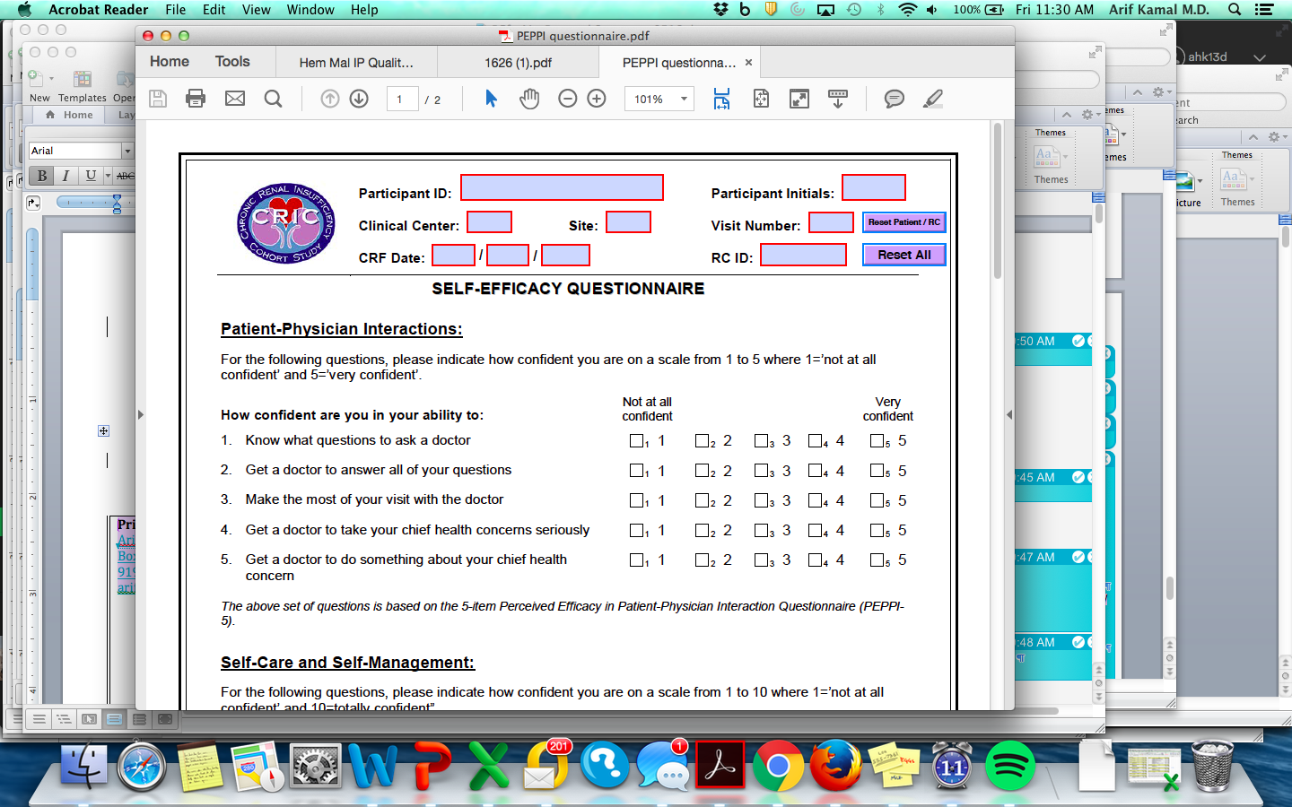

**Palliative Care Knowledge**

1. Palliative care is for what type of patient (pick the best option):
   1. Those with a specific type, stage, or seriousness of cancer (like Stage 4 cancer)
   2. Persons with a limited prognosis or time (like less than 6 months to live)
   3. Any persons with a serious illness (considered serious to the person who has it)
   4. Those not interested in more treatments to treat their cancer
   5. I don’t know
2. Code status or resuscitation status is:
   1. What types of treatments people want if they get sick, like pneumonia or a broken bone
   2. How people want to be treated if their heart or breathing stops
   3. How long a person wants to be in the ICU if they get really sick
   4. The naming of a person who can make a decision for a sick patient
   5. I don’t know
3. What statement is **true** regarding palliative care compared to hospice?
   1. Only hospice, but not palliative care, focuses on quality of life issues
   2. Palliative care and hospice both are **limited** to people with six months or less to live
   3. Palliative care provides “an extra layer of support”.
   4. Palliative care and hospice are generally not paid for by insurance, including Medicare
   5. I don’t know
4. What is a common way in palliative care to talk about your goals and what matters to you?
   1. Write down and discuss “hopes” and “worries”
   2. Always speak to a therapist or counselor
   3. Watch a video about legacy building
   4. Fill out a clinic form
   5. I don’t know
5. What is the best way to describe palliative care?
   1. An extra layer of support
   2. Help, but only at the end of life
   3. A way to be cared for, but only after stopping chemotherapy
   4. I don’t know