Workign prototype of new navigation: https://cra-test-arc.canada.ca/t1-readmes-nav-2026/
T1 Navigation change plan
Currently, the current year T1 forms readmes are already linked on the forms listing page, but they are not in the forms “folder”, and non-current forms are not linked there.
- Add all non-current forms to the listing table
- Remove all existing T1 forms
- Create new readmes (new template, with table where applicable) for current forms and non-current forms that have prior years in the last 10 years (only one readme per form)
  - https://www.canada.ca/en/revenue-agency/services/forms-publications/forms/
  - The breadcrumbs will be updated
- Updating all referring links is a huge job, so perhaps it can be done in stages (this is up to WebDev)
- We requesting approval to change the H1s of the forms listing page as follows (for cleaner and more consistent H1s and breadcrumbs):
  - Canada Revenue Agency CRA forms listed by number - Canada.ca
  - Formulaires de l’Agence du revenu du CanadaARC classés par numéro de formulaire - Canada.ca
- All guides remain where they are
- Starting 2025, the guides contain a table that points to prior year guides, but prior year guides are not updated
  - The content of the tables on all guides with tables is updated each year to the last 10 year (ajaxed)
  - As time passes, the existing prior guides will be unpublished each year
- Links are updated on all tax package pages:
  - The links are updated to the new location of the forms
  - URL parameters and anchors (e.g.: ?year=2018&region=mb#prvs-yrs) are added to all prior year links to:
    - Jump to the prior year table section
    - Filter the table by the year
    - Create the rescue/return sentence before table (e.g.: To find other 2018 forms or guides you may need for Alberta, return to the 2018 Income tax package for Alberta.)
- A (grep) search will be run to find all other links to forms readmes and update them.
- Anchors on the current year guides to the forms need to be reviewed and updated to point to the table, or directly to a particular format.
- The Previous-year versions link existing on some guides can be updated to point to the current year guide table.

Implementation plan (mostly for WebDev)
- The forms and guides table data JSON files are ready for 2025:
  - \\omega.dce-eir.net\etm\ETMWinHeadProd\cra_web_ut\cra_htdocs\test\mathieu\t1-table data-scripts-and-json
  - Also on Github
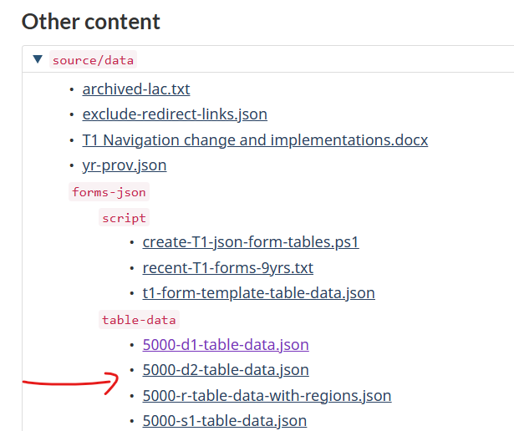
- All the table have a provisional Filter emphasis and a clear filter button above it
- We need to create 6 D2GC templates, as mocked up in (5000-S2, 5000-R and 5009-R)
- If we have heard from PP, we can place the JSON manager code into content fragments (preferable)

