Lab 2 Installing a Domain Controller

1. On **DC1** log on as Administrator (Password16)
2. Start Server Manager (if not already started)
3. Ensure the machine name is set to **DC1**
4. Then add the Active Directory Domain Services Role
5. When prompted to Add Features Click Add Features

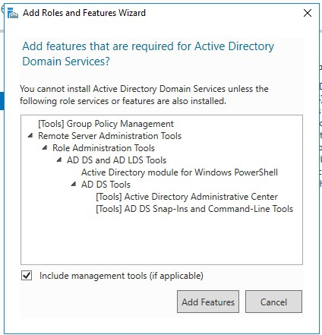

1. Proceed to Install
2. Once install is complete close the Add Roles and Features Wizard

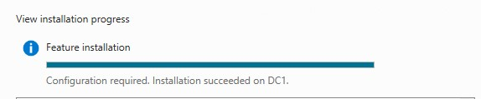

1. Now Click on the Notifications Flag to promote this server to a Domain Controller.

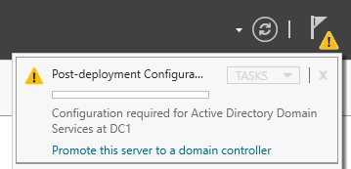

1. On the Deployment Configuration Wizard, we will be adding a new forest called NE381***XX***.comwhere XX are your initials.

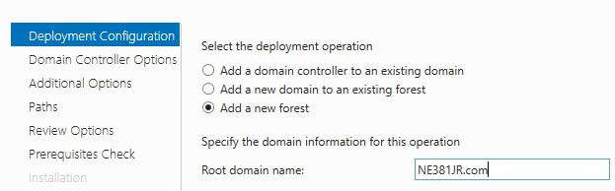

|  |
| --- |
| **Screenshot your forest root Domain Name:** |

1. On the Domain Controller Options Page Ensure that the following is checked.

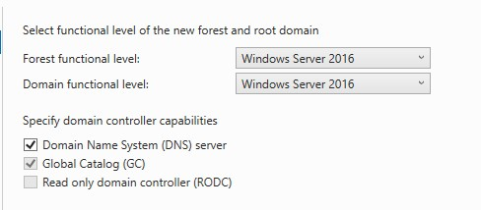

Microsoft recommends that all domain controllers provide DNS and global catalog services for high availability in distributed environments, which is why the wizard enables these options by default

1. Where it says Type the **Directory Services Restore Mode DSRM** password use the password **ActiveDirectory16**  
   *What is this password used for? ***Used to log in to DSRM when needed to repair/recover a corrupt server OS.***

1. Proceed to the Additional Options Section and verify the NetBios name.
2. Proceed forward with the install until you reach the

Prerequisites Check area. Verify that

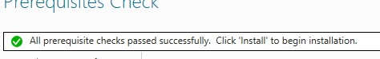

1. Click Install

After the install completes the server will reboot.

And you will be brought to a log on prompt

1. Logon to **DC1** with the **Administrator** account. **All user accounts have been converted to Active Directory Domain accounts. There are no local users on a Domain Controller.**

1. From Server Manager Launch the Active Directory Administrative Center
2. Once launched Right Click on your domain name and select properties

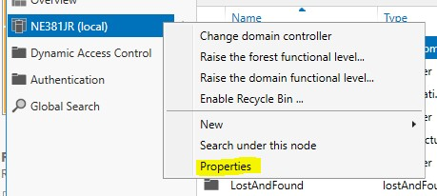

|  |
| --- |
| Shapshot the page that opens showing your Domain Name for submission to Canvas.* |

End Part 1 -> Proceed to Part 2

Part 2 AD and Powershell

1. Make sure both DC1 and DC2 are powered on.
2. Login to both DC1 & DC2 as Administrator. Open a command prompt and verify that both servers can ping each other. (You may have to turn the firewall off to do this make sure the firewall is turned back on once verified)
3. Once connectivity has been verified Join **DC2** to the domain. You will have to adjust DNS settings on DC2 to accomplish this. Make sure you reboot after joining to the domain.
4. Sign in as the domain administrator. (Make sure it is the administrator account that you are signed in to.)
5. Install Active Directory Domain Services with Powershell:
   1. **Install-WindowsFeature –Name AD-Domain-Services  
      -IncludeManagementTools**

|  |
| --- |
| Success looks like this: |
| Screenshot of your success: |

* 1. Now, Activate & Promote the Active Directory Domain Services Role.  
     **~~Install-ADDSForest –DomainName –InstallDns~~**  
     **Install-ADDSDomainController -DomainName “NE381WB.com” -InstallDNS -Credential $(get-credential)**  
     **May need to run twice with ‘General Failure’ error. Run again.**

|  |
| --- |
| Success looks like this:  Enter Administrator and Password16  Enter Password16 for SafeModeAdministratorPassword prompt: |

* 1. Powershell will Not necessarily return to a PS C: prompt. Leave the PS windows open for approximately 5 minutes then you may simply close the Powershell window.
  2. Reboot DC2, then login again with your personal domain admin account.

Part 3

1. Once DC2 is a domain controller, open Active Directory Administrative Center
2. Right click on domain name and Select Change Domain

Controller

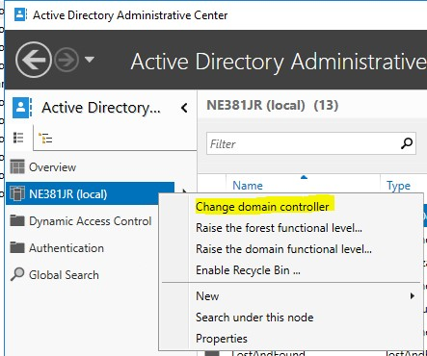

|  |
| --- |
| Screenshot the screen returned (it should look like the screenshot below) save the screenshot for submission to canvas* |

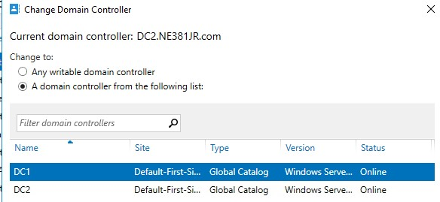

1. Next open a command prompt and issue the following command **netdom query fsmo**

The command should return DC1 as owner of all the

Flexible Single Master Operations roles

|  |
| --- |
| Screenshot: |

1. Next you will use the ntdsutil command to transfer **All** of the FSMO roles to DC2. We covered this process in class. The command and steps are detailed here.

[https://support.microsoft.com/en-us/help/255504/usingntdsutil-exe-to-transfer-or-seize-fsmo-roles-to-a-domaincontrol](https://support.microsoft.com/en-us/help/255504/using-ntdsutil-exe-to-transfer-or-seize-fsmo-roles-to-a-domain-control)   
[To transfer the FSMO roles by using the Ntdsutil utility, follow these steps:

1. Log on to DC2 where FSMO roles are being transferred. We recommend that you log on to the domain controller that you are assigning FSMO roles to. The logged-on user should be a member of the Enterprise Administrators group to transfer Schema master or Domain naming master roles, or a member of the Domain Administrators group of the domain where the PDC emulator, RID master and the Infrastructure master roles are being transferred.
2. Right-Click the **Start** button, click **Run**, type **ntdsutil** in the **Open** box, and then click **OK**.
3. At the ntsdutil.exe: prompt, type **roles** and then press ENTER.  
     
   Note To see a list of available commands at any one of the prompts in the Ntdsutil utility, type ?, and then press ENTER.
4. At the fsmo maintenance: prompt, type **connections**, and then press ENTER.
5. At the server connections: prompt, type **connect to server *DC2***, and then press ENTER, where **servername** is the name of the domain controller you want to assign the FSMO role to.
6. At the **server connections** prompt, type **q** and press ENTER to quit from the server connections prompt and return to the fsmo maintenance prompt.
7. Type **transfer *role***, where **role** is the role that you want to transfer. For a list of roles that you can transfer, type ? at the **fsmo maintenance** prompt, and then press ENTER, or see the list of roles at the start of this article. For example, to transfer the RID master role, type **transfer rid master**. The only exceptions are for the PDC emulator role and domain naming master, whose syntax is transfer pdc, not transfer pdc emulator and transfer naming master, not transfer domain naming master.
8. At the **fsmo maintenance** prompt, type q, and then press ENTER to gain access to the **ntdsutil** prompt. Type q, and then press ENTER to quit the Ntdsutil utility.]

To verify that the roles have been transferred run the  
**netdom query fsmo** command again.

|  |
| --- |
| Screenshot the output of the command showing DC2 as the owner of all the FSMO roles for submission to canvas* |

1. Change the DNS records for CLIENT1 & CLIENT2 to the DC1 server IP address then join CLIENT1 and CLIENT2 to the NE381*XX*.COM domain.
2. Once the Machines are joined to the domain open up Active Directory Administrative Center from DC1, drill into the NE381XX.COM domain -> Computers.

|  |
| --- |
| Navigate to the Computers Group and screen shot the two clients. |