Lesson 4 AD Users and Computers

Part 1

1. Log onto **DC1** and navigate to the C:\
2. In the C:\ create a new folder called **HOME**
3. Right Click on the folder and on the sharing tab click Advanced Sharing
4. Check Share this folder and set the share name to **HOME$**

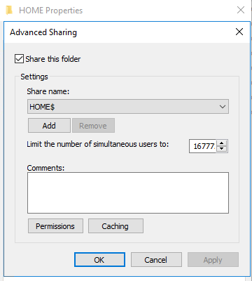

1. Set the share permissions to **Everyone Full**.

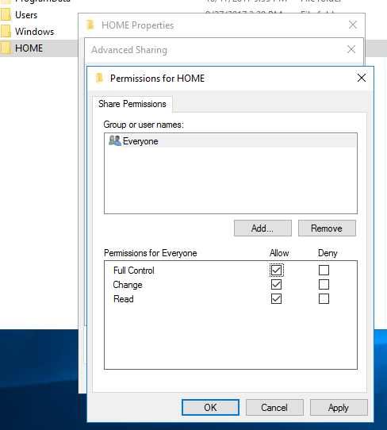

1. **Remove the Users group from the Security Tab.** (you will need to disable inheritance from the advanced tab then convert inherited permissions into explicit permissions on this object)

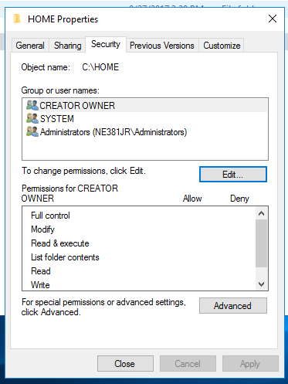

1. Create another Folder Called **SHAREDDOCS**
2. Share the folder without the dollar sign
3. Set the **Advanced Sharing Permissions to Everyone Full** Control
4. Remove the Users group under the Security Tab. (you will need to disable inheritance from the advanced tab then convert inherited permissions into explicit permissions on this object)
5. Log onto DC2 and launch Active Directory Administrative Center from the tools menu.
6. Create a new OU and name it **NE381**. (You will need to click on your domain first. Then click new on the right)

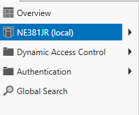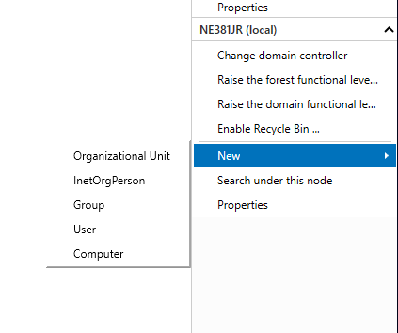

1. Click on NE381 OU and then click on **new user**

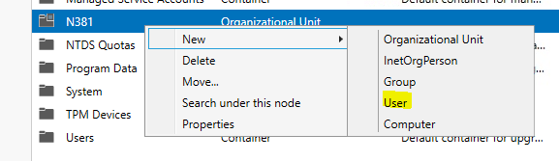

1. Fill out the following details. Leave the Password Blank

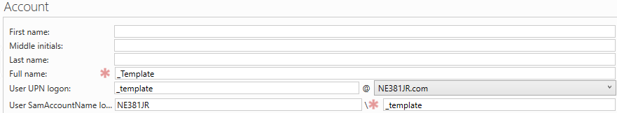

1. Click OK
2. Open Active Directory Users and Computers
3. Navigate to the NE381 OU and locate your template user.

|  |
| --- |
| **Screenshot this user for submission to canvas\*** |

1. Right click on this user and select properties
2. On the Organization Tab for Company put NEIT

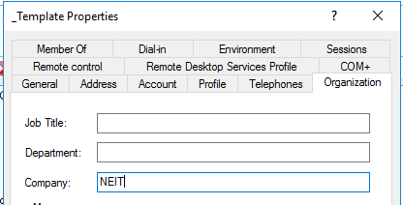

1. Under Account Tab make sure Account is set to Disabled.

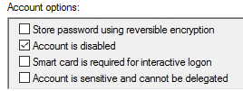

1. Under the profile tab set the following

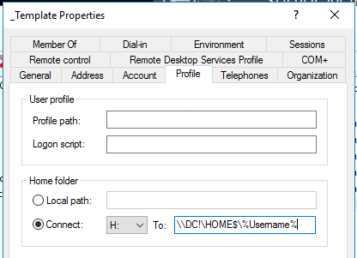

1. Click Ok to save the change.
2. Right Click on the Template User and Select Copy
3. Create a new user for each person in the class. (Exclude yourself) The people in the class can be found under the People section on the canvas course. Set the user logon name to be the first letter of persons first name and then the last name up to 8 characters in length. For example. **Jesse Roberts user logon name would be jroberts**
4. Set each users password to **Password#16** and make sure that you remove the check mark next to Account is disabled.
5. Uncheck [ ] User must change password at next logon.

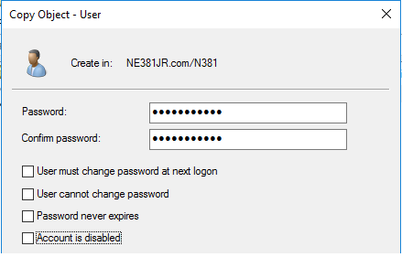

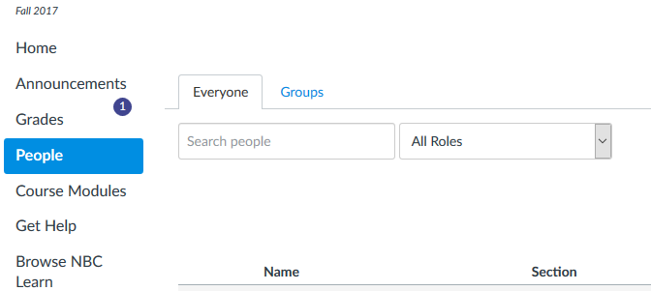

1. Once each user is created open the properties of the account and set their job title under the organization tab to one of the following.

Manager

Engineer

Sales Person

Marketing Design

Human Resources Rep (Make two of these)

Vice President

Help Desk

Security

1. Logon as one of your newly created users.
2. Open file explorer and locate the H: for that user.

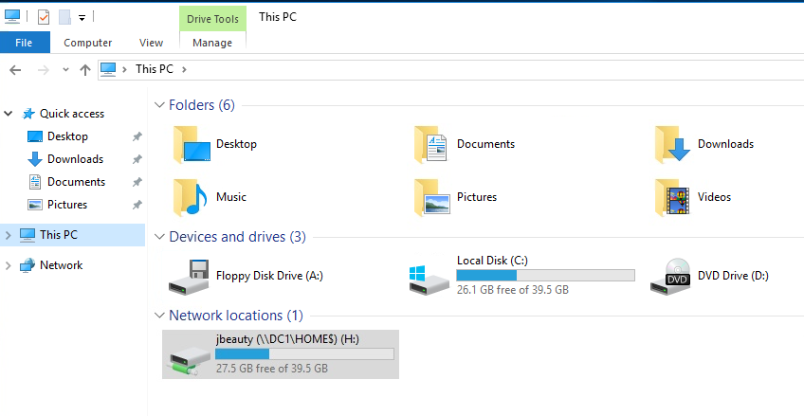

1. Open the folder and create a new text document. In the text, type **yay** the mapping worked.
2. Repeat the process for Five (5) other users.

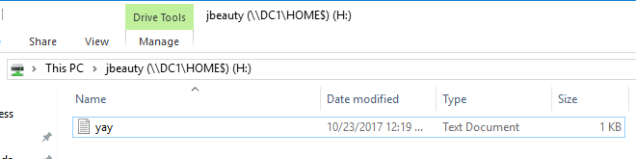

1. Log off as this user and then log on as another user.
2. Repeat the process

The mapped next work drive is unique for each individual and is created when the user is created in AD. Each user is locked into their individual home folder and it will be available on any PC they log on to.

1. **Navigate to DC1 and screenshot the Inside of the HOME folder for upload to canvas* (It should look something like this)**

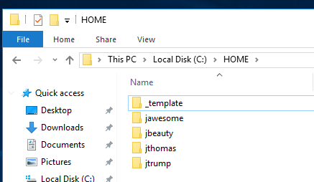

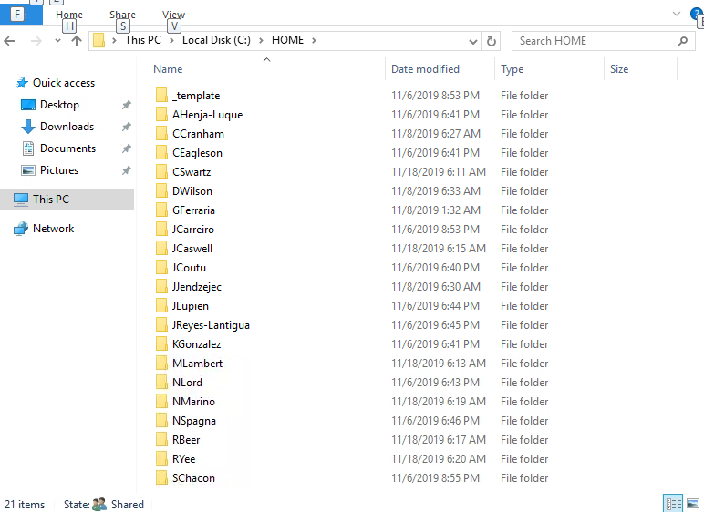

1. Create one more user called **Johnny Helpdesk**. Set his password to **Password#1** and set it to not expire.

Continued next page…….

Part 2

Computer Objects can be created in the same manner.

1. From Active Directory Administrative Center, navigate to the computers folder.
2. Click on New then select Computer

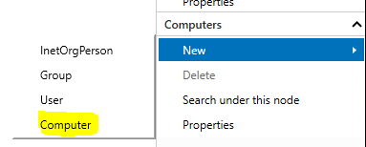

1. For computer name set it to be CLIENT3

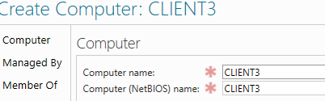

1. Then click ok to save newly created computer object.
2. Open a PowerShell command prompt as an admin and type in Get-Adcomputer. When it asks for a filter type *

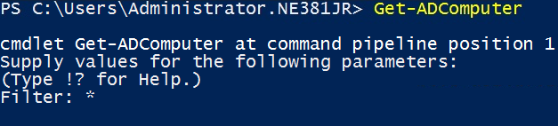

This command returns a list of computers in AD.

1. Use the get-adcomputer command to return just the client3 computer from Active Directory. (this is referenced in the book and numerous places on line)

**Screenshot this command and the output for submission to canvas\***

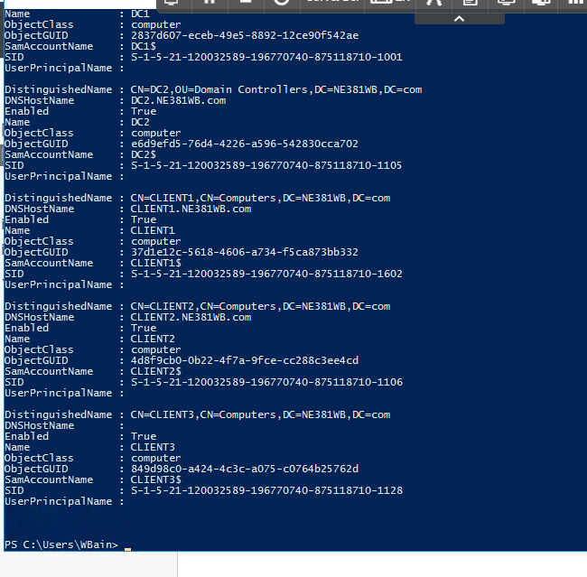

1. Now use the Remove-ADComputer -Identity CLIENT3 command to remove this computer from AD



1. Run Get-ADComputer command again to verify deletion.

Part 3

1. Open a command prompt and change directory the domain admins Desktop folder
2. Use the csvde command to export all the users in the NE381 OU that you created earlier (we only want the user class here). An example of this is in the book. You can also refer to <https://technet.microsoft.com/en-us/library/cc732101(v=ws.11).aspx>

If the command is not working for you. You probably did not format the Distinguished Name properly.

Read more about formatting distinguished names (DNs) here: <https://msdn.microsoft.com/en-us/library/aa366101(v=vs.85).aspx>.

|  |
| --- |
| Screenshot of Users folder: |

Part 4

1. Open a PowerShell command prompt
2. Type Get-Aduser -Filter *

This will return all users in Active Directory database

We can use the -Filter and -Searchbase parameter switches to limit our search to a specific OU

For example, if I wanted to search a folder/container in AD called SalesUsers in the NE381JR.com domain I would run the following command.

Get-Aduser -Filter * -SearchBase “CN=SalesUsers, DC=NE381JR, DC=COM”

1. Run a PowerShell command to get all the users in your NE381 OU

Screenshot the results of this command for submission to canvas*

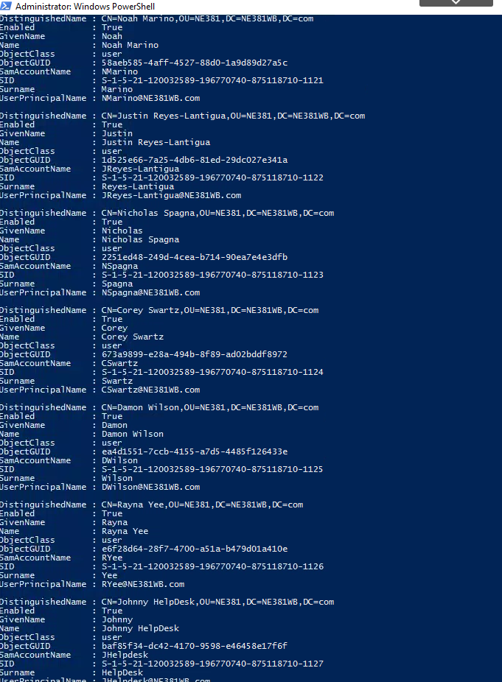

1. Once you have verified that your command is working correctly. Add the following to the end of your command

| Set-ADuser -Enabled $False



1. To verify this worked correctly open Active Directory Users and Computers and navigate to your NE381 OU all the accounts should be disabled. As indicated by the down arrow.

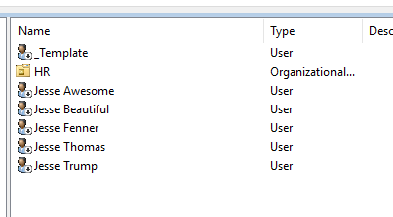

Part 5 Password Resets

1. In Powershell run the following command

$pw = ConvertTo-SecureString Password#10 -AsPlainText -Force

1. Next type in $pw It should return the following



1. Run your previous Get-ADAccount (from part 4) command and pipe the following after it. | Set-ADAccountPassword -NewPassword $pw -Reset

The command will look like this but be slightly different.



1. Enable all AD Accounts using powershell

**Screenshot the command you ran for upload\***



Part 6

1. Download the **Week 4 -> Newusers.zip** and extract to the Desktop\NewUsers folder. Edit the createusers.ps1 file to modify the UserPrincipalName to your domain name and the Path variable to reflect your domain names. Save.
2. Ensure both the createusers.ps1 and users.csv
3. Right-click and **Run with PowerShell** the **createusers.ps1** to import users into AD