From the Active Directory Users and Computer on either one of the Domain Controllers navigate to the NE381 OU

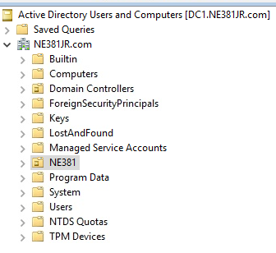

1. Create an OU called HR in the NE381 OU

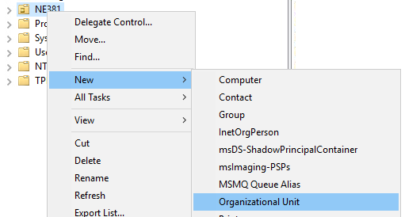

1. Create Three OU’s within the HR OU called

HR Users

HR Groups

Userwhoops (Uncheck Protect container from accidental deletion)

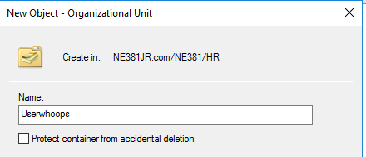

It should look like this when completed.

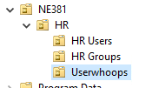

1. Open an elevated PowerShell command prompt and issue the following command.

Get-ADOrganizationalUnit -SearchBase “ou=HR,ou=ne381,dc=ne381***XX***,dc=com” -Filter ‘Name -like “*”’

The XX should be replace with what your domain name is



**Screenshot the output of this command for upload to canvas\***

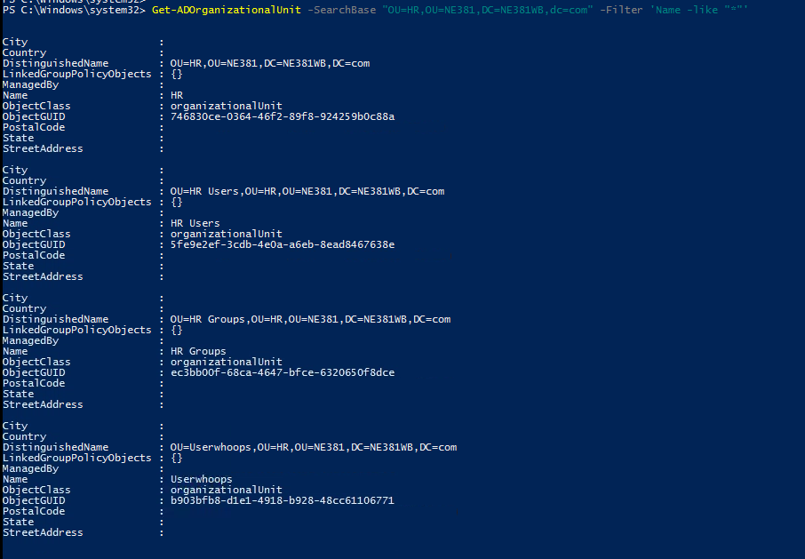

1. Userwhoops is a bad OU that we created by accident. Run the following command in PowerShell to remove it.

Remove-ADOrganizationalUnit “*In here put in the full DistinguishedName of the OU* *include the quotes*”

If you get an access is denied error Remove the protect from accidental deletion

1. From active directory users and computers, move five of your active directory users from your class list to the HR Users OU. You can simply highlight each user then select move and point to the new HR Users OU.

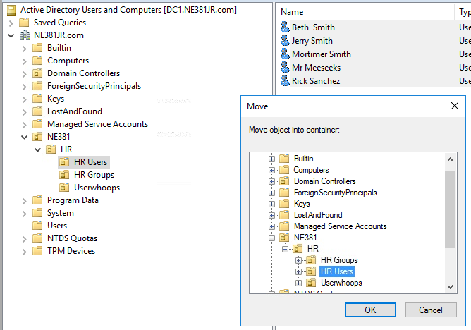

We will now create some groups for accessing the shareddocs folder that was created in the previous lab. We will use the IGDLA method for group membership. I highly recommend that you click on the following link to read up more on nesting groups. <https://blogs.msmvps.com/acefekay/2012/01/06/using-group-nesting-strategy-ad-best-practices-for-group-strategy/>

1. Right Click on HR Groups and select New à Group

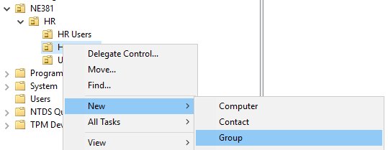

1. Call the group HRManagers and make sure it is a Global Group
2. Open an elevated command prompt and issue the following command

New-ADGroup HRStaff -GroupScope Global -GroupCategory Security -Path “OU=HR Groups,OU=HR,OU=NE381,DC=NE381XX,DC=com”



*XX should be replaced with your domain name

1. From active directory users and computers Create two more groups in the HR Groups OU with the following names and properties

HRSharedDocsChange - Domain Local

HRSharedDocsRead - Domain Local

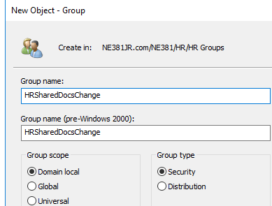

1. Once the groups are created run the following PowerShell **command and screenshot the output for submission to canvas.\*** (Remember XX is your domain name)

Get-ADGroup -SearchBase “OU=HR Groups,OU=HR,OU=NE381,DC=NE381XX,DC=com” -Filter *



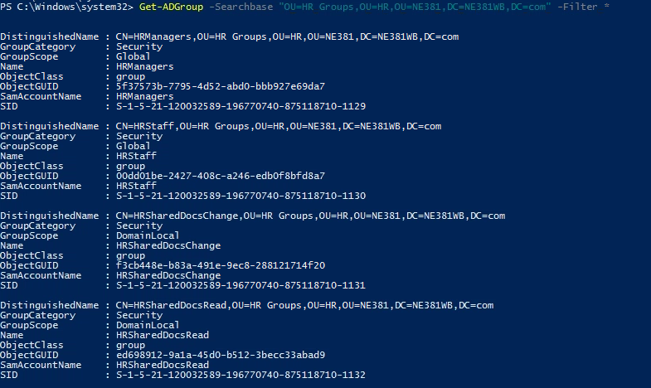

Part 2

1. In Active Directory users and computers Double Click on the HRManagers Group.
2. Go to the Members Tab and add two users of your choosing to this group. (Users that you moved earlier)

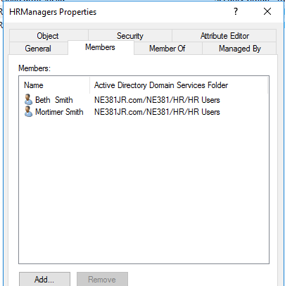

1. Repeat this process for the HRStaff group. Add the remaining 3 users to this group.

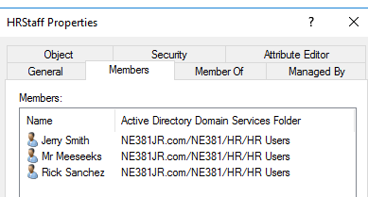

1. While still in Active Directory Users and Computers double click on HRSharedDocsRead.
2. In Members add the HRStaff group

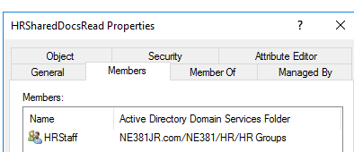

1. Double click on the HRSharedDocsChange and add the HRManagers group as a member here.

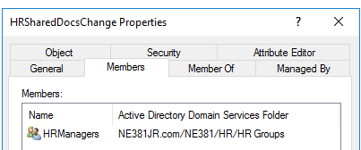

1. On DC1 navigate to the C:\SharedDocs folder in the GUI
2. Right click to open properties.
3. Verify that the folder is shared and that Everyone has Full Control

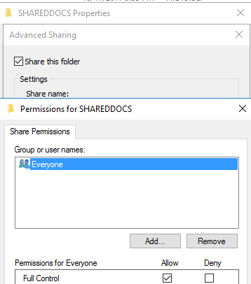

1. On the Security Tab Select Edit
2. Click Add and type in HRSharedDocsChange then click Check names and then OK

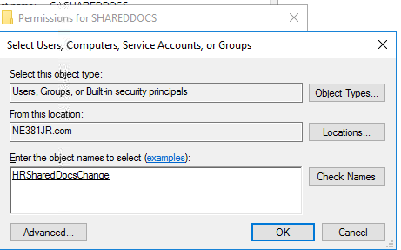

1. Check mark Modify Allow under permissions for HRSharedDocsChange. Then click OK

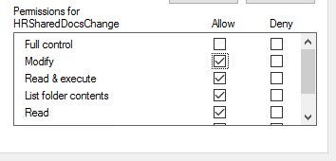

1. Click Edit Again
2. Click Add and then add the HRSharedDocsRead group like you did in the previous step
3. Under permissions Make sure only the following is selected then click Ok. Close any open dialog box.

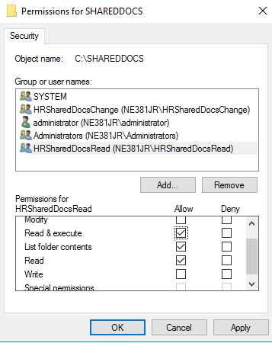

1. Log on to Client1 as any user that is in the HRManagers Group
2. Open file explorer and enter the following UNC path

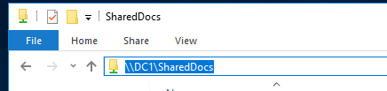

1. Create a new folder called HR

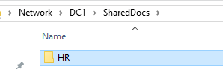

1. **Log out and log on as any user that is a member of the HRstaff Group----------------------------------------**
2. Navigate to the same UNC path

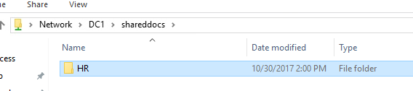

1. Try to delete the folder. You should receive an access is denied error message.
2. Back on DC1 run the following PowerShell Commands

Get-AdGroupMember -Identity HRManagers

**\*Screenshot this output for submission to canvas**

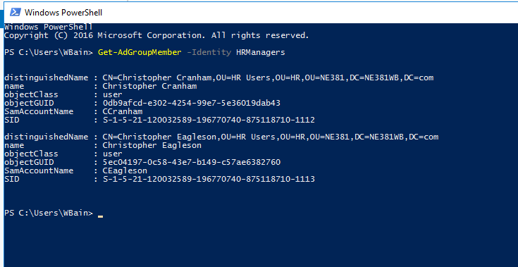

Get-AdGroupMember -Identity HRStaff

**\*Screenshot this output for submission to canvas**

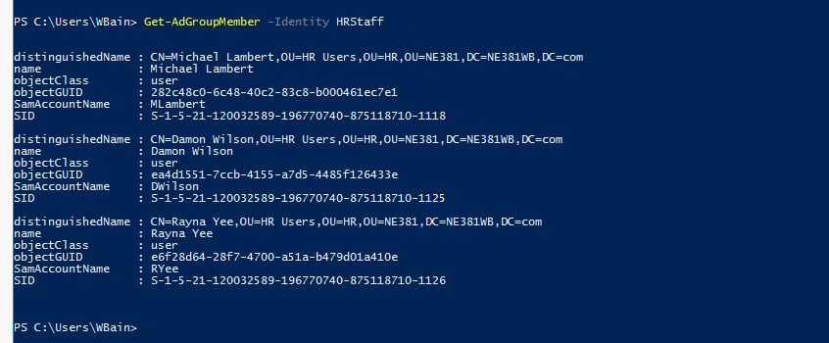

Part 3

1. Open AD Users and Computers and Navigate to the HR OU
2. Right Click on the OU and select Delegate Control
3. Add Johnny Helpdesk

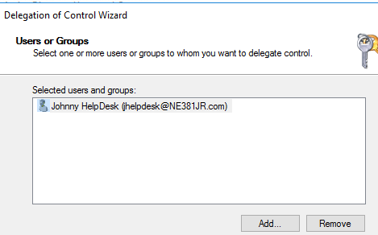

1. Put check marks next to the following

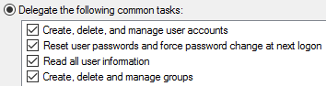

1. Click Next then finish.

Part 4

By Default, all users and computers created in the domain will be created in the Default Users and Computers OU

We will modify this

1. Log on to DC2
2. Create an OU called Users in the NE381 OU
3. Create another OU called Computers
4. Open an elevated command prompt and run the following commands. (NOTE: PS spacing is vitally important. No space after commas)

**redircmp ou=Computers,ou=NE381,dc=NE381xx,dc=com**

You should get a command completed successfully

Then run

**redirusr ou=Users,ou=NE381, dc=NE381xx,dc=com**