# Part 1 Installing AD RMS

SRV1, SRV2, SRV3 should be on.

1. On SRV3 logon as an Enterprise Admin
2. Start Server Manager
3. Click Manage Remove Roles and Features
4. Remove the Web Server ISS Role.
5. Reboot the server
6. Delete the C:\inetpub folder
7. Click Manage > Add Roles and Features
8. Click Next until you are on the Select Server Roles Page
9. Check the Active Directory Rights Management Services box and click Next (see screenshot). If prompted to Add Features that are required... review the role services that must be installed for AD RMS to work and ensure Include management tools is checked. Click Add Features to return to the Role Services page and click Next.

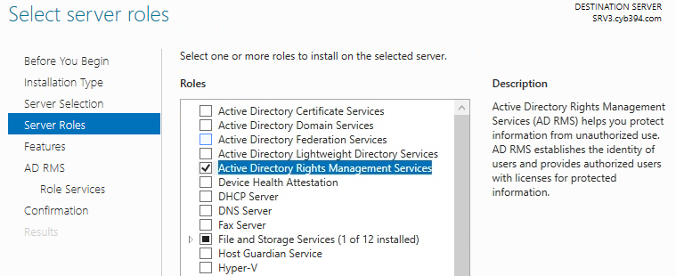

1. Click Under Role Services make sure that Active Directory Rights Management Server is checked.
2. Click next then Install
3. Once Install is complete you can close the wizard.

# Part 2 Configure RMS

1. Click on the  in server manager
2. Then click perform additional configuration

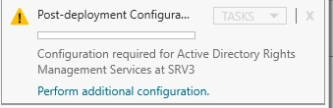

1. Read the intro screen then click next
2. Select Create a new AD RMS Root Cluster click Next
3. Choose Use Windows Internal Database on this server click Next

*In a real production environment, you will want to have a SQL server installed on a separate server.

1. On SRV1 open Active Directory Users and Computers
2. Create a new user account in the CYB394 OU the user logon name will be adrmssvc. With a password of Service#1 and make sure to set the password to never expire

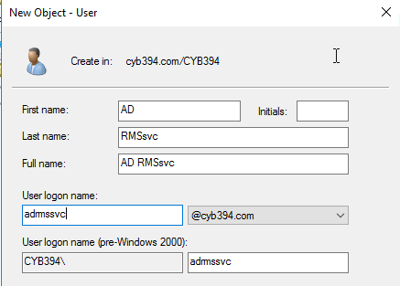

1. Back on SRV3 you should be on the Specify Service Account page.
2. Click Specify and Enter the Domain user account you just created. Then Click Next

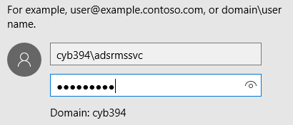

1. Read the Specify Cryptographic Mode description. Then Choose Cryptographic Mode 2 then click Next
2. Choose Use AD RMS centrally managed key storage.
3. Under Specify AD RMS Cluster Key Password Type Cluster#1
4. Keep Default Website in the selection pane
5. In the cluster address type <https://adsrms.cyb394.com>
6. Generate a new certificate for RMS to use. (You did this in the last lab) Use the Local Computer Certificate Snap in to create a new cert. Use the WEBSRV Template. The Common Name should be srv3.cyb394.com. Add the following DNS names to the request.

adsrms.cyb394.com

srv3

srv3.cyb394.com

adsrms

Have the friendly name be ADRMS

1. Once you have the certificate generated go back to the RMS configuration page and Click the Refresh Button on Choose an existing Certificate.
2. Verify you are selecting the correct certificate by clicking properties then view the Subject Alternative Name in the Details Tab

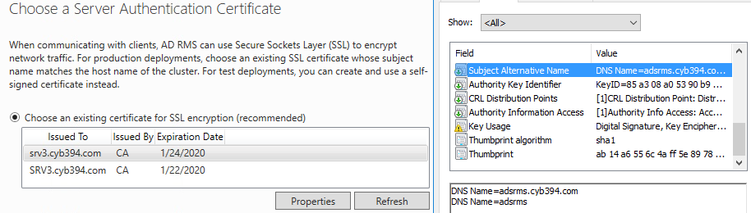

1. Click next through the rest of the prompts. Make sure you review what it is saying. When you get to the install prompt click install.
2. Log off SRV3
3. On SRV1 DNS Tool Create a CNAME for adsrms that points to srv3.cyb394.com

Continued Next Page……

# Part 3 Creating some Users and Groups for RMS

1. On SRV1 launch Active Directory Users and Computers
2. Create a Security Group called Finance Users in the CYB394OU
3. Create two users Finance User1 and Finance User2 in the

User logon name is finuser1 and finuser2

Set the password for each user to be Makedollars#1

Give each user an email address in the AD properties ex. finuser1@cyb394.com

Add the users to the Finance Users Security Group

Give the Finance Security Group and email address of

financeusers@cyb394.com

**Power ON Client1**

1. Log on to Client1 with both users and log off once the profiles have been built
2. Log on as an Administrator and Do a web search for Office 365 Login. Log on with your school account
3. Once logged on go to the office 365 home page and find the install office link then select install Office 2016

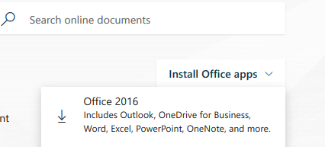

1. Install Office 2016 and once the install completes log off

# Part 4 AD RMS Templates

1. Log on to SRV3
2. Start Server Manager
3. Click Tools > Active Directory Rights Management Services
4. In the left-hand navigation pane, expand the node for the cluster
5. In the left-hand navigation pane, select Rights Policy Templates
6. In the Actions pane, click Create Distributed Rights Policy Template and Click Add
7. Fill in the following

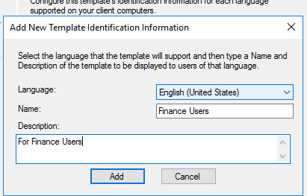

1. Then Click Add
2. In the Add users Rights box type in [financeusers@cyb394.com](mailto:financeusers@cyb394.com)
3. Under Rights grant them full control
4. Optionally, in the Rights request URL text box, type a URL that can be accessed for clients to request additional rights. This request is a manual operation. Leave it blank for now
5. Choose never expires
6. Click next through the rest of the creating process

# Part 5 Protecting a Word document with RMS

1. Log on to client1 with finuser1
2. Create a new folder on the C:\ called makedollars
3. Open a new word document and add the word Make money!!!! to the content of the word document.



1. Save the document to the makedollars folder but do not close the document.
2. In word Click File then select the info tab. To the right select Protect Document then select Restrict Access. Click on Connect to Rights Management Servers and get templates.

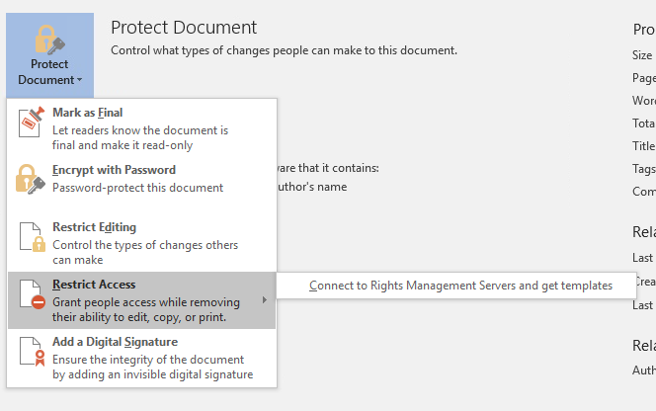

1. If prompted to confirm certificate click OK
2. If prompted for Credentials enter the following in the UPN format.

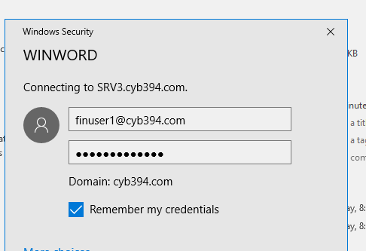

1. You may receive an error. Close out of word then open it again. Go back to the Protect document area you should see the following selections

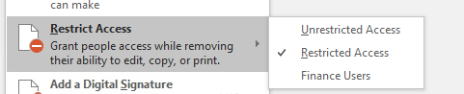

1. Choose Restricted Access
2. In the Read section type finuser2@cyb394.com

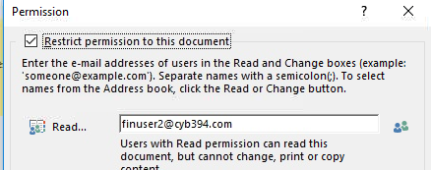

1. Click Ok then save the document
2. Log off Client1 and Log on again with finuser2
3. Navigate to the makedollars folder and open the document.
4. IF prompted with a certificate click ok
5. Then type [finuser2@cyb394.com](mailto:finuser2@cyb394.com) with password of Makedollars#1
6. You should now see the document but you are restricted to read access.

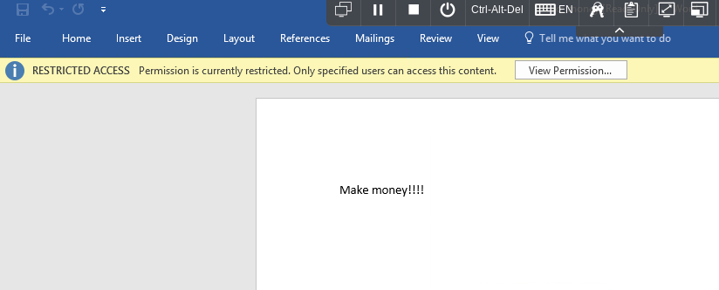

1. Log off and (Make sure your admin account has an email in AD) logon with your administrator account
2. Attempt to open the word document as an administrator. If prompted enter credentials in the UPN format. Show the professor the message you get.