WSUS

In this lab you will install and configure WSUS and use it to install updates.

# Part 1: Preparation

All your images should be shut down at this point.

1. Start the SRV1 image, but not the other images.

WSUS requires at least 1 GB of disk space on the System Partition and 2 GB for the Internal Database. It also requires space for storing content (update files). Before starting check with your, instructor to make sure a blank virtual hard drive is attached to your SRV4 Skytap image.

1. Start the SRV4 and logon with administrator Password1
2. Join SRV4 to the domain. Make sure the computer name is updated to SRV4
3. Once joined log on with your personal Domain Administrator Account.
4. From Server Manager Click **Tools** then select **Services.**
5. Right click on the Windows Update Service and select **Properties**
6. Set Startup type: Automatic then Click OK.
7. Click Start the Service.

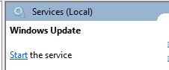

1. Click the Windows Start Menu, then Click the gear Icon to go into Settings. 
2. Click Update & Security
3. Click Check for updates.

*This process can take up to 45minutes Proceed to Part 2.

Part 2 Add the new virtual hard drive to the SRV4 image.

1. Start Server Manager, select the **Tools** menu then **Computer Management**.
2. In Computer Management select Disk Management



1. You should see the new disk as unallocated space.



1. Right click on the square where you see Disk 1 and select Online.
2. Right Click where it says Unallocated and choose New Simple Volume……



1. Click Next
2. Accept the defaults until you get to the dialog box where you can enter the name of the new volume (call it **WSUS**) and check the box for Perform a Quick Format.
3. Click Next then finish to format and bring the drive on line.
4. Create a folder on the drive called WSUS

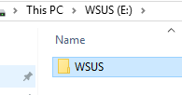

# Part 3 Install WSUS on SRV4

1. From Server Manager click Manage and Select Add Roles and Features
2. Click Next until you get to the Server Roles Selection pane.
3. Check mark the Windows Server Update Services Role.
4. When prompted Click Add Features to install the necessary features for Windows Server Update Services.
5. Click Next until you get to the Content location selection pane.
6. Make sure to check mark Store updates and type in E:\WSUS

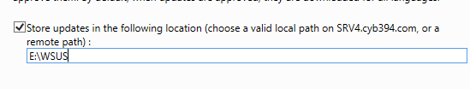

1. Click Next to keep the defaults.
2. On the Confirmation page Click Install.
3. The installation will take a few minutes, and you will see when it has succeeded.
4. Click on the yellow triangle in Server Manager and select Launch Post-Installation tasks.

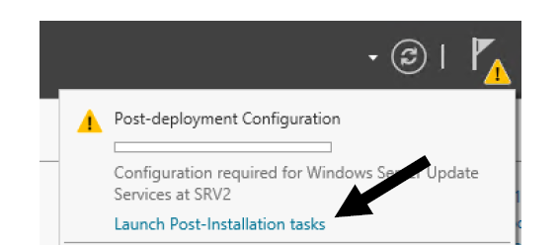

1. When this process is complete click on Tools Then Windows Server Update Services.

# Part 4 WSUS Configuration

1. Windows Server Update Services configuration wizard should launch.
2. Click next on Before You Begin
3. Uncheck the option to join the Microsoft Update Improvement Program.
4. Choose Synchronize from Microsoft Update.
5. Click Next on Specify Proxy Server
6. Click on Start Connecting.

*This will obtain information from Microsoft about what kinds of updates will be available so you can choose what you want. This process will take a few minutes and when it ends the Next button will illuminate so you can click on it.

WSUS is contacting Microsoft to update the settings are to be available in the rest of the Wizard. This process will likely take a while – 10 to 25 minutes can be expected.

1. Click the radio button to download only specific language updates and check the box for English and click Next.
2. In the Choose Products section, uncheck any options other than Windows 10 (See screenshot) and Server 2016 since those are the only two operating systems WSUS will be updating in the lab.

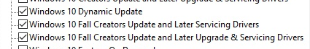 

1. When asked to Choose Classifications, accept the defaults for only Critical Updates, Definition Updates, Security Updates and Upgrades.
2. Accept the default to Synchronize Manually. Here you would normally set a time (perhaps at night), but since our test units aren’t running at night, we will control things manually.
3. Check mark Begin Initial synchronization
4. Click Next then Finish
5. When the screen switches back from the wizard to the WSUS Update Services module, click on Synchronizations and you should be able to click on the synchronization this is in progress. At the bottom of the center window you should see the % completed as it runs.



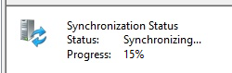

# Part 5 GPO for Intranet Update

In order for client computers to use the WSUS, you will need to configure and link a Group Policy Object. In this lab we will link the policy to the Domain container.

1. Switch focus to your domain controller (SRV1).
2. Create a GPO called WSUS Client Policy, link it to the Domain container and open the group policy editor to edit the policy. (You should know how to do this.)
3. In the Computer Configuration node Under Administrative Templates, expand Windows Components and click on Windows Update and double click on Configure Automatic Updates in the right hand pane.
4. Click on the Enabled radio button and then look under the Options section.
5. Examine the other options but leave the default in place.
6. Leave Scheduled Install day set to the default and set the Scheduled install time to the one hour after the start of class and click OK.
7. Double click on Specify intranet Microsoft update service location (this is to have all clients point to your WSUS server).
8. Enable the policy and in both dialog boxes type in the URL of your WSUS server. Be sure to add the port number as shown.

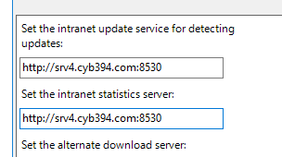

1. Double click on Automatic Updates detection frequency Properties. This is where you tell the client computers how often to check the WSUS server for updates. The time you put in here is subject to a 20% randomization time so that all the clients under the policy don’t try to update at exactly the same time.
2. Enable the policy. What is the default time? _____________
3. Set the value to 1 hour Click OK
4. Set the Do not allow update deferral policies to cause scans against windows update to enabled.



1. Finally Navigate to Computer Configurationà Administrative Templates à System à Internet Communication Management à Internet Communication Settings.
2. Enable the policy Turn off access to all Windows Update Features.
3. These are the only settings we will make for the WSUS clients. You can close the group policy editor.
4. Run gpupdate on SRV1, SRV2, SRV3, SRV4, CLIENT1 and check to see if the new policy is in effect. (Remember to use an elevated command prompt or you won’t see the Computer policy settings.)
5. On SRV1, SRV2, SRV3, SRV4 and Client1 go to the Services tool and set Windows Update to Automatic and Start the service.
6. Go to settings  on SRV1, SRV2, SRV3, SRV4, and Client1.
7. Go to 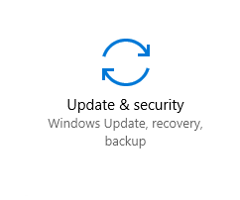 on SRV1, SRV2, SRV3, SRV4, and Client1. Check for updates on each server/client.
8. On SRV4, in the WSUS console, expand Computers, right click on All Computers and select Add Computer Group. Call the new group Testing.
9. With All Computers highlighted, change the status to Any and click the Refresh button. You should see (at least) your SRV1 computer.
10. Right click on the SRV1 computer and select Change Membership
11. In this case there will be only one choice so check the box for Testing.
12. Check to be sure SRV1 is now listed in the Testing group. It will still be listed under All Computers. You will need to change the Status to Any and click the refresh button to see the change. Don't continue until SRV1 shows.
13. If SRV1 doesn’t show in the Testing group, run the following command on SRV1
14. Usoclient.exe /refreshsettings /Startscan
15. With the Testing group highlighted, look in the center pane for the column labeled Last Status Report. If SRV1 still shows Not yet Reported, click on Refresh.
16. Normally you wouldn't reboot a computer just to have it check in with WSUS quicker, but for the lab environment you can always reboot SRV1.[Don’t reboot unless you need to.]
17. Start CLIENT1 so that it will get the new WSUS GPO
18. When CLIENT1 starts, logon with your personal domain account.
19. Check to see of WSUS shows CLIENT1 in the Computer list. If not, run Usoclient.exe /refreshsettings /Startscan
20. In WSUS on SRV4 In the Update Services console highlight Security Updates. Then set the Approval mode to Unapproved and click the Refresh button

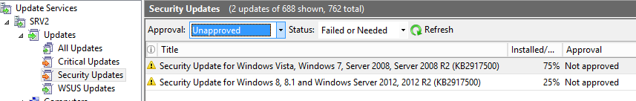

1. Once SRV1 has checked in you should see updates that are needed. When you highlight (left click on) any update you will see information about it below.

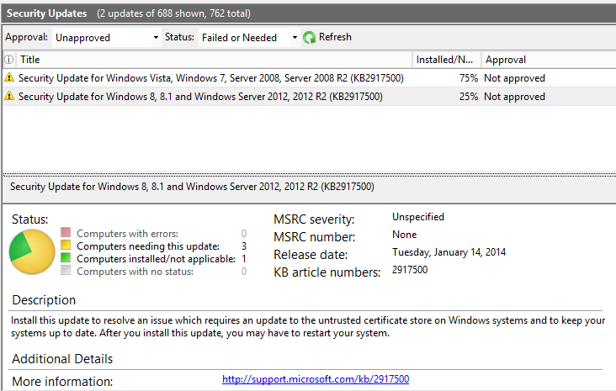

1. Select one or more updates to install. Highlight an update and then drag the mouse down to select several. Right click on any highlighted update and select Approve…

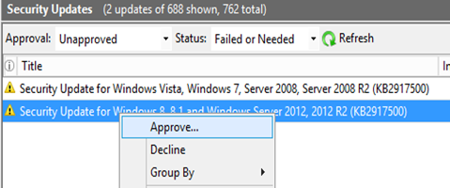

1. Highlight Testing and right click on it. Select Approved for Install and click OK.

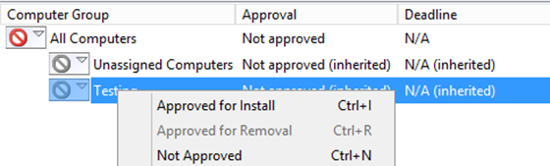

1. You will now see each update being approved for installation on any computers needing the update that are in the Testing group. You can click Closed when all show Success in the Result column.

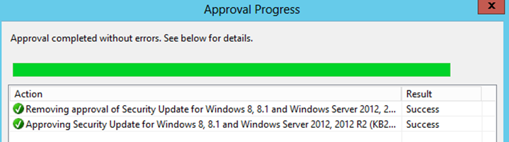

1. Switch back to SRV1 and re-issue the Usoclient.exe /refreshsettings /Startscan to quicken the process. SRV4 will download the files from Microsoft if they aren't already on the disk and SRV1 will then download the updates that you approved for installation.
2. Go to Settings then Select Update and Security
3. Install the update(s).
4. Switch to All Updated in the WSUS left pane.
5. Select more updates.
6. Update SRV4
7. After CLIENT1 has checked in, install updates.

How many Security Updates do you have for CLIENT1

1. On SRV4, check the size of the WSUS folder on the WSUS drive.

How much disk space is being used by WSUS files?

When completed, shut down all the images