**NE247 – Windows Server – Lab7**

**Points deducted if All Answers Are Not In: Ariel, 14pt, Bold, Red!**

In this lab you will configure and work with DHCP and use DHCP to provide IP configuration information to a work station computer.

Required Materials:

**SRV16** and **WIN10** images prepared in previous lab exercises

DHCP

Dynamic Host Configuration Protocol (DHCP) is used to assign IP addresses and other important IP configuration information to computers in a network. While it would be possible to run an IP network without using DHCP, the administrative effort would be prohibitive except in the smallest of networks.

DHCP is a non-authoritative protocol which means that (unlike DNS) you can’t restrict what computers are allowed to get DHCP information. Any computer sending a request to a DHCP server will get a response even if the computer is not a member of the Active Directory Domain.

Certain computers in a network will not use DHCP for configuration. These include the main infrastructure servers including domain controllers, DNS servers and DHCP servers. These machines should always have their IP configuration set manually with what are called Static IP address. Most of the other computers in the network will get their IP configuration data from a DHCP server.

Part 1: Install the DHCP Role

* Start the **SRV16** computer and log on with our personal administrative credentials.
* In Server Manager click on the Manage menu and select Add Roles and Features. This will take you to the Add roles and Features Wizard.

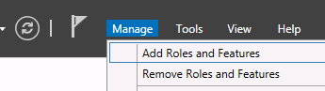

* Accept defaults as you work through the wizard until you get to the Server Roles section. When you click on the box to check DHCP you will immediately get a window asking if the DHCP management tools should also be installed. Click on Add Features to accept the management tools.

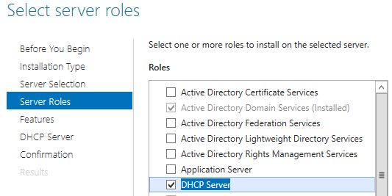

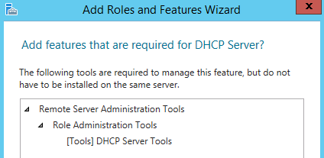

* Click on Next after you have accepted the tools and you will be taken to the Features menu. Do not select any features. You only want the DHCP role and its associated management tools.
* You can click next to finish the wizard and at the last screen you click on Install to complete the wizard.
* You will get a progress bar after clicking install showing the status of the installation. The installation should only take a couple minutes. Note on completion that you are given a link to complete the DHCP configuration. Click on this link.

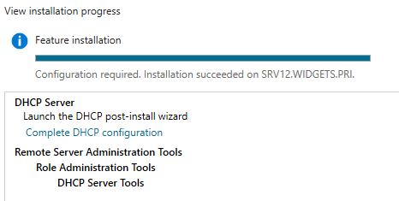

* The DHCP Post Install configuration wizard will start. The Description screen tells you about two new security groups that will be created in this process. List them below, then click Next.

__________________________________

__________________________________

* .The next screen asks for credentials that will be used to “Authorize” this DHCP server to function in the Active Directory domain. Authorization is a process to help assure that the only DHCP server that will give out addresses on the network are those set up and controlled by administrators. You can accept the default of your own account as long as that account is member of the domain admins security group. You accept this by clicking on the Commit button.

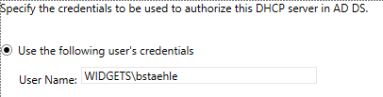

* When finished you will be returned to the final page of the Add roles and Features wizard which you can now close.
* You will now notice a number 2 next to the flag icon on the Server Manager menu bar. When you click on this you should see that it shows that Feature installation was run and that the Post Deployment Configuration was completed.

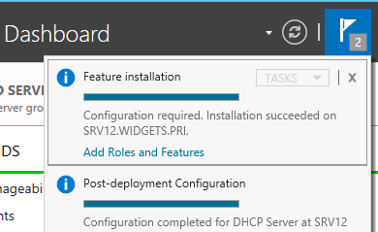

* ***Stop and show this to the instructor __________________***

***Instructor’s Initials***

* Click on the X at the top of each notice to close it. When you have done this there should not be any numbers by the flag icon.

Continue on to Part 2

Part 2: Configure DHCP

In order to give out IP addresses, the DHCP server needs to be given a “scope” which is a range of IP addresses that the server can administer. In a typical network, some addresses are always assigned statically such as those for the default gateway, domain controllers, DNS servers and DHCP servers. To prevent those numbers from being given to client computers, they will be excluded from the scope by being included in an Exclusion range. An Exclusion range is configured when you want certain addresses withheld by the server. In this lab you create a scope and then exclude a few address for static assignment.

* From the Tools menu of Server Manager select the DHCP option. This will open the DHCP module.

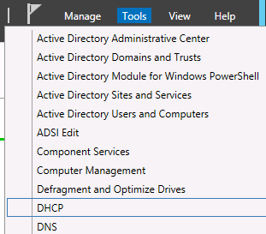

* In the left pane of the DHCP module expand the IPv4 icon. Then right click on the icon and select New Scope. This will open the New Scope wizard.
* You can give the scope any name and description you want. For lack of anything more original, you can call the scope LabScope and leave the description blank.

The IP Address Range dialog box is very important. This page gives you critical settings that cannot be changed without deleting the scope and starting over, so you want be sure the values are what you want.

* Use the entire Class C (/24) network for the scope. The third octet of your network will be different than that shown in the screen shot below. Use the correct IP addresses for your network.

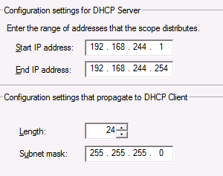

* Set the Exclusion range for the first 20 address in your scope. This will prevent the DHCP server from giving these address out dynamically. They can be used for static IP addresses for servers.

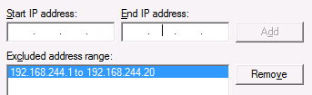

* Record, but don’t change the Lease duration in the next windows.

Lease Duration: Days _____ Hours _____ Minutes

* At the Configure DHCP options, select No, I will configure these options later. The reason you do this is that the wizard doesn’t offer all the options you may need, and you must learn to add or change options manually.

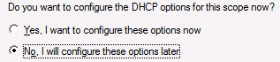

* When you finish the wizard you will be taken back to the DHCP module and will be able to see your scope. Expand the Scope folder. *[Note the very small red arrow on the Scope folder icon. This indicates that the scope has not been activated. That means that it will not give out addresses until you activate it.]*
* Click on the Address Pool folder and you should see your address range and the exclusion range.

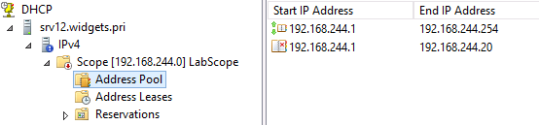

* Left click on Scope Options and you will get a description of the Scope Options in the right hand pane.
* Right click on Scope Options and select Configure Options.
* Click on the check box for 003 Router. This is actually the Default Gateway setting that will be sent out to all the clients receive IP addresses from this scope.
* Enter the Default Gateway address for your VMnet8 network by filling in the IP Address line and clicking Add. Your default gateway address will not be the same as the screen shot.

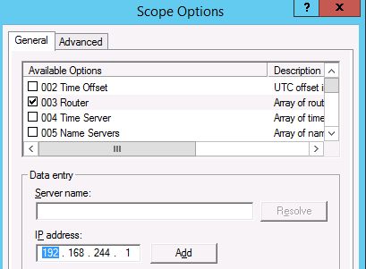

* Scroll down through the options to option 006 DNS Servers and add the address of your **SRV16** computer which is the DNS server for your small network.
* For Option 15 add the domain name of your network (Widgets.pri).
* Click OK to save your Scope Options.
* ***Stop and have the instructor check your settings. ___________________***

***Instructor’s Initials***

* Now that your scope is ready, you can Activate it. Right click on the Scope folder and select Activate. The small red arrow should disappear after activation. Do not continue if you still see the red arrow

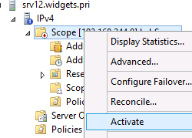

You scope is now ready to give out IP configuration information to any requesting clients.

Continue on to Part 3 …

Part 3: Have a Workstation Computer use DHCP

* Start the **WIN10** image and log on with your personal domain credentials.
* Open Network and Sharing center (Hint: icon on the taskbar near the clock) and click on Change adapter settings.
* Right click on the Ethernet icon and select Properties.

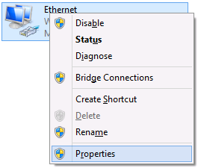

* Select Internet Protocol Version 4 and click the Properties button.
* Configure your static IP address so the last octet is 15. (Your settings will not exactly match the screen shot.) Use the correct IP addresses for your network if they are different from those shown in the screen shot.

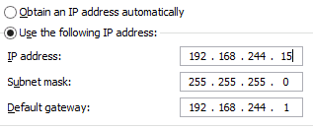

This step is not actually necessary. We are doing this to set the static IP address to be within the exclusion range of DHCP. We will soon change this.

* Close the dialog boxes to save the settings.
* Open an command prompt and issue the command **ipconfig**. Then record what you see.

IPv4 address: ________________________

Subnet Mask: ________________________

Default Gateway: ________________________

* Now go back to the IPv4 Properties settings and click both radio buttons to Obtain an IP address automatically. This tells the system to use DHCP.

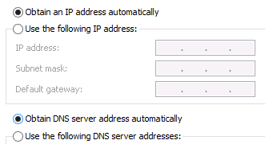

* Click OK and Close to save the settings.
* Run ipconfig again and see if the address has come from DHCP. The only change should be the last octet in the IPv4 address.

IPv4 address: ________________________

Subnet Mask: ________________________

Default Gateway: ________________________

* ***Stop and have the instructor check your settings. ___________________***

***Instructor’s Initials***

Part 4:Examine what happens with DHCP Fails

If a DHCP client computer cannot reach a DHCP server it will assign itself and IP address in the Automatic Private Address range (APIPA) in the 169.254.0.0 /16 network. In the next steps you will see this happen.

* Switch back to **SRV16** and open the DHCP snap in if it isn’t already open.
* Click on the Address Leases icon under your scope and examine the lease data for you **WIN10** client. Record what you see.

Client IP Address Name Lease Expiration

__________________ __________________ __________________

* Now right click on the Scope folder and select Deactivate and accept the deactivation. You should see the small red arrow on the icon after you deactivate the scope.

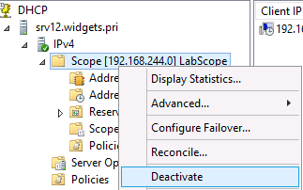

* Return to **WIN10** and issue the following commands, pressing enter after each one. *[You may experience a delay of a minute or two after the /renew command as your client computer repeatedly tries to reach the DHCP server. When it finally gives up, it will have a new IPv4 address in the APIPA range.]*

Ipconfig /release

Ipconfig /renew

* When the command finishes (with an error message) issue the ipconfig command again and record what you see.

IPv4 address: ________________________

Subnet Mask: ________________________

Default Gateway: ________________________

Remember: If the DHCP scope was deactivated and no other DHCP server could be located, the computer will assign itself and address in the APIPA range.

* If the above address does not begin 169.254 ask for assistance.
* Return to **SRV16** and **activate** the DHCP scope.
* Return to **WIN10** and issue the **ipconfig /renew** command and record the results. You should have a correct IP address from the DHCP server. Don’t continue if you still have a 169.254 address.

IPv4 address: ________________________

Subnet Mask: ________________________

Default Gateway: ________________________

Part 5:Configure another scope for practice

* Switch to **SRV16** and create a new scope with the following settings. You will not activate this scope; you are just doing this for practice.
  + Scope Name: Practice
  + Scope range: 192.168.2.1 – 192.168.2.128
  + Set the subnet mask to /24
  + Exclude the first 10 addresses for static addressing
  + Set the default gateway (Option 3) to 192.168.2.1
  + Set the DNS server IP address (Option 6) to 8.8.8.8.
  + Set the domain name (Option 15) to acme.net.
* ***Stop and have the instructor check your settings. ___________________***

***Instructor’s Initials***

* When completed, shut down both images normally

-END