**NE259 – Windows Server – Lab1**

**Points will be deducted if All Answers Are Not In:**

**Ariel, 14pt, Bold, Red!**

In this lab you will access a Server 2016 image and a Windows 10 image that have been prepared for you on the Skytap site. You will be running these images “in the cloud” since your images will not be on your local computer, but will be on Skytap servers. You will access these images through you browser. You can use any standard browser (Internet Explorer, Chrome, Firefox, etc.). Skytap requires a recent version of Java on the system you use to access the images.

Required Materials:

Server 2016 (**SRV16**) and Windows 10 (**WIN10**) Skytap images

**SRV16: Administrator : Password16  
 WIN10: Administrator : Password10**

URL to access the images installation DVD

Standard browser with up to date Java on the system.

**REGARDING SYSTEM UPDATES:  
When Prompted, Click [Get Updates]**  
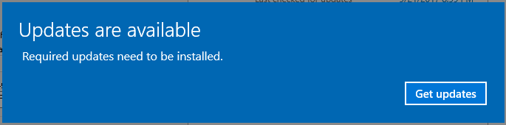

**THEN: Click [X] to CANCEL UPDATES for ALL LABS!!!!**  
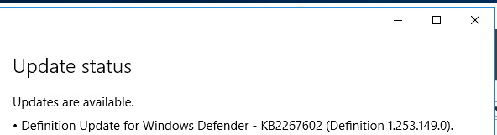

**Part 1: Access and Configure Your Server Image**

The instruction will provide you with a URL

* Canvas -> Week 1 -> NE259 Skytap Link Environment -> Create Lab

This will create your Windows 10 and Windows Server 2016 environments.

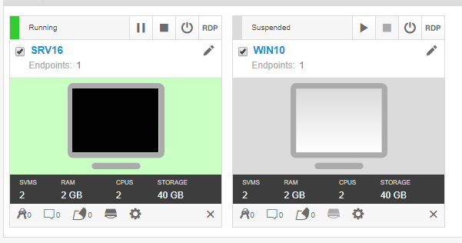

* Click on the arrow to the right of Powered off to start your **SRV16** image.
* Click on the middle of the computer screen icon to access you image.
* The bar at the top of the window allows you to click to send a **Ctrl-Alt-Del** signal to the image. (If you use your keyboard it will send Ctrl-Alt-Del to your lab computer not the image.)



* Click on the Ctrl-Alt-Del link and log on to **SRV16** as **Administrator with Password16** as the password.
* 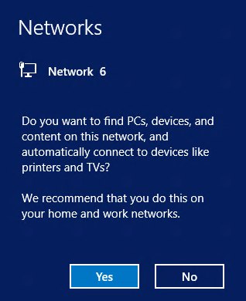If you get a box asking about connecting to the network, click Yes.
* In the left pane of Server Manager select Local Server, and then click on the current computer name to open the System Properties window.

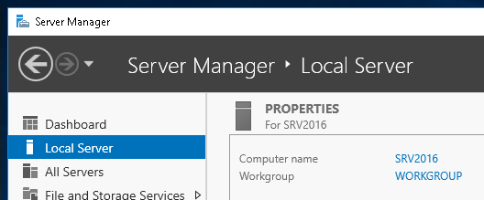

* In Server Properties, click on Change to change the computer name. NOTE: The Computer Description box is NOT for the computer name. You must click Change to get to the proper place to actually change the name of the computer. Set the computer name to **SRV16** and the Workgroup name to **NE259**. You will be required to restart the image after changing the name.

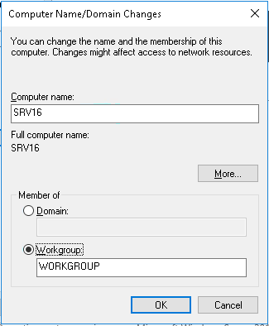

* After rebooting, log back onto SRV16 as Administrator and close Server Manage when it starts. (You can always reopen Server Manger later by using the icon next to the start button.)
* Click on the **Magnifying glass** button, type CMD, right-click the **Command Prompt icon and select ‘Pin to Task Bar’**  
  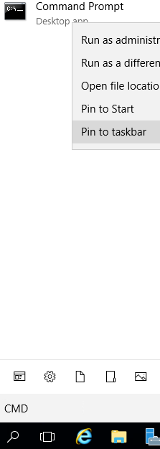
* Return to the Desktop and you will see the command prompt on the Task Bar. Click on it to start the Command prompt.
* In the Command Prompt, issue the **ipconfig /all** command and record what you see. You will need to refer to this later. *(Note: The DNS entries you see won’t be labeled Preferred and Alternate, but that is what they represent, so the table below shows those names.)*

IPV4 Address: **192.168.1.10**

Default Gateway: **192.168.1.1**

Subnet Mask: **255.255.255.0**

Preferred DNS **192.168.1.1**

Alternate DNS **8.8.8.8**

* **IMPORTANT TO SET CORRECTLY!!:** Right click on the clock in the lower right corner of the Task Bar, select Adjust Date/Time and then verify the Time Zone to Eastern Time (US & Canada). During a standard installation, Windows sets the Time Zone to Pacific Standard time.

In the next section of the lab you will set or verify that certain services are set to run every time the server boots up. This is done to be sure that the server will be visible to other computers on the network when they browse the network.

* On **SRV16** go to **Start** -> **Server Manager** -> **Tools** menu in Server Manager and select the **Services** option.
* In the list of services, scroll down to the **Function Discover Resource Publication** service and double click on it. (*There are two different Function Discovery services; be sure to pick the correct one.*)
* Verify that the server is set to Automatic and click the Start button

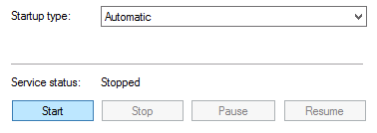

* After the service starts, click OK.
* Locate the **SSDP Discovery** service, set it to start automatically and start it and click OK.
* Repeat the process for the **UPnP Device Host** service.

Part 2: Prepare Windows 10 Image

* Start the **WIN10** Skytap image
  + Log on with the account of **Student** and the password of **Password10**.  
    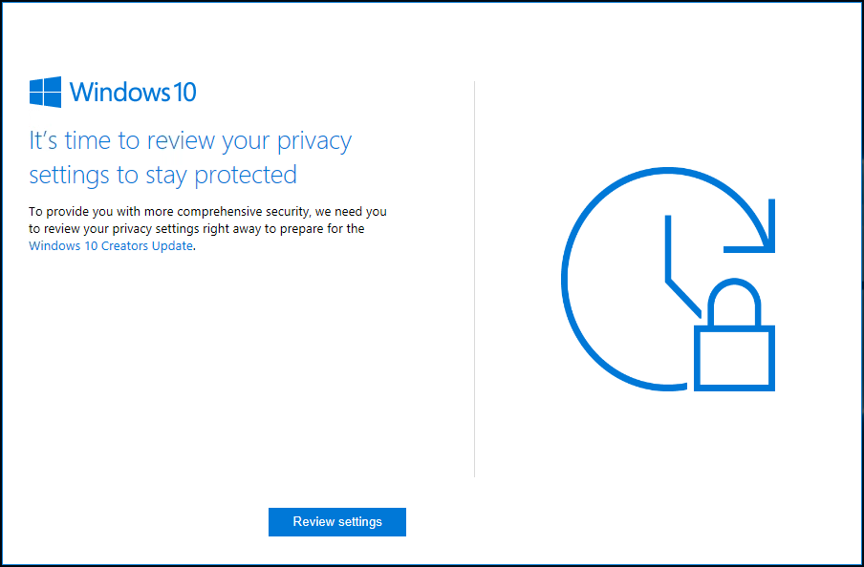 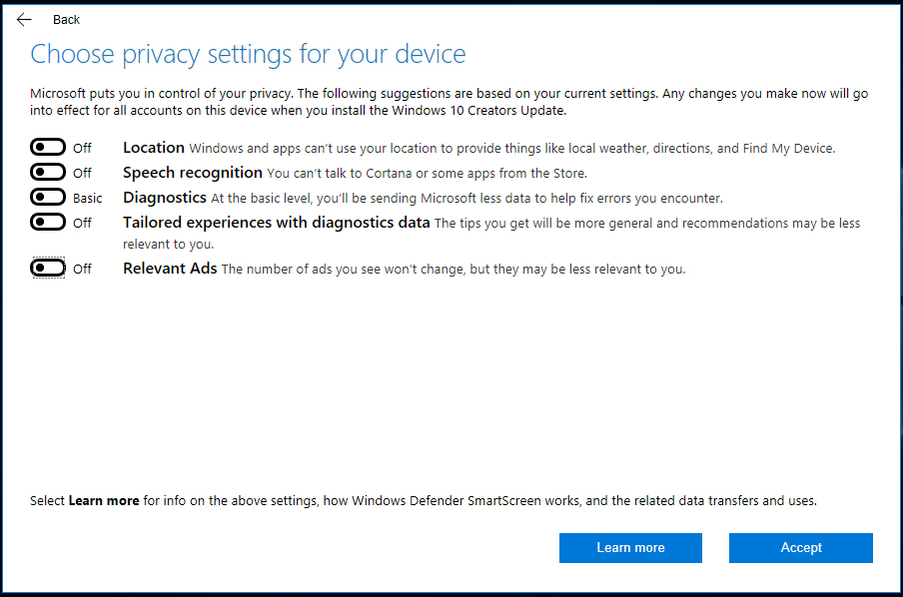 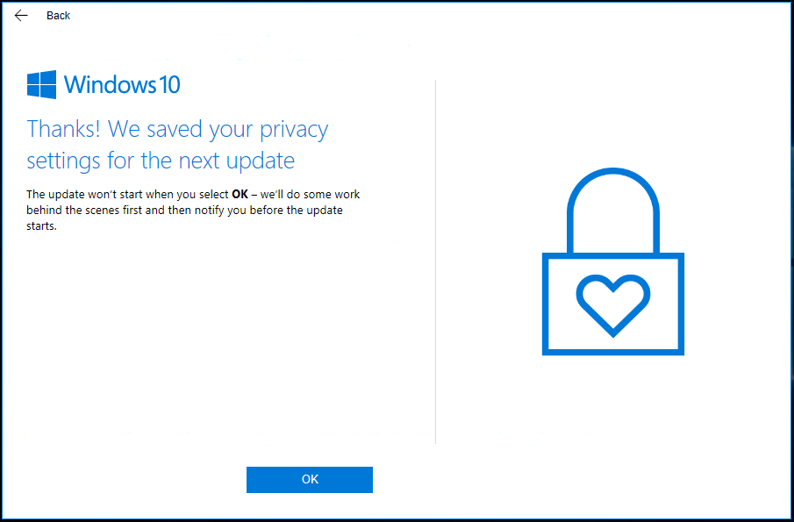  
    [Review Settings] Turn OFF Everything > [Accept] [OK]
  + Open System settings by clicking on the File Explorer [Folder] icon on the Taskbar, then right clicking on This PC and select Properties.
  + Across from Computer Name click on **Change settings.**
  + Click the **Change Settings** button and set the workgroup name to **NE259** as you did on your server image.
  + RESET the computer Name from **WIN10ED** to **WIN10**. **Ignore if already set.**  
    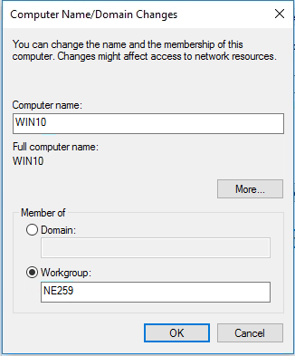
  + After clicking on OK you will have to restart your **WIN10** computer and log back in again.
  + Open a command prompt and issue the IPCONFIG command, then record what you see. (You may want to pin the Command prompt to the taskbar as you did with the server.)

IPV4 Address: **192.168.1.50**

Default Gateway: **192.168.1.1**

Subnet Mask: **255.255.255.0**

* + Shutdown **WIN10** by first right clicking on the Start menu then selecting Shut down or sign out and choosing Shut down.
  + Shut down your server image.