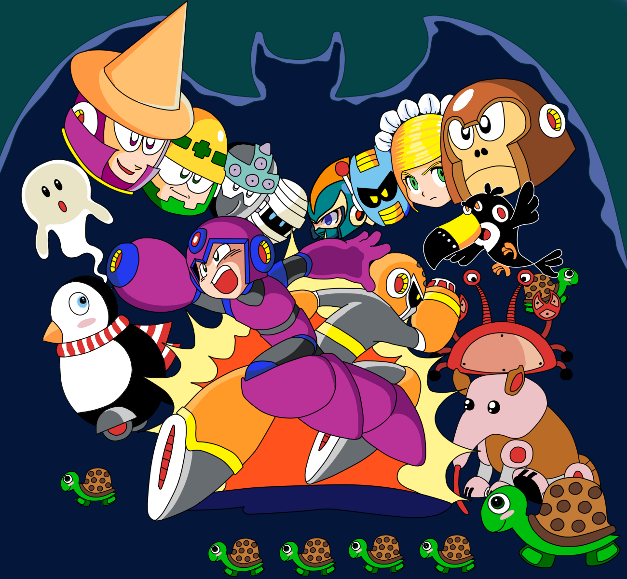

NES-4V-USA





INSTRUCTION MANUAL

ロックボット
A special message from Upperland Studios:

Thank you for experimenting the quick and fun open-source Rockbot® game. This is a game created by Upperland and GreenNeko made for everyone to be able to contribute and enjoy in their favorite system, including Windows, Linux, Mac and Playstation 2.
Rockbot® features old-school colorful low resolution artistic graphics. We are proud to deliver this 1980's like experience to the 21st century.
Iuri Fiedoruk  President  Upperland Studios | Rockbot is trademark of Upperland or GreenNeko.  This game is not licensed, but plays on the Sony Playstation 2, Dingux (Dingoo), Linux and Windows.  Upperland, Rockbot and Betabot are tm of Upperland Studios. | This game engine is open source licensed under the GPL v2. The art and music data are under other licenses, check the license text file on the package for details.

Safety Precautions

TABLE OF CONTENS
Safety Precautions 2
Getting Started 5
Attack in Kyoto City 5
Game Control 6
Player Characteristics 8
Playing the Game 9
Power Up! 10
Robot Masters 11
Tips for Victory 12
LICENSE AND WARRANTY 13
WARNING 15

Getting Started

- Choose your favorite videogame or computer system.
- Turn on your videogame or run Rockbot® executable in your computer system.
- At the title screen, choose if you want to start a new game or continue a previous one.
- Choose one or two player mode and press Start.
- In case of one player mode, select your character and press Start on your joystick.
- In the Stage Select screen, you can choose one of the eight robot masters to start its stage.

Attack in Kyoto City

This is year 20XX, the city is Kyoto in Japan, and unlike Tokyo, the city does not have any hero to protect it.
“Calling Dr. Kanotus, please answer!
“This is the Mayor, we need you to build a robot to defend our city against enemies. Look on what is happening in Tokyo, we need a robot hero to protect the people!

As answer, Dr. Kanotus created one robot, called Betabot, to fight; but is was an early and rushed project, thus he kept constructing a second one better and smarter and finished him right before a horde of enemy robots started rampaging the city.

The time was short, and they were not fully tested, but the enemies would not wait. So Kanotus sent both to the fight.

Now it is up to Betabot and Rockbot to fight evil forces and protect the city!

Game Control

PC
- Jump: X
- Attack: A
- Shield: Z
- Dash/Slide: C
- Start/Menu: Enter
- Quit: Esc
PS2 and PSP
- Jump: Circle
- Attack: X
- Shield: Square
- Dash/Slide: Triangle
- Start/Menu: Start
Dingoo
- Jump: A
- Attack: B

Controls Information
- Move left or right: Press the left/right controls in pad or keyboard
- Climb up or down: Press the up/down controls in pad of keyboard
- Jump: Press the jump button. Press the left/right while jumping to move. The longer you hold the jump button, the higher you'll jump.
- Fire weapons: Press the attack button. Press attack and jump altogether to fire while jumping. You can fire anytime, even when climbing.
- Slide left or right (Rockbot only): Press the down with left or right and press jump.
- Shield (Rockbot only): project against projectiles shot by enemies.
- Charged shot (Rockbot only): Press and hold the attack button until the charge is complete and then release it.

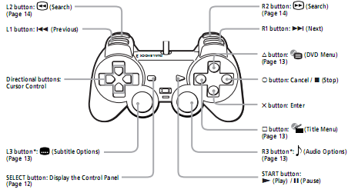

Player Characteristics

Betabot project was rushed, due to the city mayor urgency, thus is was built with harder and heavier materials, limiting his movements a bit. Also, he is very straightforward, and when make a decision, is unable to change his mind and the incomplete vocabulary system makes him talk in a very limited way. He have two cannon arms, enabling him to shot twice at once, being easier to hit a movable target.
Rockbot is smarter, faster and have a anti-gravity jump system, allowing him longer and slower jumps. He also have a special cannon arm, that can be charged and shot a more intense energy projectile, but due to this feature, he can't shoot more than 3 regular, or one charged, until his energy unit gets cooled. He also can slide to avoid attacks or enter some areas in the game.

Playing the Game

Your mission is to cross a series of mazes dominated by out-of-control robots and evil machinery. From everywhere they come, you must dodge, shot, run, jump and climb to reach the end of this madness.
At the end of each stage you will have to confront a robot master and if you win, its special weapon will be yours.

You start with three chances to win, and an energy meter in the left of the screen to keep an eye in your robot health. Each time you are hit by a enemy or its shots, you loose a bit of energy, when it reaches zero, you'll loose one chance, and, when no more chances are left, it is the end, the city is doomed without your help!
Luckily some enemies drop items, that can also be found in some parts of the mazes, those items help you. Energy tanks can be used anytime to fully refill your energy, red remedy pills restore some energy and the green ones restore some energy on the special weapon you are equipped with. The robot face gives you one extra chance, up to nine you can store.

Do not give up, fight til the end! The destiny of Kyoto depends on your skills with the joystick, and you must prevail.

Power Up!
Press start during the game to open the weapons menu. Press up, down, left and right to move the selection cursor to a weapon or item, pressing start again to activate it.

Arm Cannon: Pick this to shot regular weapon.
Life: Shows how many chances are left.
Item: Can pick energy or weapons tank.
Bolts: How many bolts you have. Those can be used in the shop to buy extra and special items.
Master Items: Use the special abilities from robot masters.
Coil Item: Go higher by jumping over this item.
Jet item: You can pass abysses by jumping over this item that will fly you over it.

Energy Tank: Refill the whole life of the robot you control.
Weapon Tank: Will refill all your weapons.

 | 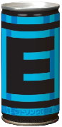

Robot Masters
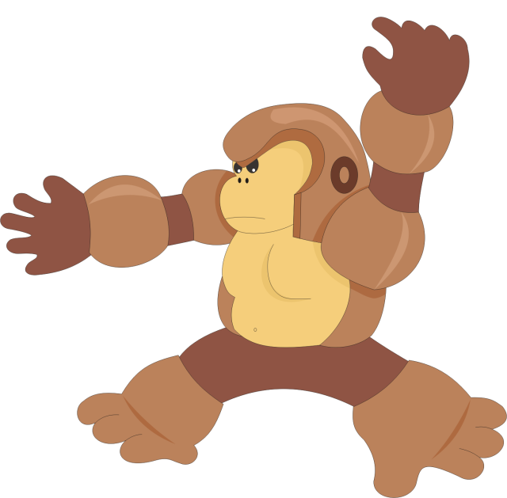  Ape Bot |   Daisie Bot
  Seahorse Bot | 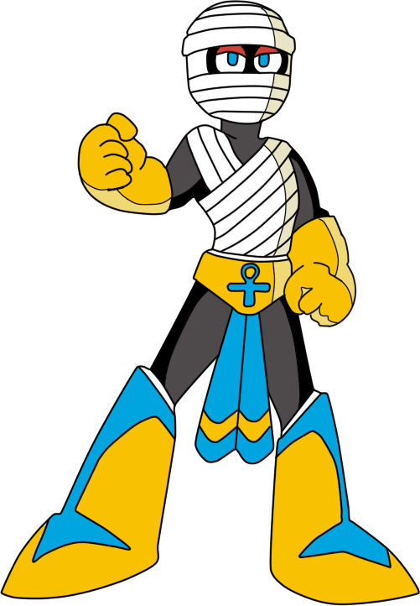  Mummy Bot
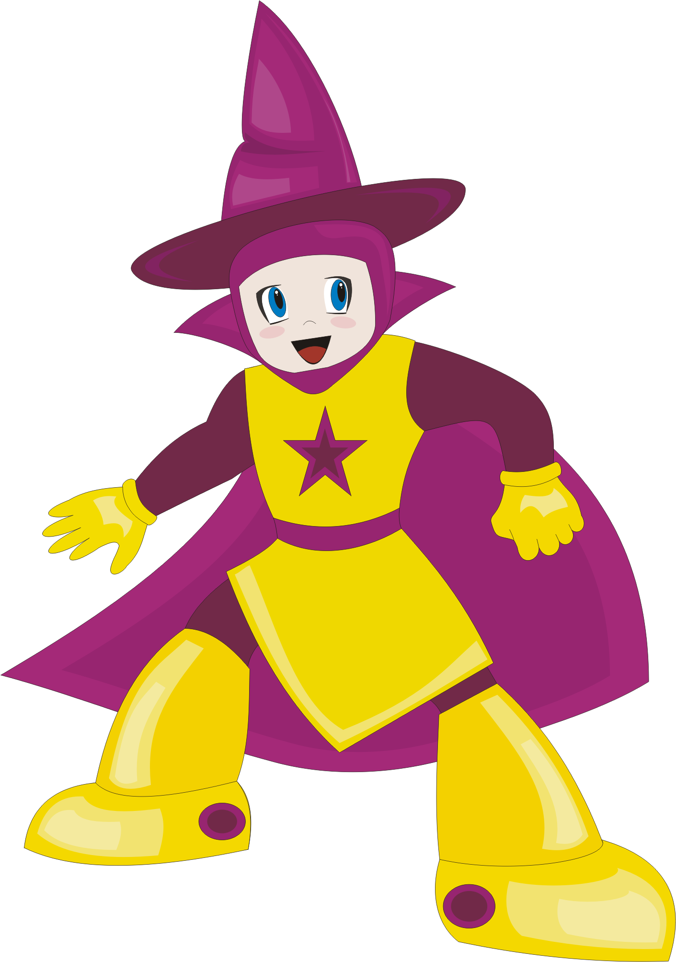  Mage Bot | 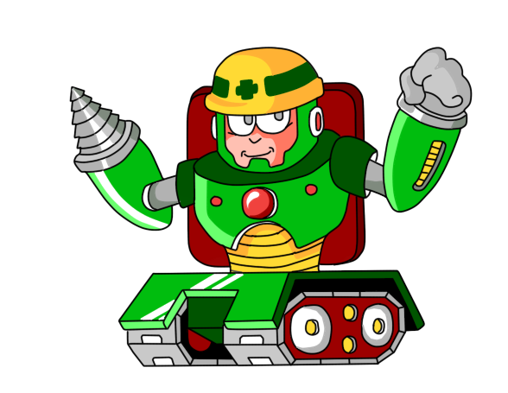  Dynamite Bot
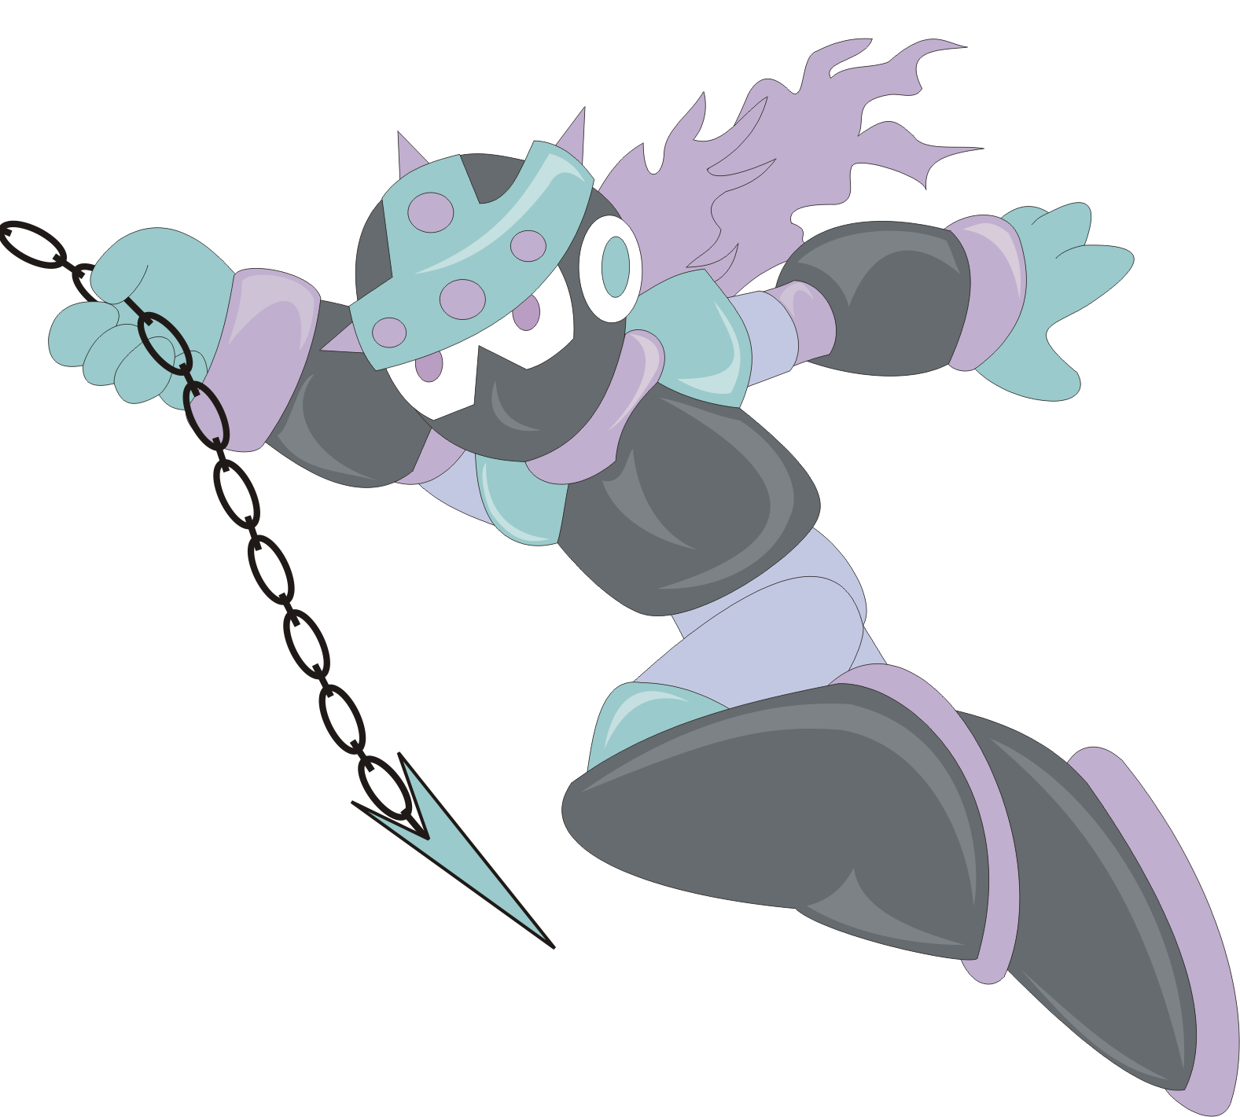  Spike Bot | 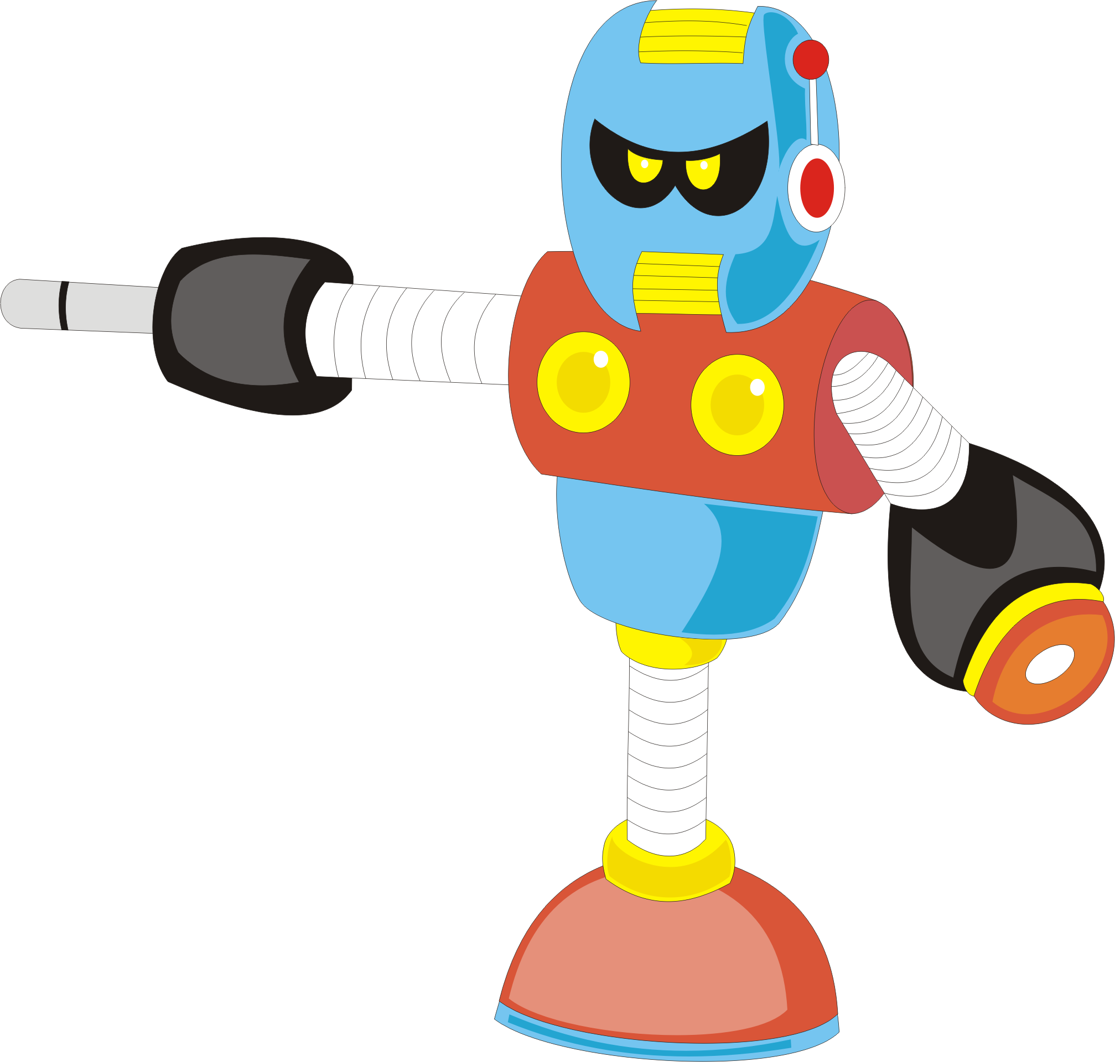  Techno Bot

Tips for Victory
- Be cautious, try to shot enemy from longe range
- Measure well your jumps, if you miss, try again placing your player more near the edges.
- After being damaged, your players becomes invincible for a short period of time, use this to avoid the enemies and destroy them.
- Test the master robots weapons in each master or stage enemy to find out what are their weaknesses.

WARNING

Do not use play this game for more than a couple of hours. Make regular pauses to rest your eyes. Best playable in a LCD TV or computer monitor.
In portable systems such as Dingoo, check your battery level before playing. This game uses auto-save feature, but if battery dies in the middle of a level, you'll loose all data from the game.

http://rockbot.upperland.net
Porto Alegre, Rio Grande do Sul, Brazil

made in Rio Grande do Sul, Brazil

