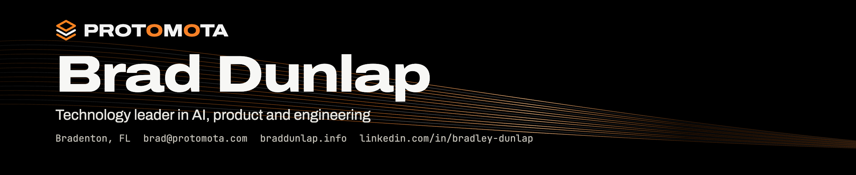
Brad Dunlap Technology leader in AI, product and engineering Bradenton, FL brad@protomota.com braddunlap.info linkedin.com/in/bradley-dunlap
1 Summary
Technology leader with 20+ years automating business and technology work, from hand-written scripts, test-driven development and CI/CD pipelines at RIIS to AI agents built with Claude and Codex today. Focuses on signal over noise and roots out performance theater: work that checks boxes but doesn't move the needle. At NTT DATA, leads the team behind a Fortune 500 AI pilot. Now, with AI as a force multiplier, builds and ships native AI-powered apps and AI agent systems solo through Protomota Lab.
Table 1. Key figures
Professional experience | 20+ years
Overruns during scoping program | 0 projects
Apps built solo, live on the App Store | 2
Self-published websites and web apps | 6
Native apps shipped through Protomota Lab | 6
Automotive brand apps led | 7
Shopping center apps directed | 15
2 Professional experience
NTT DATA
Digital Solution Consultant Associate Director Oct 2023 – Present
Technical Lead and Product Owner Jan 2026 – Present
■ Lead a small multidisciplinary engineering team building VR, voice and AI-assisted automation applications for a Fortune 500 client's confidential workflow initiative, now in pilot.
■ Lead Azure, Next.js and Unity architecture, including Infrastructure as Code (IaC) and CI/CD.
■ Build AI and voice capabilities: speech recognition, text-to-speech, conversational AI and voice commands.
Research and Development in AI and Robotics Simulation Apr 2025 – Dec 2025
■ Built agentic systems with Claude and Codex to coordinate technical, research and delivery work.
■ Simulated robots in NVIDIA Omniverse and Isaac Sim and trained them in NVIDIA Isaac Lab; built ROS 2 workflows connecting hardware behavior and software-driven test environments.
Product Owner, Enterprise Mobile Application Oct 2023 – Apr 2025
■ Owned a multi-year iOS and Android application for a top U.S. manufacturing company, translating product direction into epics, user stories and acceptance criteria for a 20+ person team in Azure DevOps.
Protomota Lab
Independent work outside professional employment
Founder and Independent Developer protomota.com
■ Built Jotley solo, from concept through all development, marketing and training materials; live on the App Store.
■ Built PulseCanvas Studio solo the same way; live on the App Store for Mac, iPhone, iPad and Apple Vision Pro.
■ Shipped four Mac apps, available from their websites: OpenTalon, Inkspring, Voxley and Textley.
■ Build AI agents with Claude and Codex, including a dashboard that automates lab workflows.
■ Built REST APIs for personal apps and automated their environment setup and releases.
■ Run airesourcepro.com and two YouTube channels: free tutorials and videos for learning AI by building with it.
■ Hobby builds: robots with ROS 2, NVIDIA Isaac Sim and Isaac Lab, plus CAD and 3D printing.
Vectorform
Director of Scoping and Estimation Nov 2019 – Oct 2023
■ Built and led a scoping and estimation process that took the company from several overrun projects per year to zero during program ownership.
■ Improved estimate accuracy and profitability by aligning scope, staffing, feasibility and risk with Sales and Delivery; introduced analytics comparing actuals against estimates.
Director of Quality Experience Sep 2017 – Oct 2023
■ Led a small QA team and brought TDD and automated UI testing from RIIS to Vectorform.
Technical Lead, Mobile Application Engineer Nov 2012 – Nov 2019
■ Led the full lifecycle of seven Stellantis/FCA apps: Mopar, Chrysler, Dodge, Jeep, Ram, Alfa Romeo, Fiat.
■ Led the DTE Energy Insight App and real-time Energy Meter integration from concept through launch, supported FCC approval, and contributed technical and product expertise to its spin-off into a new company, Powerley.
■ Directed 15 Taubman shopping center apps with Bluetooth and Wi-Fi indoor navigation. Automated environment setup and CI/CD releases for mobile projects.
RIIS
Senior Tech Consultant, Mobile Strategy and App Development Oct 2011 – Nov 2012
■ Wrote scripts to provision and configure development and test environments on a small team.
■ Directed iOS and Android apps and introduced test-driven development, Jenkins CI/CD pipelines and automated UI testing.
■ Reverse engineered and penetration tested clients' iOS and Android apps to help harden their security.
MRM Worldwide
Technical Lead, Front End Sep 2010 – Oct 2011
■ Led front-end development for Chevrolet.com's annual model refresh, defining architecture and coding standards.
Vectorform
Senior iOS Engineer Sep 2007 – Sep 2010
■ Founded Vectorform's mobile practice as its first iOS developer; led apps featured on the Apple App Store.
3 Technical skills
Area | Capabilities
AI and automation | AI engineering, Model Context Protocol (MCP), prompt engineering, AI agents, LLM fine-tuning, end-to-end workflow automation, Claude, Codex, Cursor
Product engineering | React, Next.js, Python, REST API development (personal apps), databases, Swift, SwiftUI, macOS, iOS, Android, Unity, virtual reality (VR), voice technologies, Internet of Things (IoT), technical design
Platform and delivery | Infrastructure as Code (IaC), DevOps, CI/CD pipelines, GitHub Actions, Jenkins, Azure DevOps, Azure, AWS, Cloudflare, Linux administration, Docker, Proxmox, JIRA, Fastlane, release automation
Testing and security | Playwright, mobile UI automation, BrowserStack, test strategy, QA process design, mobile penetration testing, reverse engineering, vulnerability analysis
Methods | Agile, Scrum, Scaled Agile (SAFe), XP, TDD, PI planning, backlog management, estimation, scope governance
Robotics and hardware | NVIDIA Omniverse, Isaac Sim, Isaac Lab, ROS 2, robot assembly and programming, electronics, 3D printing, Blender, Plasticity CAD
4 Education  Bachelor of Fine Arts (BFA) in Graphic Design, Eastern Michigan University |  | 5 Certifications  ■ Google IT Automation with Python Professional Certificate  ■ NTT Gen AI White, Yellow and Green Belt  ■ NTT DATA Agile and Scrum Internal Certification  ■ GitHub Copilot Certified  ■ Google AI Essentials |  | 6 Industries  Manufacturing, utilities and energy, automotive, retail and shopping centers, IoT and connected hardware, sweepstakes and promotions, entertainment and consumer brands

7 Selected work
My client work is confidential, so these are my own builds from Protomota Lab.
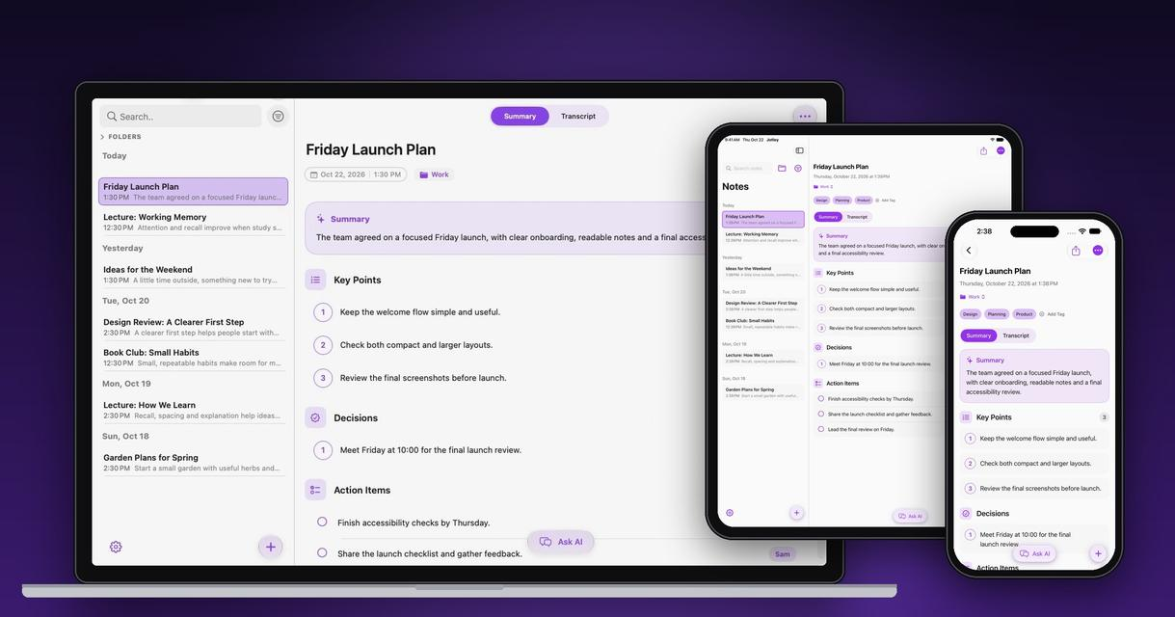  Jotley Fig. 2  Private AI notes for Mac, iPhone and iPad. Transcribes speech live, then summarizes and answers questions on the device with Apple Intelligence.  Built solo: concept, design, development, marketing and training materials. On the App Store.  Swift, SwiftUI, Apple Intelligence, iCloud  jotley.ai |  | 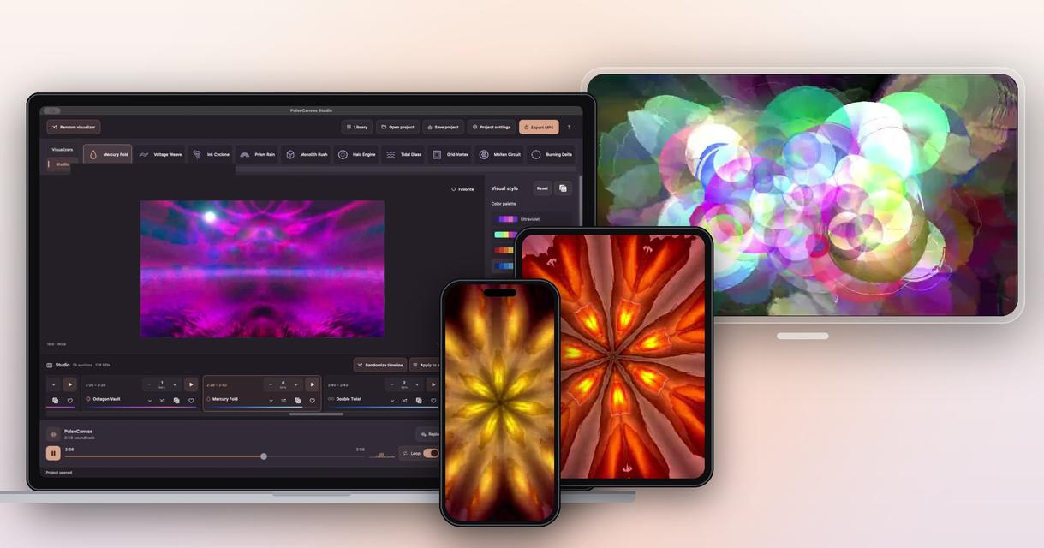  PulseCanvas Studio Fig. 3  Music visualizer and video maker for Mac, iPhone, iPad and Apple Vision Pro. Finds the beat, splits the song into sections and plays native visualizers and MilkDrop effects.  Built solo: concept, design, development, marketing and training materials. On the App Store.  Swift, SwiftUI, Metal, export up to 4K at 60 fps  pulsecanvas.si

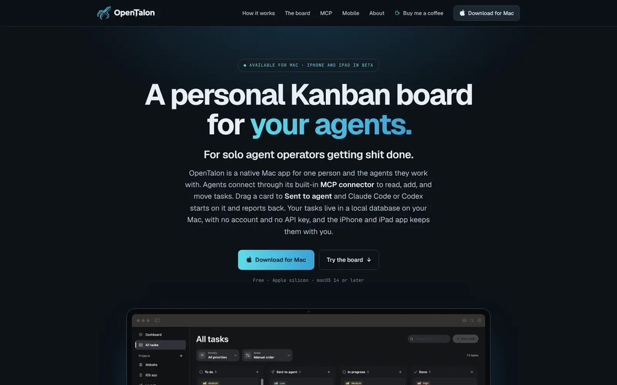  OpenTalon Fig. 4  A Kanban board for you and your AI agents. Claude Code and Codex pick up tasks over MCP and report back.  opentalon.ai |  | 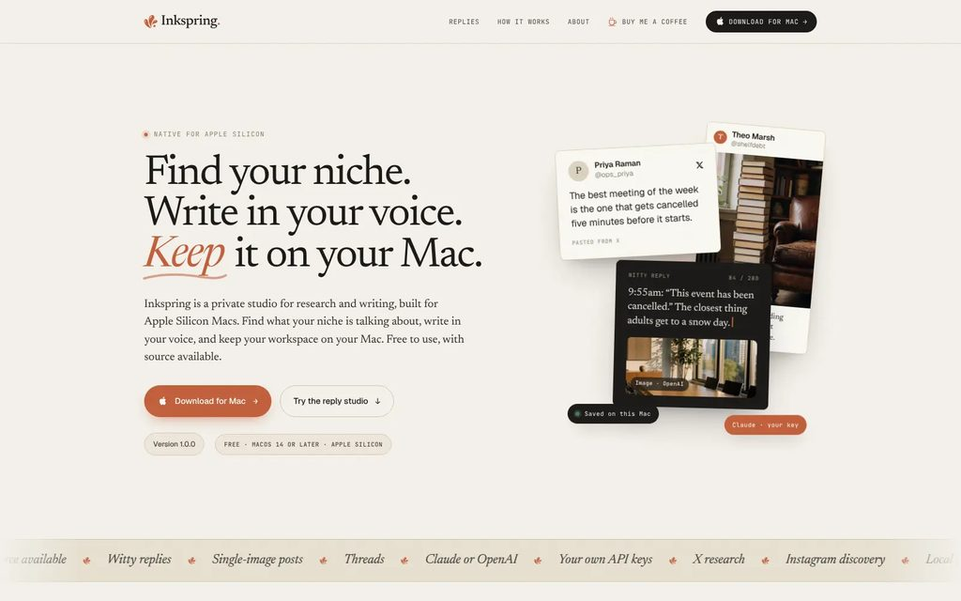  Inkspring Fig. 5  A private research and writing studio. Find what your niche is talking about and write posts in your voice.  inkspring.ai |  | 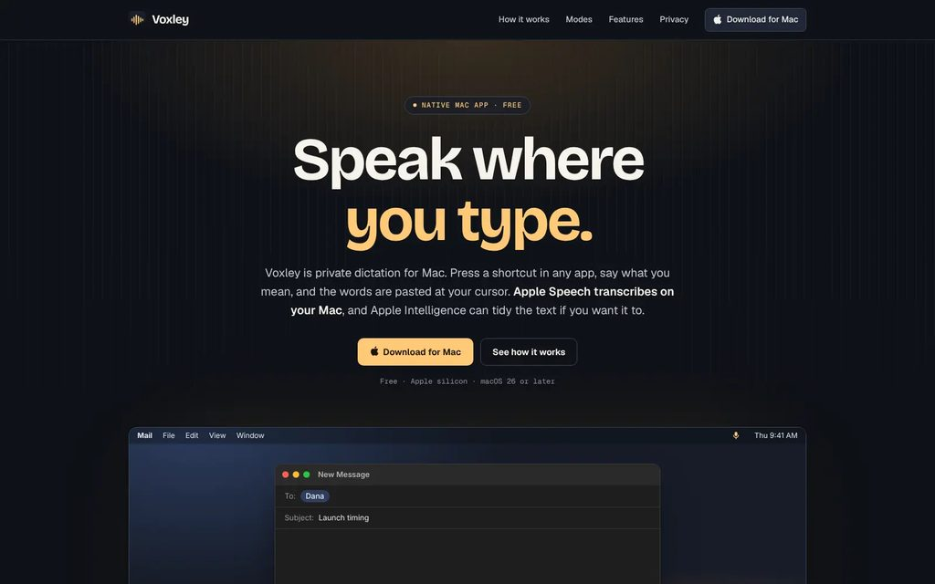  Voxley Fig. 6  Private dictation in any app. Apple Speech transcribes on your Mac; Apple Intelligence can tidy the text.  voxley.si |  | 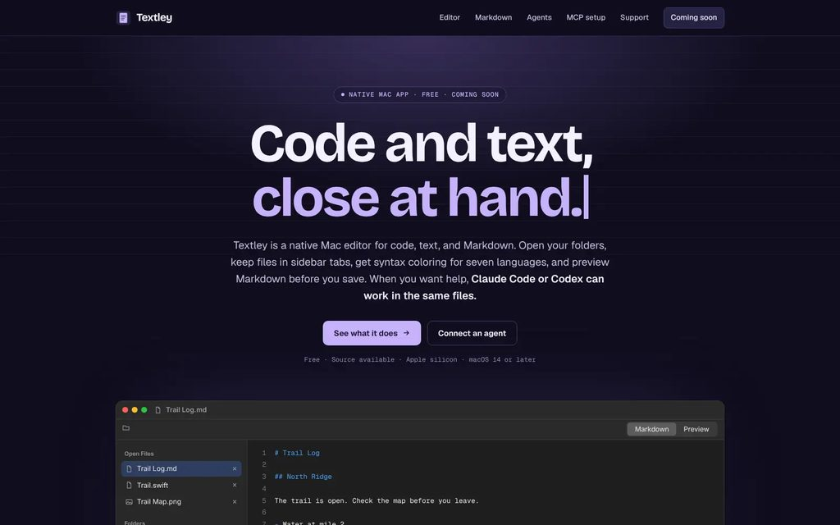  Textley Fig. 7  An editor for code, text and Markdown that Claude Code or Codex can work in alongside you.  textley.ai

More work protomota.com github.com/protomota newsletter.protomota.com x.com/protomotalab

