# Solution Requirements Document

Sindeo Mortgage Operations Platform:

Phase 1 MVP

Betsy Chapman

November 11, 2013



Contents

Solution Requirements Document 1

2.0 Revision History 3

3.0 Introduction 4

4.0 Borrower Interface / MyAccount 5

4.1 Account Creation 5

4.2 MyAccount Login Page 7

4.2.1 MyAccount Home Page 7

4.2.2 Account Settings 8

4.2.3 MyMortgage Status 10

4.2.4 Briefcase 10

4.2.5 Message Center 11

4.2.6 Live Chat 12

5.0 Mortgage Operations Platform - Loan Advisor (Originator/Processor) Interface 12

# 2.0 Revision History

|  |  |  |  |
| --- | --- | --- | --- |
| Date | Version | Description | Author |
| November 12, 2013 | 1.0 | Phase 1: MVP | Betsy Chapman |
|  |  |  |  |
|  |  |  |  |

# 3.0 Introduction

Consumers shopping for a mortgage are faced with a complex and unclear process. From exploration to shopping to closing, the challenges borrowers encounter are many. The process is full of surprises, it is highly manual and paper-based and it is currently built not around the needs of the borrower, but those of the lender. For the originator/processor, systems and tools are clunky and piecemeal. Loan Originators need a streamlined process and toolkit to be more efficient. This includes the ability to access data quickly, communicate with third parties efficiently and to ensure the loan submissions to lenders are complete and accurate 100% of the time.

Sindeo is introducing a new way to get a mortgage that offers borrowers a clear and simple process, that offers the most competitive rates, guided by advisors that represent the borrowers’ interest, and leverages technology to simplify the process. For consumers learning about the process, Sindeo offers a robust and dynamic information portal. When a consumer is ready to select a product, provider and compare rates, Sindeo provides an unbiased advisory team to guide the borrower’s decision in light of their financial objectives. Finally, Sindeo leverages technology to eliminate complexity and hassle in applying for and closing the loan.

Sindeo’s platform will be driven by Ellie Mae’s Encompass Loan Origination Software. In addition to an Advisor (Originator/Processor) interface, the platform will also have a web-based Borrower interface accessible via Sindeo.com. The platform will be fully integrated with Encompass in that data and documents will flow freely between the systems, allowing Loan Originator and Borrower to input data once, submit and transfer documents, and allow a borrower to see where he/she is in the process at any point in time, what are the tasks that need to be complete to achieve the next milestone, and other information pertaining to their loan application.

# 4.0 Borrower Interface / MyAccount

The MyAccount sub-area of the website will be the Borrower’s interface into Sindeo’s Mortgage Operations Platform. It is here that a borrower will enter personal information, upload relevant documents, download documents, complete electronic signatures as well as view milestones and tasks and track progress towards getting a mortgage. The Mortgage Operations Platform and the various interfaces will be fully integrated with Encompass in that when a new account is created and data and/or documents submitted via MyAccount, this information flows seamlessly to Encompass. Likewise documents and checklists that need to be sent to the borrower can be pushed from Encompass to the Mortgage Operations Platform and downloaded by the borrower via MyAccount. For this phase of the project, the main content and functionality within MyAccount include:

* Account Settings: Login and Password, Contact information, Preferences (contact)
* MyMortgage: Loan Provider, Program, Rate, Amount, Address; Target Close Date
* Concierge: Contact info for Sindeo Advisor (Originator, Processor?)
* Progress Tracker: Where am I in the process? What are my to-do’s? How close am I to getting my mortgage?
* Briefcase: Document Storage, Upload and Download
* Message Center
* Electronic Signature

## 4.1 Account Creation

* An account may be created either by a visitor to the website (borrower) or internally by a Sindeo Mortgage Advisor
* Upon inquiry (email/phone) from a website visitor, a Sindeo Mortgage Advisor may create a new account within the Mortgage Ops System.
* Alternatively, a website visitor will trigger the creation of a new account by taking any path with a Contact Info>Submit button
  + Home Contact>Submit
  + Apply>Submit
  + Mortgage Profile Builder>Send My Request
* Pressing ‘submit’ will trigger the following actions:

1. New Account will be created in the Mortgage Operations Platform, populating corresponding data from Submit Form in the new account, and assigning the account a unique account number for internal tracking purposes
   * First name, last name > Existing in Encompass (Personal Info)
   * Phone Number > Existing in Encompass (Personal Info)
   * Email Address > Existing in Encompass (Personal Info)
   * Purpose: Existing? Purchase/ Refi
   * Timing: New field: Standardize answer choices
   * Account Number > Existing (?)
   * Login Credentials (Login, password) > New fields
2. Credentials for the new account will be assigned such that login = email address (or phone number if email not provided), password will be automatically generated.
3. Welcome email will be sent with a welcome message in addition to the account username and password (define). If email is not supplied, truncated message will be sent via SMS
4. On the website, after clicking ‘submit’ a ‘THANK YOU FOR REGISTERING’ page will appear with information on the next steps(define).

* When a new account is established, a ‘blank application’ is created in the Sindeo Mortgage Operations Platform (a new record in the database)
* A single account will allow for multiple purchase properties
* The following data is pushed from the online Mortgage Profile Builder (or contact form) into Encompass
  + Personal Information> First Name; Last Name
  + Contact Information > email; phone
  + What would you like to do maps to Encompass > Loan Information > Purpose of Loan (Refi/Purchase)
  + For Purchases:
    - Question 1 (Timing) maps to Encompass> need custom field (don’t see equivalent in Encompass)
    - Question 2 (Type of Purchse) maps to Encompass> Property Useage (do answer choices need to replicate encompass?)
    - Question 3 (Where?) maps to Encompass > Loan Information > Purpose of Loan: zip, state
    - Question 4 (Prop Value) maps to Encompass >Loan Information > Purchase Price
    - Question 5 (Downpayment) maps to Encompass >
    - Question 6 (Credit) maps to Encompass > need custom field (don’t see equivalent in Encompass)
    - Calculate Loan amount by taking question 4 – question 5 and map that to Encompass > Loan Information > Loan Amount
  + For Refi > Map to Encompass fields
    - Question 1 (Why refi?)
    - Question 2 (Property Location):
    - Question 3 (Property Type):
    - Question 4 (how much do you owe?):
    - Question 5 (how much is home worth?):
    - QUesiton 6: (Credit): need custom field (don’t see equivalent in Encompass)

## 4.2 MyAccount Login Page

The first release of MyAccount will have limited functionality, focus on 3 core functional requirements: Information Display, Document Management (Storage, Upload and Download), and Progress Tracking and Electronic Signature.

* When a website visitor clicks on MyAccount, the login page launches: ‘Log in to your LearnVest account’
  + Login credentials
  + Remember me functionality
  + Forgot your password functionality
  + Need Help? Call 855-746-3361
  + Sign Up (instead of ‘Create an Account’)
  + Clicking ‘Sign up’ will take the user to the “Apply Now” page described in Website requirements
* After successfully inputting login credentials, the borrower is given access to the MyAccount home page (see below)

[Login Page Reference]: https://www.learnvest.com/mylv/login

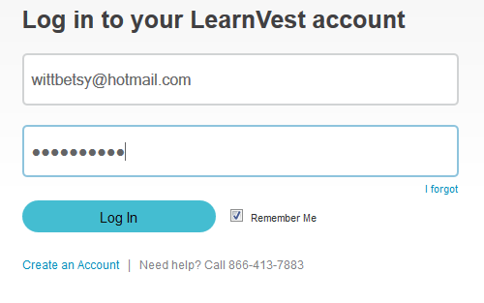

### 4.2.1 MyAccount Home Page

The MyAccount home page will be a very clean, highly graphic, one page glimpse into the borrower’s mortgage application. It will include the following modules (sections of the page). See ppt slide 1 for mock-up.

* Top Right = ‘Welcome, Betsy’ clicking on it displays settings and logout (see below)
* Customer Service phone number – rather than being a generic help line, this will be the direct line to the borrower’s advisor/processor (whether advisor or processor is shown will be based on rules – TBD)
* Live Chat (lets figure out where to put this – would be good for it to always be in the same place)
* MyMortgage: Content pulled directly from Encompass: (Figure out where in encompass this comes from)
  + Loan Provider
  + Program (what product)
  + Interest Rate
    - Lock Icon that is either locked or not locked
    - For not locked, show lock date
  + Loan Amount
  + Loan Address
  + Target Close Date:
* MySindeo Team: Contact info for Sindeo Advisor and Processor (Figure out where info comes from encompass/new – have a feeling this is custom database that we create)
  + Photo
  + Phone
  + Email
  + Live Chat
* MyMortgage Status: Where am I in the process? What are my to-do’s? How close am I to getting my mortgage? (See details below)
* Briefcase: Document Storage, Upload and Download, organized by To Do, Under Review, Completed (See details below)
* Message Center: Receives messages and alerts sent to the borrower by the advisor, or automatically by the platform (see details below)
* Account Settings: Login and Password, Contact information, Preferences (contact)

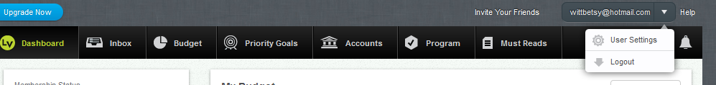

### 4.2.2 Account Settings

* Account Settings will be displayed upon clicking the ‘Welcome, Betsy’ link at top of page
* Clicking ‘Settings’ will open the settings page, allowing user to change the following information (which is fed to Encompass):
  + Login credentials (username and password) do we need to have specific password requirements for security reasons?
  + First and last name (free entry)
  + Phone number (free entry of a 10 digit number formatted as a phone number i.e. (646) 276-5342, text appears in red if not a valid phone number)
  + E-mail address (free entry, appears in red if not a valid e-mail)
  + Communication Preferences (I prefer to be contacted by phone, email – determine options/language for this)

This page should look very similar to the Contact page on the homepage:

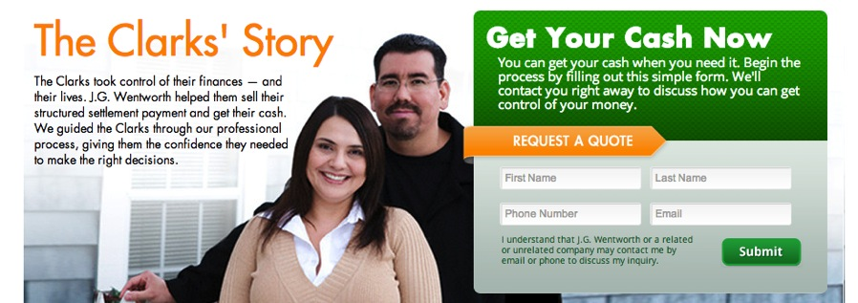

### 4.2.3 MyMortgage Status

MyMortgage Status view will reflect where the borrower is in the loan application process, identify the step underway, the next milestone, & activities required to complete the next milestone.

* Progress bar will populate % complete per the chart below, based on the phase/milestones completed to date
* Milestones are overlaid on the progress bar to represent the most recently completed milestone and the next milestone in the process
* The data for the current and next milestone will come from Encompass (determine where)

|  |  |  |
| --- | --- | --- |
| % Complete | Phase | Milestone |
| 5% | 1 | Build Your Mortgage Profile |
| 10% | 2 | Get Prequalified |
| 20% | 3a | Lender and Product Review and Selection |
| 35% | 3b | Transfer to Processing for Disclosures; Document Request & Lender Submission |
| 50% | 4a | Disclosures and Documents |
| 55% | 4b | Finalize Loan Submission |
| 70% | 4c | Appraisal |
| 80% | 5a | Loan Approval Received |
| 85% | 5b | Conditions Met |
| 90% | 5c | Clear-to-close Received |
| 95% | 5d | Close |
| 100% | 5e | Lender Clears and Funds File |

* Outstanding ‘To do’s’ shown in bulleted list form with Due Date and Upload , View/Download functionality (see description of Briefcase>To Do page below); these To Dos will come from Encompass (determine where)

### 4.2.4 Briefcase

The Briefcase area (potentially driven by Box.com) will house all and conditions and documents provided by or to the borrower.

* It will be represented on the MyAccount homepage by an icon (briefcase, for now)
* Clicking on briefcase will open up Briefcase page: menu bar across the top with 3 sections ‘To do’, ‘Under Review’ and ‘Complete’
  + To Do: houses all documents/conditions tagged as ‘to do’ and allows for upload/download
  + Under review: houses all documents/conditions tagged as under review (view/download only)
  + Complete: houses all documents/conditions tagged as complete (view/download only)
* Each document will be tagged with metadata
  + Document Type (work with Christopher to create list)
  + Date Submitted
  + Due Date
  + Status (To Do, Under Review, Complete)
  + Meets Condition
* A condition is a request for a document; Each condition will be tagged with
  + Condition number
  + Condition description
  + Date Submitted
  + Date Received
  + Status (To Do, Under Review, Complete)
* The ‘To Do’ section will list all conditions and/or documents that need action
  + Metadata displayed for each document or condition include
    - Date Submitted
    - Document Description
    - Date Completed
  + Next to each document or condition in ‘To Do’ will be two buttons:
    - Upload
    - View/Download
* The ‘Upload’ function will include the following capabilities
  + Upload document
  + Tag with metadata (Doc Type, Meets condition)
    - The metadata will default to its pre-assigned values
    - User will be able to over-write those values in free-from entry
  + Upload additional documents (and tag with metadata)
* ‘View/Download’
  + When clicked, an item will be opened for viewing (in HTML?)
  + Electronic signature?
  + Download (PDF?)?
* Documents (and associated metadata ) uploaded by the borrower to the Briefcase will be available for viewing by the advisor in Encompass (or the Advisor interface?)
* Conditions and/or documents that need to be sent to a borrower will originate in Encompass, a local library, or generated manually
  + There will be a list of standard conditions from which an advisor can select the applicable conditions to send to the borrower (create with Christopher)
  + There will be a list of standard documents from which an advisor can select the applicable documents to send to the borrower (create with Christopher)
  + An advisor will be able to add a custom non-standard) document or create a non-standard condition

### 4.2.5 Message Center

The message center will serve as the inbox for all messages/alerts sent to the borrower from the advisor, processor or automated message.

* The message center will be represented on MyAccount home page by an icon
* Messages will include confirmation emails (your document has been received), status updates (your loan application has been submitted), information requests (Please send copies of your W-2, (what other types?)
* The message center will display all messages, with unread messages bolded.
* Fields displayed will be Message Subject, Message Type (tbd), time, paperclip will indicate attachment
* Clicking on the message subject will open the message in a new window
* If there is an alert that documents need submitting, a link should take the borrower directly to the ‘To do’ page

### 4.2.6 Live Chat

* There will be a link to live chat on all pages – same spot throughout (flesh out requirements in more detail)

# 5.0 Mortgage Operations Platform - Loan Advisor (Originator/Processor) Interface

The Sindeo Advisor Interface will ultimately replicate the core capability of Encompass with improvements in design and functionality, and be fully integrated with Encompass such that data and documents flow seamlessly from Sindeo’s Mortgage Operations Platform (either via MyAccount or Advisor Interface) to Encompass and vice versa. The first release of the Mortgage Operations System will facilitate the MyAccount functionality described above and will therefore have little-to-no mortgage ops functionality. Thinking about the Mortgage Operations Platform initially as a database, the following fields will be required in order to support the functionality noted for MyAccount above.

* Inquiry/Contact Form Input
  + Borrower’s Name
  + Borrower’s Email Address
  + Borrower’s Phone
  + Mortgage Purpose (New Home, Refi)
  + Refi Type (Change Rate, Cash Out)
  + Mortgage Timing (Need Mortgage Now, Actively Shopping, Just Researching)
* Account Settings
  + Login
  + Password
  + Communication Preferences
  + Mailing Address
* MyMortgage Status
  + Most Recent Milestone & date
  + Next Milestone & deadline
  + Itemized list of milestones & timeline
  + Itemized list of tasks
  + Itemized list of documents