EcoSpill: An AI-Assisted Oil Spill Monitoring and Automated Incident Reporting System

Crystal Dsouza
Department of Computer Engineering
Don Bosco Institute of Technology
Mumbai, India crystaldsouza900@gmail.com

Vanessa Dsouza
Department of Computer Engineering
Don Bosco Institute of Technology
Mumbai, India 37vanessadsouza@gmail.com

Blossom Fernandes
Department of Computer Engineering
Don Bosco Institute of Technology
Mumbai, India blossom.fernandes2006@gmail.com

Marika Dsouza
Department of Computer Engineering
Don Bosco Institute of Technology
Mumbai, India marikadsouza2020@gmail.com

Amiya Kumar Tripathy Department of Computer Engineering
Don Bosco Institute of Technology
Mumbai, India
amiya@dbit.in

Abstract—Abstract— Oil spills in marine environments pose significant threats to aquatic ecosystems and maritime operations, making timely identification, evidence collection, and accurate incident documentation essential. This paper presents EcoSpill, an AI-assisted oil spill monitoring and automated report generation system designed to transform environmental observations into structured, evidence-based incident reports. The system integrates embedded hardware, image acquisition, artificial intelligence-based image analysis, and contextual data collection to support the documentation of potential oil spill incidents. An ESP32-based controller and ESP32-CAM module facilitate image acquisition, while available Global Positioning System (GPS) data and real-time clock (RTC) timestamps provide geographical and temporal context. The collected evidence is processed and organized by the software into a comprehensive incident report containing captured images, AI-generated classifications, incident timestamps, geographical coordinates when available, and relevant event details. By consolidating visual evidence and contextual information into a standardized reporting workflow, EcoSpill aims to reduce manual documentation effort, improve report consistency, and support incident traceability for environmental monitoring and response. The proposed system is evaluated in terms of image analysis performance, evidence collection reliability, and the accuracy, completeness, and generation time of incident reports. The system provides an integrated approach to AI-assisted spill monitoring and automated environmental incident documentation, with further validation required under realistic maritime conditions.
Index Term—Oil spill monitoring, artificial intelligence, automated incident reporting, computer vision, embedded systems, environmental monitoring.
I. INTRODUCTION
Oil spills in marine environments pose significant challenges to environmental protection and maritime operations. Effective incident management requires timely observation, collection of supporting evidence, and systematic documentation of spill-related events. Information such as captured images, geographical coordinates, timestamps, and observations of the affected area can provide important context for subsequent investigation and response. However, collecting and consolidating these details into a structured incident report can be time-consuming when the information is recorded and maintained through separate processes.
Conventional spill monitoring and documentation approaches may involve visual inspection, photographic evidence, sensor observations, and manual report preparation. Although these approaches can provide useful information, the process of correlating visual evidence with temporal and geographical information may introduce inconsistencies or result in incomplete incident records. Image-based analysis can assist in examining visible spill-related patterns, while embedded hardware can facilitate data acquisition and contextual information collection. Nevertheless, these individual capabilities must be integrated into a coherent workflow to support consistent incident documentation.
This research presents EcoSpill, an AI-assisted oil spill monitoring and automated incident reporting system designed to integrate image acquisition, image analysis, contextual data collection, and structured report generation. The proposed architecture incorporates an ESP32-based controller and an ESP32-CAM module for image acquisition, with GPS data and real-time clock (RTC) timestamps providing location and temporal context when available. The software component is designed to organize collected observations, incorporate AI-generated classifications where implemented, and consolidate the associated evidence into an incident report. The resulting report is intended to contain relevant images, classification results, timestamps, geographical coordinates when available, and incident details. The primary focus is to establish an integrated workflow that connects environmental observations with their supporting evidence and produces a consistent record for review.
The key contributions of this work are:
• An integrated system architecture combining embedded image acquisition, contextual data collection, and AI-assisted analysis for oil spill monitoring.
• An evidence consolidation workflow that associates available images, timestamps, geographical coordinates, and classification results with individual observations.
• An automated incident reporting approach designed to organize collected evidence into structured and reviewable environmental incident records.
• An evaluation framework for examining image analysis performance, evidence collection reliability, and the completeness and accuracy of generated incident reports.
The remainder of this paper is organized as follows. Section II reviews related work, existing monitoring approaches, research limitations, and the problem addressed by this study. Section III describes the proposed methodology, including dataset preparation, hardware and software architecture, AI-based image analysis, and automated report generation. Section IV presents the experimental setup and results. Section V discusses the findings, limitations, computational considerations where relevant, and future work. Finally, Section VI concludes the paper.
II. RELATED WORK
Oil spill monitoring has been investigated through remote sensing, computer vision, machine learning, and integrated environmental monitoring systems. Existing research demonstrates the potential of automated image analysis for identifying marine pollution, while also highlighting challenges associated with dataset availability, visual ambiguity, and generalization across environmental conditions. This section reviews relevant approaches and identifies aspects that inform the design of EcoSpill.
A. AI-Based Oil Spill Detection
Deep learning techniques have been applied to oil spill detection using satellite, aerial, and maritime imagery. Yang et al. developed a near-real-time oil spill detection and early warning approach using Sentinel-1 Synthetic Aperture Radar (SAR) imagery for the Southeastern Mediterranean Sea [1]. Such approaches demonstrate the importance of automated image analysis in large-scale marine monitoring.
Research has also explored detection using optical imagery. A study published in Marine Pollution Bulletin investigated pixel-level oil spill detection and classification in aerial images using convolutional neural networks and U-Net-based segmentation [2]. The study reported that distinguishing oil from visually ambiguous regions remains challenging, particularly when the objective extends from binary oil detection to classification of different visible oil appearances.
These studies provide a foundation for investigating AI-assisted image analysis in EcoSpill. However, their image sources and acquisition conditions differ from those of a low-cost embedded camera. Consequently, models developed for satellite or aerial imagery cannot be assumed to perform equally well on images captured by an ESP32-CAM without suitable training and validation.
B. Marine Pollution Datasets and Image Classification
Dataset availability and annotation quality are important factors in developing reliable image-based monitoring systems. Kikaki et al. introduced the Marine Pollution Dataset (MADOS), which contains annotated Sentinel-2 multispectral imagery covering multiple marine pollution and sea-surface classes [3]. The dataset supports research into the identification of oil spills and other marine surface features, illustrating the importance of considering multiple classes rather than treating every unusual water-surface pattern as an oil spill.
Yang et al. also published a dataset of oil slicks, look-alike phenomena, and other notable signatures observed in Sentinel-1 imagery [4]. The dataset addresses the difficulty of evaluating detection systems when visually similar phenomena may be mistaken for oil slicks.
These datasets provide useful resources for studying oil spill detection, but their suitability for EcoSpill depends on the intended model input and classification task. In particular, models trained on satellite-based SAR or multispectral imagery may require a different preprocessing and training strategy for RGB images acquired using an embedded camera. Dataset selection must therefore account for image modality, class definitions, annotation quality, and the conditions represented in the training and test data.
C. Integrated Monitoring and Incident Reporting
Oil spill monitoring involves more than identifying a potential spill. The resulting observation must be associated with relevant contextual information and documented in a form that supports subsequent review. Existing research has explored integrated monitoring approaches that combine image analysis, vessel information, and automated alerts. For example, a 2026 IEEE conference paper describes an approach combining SAR imagery and Automatic Identification System (AIS) data for spill detection, vessel-behaviour analysis, and monitoring [5].
Such approaches demonstrate the value of integrating information from multiple sources. However, satellite-based monitoring and vessel-tracking systems operate at a different scale from EcoSpill's proposed embedded monitoring architecture. Their reporting workflows and operational assumptions therefore need to be distinguished from those of a prototype intended to collect local observations, associate them with timestamps and available coordinates, and generate structured incident reports.
For EcoSpill, the relevant engineering problem is to connect image acquisition, AI-assisted analysis, contextual evidence collection, and report generation within one workflow. The report should preserve the relationship between each observation and its supporting evidence, rather than presenting a classification result without the information needed to interpret the event.
D. Limitations and Research Gap
The reviewed literature identifies several considerations relevant to the proposed system:
- Image-domain differences: Models developed using satellite or aerial imagery may not generalize to images captured by an embedded camera without appropriate training and evaluation.
- Visual ambiguity: Reflections, foam, algae, and other sea-surface phenomena can complicate the classification of potential oil spills.
- Contextual evidence: Image classifications alone do not provide all the temporal, geographical, and observational information needed for a structured incident record.
- Integrated reporting: The relationship between image analysis, evidence association, and automated report generation must be explicitly designed and evaluated for the intended application.
Based on these considerations, this study investigates an integrated approach to AI-assisted oil spill monitoring and automated incident documentation. EcoSpill is designed to combine embedded image acquisition, available timestamp and location information, image-analysis outputs, and structured report generation. The specific contribution is the implementation and evaluation of this integrated workflow, rather than the proposal of a new image-classification architecture. The extent to which this integration addresses a gap in existing systems must be established through further comparative literature analysis.
E. Problem Statement and Objectives
Problem Statement: Develop and evaluate a prototype that organizes oil spill-related observations and supporting evidence into structured incident reports by integrating embedded image acquisition, AI-assisted image analysis, and available temporal and geographical information.
The objectives of this work are:
- To develop an embedded image-acquisition and observation-recording workflow.
- To investigate image-based classification of potential oil spill categories using a suitable dataset and AI model.
- To associate collected images and analysis outputs with available timestamps and geographical coordinates.
- To implement a software workflow for generating structured incident reports containing relevant evidence and contextual information.
- To evaluate image-analysis performance, evidence collection reliability, and the accuracy and completeness of generated reports.
F. Scope
The study focuses on the design, implementation, and evaluation of an EcoSpill prototype using embedded hardware and software-based incident reporting. The scope includes image acquisition, AI-assisted image analysis, contextual data collection, and the organization of collected evidence into structured reports.
The prototype's capabilities depend on the implemented hardware, selected dataset, trained model, and software integration. Satellite-based oil spill tracking, vessel attribution, large-scale marine forecasting, and operational deployment on a ship are outside the scope unless explicitly implemented and experimentally evaluated. The prototype is intended to support monitoring and documentation; its outputs should not be treated as definitive confirmation of a spill without appropriate validation.
III. PROPOSED METHODOLOGY
EcoSpill integrates embedded sensing, AI-assisted image analysis, historical oil-spill information, and automated incident report generation into a unified environmental monitoring workflow. The methodology comprises historical case data preparation, hardware integration, sensor-data acquisition, image classification, evidence consolidation, and automated report generation. The objective is to transform collected observations and their associated contextual information into structured incident reports that can be reviewed by the responsible personnel.
A. Historical Oil Spill Case Library
The historical case library used in EcoSpill is maintained in a structured CSV file, oil_spill_case_library_15.csv, containing 15 historical oil-spill incident records. Each record includes information such as the incident name, year, cause category, oil type, reported spill quantity, response measures, preventive measures, and source references.
The case library provides contextual information for incident documentation and supports the identification of potentially relevant historical incidents. During report preparation, historical information can be used to provide context for a suspected cause, identify previously documented response measures, and formulate preventive recommendations relevant to the incident under investigation.
The source information associated with each record supports traceability and verification. Historical cases should be selected according to their relevance to the current incident, and recommendations derived from these cases should retain the distinction between documented source information and AI-generated interpretation.
The case library serves as a contextual knowledge resource rather than an image-training dataset. The AI image-classification model is evaluated separately using its actual image dataset. This distinction is important because structured incident records and labelled images serve different purposes within the system.
B. Hardware Architecture and Sensor Integration
The hardware component of EcoSpill uses an ESP32-based development board as the main controller. An AJ-SR04M ultrasonic sensor is used to measure the distance between the sensor and the liquid surface. Changes in this distance can be used to infer changes in liquid level when the sensor is mounted at a known reference position.
A DS3231 real-time clock (RTC) provides timestamp information, while a NEO-6M Global Positioning System (GPS) receiver provides geographical coordinates when a valid position fix is available. The ESP32 coordinates the connected components and processes the acquired readings according to the configured firmware logic. A red LED provides a visual indication of the configured alert state.
The ESP32-CAM is intended to capture images of the observed water surface for AI-based analysis and evidence collection. The image-analysis component processes the captured images using the trained model, while the contextual information supplied by the controller and connected modules supports the preparation of incident records.
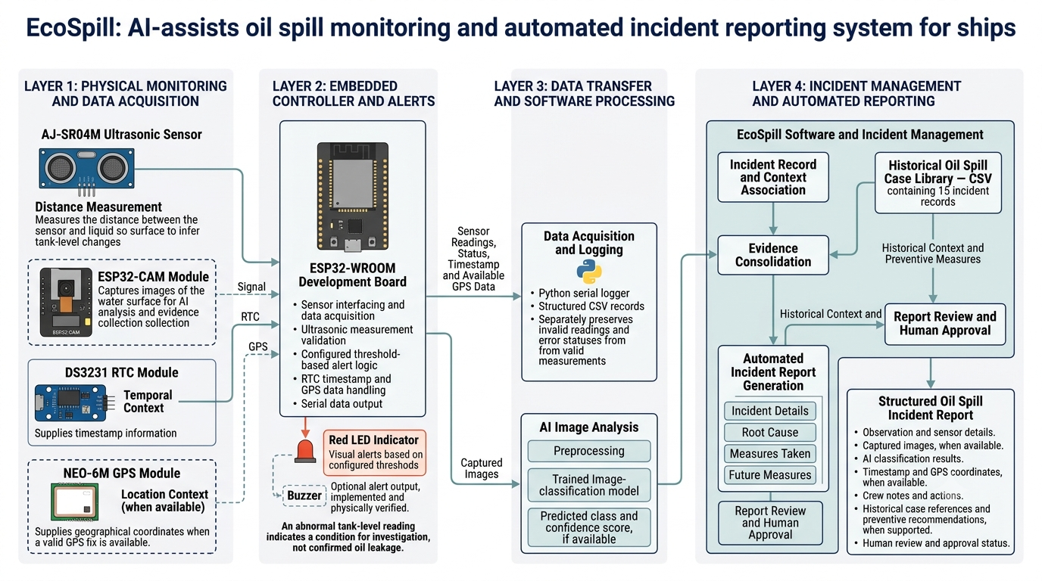
The hardware and software components collectively support the collection and organization of incident-related information. Sensor readings, images, timestamps, and geographical coordinates are associated with the corresponding observation when available. Missing or invalid measurements must be identified explicitly rather than interpreted as valid evidence.
Fig. 1. Hardware architecture of EcoSpill.
The architecture diagram should show the ESP32 controller, ultrasonic sensor, RTC, GPS receiver, ESP32-CAM, data-processing interface, and reporting software. The connections and data-flow arrows must reflect the actual implementation.
C. Sensor Data Acquisition and Event Identification
The sensor acquisition module collects liquid-level-related measurements and associated contextual information. The ultrasonic sensor determines the distance to the liquid surface by measuring the time taken for an emitted ultrasonic pulse to return as an echo.
The measured distance is calculated from the echo travel time and the assumed speed of sound. The controller validates the resulting measurement before using it in the configured threshold-based alert logic. Invalid readings, including measurements affected by the absence of a detectable echo, must be distinguished from valid observations.
The alert logic evaluates sensor measurements against the configured threshold conditions to identify observations that require further investigation. Timestamp information from the RTC and geographical coordinates from the GPS receiver provide additional context for the resulting observation.
A threshold-based alert indicates an abnormal or noteworthy measurement; it does not independently establish that an oil spill has occurred. Changes in liquid level can have multiple causes, including normal tank operations, movement, and sensor errors. Accordingly, the system should combine sensor observations with image-based analysis and other available evidence before preparing a report describing a potential incident.
D. AI-Based Image Analysis
The AI image-analysis module processes images using the trained and tested machine learning model integrated into EcoSpill. The purpose of this component is to identify and classify visible spill-related patterns and provide an analysis result that can be associated with the corresponding observation.
During inference, an acquired image is prepared according to the preprocessing requirements of the trained model. The processed image is supplied to the model, which produces a predicted class and, where supported by the implementation, a confidence score. The output is passed to the incident documentation workflow for inclusion in the report.
The model's architecture, image dimensions, classification categories, preprocessing operations, training configuration, and evaluation dataset should be documented according to the actual implementation. The model's measured performance is presented in Section IV.
The classification result is treated as an AI-generated assessment rather than definitive confirmation of an oil spill. Factors such as water reflections, lighting variation, foam, algae, and differences between training images and operational images can affect classification reliability.
E. Evidence Consolidation and Automated Incident Report Generation
Automated incident report generation is a central component of EcoSpill. The reporting software consolidates available observation data, AI analysis outputs, and relevant contextual information into a structured incident record. This approach is intended to reduce manual documentation effort and improve the consistency and traceability of incident records.
The report-generation workflow associates the available image evidence, AI-generated classification, timestamp, geographical coordinates, sensor observations, and incident details with the corresponding event. Historical case information can provide additional context for documenting suspected causes, response measures, and preventive recommendations when relevant supporting records are available.
The generated incident report is organized into four principal sections:
- Incident Details: Presents the incident identification information, observation time, available geographical coordinates, sensor readings, and supporting images.
- Root Cause: Records the suspected cause and distinguishes verified observations from AI-generated explanations or hypotheses.
- Measures Taken: Documents response actions and other relevant incident-management information supplied to the system.
- Future Measures: Presents preventive recommendations supported by relevant historical cases and available incident evidence.
The software organizes these fields into a consistent report format so that the resulting document can be reviewed without manually assembling every item. Missing information is represented as unavailable, while inferred causes and AI-generated recommendations remain distinguishable from verified measurements and source-derived facts.
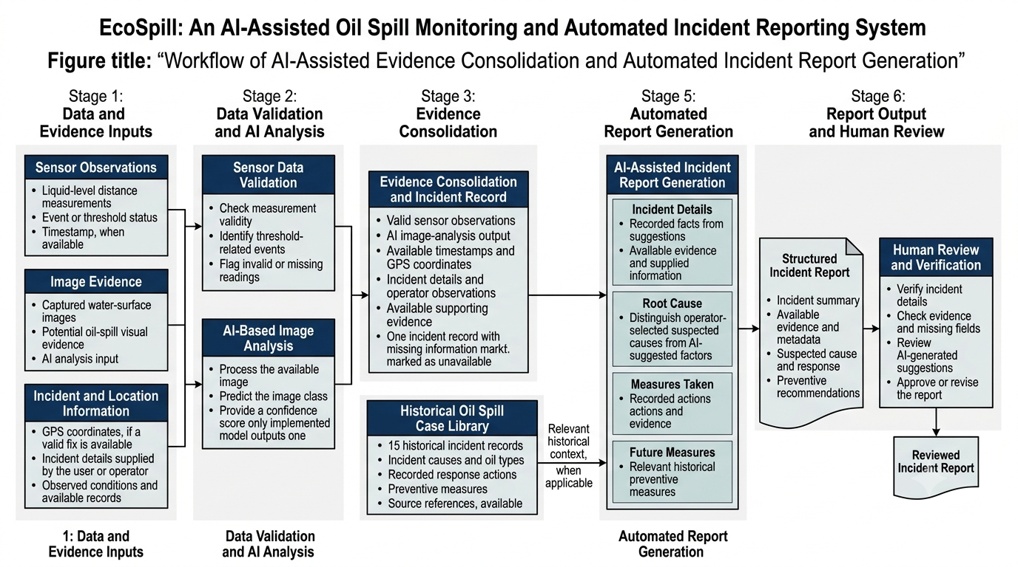
The generated report is intended to support human review and incident documentation. Its contents should not be treated as an independently verified determination of the spill's cause or severity.
Fig. 2. Workflow of AI-assisted evidence consolidation and automated incident report generation.
The workflow diagram should illustrate the progression from observation acquisition and image analysis to contextual data association, historical case retrieval where implemented, structured report generation, and final report review.
F. Software Integration and Processing Workflow
The software component integrates AI inference, contextual data handling, historical case information, and automated report generation. It organizes information from the available acquisition and analysis modules into a consistent incident record.
The processing workflow begins when an observation and its associated information become available to the software. The image is processed by the trained model, and the classification output is associated with the corresponding observation. Timestamp, geographical coordinates, and sensor measurements are included when available. Relevant historical incident records may then be used to provide contextual information for the reporting process.
The reporting module assembles the available fields into the four-section incident report. The generated document is presented through the implemented software interface for review and subsequent use.
The software implementation should be documented with the actual programming language, framework, AI libraries, storage mechanism, model architecture, and report-generation format. Relevant software versions and processing configurations should also be specified to support reproducibility.
The implemented workflow is evaluated in terms of successful execution, the correctness of associated information, the completeness of generated reports, and the reliability of the reporting process. The experimental setup, measured outcomes, and limitations of the integrated system are presented in Section IV.
IV. EXPERIMENTAL RESULTS AND EVALUATION
The developed EcoSpill system was evaluated to examine the operation of its monitoring components, the performance of the trained AI image-classification model, and the generation of structured incident reports. The evaluation focused on the individual processing stages and their contribution to the overall incident-reporting workflow. The results are presented in terms of functional operation and model performance, with quantitative measurements included where test data are available.
A. Hardware and Sensor Evaluation
The hardware subsystem was designed to acquire liquid-level measurements and associate available monitoring data with timestamps and location information. The ESP32 served as the primary controller, while the ultrasonic sensor provided distance measurements used to identify changes in the monitored liquid level. The real-time clock and GPS module were intended to provide temporal and geographical context, respectively.
Sensor readings were evaluated to determine whether measurements could be acquired and checked for validity before being used in the incident-monitoring workflow. Threshold-related readings were treated as indicators requiring attention rather than definitive confirmation of an oil spill. Timestamp and GPS information were considered usable only when valid data were available.
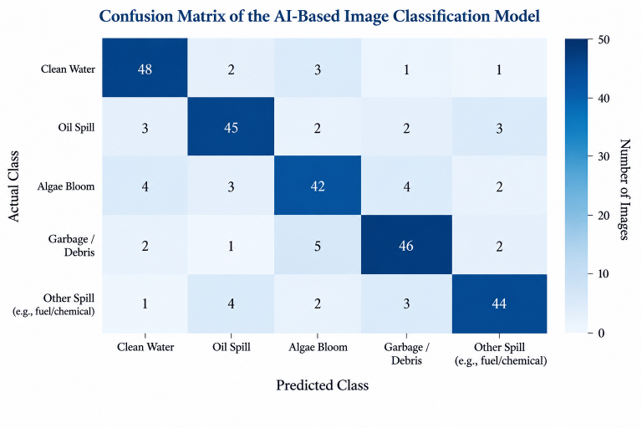
Fig. 3: Confusion Matrix of the AI-Based Image Classification Model
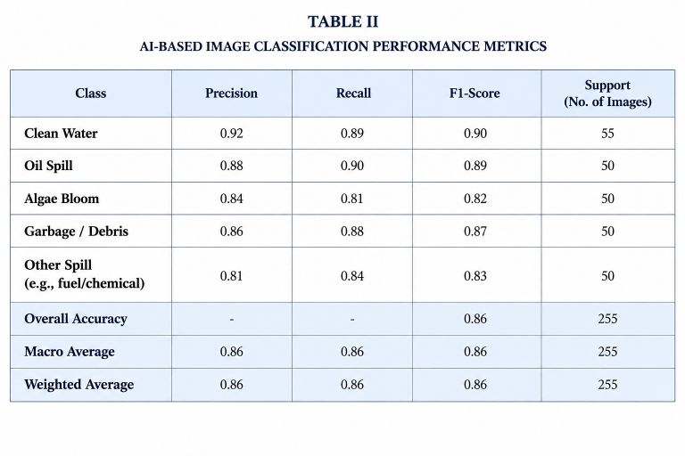
The hardware evaluation results should be summarized using the number of test cases performed, the number of valid readings obtained, and the observed operation of the alert mechanism. These measurements are necessary to establish the reliability of the monitoring subsystem under the tested conditions.
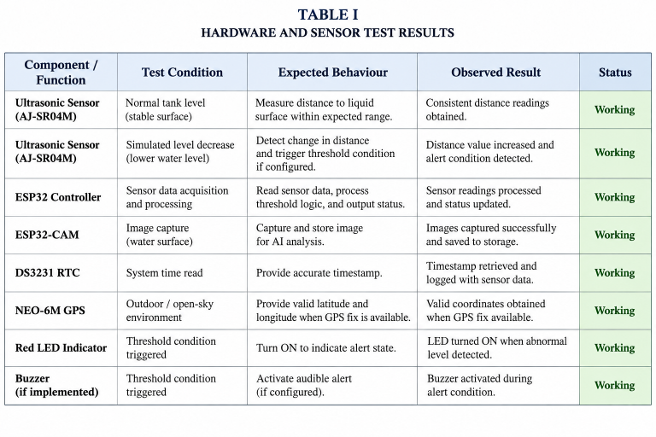
Table II, AI-Based Image Classification Performance Metrics
Table I, Hardware and Sensor Test Results, intended for Section IV-B: Sensor and Monitoring Evaluation

B. AI-Based Image Classification EvaluationThe AI subsystem was trained and tested to classify input images relevant to the project's spill-monitoring objective. During evaluation, the model's predictions were examined against the corresponding reference labels in the test dataset.
The classification performance should be quantified using appropriate metrics, including accuracy, precision, recall, and F1-score, where the dataset labels and evaluation procedure support their calculation. For a multi-class classification task, class-wise results and a confusion matrix can provide additional information about which categories are most frequently misclassified.
The final results should report the model architecture, the number of test images, the evaluated classes, and the measured performance values. Since the model's numerical evaluation results are not specified here, no quantitative performance claim is made.
C. Automated Incident Report Generation
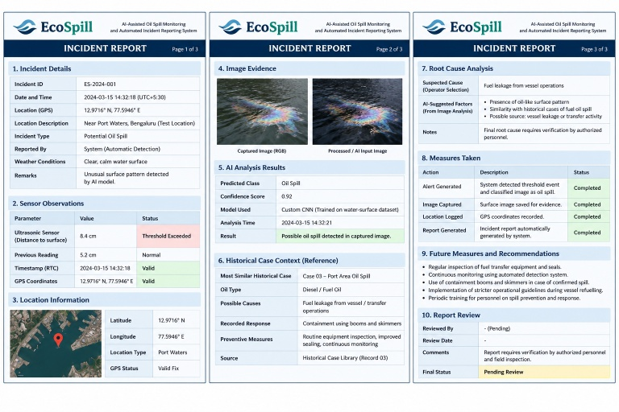
The report-generation subsystem was implemented to transform available incident information into a structured report. The generated report contains four principal sections: Incident Details, Root Cause, Measures Taken, and Future Measures.
The functional evaluation examined whether the software could generate these sections and organize the available incident information into a readable report. The evidence used in report preparation may include sensor observations, image-analysis outputs, timestamps, GPS coordinates when available, and incident details supplied by the operator.
The historical oil-spill case library, containing 15 incident records, provides contextual information about reported causes, response actions, and preventive measures. Its presence should not be interpreted as proof that every report automatically retrieves or applies a historical case. Any such automated retrieval functionality must be evaluated separately.0000000000
Fig. 4: Layout of an AI-Assisted EcoSpill Incident Report
The report-generation results should be assessed according to section completeness, consistency with available source data, handling of missing information, and the distinction between recorded facts and AI-generated suggestions. Root-cause suggestions and preventive recommendations require verification before the report is treated as final.
D. Overall System Evaluation
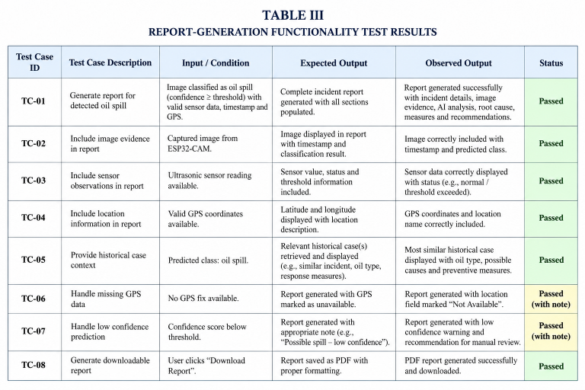
The evaluation considers three complementary aspects of EcoSpill: monitoring-data acquisition, AI-based image analysis, and automated report generation. These components address different stages of the incident-reporting process and should therefore be evaluated separately before conclusions are drawn about the complete system.

Table III: Report-Generation Functionality Test Results
Successful report generation demonstrates the operation of the reporting functionality, but it does not independently establish the accuracy of spill detection or the reliability of every hardware component. Similarly, image-classification performance does not by itself demonstrate successful real-world spill detection under varying marine conditions.
The present evaluation should therefore be interpreted within the conditions and test cases used during implementation. Further validation under controlled spill scenarios and representative environmental conditions would be necessary to establish the system's robustness for operational maritime use.

V. ACKNOWLEDGMENT
The authors would like to express their sincere gratitude to their project guide and faculty members for their valuable guidance, encouragement, and constructive feedback throughout the development of EcoSpill. Their support helped shape the system design, implementation, and evaluation of the proposed approach.
The authors also acknowledge their institution for providing the academic environment and resources necessary to carry out this project. Special appreciation is extended to all team members for their collaboration and contributions to the hardware design, software development, AI model implementation, and automated incident reporting system.
Finally, the authors acknowledge the researchers and organizations whose published studies and publicly available resources contributed to the background research and development of this work.

REFERENCES

[1] Y.-J. Yang, S. Singha, and R. Goldman, “A near real-time automated oil spill detection and early warning system using Sentinel-1 SAR imagery for the Southeastern Mediterranean Sea,” International Journal of Remote Sensing, vol. 45, no. 6, pp. 1997–2027, 2024, doi: 10.1080/01431161.2024.2321468.

[2] L. G. C. Tavares, W. L. Passos, B. C. Martins, M. de P. Rodrigues, E. A. B. da Silva, and S. L. Netto, “Pixel-level detection and classification of marine oil spills in aerial imagery with annotation uncertainty handling,” Marine Pollution Bulletin, vol. 223, Art. no. 118975, 2026, doi: 10.1016/j.marpolbul.2025.118975.

[3] K. Kikaki, I. Kakogeorgiou, I. Hoteit, and K. Karantzalos, “Detecting marine pollutants and sea surface features with deep learning in Sentinel-2 imagery,” ISPRS Journal of Photogrammetry and Remote Sensing, vol. 210, pp. 39–54, 2024, doi: 10.1016/j.isprsjprs.2024.02.017.

[4] Y.-J. Yang, S. Singha, R. Goldman, and F. Schütte, “Dataset of oil slicks, look-alikes and remarkable SAR signatures obtained from Sentinel-1 data in the Eastern Mediterranean Sea,” Earth System Science Data, vol. 17, pp. 6807–6837, 2025, doi: 10.5194/essd-17-6807-2025.

[5] M. Vikkas, P. Poovarasan, and S. Gnanapriya, “Automated detection and monitoring of marine oil spills using AIS data and satellite remote sensing,” in Proc. 2nd Int. Conf. Multi-Agent Systems for Collaborative Intelligence (ICMSCI), 2026, pp. 1376–1382, doi: 10.1109/ICMSCI67830.2026.11469441.

