

**WIPRO CLOUD PRODUCT AND PLATFORM ENGINEERING – 2025**

**Mini Project Report**

**Name of the Student : Prakash P**

**Department : Computer Science And Engineering**

**Year / Sem / Section : IV/VII/A**

**Date of Submission :**

**Scenario - #1**

**Title: Host an E-Commerce website on a scalable cloud platform with AI-driven load balancing and data Encryption**

**Steps for Cloud Engineering:**

**Create a virtual machine in AWS**

**Step1:**Create an Instance with amazon EC2, Give name for the instance and select the machine image (os) of the instance

**Screenshot 1:**

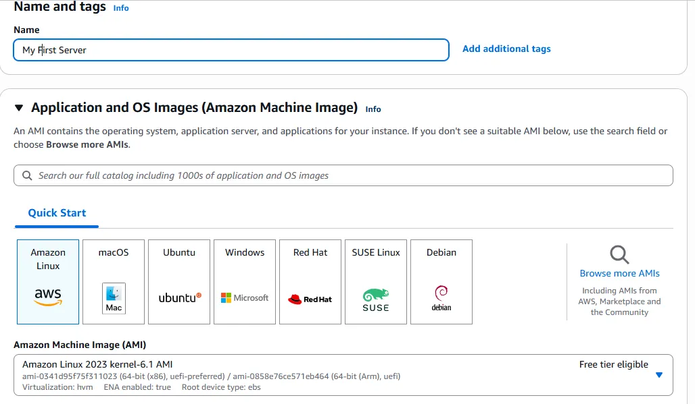

**Step2:** Create a key pair for the instance, this will be used to login to the virtual machine with open ssh connection

**Screenshot2:**

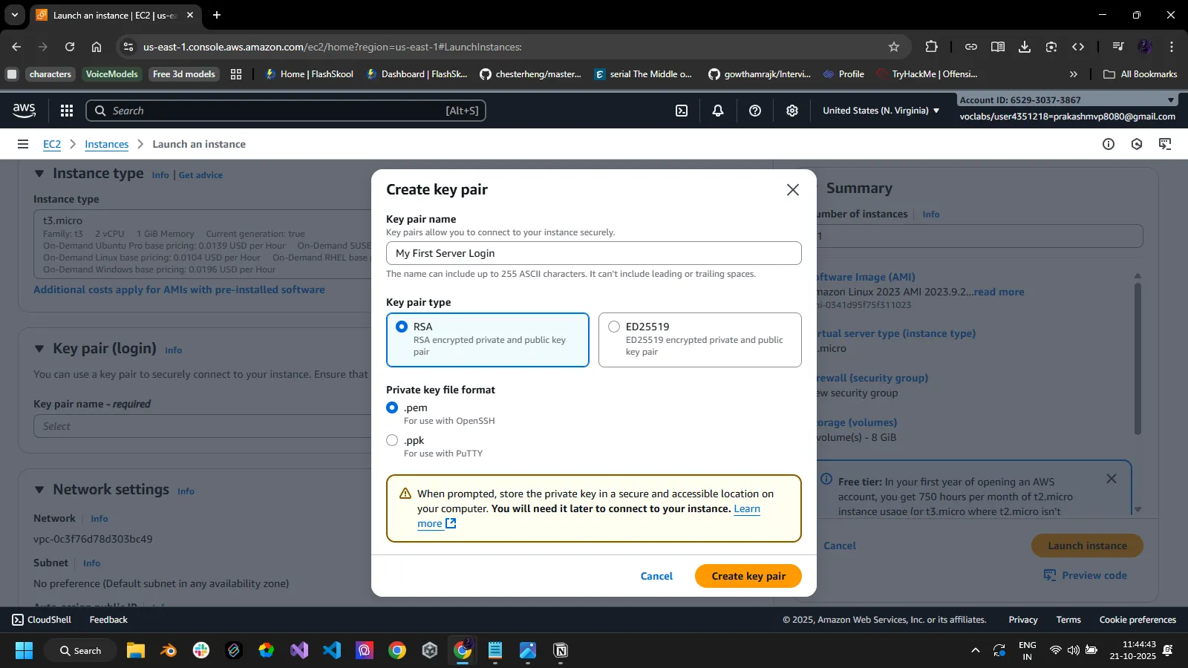

**Step 3:** select the instance type , storage size requited and create a new security group for the instance

**Screenshot 3:**

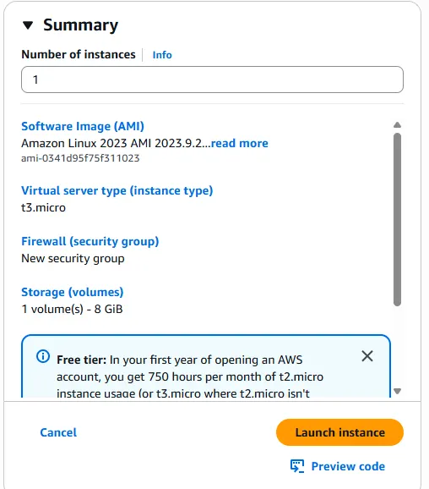

**Step 4:**  Connecting to the instance with ssh using the .pem key file

**Screenshot 4:** 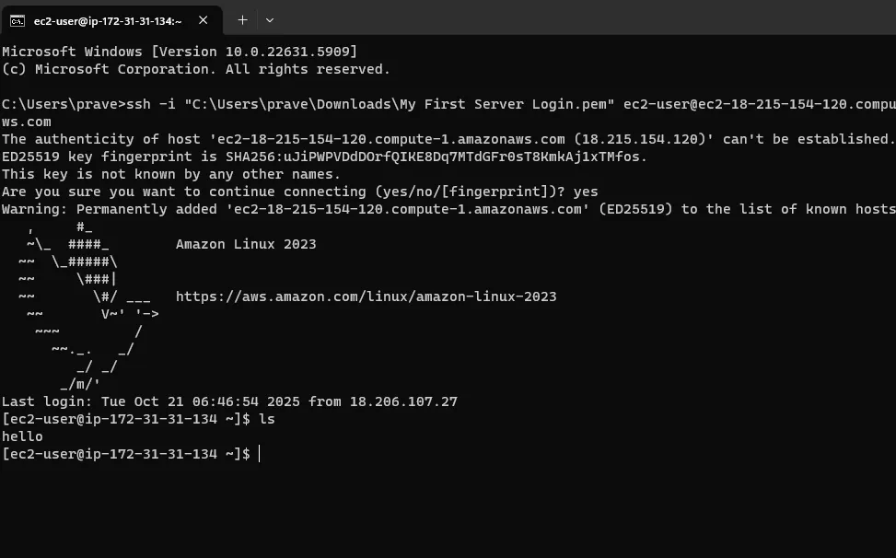

**Step 5:** install httpd and update the system to latest version using yum update -y and yum install httpd -y

**Screenshot 5:** 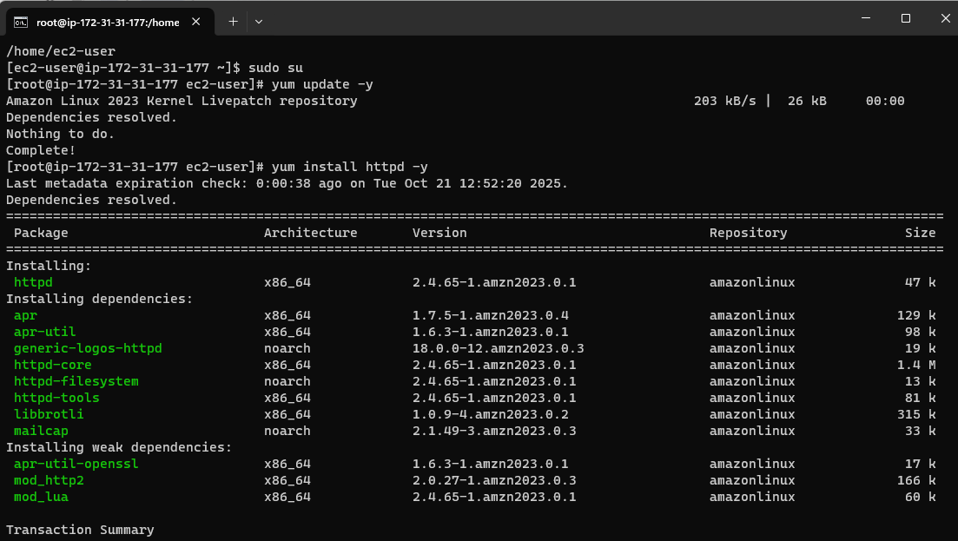

**Deploy a simple web server on the created instance**

**Step 6:** Create a index.html file containing the code for the website

**Screenshot 6:**

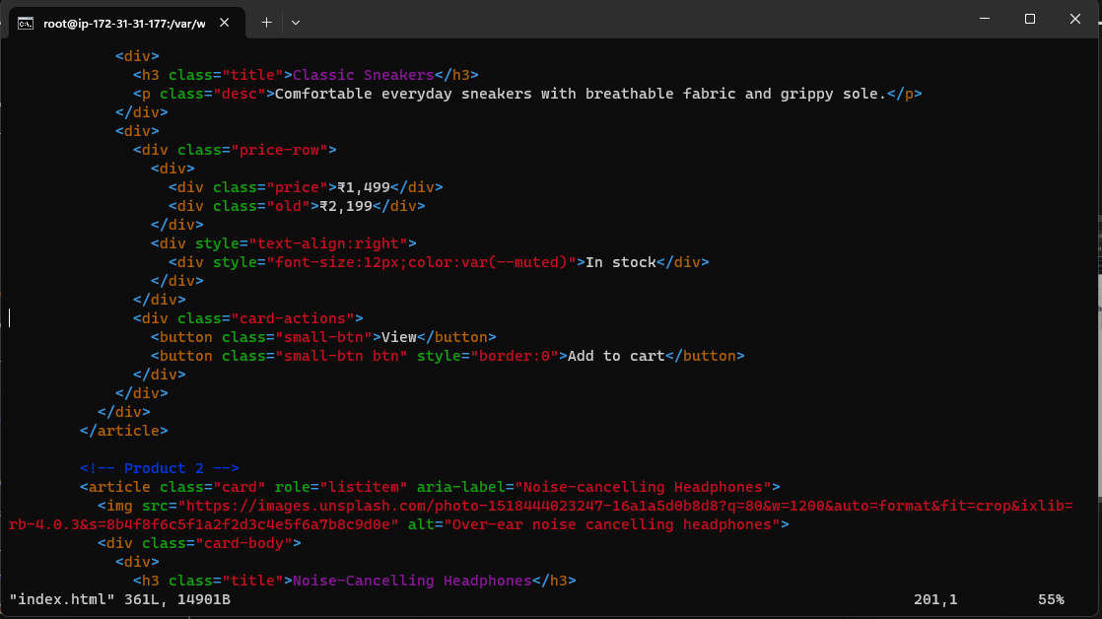

**Step 7:** start the htdp service to run the index.html and host in on the created instance in aws

-service httpd start

**Step 8:**  Use the public ip in the instance to launch the E commerce site

**Screenshot 8:**

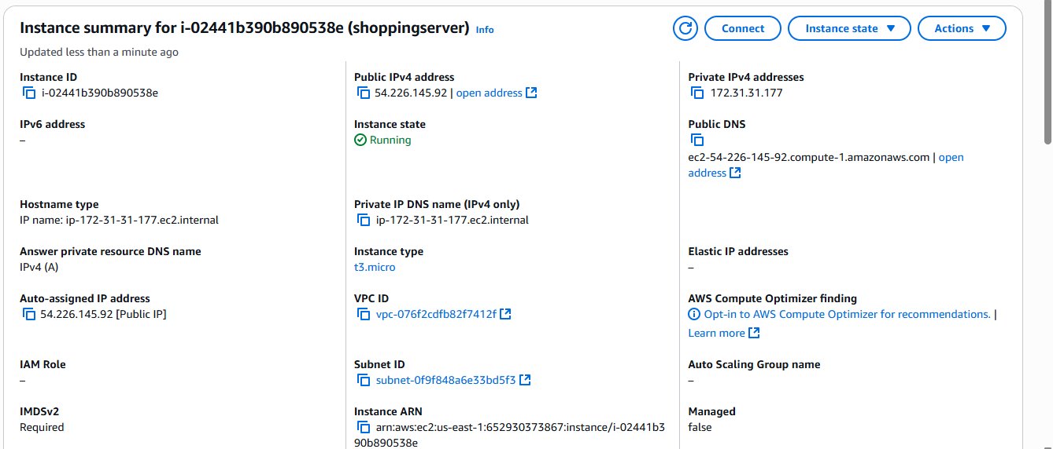

**Step 9:** Create another EC2 instance form the EC2 dashboard to create a load balancer

**Create a load balancer**

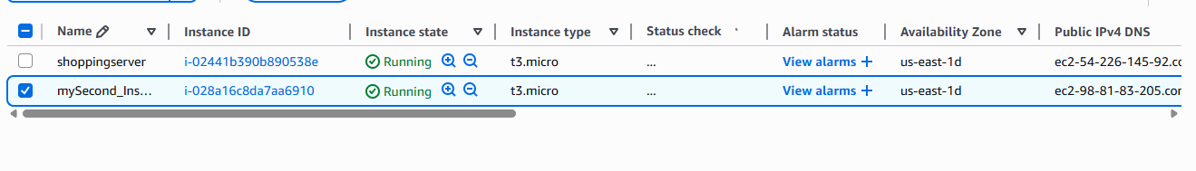**Screenshot 9:**

**Step 10:** go to load balancer dashboard and create a new application load balancer

**Screenshot 10 :**

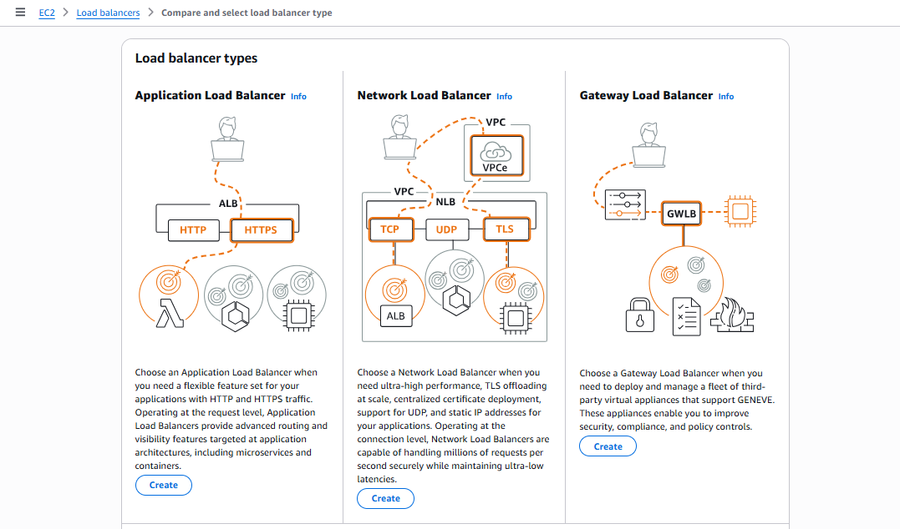

**Step 11:** do the basic configurations for the load balancer , setup the VPC (virtual private network) and finally create a new security for the loadbalancer and uncheck the default one.

**Screenshot 11:**

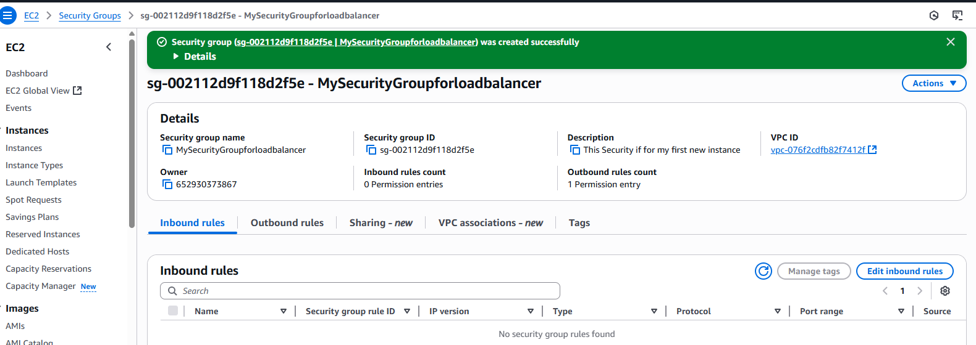

**Step 12:** Create a new Target group for the load balancer

**Screenshot 12:** 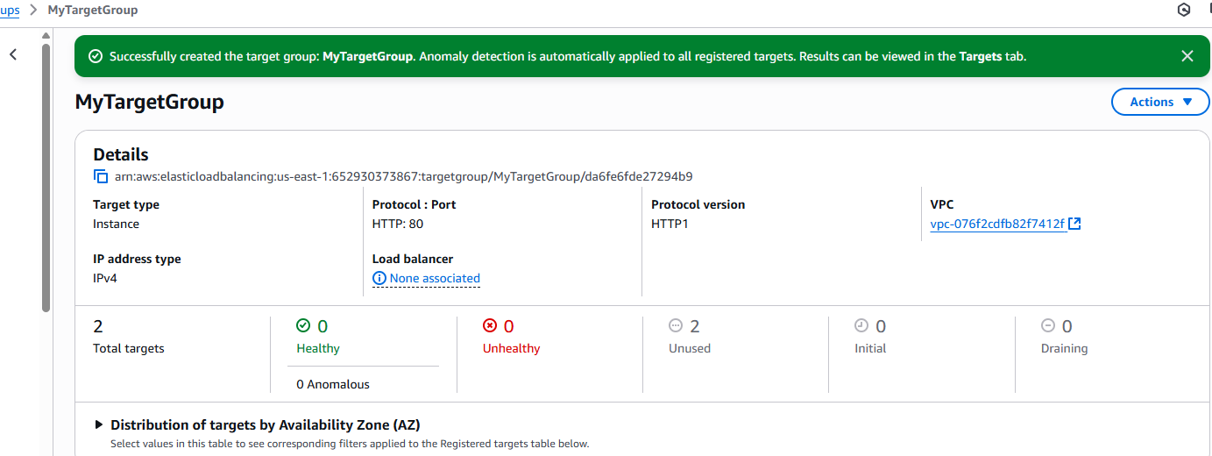

**Step 13 :** Verify the summary and create the load balancer

**Screenshot 13:** 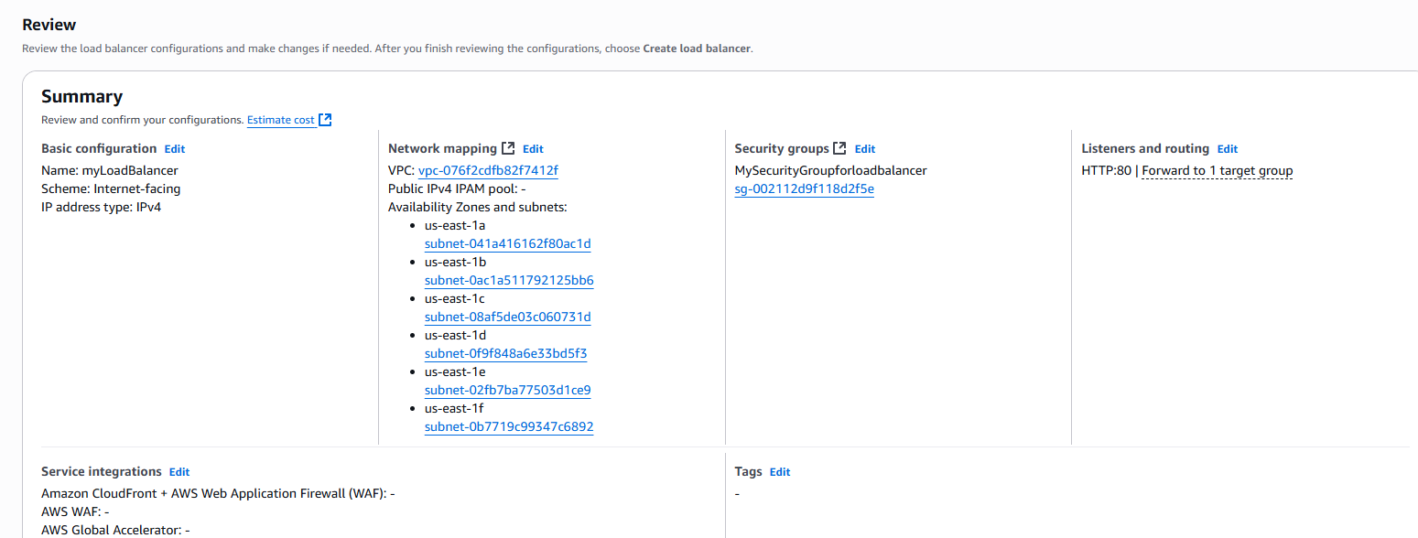

**Load sample data and visualize it using Matplotlib**

**Step 14 :** Create an amzon s3 bucket and upload the dataset in it

**Screenshot 14**: 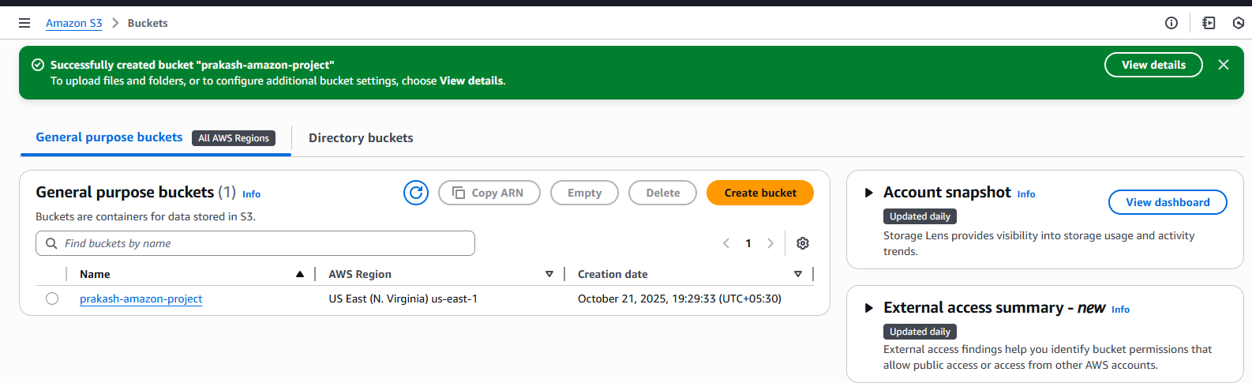

**Step 15:**  Create a manifest.json file and upload the file and the dataset into the bucket

**Screenshot 15:**

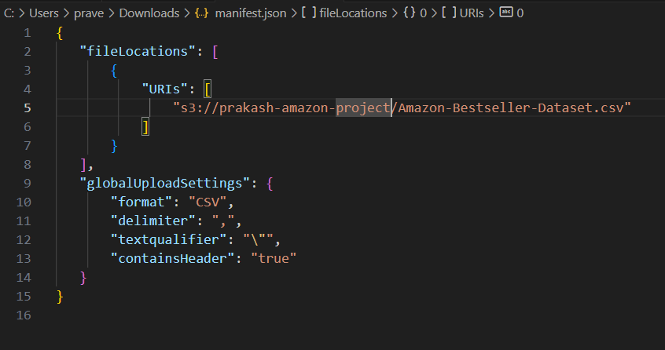

**Step 16 :C**reate a maazon quicksight account and open the quicksight tool

**Step 17:** Import the s3 dataset into quick Sight

**Screenshot 17:**

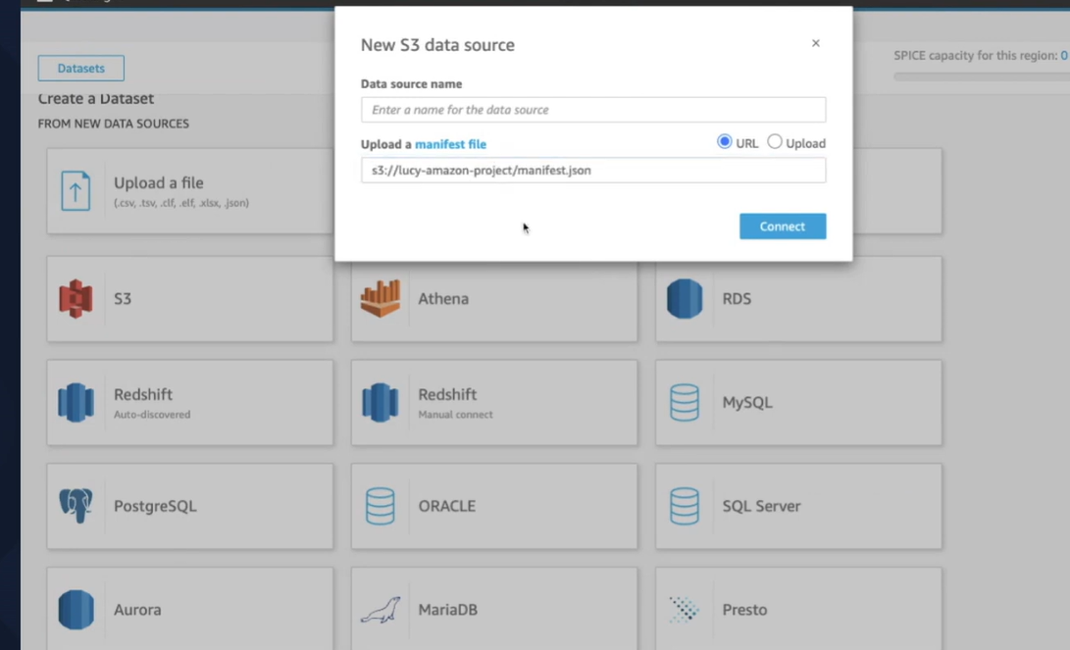

Step 18: visualize the data in the dataset with quicksight visualization tool

Screenshot 18: 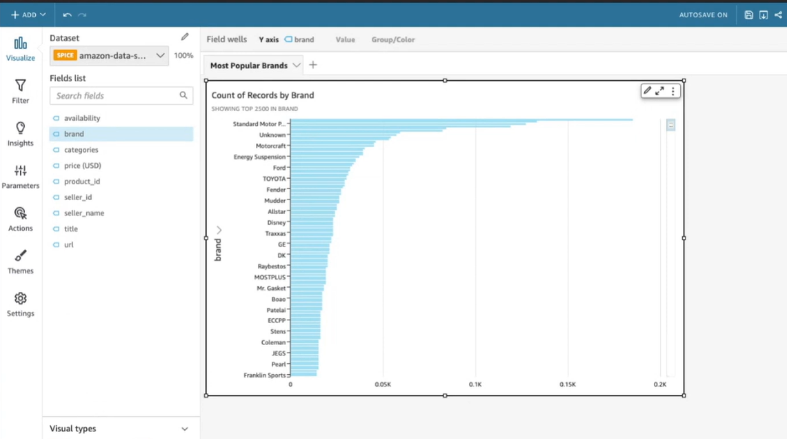

**GitHub Link for Scenario #1:**

**Scenario - #2**

**Title:**

**Steps for Cloud Engineering:**

**Step1:**

**Screenshot 1:**

**Step2:**

**Screenshot2:**

**:**

**:**

**GitHub Link for Scenario #2:**

**Scenario - #3**

**Title:**

**Steps for Cloud Engineering:**

**Step1:**

**Screenshot 1:**

**Step2:**

**Screenshot2:**

**:**

**:**

**GitHub Link for Scenario #3:**