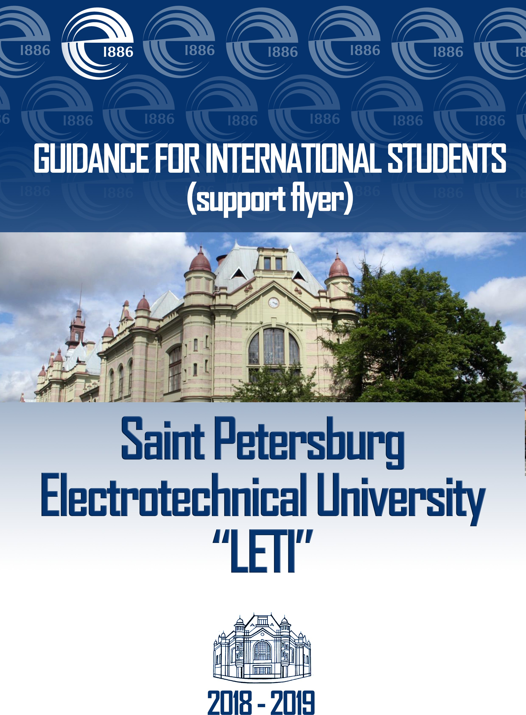

CONTENTS  RUSSIA IN BRIEF……………………………………………………...……….…...... Official name and Authorities…………………………………………………….….. Territory…………………………………………………………………………..…… Capital…………………………………………………………………………….…... Population……………………………………………………………………….……. Religion……………………………………………………………………………….... Official language……………………………………………………………………...... Currency…………………………………………………………………….................. | 3  3  3  3  3  3  3  3
Time in Russia……………………………………………………………………........ SAINT PETERSBURG……………………………………………………………..… Main attractions……………………………………………………………………..... | 4  4  4
Climate and weather…………………………………………………………………. Russian Customs and Traditions……………………………………………………... | 5  5
Money……………………………………………………………………..................... | 7
Customs office……………………………………………………………………...... TRANSPORT……………………………………………………………………......... Airport Pulkovo……………………………………………………………………..... Railway stations…………………………………………………………………….... | 8  8  8  8
Metro, the underground………………………………………………………………... Public transport in St. Petersburg: …………………………………………………… | 9  9
Night bus routes and metro. Working schedule……………………………………… OTHER USEFULL INFORMATION……………………………………………….. Cell (mobile) phones………………………………………………………………..… | 10  10  10
Safety……………………………………………………………………....................... | 11
Health care…………………………………………………………………….............. Emergency phone numbers……………………………………………………………. Pharmacies………………………………………………………………………….…. | 12  12  12
Foreign consulates in Saint Petersburg………………………………………………… Electricity …………………………………………………………………………… Must have apps in Saint Petersburg ………………………………………………… | 13  13  13
Education…………………………………………………………………………...... ST. PETERSBURG ELECTROTECHNICAL UNIVERSITY «LETI»……….…… | 14  14
The University today…………………………………………………………………. | 15
Applying to ETU “LETI”……………………………………………………………… Preparatory Department for International Students…………………………………… | 16  16

International Students Office……………………………………………………..…… Required documents you need to apply for study……………………………………… | 18  18
Legalization of educational certificates……………………………………………...… | 19
Visa: how to obtain Russian Student’s visa step by step……………………………… | 22
Migration Card…………………………………………………………………….…… Registration of foreign citizens………………………………………………………. | 23  23
Upon graduation……………………………………………………………………..… | 24
Student accommodation ………………………………………………………………. Medical insurance……………………………………………………………………… | 25  25
Welcome to ETU “LETI”………………………………………………………….…... How to get from the airport to the dormitory or ETU “LETI”………………………. | 26  26
STUDENT LIFE……………………………………………………………..………... Canteens…………………………………………………………………………...…… Leisure…………………………………………………………………………..……... Self-administration……………………………………………………………..……… | 28  28  28  28
Library…………………………………………………………………………...……... | 30
Needful University phone numbers…………………………………………………... Contact information………………………………………………………………...….. | 31  31
BASIC RULES OF STAY OF FOREIGN CITIZENS IN RUSSIAN FEDERATION | 32
Pic. 1. Scheme of Saint Petersburg metro………………………………………………  Pic. 2. ETU “LETI”. Professor Popov St., 5. Metro “Petrogradskaya” (Петроградская)………………………………………………………………………..  Pic. 3. Dormitory № 7. Ispitateley Prospect, 10. Metro “Pionerskaya” (Пионерская)..  Pic. 4. Dormitory № 8. Address: Torzhkovskaya st., 15. Metro “Chernaya rechka” (Черная речка) ………………………………………………………………...............  Pic. 5. Campus’ scheme………………………………………………………………... | 33  34  35  35  36
How to navigate……………………………………………………………………… | 37

RUSSIA IN BRIEF

Official name and Authorities

The Russian Federation (Russia) (Российская Федерация (Россия) is a country in Northern Eurasia. It is a federal semi-presidential republic. Each region has its own regional government and parliament. The Head of the State is elected by direct voting every six years. The Russian Federation was formed after the collapse of the Soviet Union (USSR) in 1991.

Territory
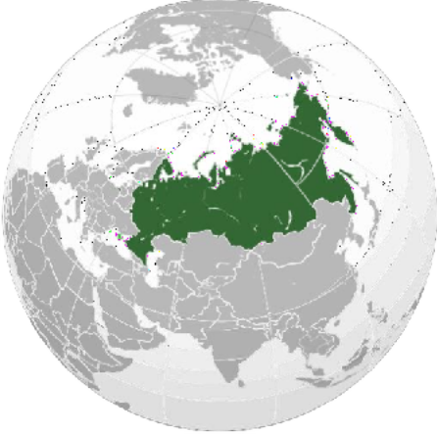
The total area of Russia is 17 million square kilometers, its length - 9000 km from West to East, 5000 km from North to South. One quarter of the country's territory is located in Europe and the rest - in Asia.
Russia is the largest country in the world, covering more than one- eighth of the Earth and is home to a wide range of environments and landforms.
Capital

Moscow (Москва), 13.2 million (2016).

Population

146.3 million people (2015). Russia is the world's ninth most populous nation. The ethnic groups of Russia are Russians (80%), Tatars, Ukrainians, Bashkirs, Chuvashs, Chechens, Armenians and others (more than 190 different ethnic groups).

Religion

Russia is a secular country - there is no official religion. However, the majority of the population consider themselves as Orthodox (75%). Also, Russia is home to many Muslims (6-7%), Buddhists and others. Many people are atheists (16%).

Official language

Official language is Russian.

Currency

The Russian currency is the Russian Ruble (рубль) – RUB, 1 ruble = 100 kopeecks (копейка).

Time in Russia

Russia spans eleven time zones. St. Petersburg is located in the same time zone as Moscow (+3 hours from Greenwich). Since 2011 Daylight Saving Time was cancelled, so people do not adjust clock one hour close to the start of spring and do not adjust them backwards in the autumn to standard.
SAINT PETERSBURG
Saint Petersburg (Санкт-Петербург) is the second largest city in Russia. Petersburg is situated on the middle taiga lowlands along the shores of the Neva Bay of the Gulf of Finland and islands of the river delta. In 1914 the name of the city was changed from Saint Petersburg to Petrograd, in 1924 to Leningrad and in 1991, back to Saint Petersburg.
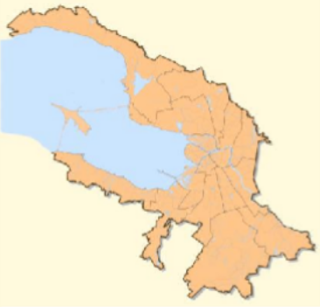
In Russian literature, informal documents, and discourse, the word "Saint" (Санкт) is usually omitted, leaving "Petersburg" (Петербург). In casual conversation Russians may drop the "burg" as well, referring to it as "Piter" (Питер).
Saint Petersburg was founded by Tsar Peter the Great on May 27, 1703 as a window to Europe. Between 1713–1728 and 1732–1918, Saint Petersburg
was the imperial capital of Russia. In 1918, the central government bodies moved from Saint Petersburg to Moscow.
Saint Petersburg is a major trade gateway, financial and industrial centre of Russia specializing in oil and gas trade, shipbuilding yards, aerospace industry, radio and electronics, software and computers; machine building, heavy machinery and transport, including tanks and other military equipment, mining, instrument manufacture, ferrous and nonferrous metallurgy, chemicals, pharmaceuticals, medical equipment, publishing and printing, food and catering, wholesale and retail, textile and apparel industries, and many other businesses.
St. Petersburg is one of the largest scientific centers in Russia; the Saint Petersburg Scientific Center of the Russian Academy of Sciences unites over 60 academic and research institutions. Petersburg is a renowned center of higher education in Russia. The city has dozens of public and private higher education institutions, including one of the most famous - St. Petersburg Electrotechnical University "LETI".

Main attractions

Saint Petersburg is often described as the most westernized city of Russia, as well as its cultural capital. The city has a large number of cultural and historical monuments. The historic centre of Saint Petersburg and related groups of monuments constitute a UNESCO World Heritage Site.
Saint Petersburg is home to more than two hundred museums, many of them are located in historic buildings. The largest museums are the Hermitage Museum, featuring interiors of the former imperial

residence and a vast collection of art. The Russian Museum is a large museum devoted specifically to Russian fine art. There are more than 70 theaters in St. Petersburg including the pearl of St Petersburg performing arts - Mariinsky theatre.
Petersburg is not only the city itself but also its famous suburbs. The Southern suburbs of the city feature former imperial residences, including Peterhof, with majestic fountain cascades and parks, Pushkin, with the baroque Catherine Palace and the neoclassical Alexander Palace, and Pavlovsk, which contains a domed palace of Emperor Paul and one of the largest English-style parks in Europe.
For more information on attractions follow http://www.saint-petersburg.com/

Climate and weather

Saint Petersburg is classified as a humid continental climate. Distinct moderating influence of the Baltic Sea cyclones result in warm, humid and short summers and long, cold wet winters.
The average summer temperature is +20 °C, but can reach +25 °C, +30 °C. The average winter temperature around -8 °C, but may be cooling to -30 °C or -25 °C and warming to 0 °C, +5 °C. The Neva River within the city limits usually freezes up in November–December and break-up occurs in April. From December to March there are 118 days on average with snow cover, which reaches an average snow depth of 19 cm by February. The frost-free period in the city lasts on average for about 135 days. The city also has a slightly warmer climate than its suburbs. But average data can be deceiving, and weather conditions are quite variable all year round. St. Petersburg is famous for its unpredictable rains at any time of the year (even in winter), and we recommend that when you travel to St. Petersburg to take an umbrella. At the same time, St. Petersburg is famous for its white nights.
For more information about the weather follow http://www.saint-petersburg.com/weather/

Russian Customs and Traditions

Russian names are comprised of:

- First name, which is the person's given name.

- Middle name, which is a patronymic or a version of the father's first name formed by adding '- vich' or '- ovich' for a male and '-avna' or '- ovna' for a female. The son of Ivan would have the patronymic Ivanovich while the daughter's patronymic would be Ivanovna.

- Last name, which is the family name or surname.
By the way, you, as a foreigner when you officially introduce yourself to somebody you should indicate which part of your name is your personal name, and which part can be considered as a surname, even if in your traditions there are no surnames as such. In Russian documents, from a visa to a diploma of education, your name will be divided into a first name and a surname.

It is polite to refer to elderly people or seniors by both first and middle name. To others you can address only by first name. It is better to avoid addressing people by their surnames.
For example, Elena Vladimirovna Zueva, where Elena is the first name, Vladimirovna is a patronymic (her father's name is Vladimir), and Zueva is a surname. So, in a conversation it is polite to address her Elena Vladimirovna. In all official documents she will be referred to as E.V. Zueva.
- The typical greeting between men is a handshake. With older people you shake hands only if they stretch out their hand first. And a simple greeting according to the time of day would be good for everyone.
- Women and old people are respected here. It is considered basic politeness to offer your seat to a woman or an elderly person in public transport.
- Russian etiquette dictates that men take off their headwear (hat, cap etc.) when they enter a room.

- If you are invited to a non official party or dinner it is polite to bring something with you – a small snack or drink is usually accepted with pleasure.
- It is not customary for us to smile at strangers, so it may seem that people here are surly or grumpy. The Russian smile is a sign of genuine personal affinity and good graces rather than mere politeness. The Russians rarely smile to strangers. In Russian communication the smile is generally addressed to friends and acquaintances. It is not typical for the Russians to smile in response. Anyway most of the Russians are quite cheerful and witty. Thus, for example, customs officers at the airports rarely smile because they are occupied with a matter of concernment. The Russian smile is aimed to be sincere only: it is considered as one’s heartfelt expression of good mood or goodwill to the interlocutor. So, if a foreigner smiles at you it may mean nothing but the fact that he/she was taught to smile at everyone, but if a Russian smiles it is only because he or she really wants to smile.
- In Russia, there are days of national holidays, when no one works. If this day falls on the weekend, then Friday or Monday is also appointed as a day off - in order not to happen, that people lost a "legitimate" additional day of rest because of an unsuccessful calendar. All official institutions, including consulates and embassies in your country do not work these days. The calendar of holidays for each year is different, but it can be easily found on the Internet. This is a list of national holidays:
⋅ 1-6 and 8 January - New Year holidays;
⋅ January 7 - Orthodox Christmas;
⋅ February 23 - Defender of the Fatherland Day;
⋅ March 8 - International Women's Day;

⋅ May 1 - Spring and Labor Day;
⋅ May 9 - Victory Day;
⋅ June 12 - Day of Russia;
⋅ November 4 - National Unity Day.

More information about customs and traditions you can find here: http://www.commisceo-global.com/country-guides/russia-guide

Money

It's better to carry US dollars or Euros - then you won't have any problems with changing them. There are currency exchange offices all around St. Petersburg, many of them work 24 hours, but it's safer to change money in banks. There are also many ATMs, usually next to banks, metro stations’ exits and department stores. The ATMs take no commission or only 1%, but your bank in your country will charge you about $5 for the transaction. Take enough cash, credit cards and checks in advance to avoid problems.
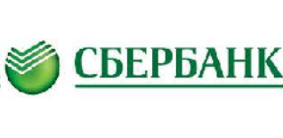
It is best to have a bank card that supports an international payment system, such as Visa, MasterCard, Maestro, etc. Or, to use international money transfer systems (MoneyGram, Western Union or others). But do not forget that when you use a credit card, you can withdraw the money gradually, which is always a safer option than getting a large amount of money by transfer at once and walk with it in the crowd. Most banks are open from 9.00 to 17.00-20.00.
The state bank of Russia is Sberbank (Сбербанк).

On average, 15 thousand rubles a month are sufficient. This is enough for subsistence, travel expenses and other minor expenses. In reality it can be less or more, but this amount of money is enough for a normal existence.
There are many shops in St. Petersburg. For example, around metro Pionerskaya you can find the supermarkets Ashan, Karusel’, O’key, Dixi, Lenta, Pyaterochka, Lime, etc. Some food stores are open 24 hours, so you can buy almost anything you need at any time.
Here are the approximate prices of some items (2017): bread (1 kg) – $ 0,7; milk (1 l) – $ 0,8-1; potatoes (1 kg) – $ 0,6-1; eggs (10) – $ 0,8; chicken (1 kg) - $ 3; water (2 l) - $ 0,5; Coca-Cola (0,5 l) - $ 0,7.









More information about cost of living you can find here: www.numbeo.com

Customs office

The export of antiques made earlier than 1945 is not allowed. The export of souvenirs and handicrafts (including handmade items) does not require special permission. However, it is better to keep the sales receipt or registers before leaving Russia.
Restrictions also apply to the export of currency - no more than $ 10,000. The amount of money is to be registered in the customs declaration, which should be kept until your departure from Russia. The import of foreign currency is unlimited.
It is advisable to save the customs declaration to be able to exchange currency on more favorable terms.
TRANSPORT

Airport Pulkovo

Pulkovo Airport (Аэропорт Пулково) is the international airport serving Saint Petersburg. It consists of one terminal, which is located 23 km south of the city centre.
The plan, schedule and other information of the airport "Pulkovo" can be found here: http://www.pulkovoairport.ru/en/, or by phone +7 (812) 337-38-22, +7 (812) 337-34-44

Railway stations

There are 5 railway stations in St. Petersburg. You can call and ask about schedule, tickets, prices by phone
+7 (800) 775-00-00. Or use www.pass.rzd.ru, www.tutu.ru.

Baltiisky station: Serving trains to suburb Peterhof, Oranienbaum (Lomonosov), Gatchina. Address: 120 Obvodnogo Kanala nab. Metro: Baltiyskaya.
Vitebsky station: Serving trains to South-Western Russia, Ukraine, Belarus, Estonia, Latvia, Lithuania, Poland, Germany, Bulgaria, Czech Republic, Slovakia, Hungary. Serving trains to suburbs (Пушкин) Pushkin, Pavlovsk. Address: 52 Zagorodnyy pr. Metro: Pushkinskaya.
Ladozhsky station: Serving trains to North/ North-East of Russia, Finland. Address: 73 Zanevsky pr. Metro: Ladozhskaya.
Moskovsky station: Serving trains to Moscow, Northern Russia, Urals, Siberia, Central and Southern Russia. Address: 85 Nevsky pr. Metro: Mayakovskaya, Pl. Vostaniya.
Finlyandsky station: Serving trains to Vyborg, Karelia and Finland. Address: 6 Lenina pl. Metro: Ploschad Lenina.
Information about train schedules can be found on www.rzd.ru

Metro, the underground


It's easy and safe. Saint Petersburg metro has five color-coded (red, yellow, blue, green, violet) and numbered metro lines (M1, M2, M3, M4, M5) and 67 stations. When getting the
Russian underground, so be ready to do some additional walking. The trains run quite frequently (every 2-3 min) and are on time, even though it is often crowded during rush hours, so it is better to avoid travelling during these times if possible. The map of Saint Petersburg metro, all tourist information and metro signs are provided in English.
Interactive metro map you can find here http://www.metro.spb.ru/map1/route.html

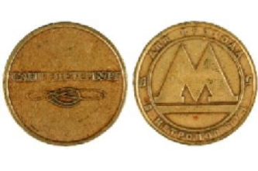
The Saint Petersburg Metro entrances are marked with a blue letter “M” over the entrance. The Metro is open from 5.45 to 24.00. To take the metro you will have to pay with tokens which can be bought from the ticket windows (labelled “Kacca”) inside each metro station.
The fare is fixed. Cost of token for passenger or luggage - 45 RUB/1 way. And you will pay only to enter the metro - the time spent there, distance travelled and routes covered will be unlimited.
A really good way to save time and money is to buy a magnetic card or electronic pass for as many rides as you want (10/20/40/70 units). Or simply a travel card called "Podorozhnik" - you just top up the amount money you need and you are ready to go.
If you come for more than three months, you can buy a student card. A student monthly card valid for 100 journeys in the metro and unlimited use in ground transport. It costs 1035 rubles per month (2017). For more information please contact the International Students Office.
Smoking in the metro is prohibited.

Metro scheme you can find at the end of this booklet, p. 33, pic. 1.

More information about Petersburg subway you can find here: http://hp10.metro.spb.ru/en/

Public transport in St. Petersburg

You can download application with routs and on-line location of transport (“YANDEX TRANSPORT”)



Bus (running from 6.00 to 24.00)

- Regular buses. You can pay the fare by purchasing a single ticket or monthly travel card. Tickets can be purchased on board the bus directly from the conductor (note that most conductors are unlikely to speak

English) (40 RUB/1 way). There are more ways to pay for the trip: http://www.metro.spb.ru/en/pricetickets.html Keep the ticket during the trip by bus, tram or trolleybus - you have to be able to show ticket or travel card to the conductor or inspector.
- Public taxi buses (“marshrutka”). The fare is paid to the driver in cash only or by card “Podorozhnik” (about 35-45 RUB/1 way). Stops are made at the request of passengers. The driver should be informed of the stop loudly and in advance.
More information about fares you can find here: http://www.metro.spb.ru/en/pricetickets.html

Trams and trolleybuses (running from 6.00 to 24.00).

The procedure is the same as in regular buses (40 RUB/1 way).

Night bus routes and metro. Working schedule

The navigation season in St. Petersburg begins on April 10. At this time the bridges across the Neva River and its tributaries are open during the night. Navigation is over on November 20. During the navigation season check the bridges schedule carefully when planning to go out in the city centre at night. For the convenience of the residents at this time there is a night bus route and metro shuttle.
Night train-shuttle service is provided between the stations "Admiralteyskaya" and "Sportivnaya" on the nights from Friday to Saturday and from Saturday to Sunday. Train shuttle will transport passengers from 01:00 to 03:00 with a 20 minutes interval.
Night buses during those nights run from 00:00 till 06:00 with a 30 minutes interval. The route is altered in accordance with the bridge schedule.
The bridge schedule and the night bus map can be found here:

https://en.mostotrest-spb.ru/ or http://www.metro.spb.ru/en/avtonightline.html or http://transportmap.ru/nightspb.html
OTHER USEFULL INFORMATION

Cell (mobile) phones



Make sure that your mobile operator provides roaming in Russia (St. Petersburg). The major mobile operators in St. Petersburg are:

Megafon (Мегафон) | www.megafon.ru
MTS (МТС) | www.spb.mts.ru



Beeline (Билайн) | www.beeline.ru
Tele2 (Теле2) | www.tele2.ru
Yota | https://www.yota.ru/


SIM cards for Russian mobile operators in St. Petersburg can be purchased in mobile operators offices at the nearest metro station. To buy a card you must show your passport. Phone calls to St. Petersburg: the code for Russia is +7 (or 007), St. Petersburg city code is 812, landline number contains 7 digits. If you call the mobile number, the number will consist of +7, three digits denoting the mobile operator and 7 digits denoting the personal number.

Safety
The police may stop you and ask you to show your documents at any time. Your documents should always be with you (passport, registration, migration card, medical insurance and student card). In case there is a problem, please inform the International Students Office immediately.

St. Petersburg generally has the same level of security as any other big European city; in some cases it is safer. There are quite as many policemen on the streets as in Moscow and there's a rare chance to see somebody who might represent any danger (especially in the centre). Like in any big city you should avoid dark streets and courtyards at night and some urban areas. If you are vigilant, the event of robbery is unlikely, however, take extra care in busy streets and watch out for pickpockets.
If you are robbed or lose something important, please contact the International Students Office in ETU first and then do as they advise
you. The police phone number is 02 (or 020, 112). You can dial this number from any payphone or mobile for free. Also, you can find police stations in the city (Полиция (Politsia) sign) or inside metro stations. The problem is that policemen usually speak Russian only, so it is better to find someone to help you to explain.

Safety Tips

Your health and safety depend on the decisions that you take every day. What you need to know, not to get into a crisis situation:
- Take into account the characteristics of your health and other personal circumstances when applying for an educational program.

- Provide your educational institution with detailed personal information needed for planning your stay in Russia.
- Buy and timely renew your health insurance.
- Inform your relatives about your decisions and your health.
- Fulfill the set conditions for participation in the program, follow safety rules and the laws of Russia.
- Get acquainted with the conditions and traditions of the host country which may pose a risk to your health and safety in advance. Promptly inform the administration or other authorized persons about any security threat or health problems.
- Be aware of the responsibility for the decisions you take.
- Familiarize yourself with current Russian laws and the terms of service in emergency situations.
- Follow the rules set by the program and inform the management of the program about your whereabouts and state of health.
In the event of any health emergencies, call the number listed on your medical insurance.

Health care

Medical services are provided on the terms of your health insurance, which must be purchased for the time of your arrival. For more details see p. 25.

Emergency phone number

In the event of any danger to your life and health call 112.

System-112 provides calls to emergency services on a single number "112" on the territory of the Russian Federation. The system provides emergency assistance to the population in health and life-threatening situations to reduce material damage in case of accidents, fires, violations of public order and other accidents and emergency situations.
You can also call a specific service from your mobile phone:

Fire service – 010 | Police – 020 | Ambulance – 030 | Gas service – 040

Pharmacies

There are lots of pharmacies around the city. So if you need to find one look for the sign Аптека (pronounced as Apteka). Usually they close after 22.00, but there are several in every district that remain open all night as pharmacies on duty. You can find out about pharmacies on duty by calling 003.
Here is an address of 24h pharmacy near the Dormitory 7: “Fialka” (Аптека «Фиалка»), Alleya Polikarpova 2, +7 (812) 392-48-67, +7 (812) 292-00-00.

And near the Dormitory 8 is pharmacy “Pervaya pomosch” (Аптека «Первая помощь»), Savushkina str., 1/2, +7 (812) 492-04-09, +7 (812) 324-44-00.
If you are looking for a specific medicine, it is better find out where to find one in advance by calling 003. They will tell you what is the nearest pharmacy with the necessary medicine and inform you of the prices. You can also find out which pharmacy sells it at the lowest price.

Foreign consulates in Saint Petersburg

Many countries have their consulates and embassies in St Petersburg, so if you need assistance or a visa, there's no need to travel to Moscow. You can find list of them here:
http://waytorussia.net/SaintPetersburg/Consulates.html or http://en.russia.edu.ru/posol/.

Electricity

The electric current in Russia operates at 220 Volts and uses C type plugs (Europlug)  or  F type plugs (Schuko), which is a European standard. Please, make sure that you have the necessary adapters.

Must have apps in Saint Petersburg

- MAPS.ME


MAPS.ME - Free/ iOS/ Android/ 

MAPS.ME – These maps work off line and it is very important when you are roaming. You need only download the map to your phone when you are in Wi-Fi zone (or when you are at home before coming to Russia). It is hard to get lost with it - offline search find everything you need on the map.
- Google Translate

Google Translate - Free/ iOS/ Android/

As you know the Russian language uses the Cyrillic alphabet. So it is very important app for you. In addition Google’s translation app can now recognize and translate text just by looking at it.
- Yandex.Metro

Yandex.Metro - Free/ iOS/ Android/

Yandex.Metro is a must-have app similar to HopStop. It builds the most convenient metro route based either on your current location or the station name you type in. The app does not require an internet connection so you can use it on the go. You can get an estimation of your journey time and find out which carriage to sit in to avoid lengthy walks to the other end of the platform. The only disappointment is that station names are written in Cyrillic.

- Yandex.Taxi, Get.Taxi and Uber

Yandex.Taxi - Free / iOS/ Android/ Get.Taxi - Free/ iOS/ Android/ Uber - Free/ iOS/ Android/
Yandex.Taxi and Get.Taxi are two very similar apps that allow you to order a taxi based on your current location or address. You can use the option “Get Taxi Now” or indicate a specific time. You can choose the best rates (economy, comfort or business) and mark that you had rather get a ride with a non-smoking driver. Depending on the taxi company that picks up your order, you can pay using cash or Visa/MasterCard.
Also you can use Uber which is known all over the world.

- XE currency converter

XE currency converter - Free / iOS/ Android/

Need to calculate currencies on-the-go? With the XE Currency App, you can access live exchange rates, view historical charts, and calculate prices on your smartphone or tablet. The XE Currency App for the iPhone lets you keep track of live rates for every world currency – or calculate prices with the mobile currency calculator.
ST. PETERSBURG ELECTROTECHNICAL UNIVERSITY «LETI»

Education

A full school education in Russia lasts 10 – 12 years. Higher education in Russia consists of three steps:
  - undergraduate study - Bachelor's degree with duration of 4–4,5 years of study;
  - graduate study – Master’s degree (2 years);
  - post graduate education – 3–4 years of study with receiving a PhD degree.

In addition, there is a possibility to study specialty (there you can apply right after school). A specialty degree takes 5-5,5 years. In this case you receive the Graduate Specialist degree, and after that you can go on to doing masters or postgraduate studies.
Education is usually provided in Russian; therefore, it is necessary to study Russian at the Preparatory Department (1 year).
The academic year (including Doctorate studies) starts in Russia on September 1 and is divided into two semesters. Each semester ends with the exam period, followed by holidays. During the exam period, students take tests and exams. If you get an unsatisfactory mark, you can reset exams and tests during the

extra period that usually takes place during student holidays. The first semester ends in late January. The second – in the end of June. Preparatory Department starts on October 1.

The University today

The English name of the university is Saint Petersburg Electrotechnical University «LETI» = ETU «LETI» (ETU).
In Russian it is called Санкт-Петербургский государственный электротехнический университет
«ЛЭТИ» = СПбГЭТУ «ЛЭТИ» (СПбГЭТУ).

St. Petersburg Electrotechnical University «LETI» was founded in 1886 and became the first higher education institution in Europe that specialized in the field of electrical engineering. Today ETU is a leading Russian educational and research center whose mission is to contribute to society through the pursuit of education, learning and research at the highest international levels of excellence. As such, ETU tries to sustain, strengthen, and increase its competitiveness, and to ensure a continuously high level of education and research.
According to the SIR World Report 2010, Global Ranking of Worldwide Research Institutions by the SCImago Research Group, ETU was ranked one of the top 14 Russian institutions of the highest research significance, and one of the top 4 Russian universities of technology with the highest citation index.
Today ETU consists of seven faculties:

- Radio Engineering
- Electronics
- Computer Science and Technology
- Industrial Automation and Electrical Engineering
- Information Measurement and Biotechnical Systems
- Economics and Management
- Humanities

Training is conducted according to the Federal State Educational Standard. Bachelors are prepared on 44 educational programs, Masters on 56 educational programs + 6 programs in English, Specialists – on 2 programs.
The University hosts five research institutes:

- Radiotechnics and Telecommunication;
- Radioelectronic Systems of Emergency Forecast;
- Biotechnical Systems;
- Modeling and Intellectualization of Complex Systems;
- Advanced Education.

Over 50 research teams in modern well-equipped laboratories carry out breakthrough fundamental and applied research in Radio Electronics, Radio Physics, Information and Telecommunications Systems, Solid State Physics, Nanotechnology, Optoelectronics and Quantum Electronics, Vacuum and Plasma Technology, Microwave and Millimeter-wave Technology, Biomedical Engineering etc.
The ETU has strategic partnerships with more than 50 high-tech enterprises of industries. The University's foreign partnerships include 19 large plant facilities, 10 science and research institutes and centers, 63 universities from 23 countries.
The University infrastructure includes the Center for Microelectronics and Diagnostics. The Center for Science and Education “Nanotechnologies for Safety Systems” was established at ETU as part of the Federal Target Program “The Russian Federation Nanoindustry Infrastructure Development”.
Our University offers a wide range of educational courses of different levels. Graduates of the Saint Petersburg Electrotechnical University «LETI» have deep fundamental knowledge and practical skills. Friendly University environment helps open the abilities of scholars, support their creativity, develops internal culture, generates interest in acquiring new knowledge, and a taste for future professional activity. Excellent theoretical and practical basis of «LETI» graduates, their business acumen and wide outlook provide high competitiveness in the modern job market and stable career growth.
In 2013 the ETU «LETI» was awarded the St. Petersburg Government Educational Services Quality Prize.

Campus map you can find at the end of this booklet, p. 36, pic. 5.

Applying to ETU

- Choose your program and degree
•Explore the curriculum to make sure the program suits you
•Make sure you qualify for the chosen program and degree of study

If you apply for program that is taught in Russian and you do not speak Russian or your Russian level does not feet University requirements, you will have to complete a year's course at the Preparatory Department for international students.

Preparatory Department for International Students
Sandra V. Kilina –
Head of the Preparatory Department for International Students
+7 (812) 234-35-53
+7 (812) 347-53-30
2343553@mail.ru kilinaetu@gmail.com https://vk.com/poi_leti

The Preparatory Department provides basic training (9 months, from October to June), and special training programs.
The most training programs for students in our University are taught in the Russian language. To study undergraduate, graduate and PhD programs in
Russian foreign citizens have to pass a Foundation course (basic training) of the Russian language and other subjects. At the Preparatory Department there are three areas of training: Technical Profile, Humanities profile

and Economic profile. Each profile consists of subjects for which applicants have to pass examinations to be admitted to the University. In the first semester (October - January) students of the Preparatory Department study Russian 5 days a week (5-6 hours a day) and then pass the exam. In the second semester (February - June) students study:

Technical Profile | Humanities profile | Economic profile
Russian as a foreign language | Russian as a foreign language | Russian as a foreign language
Mathematics | Russian language and literature | Mathematics
Physics | History of World culture | Social studies
Computer Science | History of Russia | Computer Science
 | Social studies
At the end of the Foundation course and after passing the exams at the Preparatory Department students receive a certificate with which they can enroll in our University or other universities of Russia on the basic training programs.
Also students of Preparatory Department have possibility to participate at Special programs which are provided at the Preparatory Department:
- Russian language for graduate students (1 - 12 months)

If you wish to improve your knowledge of the Russian language, we can arrange individual or group training on topics that you find interesting
- Summer Schools of Russian (2 – 4 weeks)

If you don't go home for the summer, Summer School is a good way to improve your knowledge of the Russian language and understand more about life, history and culture of St. Petersburg. Summer School consists of training in classes 3-4 days per week and 1-2 days per week tours around the city and suburbs in Russian. You are welcome to invite friends from your country for 2-4 weeks. The University shall make invitations for them and provide a place in a dormitory.
- Professional summer schools (2 weeks)

If you wish to improve skills in your professional area or broaden your horizons in other fields, you can attend Professional Summer School in our university.
Summer Schools provides in two areas:

Biomedical Engineering consists of next modules:

Computer Analysis of Biomedical Signals Electronics and beam robots in BME
Using of modern technologies in Rehabilitation and Prosthetics The secrets of successful science and innovation projects in BME Student research proposal competition
Software Engineering consists of:

Introduction to embedded programming for microcontrollers Introduction to embedded linux programming
Introduction to Robot operation system (ROS)

- Research Internship (1 - 12 months)

We organize scientific internship in Russian and English at the departments of our University under individual or group programs. We will help you to choose supervisor (scientific advisor), subject and department for internship. Training will help to develop your knowledge. Scientific internship is a good opportunity to writer your PhD thesis if you didn’t finish work in time.
- Individual programs (3 - 6 months)

- Cultural program and social adaptation

International Students Office

International Students Office is in charge of enrolment and assistance for students.
Renat A. Yalyshev – Head of the International Students Office
+7 (812) 234-35-53
+7 (812) 347-53-30
2343553@mail.ru renyal@mail.ru
Functions:

- Foreign student’s enrolment to ETU «LETI» for degree programs;
- Receipt of Russian visa and registration of foreign citizens;
- Academic activity assistance;
- Assistance for accommodation for foreign students.

Required documents you need to apply for study

- Passport (should be valid more than 18 months)
- Education certificate
- Transcript of your education certificate
- ETU «LETI» Application
- Medical certificate & insurance

Passport

Your passport has to be valid for least 1,5 years at the moment of arrival. This is essential as your Russian Student’s Visa expires automatically 6 months before the expiration of your passport.

Educational certificates

If you are applying for a Bachelor's or Specialist program you will need to present a school-leaving certificate. If you wish to apply for a Master's program, a university certificate is required Bachelor or Specialist. For PhD programs the procedure is a bit more complicated. You need following documents: application form with photo, passport, Specialist or Master's diploma, an academic essay on the topic of your research, a list of your scientific publications, letters of recommendation from at least two researchers.
More information about programs can be viewed here: http://www.eltech.ru/en/study

NB: Educational systems may vary from country to country. About Russian system see p. 14. If the degree system of your country or in your particular case is different from Russian system described above, please contact the ETU University for more information.

Transcript

Every certificate has to include a transcript listing the courses you have taken and the marks you have received.

ETU application form

The application form can be filled in on the University website https://priem.etu.ru/login?lang=en or downloaded http://www.eltech.ru/assets/files/en/study/admissions/application-form.pdf and sent to the ETU by e-mail.

Health certificate and insurance

Foreign students are required by the law of the Russian Federation to have a medical insurance covering the entire period of study. Medical insurance can be purchased anywhere in accordance with your desires and budget. But you can also do this directly at the University - we can provide you with standard insurance for students. Once the insurance is issued, you will be required to pass a medical examination after which you will receive a health certificate which will allow you to proceed with your studies at the University and become a resident at one of ETU's dormitories.
NB! Every student must provide results of fluorography as one starts studies at our university. Moreover this test must be taken every year and then report results to International Students office.

Legalization of education certificates

Education certificates submitted to the ETU have to be legalized. All application documents (passport + certificates) have to be translated into Russian and be notarized. Legalization of documents is ONLY possible in the country of issue. Translations can be made both in your home country and Russia.
NB: It is essential that the spelling of your name is identical on all documents. To simplify the application procedure and avoid complications, we advise you to wait for an official invitation to Russia before you apply for a visa. For more information see "Visa: how to get Russian Student’s visa step by step" (p. 22). After receiving an invitation, you can proceed to legalising your school-leaving certificate or diploma (if applicable) and translating your application papers.
If your name has been spelt differently in any of your papers or translations, please contact the ETU for information.
Studying in Russia requires legalization of your education certificates. To use education certificates issued in your country in Russia, you have to legalize them. For example, a certificate issued in Nigeria is valid only in Nigeria. To use it in Russia it needs to be legalized.
There are two types of legalization: Stamp "Apostille" and Consular legalization. Choosing the type of legalization in each case depends on the country of destination. The country of your destination is Russia.

Apostille (stamp)

An apostille is valid in countries that have signed the Hague Convention. One Apostille is valid for all countries on the list. If your country is on the list, then you only need an apostille.
How does an apostille (stamp) looks like? It is a form of 10 points, which is filled by an employee of a state institution + Signature and seal. Title is required: Apostille (Convention de la Haye du 5 octobre 1961)

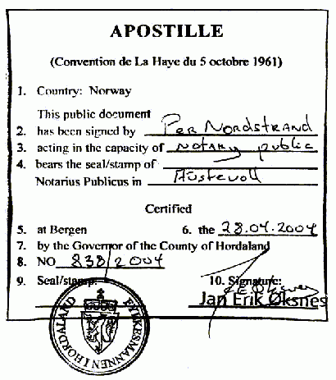
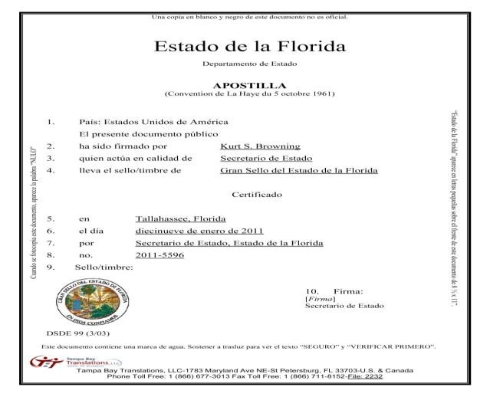
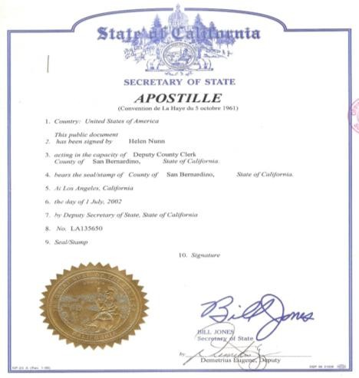

Albania | Dominica | Liechtenstein | Saint Kitts and Nevis
American Samoa | Dominican Republic | Lithuania | Saint Lucia
Andorra | Ecuador | Luxembourg | Saint Vincent and the Grenadines
Antigua and Barbuda | Estonia | Macedonia | Saint-Pierre and Miquelon
Argentina | Falkland Islands (Islas Malvinas) | Malawi | Salvador
Armenia | Fiji | Malta | Samoa
Aruba | Finland | Marshall Islands | San marino
Australia | France | Mauritius | Sao Tome and Principe
Austria | French Guiana | Mayotte | Serbia
Azerbaijan | French Polynesia | Mexico | Seychelles
Bahamas | Georgia | Moldova | Slovakia
Barbados | Germany | Monaco | Slovenia
Belarus | Gibraltar | Mongolia | South Africa
Belgium | Greece | Montenegro | Spain
Belize | Grenada | Namibia | Suriname
Bermuda | Guadeloupe | Netherlands | Swaziland
Bosnia and Herzegovina | Guam | Netherlands Antilles | Sweden
Botswana | Honduras | New Caledonia | Switzerland
British Virgin Islands | Hungary | New Zealand | The Republic of Korea
Brunei | Iceland | Niue | Tonga
Bulgaria | India | Northern Mariana Islands | Trinidad and Tobago
Cape Verde | Ireland | Norway | Turkey
Cayman islands | Isle Of Man | Oman | Turks and Caicos Islands
China | Israel | Panama | Ukraine
Colombia | Italy | Peru | United Kingdom
Colombia | Japan | Poland | US Virgin Islands
Costa Rica | Jersey | Portugal | USA
Croatia | Kazakhstan | Puerto Rico | Uzbekistan
Cyprus | Kyrgyzstan | Reunion | Vanuatu
Czech Republic | Latvia | Romania | Venezuela
Denmark | Lesotho | Russia | Wallis and Futuna
 | Liberia | Saint Helena Island

Consular legalization

Each country has its own laws and procedures. Therefore, you have to present yourself with your documents at the Russian Embassy or Consulate and ask the officials what and in what order you need to do.
Perhaps you need to notarize your documents in several organizations. But it is only the final stamp that's important for us. The legalization stamp is made at the end of the procedure.
What does the consular legalization stamp looks like?

We need here such stamp. It may be on the original document or translated or copy - it does not matter.

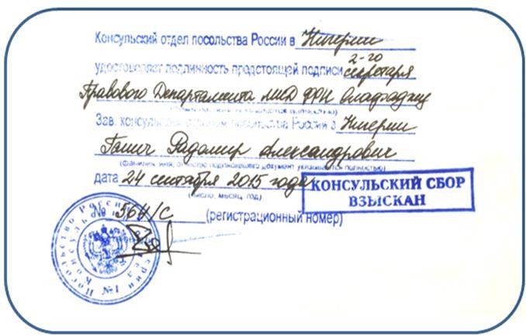

NB: Please note that this information is purely introductory. You need to contact the Consulate or Embassy of Russian Federation in your country and learn how to certify documents. Follow the instructions offered by Embassy or Consulate officials.
Legalization has to be done TWICE:

- Legalization of the documents obtained in your country to study in Russia

- Legalization of Russian diploma, so that it is valid in your country

Remember: You will also need a notarized translation of your document in the language of the country you are traveling to. In this case it is Russia.

Visa: how to get a Russian Student's visa step by step

- You make an advance payment to the ETU

- The ETU issues an Invitation

- You get a visa based on the ETU Invitation you have received

- You arrive to Russia

- You extend your visa at the ETU University

Your visa is issued at the Russian Consulate or Embassy based on the Invitation you receive. A Russian visa issued for the first time is always a single-entry visa valid for 90 days. This visa allows you to enter and leave Russia only once.
It is important that you give notice of your arrival a week in advance. The ETU informs the dormitory of your arrival. We can organize a paid transfer to collect you from the airport. We will also be happy to provide you with instructions on how to get to the city by public transport or taxi.

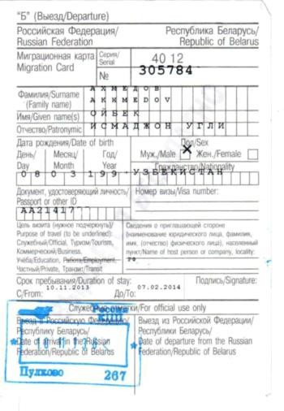
If the period of your study at the ETU lasts more than 3 months, you have to apply for a visa extension at the University. You can extend your visa upon making an advance payment for further study at the ETU. After this procedure you will get a multi visa. A fee is charged for the extension.

Migration Card

When you cross the Russian border you will receive a migration card. It is essential that you retain this card until your departure from Russia.

Registration of the foreign citizen

Upon your arrival to St. Petersburg, you must be registered in The Ministry of Internal Affairs of Russia (Federal Migration Service) (= FMS) as a foreign citizen in the Russian Federation. It is necessary to come to the University for the
registration of all documents at the very same day. If you arrive in the evening or at the weekend - on the first working day we are waiting for you at the University. The documents for the registration must be presented to the International Students Office (r. 3418 or 3423-1, 11:00 – 16:00).

The following documents are required for the registration at FMS:

- Passport: original and 2 copies: one copy of the passport - a copy of all pages, where exist any data (something is written, there is a visa or any stamp). A second copy - a copy of ALL pages, even empty. Make them 2 pages on one sheet on both sides. So get 4 pages onto a single sheet.
- Migration card: original and copy

- Visa: original and copy (if applicable)

- Ticket

- Copy of study agreement or other confirmation of enrollment.

If you arrive on Saturday, Sunday or during public holidays, the documents should be presented on the first working day.

Prolongation of registration

While studying you need to take care about prolongation of your registration in Federal Migration Service. It must be prolonged no less than 45 days before its termination. The academic progress and duly paid tuition fees are required from the student wishing to prolong his/her registration term.
- Print out the statement for registration prolongation and fill it in: (http://www.eltech.ru/assets/files/en/STATEMENT.docx);
- Gather the necessary signatures;

- Take all documents needed: passport (original and copy), migration card (original and 2 copies), copy of the referral of Ministry of Education or study contract, insurance certificate.
- Receipt for payment of fee.

- Bring the statement with the full set of documents to the International Students Office (r. 3418),

- Provide all documents in the Visa and Registration Department (r. 3423-1).

Please, make sure you bring all the documents in due time – the violation of deadlines can lead to deportation.
NB: Each NEW ENTRY to the Russian Federation should be accompanied by the NEW registration in Federal Migration Service.
NB: The current registration is ANNULED in the event of any change of accommodation in the Russian Federation (different dormitory, hotel change, stay in a hospital).

Before your departure from St. Petersburg (temporary departure)

All the foreign students must report to the International Students Office if they wish to leave St. Petersburg for any amount of time or purpose. Also, please make all the necessary arrangements before you set out:
- Print out the statement for departure for holidays: (http://www.eltech.ru/assets/files/en/STATEMENT_2.docx);

- Get the document signed by the appropriate institutions;

- Bring the statement to the International Students Office (r. 3418 or 3423-1) – no later than 14 working days before the departure!
Foreign students with visa-free entry who are studying on a non-paid basis should report to the International Students Office (r. 3418 or 3423-1) about his/her wish to depart for a certain time and to acquire the original of his/her Federal Migration Service registration (r. 3423-1).
If you wish to travel inside the Russian Federation, please consult the International Students Office (r. 3418 or 3423-1).

Upon graduation

Foreign students should:

- Acquire the check list in the International Students Office (off. 3418)

- Have the check list signed by all the appropriate departments;

- Leave Russia before the termination of your visa (for visa entry) / leave the Russia before the termination of your FMS registration (for visa-free entry)
Students who have terminated their studies or have been expelled

Nationals of visa-entry countries must acquire a transit visa. Nationals of visa-free entry countries must leave Russia within 3 days after expulsion.
More details about visa and registration see http://www.eltech.ru/en/study/dean-s-office/visa-insurance-registration

Student Accommodation

While studying at "LETI" all international students can get a place in one of seven University dormitories (usually foreign students are provided with
Before arrival you must inform the International Students Office or the Preparatory Department for International Students exact date and time of your arrival and get exact instructions on how and where you will be welcomed. Or how do you get by yourself to the dormitory. At the dormitory you will receive a temporary pass and a room. You have to go to the University to International Students Office as soon as possible: if you come in the morning - during the current working day, and if in the evening or at the weekend - the morning of the next working day. There you will be told what to do next. You will need to prepare all the necessary documents for the tuition, registration, accommodation and so on. All the documents you need to have with you (see next page).
dormitories 7 and 8).

Students who live in dormitories are registered at the address of the dormitory. Registration is obligatory for international students according to the law of the Russian Federation. For the dormitory you should pay about 1500 rubles per month.
Our dormitories are very reasonable priced, safe with fitted kitchen, showers, sport rooms, gyms and elevators in every hall of residence. Security guards are on the premises 24 hours and are in charge of keeping order. Every resident has a pass to get inside the building.
Only students can live in dormitories. Places for their friends and families are not provided.
International students are entitled to live outside of a dormitory. In this case they will be registered at the legal address of ETU «LETI».

Medical insurance

All foreign students, studying at ETU «LETI» must have a medical insurance certificate valid for Saint- Petersburg.
A medical insurance can be acquired upon arrival in the International Students Office (r. 3418 or 3423-1), or in any insurance company. The medical insurance should be valid until the date of the termination of registration in Russian Federation.

If you decide to acquire the insurance certificate at ETU «LETI», the staff or International Students Office will help you with the necessary arrangements. If the insurance is acquired in the other insurance company, the student should make all the necessary arrangements by him/herself.
NB. If you participate in any competitions or go in for sports on your own, keep in mind that this requires special insurance. Normal insurance does not cover cases with sports (if it is not mandatory classes at the university), chronic diseases, and more. Do not forget to read carefully the conditions for providing medical assistance for the insurance.

Welcome to ETU

Fereign students arrive at the ETU for studying not earlier than a week before beginning of the
course:
Please kindly inform us in advance about the date and time of you arrival by phone
+7 (812) 234-35-53 or via e-mail: 2343553@mail.ru
Make sure you specify the number of the dormitory where you will stay.

- Bachelor, Master, Phd students and Specialists start studying on the 1st of September.
- Studies on the Foundation Course start on the 1st of October.
- Trainees: the date is specified in the contract.

How to get from the airport to the dormitory or ETU «LETI»

After landing in Pulkovo Airport you will go through passport control and receive a migration card after which you will collect your luggage. Inside the airport building you can change money in the exchange office (it is sufficient to exchange 50-100 USD for your immediate expanses) or to get rubles in cash in ATM (2000-4000 rubles).
- You can take a taxi at the counter directly in the airport– the price is about 1000-2000 rubles. Ordering a taxi through the Internet reduces the price at least twice. Or you can use one of the following apps Yandex.Taxi, Get.Taxi or Uber to take a taxi. Addresses of the dormitories see below.
- You can also use public transport:

The plan of the airport premises can be found here: http://www.pulkovoairport.ru/en/map/

- In front of the exit from the airport you can take bus No. 39 (40 rubles) or minibus № K-39 (45 rubles) and go to the "Moskovskaya" metro station (about 20-25 minutes). Payment is made inside the bus.
- In the subway to the right from the entrance you should buy a ticket (a metal token) (for more details see chapter Metro on p. 9) and go directly from the metro station "Moskovskaya" to station "Pionerskaya"

(dormitory No. 7) or station "Chernaya Rechka" (dormitory No. 8) or station "Petrogradskaya" (the University).
ETU. Professora Popova st., 5. Metro “Petrogradskaya” (Петроградская) Dormitory № 7. Ispitateley prospect, 10. Metro “Pionerskaya” (Пионерская).
Dormitory № 8. Address: Torzhkovskaya st., 15. Metro “Chernaya rechka” (Черная речка)

Maps of how to reach Dormitories and ETU you can find at the end of this booklet, p.34, pic.2, p.35, pics.3-4.

STUDENT LIFE

Canteens

You will find several canteens in building 5 that offer a set lunch (soup, main dish, drink and bread) at a very reasonable price (150 or 200 rubles). The canteen provides a varied menu and good quality food. There is also a coffee shop and a few stands selling snacks. There are canteens in 1st and 3rd building also.

Leisure

Student life is not only about lectures, seminars, exams and marks. Students' leisure is full of diverse and interesting activities. In ETU there is a Cultural Center (CC) where everyone can find something to their taste. There are dancing classes, the famous LETI choir and a drama school. Members of ETU CC participate in awarding ceremonies, choir concerts, festival "Step to the Stage", etc. The most successful ones represent University at different festivals and competitions.
Major sporting activities include annual competitions, performances and championships. At our university Physical education is an obligatory subject during the first two years of studying at LETI and students can choose kind of sport activity. There is an opportunity to do some sports professionally.
In accordance with this approach, Department of Physical Education and Sports offers the following sports: aerobics, football, basketball, volleyball, rock climbing, power lifting and arm sport, boxing, chess and checkers, tennis, table tennis, swimming and darts.
For details see http://www.eltech.ru/en/student-life

Self-administration

Several thousand students from Russia, CIS and other countries study in our university. In addition to academia and research they are united by what is called social life. This is the free, creative, constructive activity of many student groups, united by common goals and interests.
Working together in the volunteer center of the university, training and competition of sports teams, rehearsal of students’ theater group, musicians, singers and dancers, creative work in the literary association, and photo workshop, intellectual game club and student performances - all this makes student days the most unforgettable and exciting stage of life.

Working in the trade union committee and the student council teaches teamwork and helps develop leadership qualities, makes it possible to formulate for yourself and most importantly to defend, if necessary, your civil position. Public life helps you to feel your strength and capabilities, assess the support of friends.
Participation in student's social life is a start for your professional career and an important step towards the formation of a new citizen of your country!
Student Council is a body of student self-governance in the field of educational activities of the University. The purpose of the Student Council is to promote the quality improvement of the educational process and support student initiatives in the field of training and educational process in the ETU.
Each dormitory has a Student Dorm-council - activity is directed on the realization of the student self-government. Main purpose: to create more comfortable living conditions in our dorms, if necessary, to stand up for students and diversify its leisure. Student Dorm-council discusses and approves at the meetings planned activities, current issues, hears reports floors’ monitors, noting positive and negative aspects of their work, take the appropriate decision. Student Dorm-council represents the interests of students living in dormitories and protects their rights; organize public life, in particular engaged in organizing social events (competition for the best floor and the room, culinary competition, neighborhood clean-up). Also, an important aspect of the work is improving the life and leisure of students. Student Dorm-council organizes annual competitions among teams of hostels in 10 sports (volleyball, basketball, arm wrestling, weightlifting, swimming, darts, chess, football, cheerleading, and table tennis). The winners receive awards and prizes.
The university has a system of Curatorship. Curator becomes the senior students, who is a good student and has an active life position. It helps freshmen to adapt - it is possible to ask a question and get help. Any newcomer always has a lot of questions - from how pay for the dormitory, to banal where is better and cheaper food. And curators will help you.
And last in the list, but not least. The university has also actively working Trade Union of students and graduate students. You can join it (an entrance fee is paid once in semester at a rate of 280 rubles) and then use a long list of all the benefits provided by the union. For example:
- organizes discos, festivals and other public events;
- helps students to solve specific issues of both temporary and permanent employment;
- organizes and conducts sports activities at the university;
- organizes excursions at a reduced price;
- provides benefits and discounts in theaters and clubs of St. Petersburg;
- provides legal advice for union members;

Library
Enrollment in library

For receiving a library pass you should go in the reading room № 1 (1201), the left door next to the office-museum of Professor Popov.
You should have a student card with you. They will make your photo for the library card.
Working hours: Tuesday and Thursday from 13:00 to 18:30, break from 15:00 to 16:30.
You can receive a library card in the reading room № 1 the next day after photographing.

ETU library was founded in 1886 with the foundation of Institute. A big part of the library collection was Emperor Alexander´s III gift.

Today the ETU library consists of 8 units, 5 reading halls and 5 loan departments. The library collection contains 1 200 000 volumes. Every year's acquisition amounts to 30 000 items. The library holds publications in different fields: technical science, social science, economics, management etc.

Some publications are available on-line, for instance, the full collection "Computer science". Users of the library use electronic information sources to a great extent. Students can have access to full database using computers in Reading Halls.

Successful work of ETU library is defined by its participation in national and international programs and projects devoted to the development of libraries.
Working hours: 10.00-19.00, from Monday till Friday. Additional services at the library valid only with library card:
- Photocopying only publications – 5 rubles (1 page A4).

- Printing – 5 rubles (1 page A4). Only files in .doc, .xls, .docx, .xlsx. and files from program MathCAD. You have to pay for library service using Bank terminal in 3rd bulding
Find more details on the official website of ETU library - http://library.eltech.ru/

Needful University phone numbers

Vice-Rector for International Affairs Viktor Anatolievich Tupik, D.Sc., Professor Assistant: Nina Yurievna Pisarenko | Office 3203 | +7 (812) 346-28-53  VATupik@etu.ru
International Students Office  Head: Renat Amirullovich Yalyshev, Ph.D. Deputy Head: Irina Alekseevna Shahkova Staff: Maria Semenyuk  Maria Kovaleva | Office 3418  Office 3419 | +7 (812) 234-35-53  +7 (812) 347-53-30  renyal@mail.ru 2343553@mail.ru
Preparatory Department for International Students  Head: Sandra Kilina  Staff: Vera Mikhailovna Gutveyb Marianna Kozlova | Office 3419 | +7 (812) 234-35-53  +7 (812) 347-53-30  kilinaetu@gmail.com 2343553@mail.ru https://vk.com/poi_leti
Department of Visa and Registration Tatiana Anatolievna Kosareva Maria Shevelko  Galina Alekseevna Zavorotko | Office 3423-1 | +7 (812) 234-35-53  +7 (812) 347-53-30  2343553@mail.ru
Dormitory for International Students № 7  Head: Nina Alekseevna Sinitckaya | Dorm. № 7 1-st floor | +7 (812) 393-93-56  sininina@yandex.ru
Dormitory for International Students № 8  Head: Elena Vasilievna Pimenova | Dorm. № 8 1-st floor | +7 (812) 492-05-30

Contact information

Saint Petersburg Electrotechnical University “LETI” International Students Department and Preparatory Department.
Address: office 3418-3419, Professor Popov St., 5, 197376, St. Petersburg, Russian Federation ETU “LETI”: http://www.eltech.ru/en/university

BASIC RULES OF STAY OF FOREIGN CITIZENS IN RUSSIAN FEDERATION
- When crossing the border of the Russian Federation every foreign citizen (except citizens of the Republic of Belarus) must fill in the MIGRATION CARD and have it with you during your stay in Russia.

- A foreign citizen who has arrived to study at the ETU, shall, within the FIRST DAY after arrival in St. Petersburg provide to the office 3423-1 copies of your passport, migration card and visa (if any) for making a migration registration in the FMS for a period of 90 days (for the visa waiver) or on the validity of the visa, get a coupon on migration registration. For the migration registration you should make a medical insurance at the office 3423-1 or to provide an existing insurance policy, valid on the territory of the Russian Federation.

- Senior students who arrived after the holidays on visa-free entry may receive the migration registration for up to 1 year, depending on the progress of study and tuition fee. You must provide copies of your passport, migration card, the contract for studding to the office 3423-1 during the FIRST DAY after arrival in St. Petersburg. For the migration registration you should make a medical insurance at the office 3423-1 or to provide an existing medical insurance, valid on the territory of the Russian Federation not less than a year.

- In case of temporary change of the place of stay in the Russian Federation (stay in hospital, hotel) it is necessary to provide documents to the office 3423-1 for the resumption of the migration registration in the FIRST DAY of your return to the former place of residence.

- The foreign citizen must extend period of stay in the Russian Federation as a student in the ETU not later than 45 days before its termination. Prolongation is carried by taking into account the academic progress and tuition fees for a period no more than the period of insurance validity.

- Before departure from the Russian Federation a foreign citizen, who is studying in the ETU, must address to the office 3423-1 NO LATER than 3 working days before the departure date. After return to the Russian Federation the foreign citizen is obliged within the FIRST DAY from the date of arrival in St. Petersburg to provide in an office 3423-1 documents according to point 2 or point 3 for implementation of new statement on migration registration.

- The foreign citizen, who is studying in the ETU has a right to live in university dormitories or private address.

- The foreign citizen with expiring passport is required to renew or replace a passport no later than 45 days before the expiration of the period of stay in the Russian Federation. New passport must be submitted to the office 3423-1 within two days from the date of receipt of the passport in the territory of the Russian Federation.

- In case of loss of national passport, migration card the foreign citizen is obliged to file a petition in competent authorities. Certificate confirming acceptance of the application of the loss of the passport, the migration card must be provided within one day in the office 3423-1. New passport or other identity document, a new migration card must be submitted to the office 3423-1 within one day from the date of their receipt on the territory of the Russian Federation.

- In case of expulsion in connection with the training termination the period of temporary stay of the foreign citizen in the Russian Federation is reduced. A foreign citizen is obliged to leave the Russian Federation within three days from the date of expulsion. Foreign citizen who has an entry visa must obtain a transit visa.

- For infringement of rules of stay of foreign citizens in accordance with the legislation of the Russian Federation on presentation of the Federal Migration Service in St. Petersburg and the Leningrad region, and by the court are provided a penalty of up to 7 (seven) thousand rubles and DEPORTATION from the territory of the Russian Federation without the right to return within 5 years.

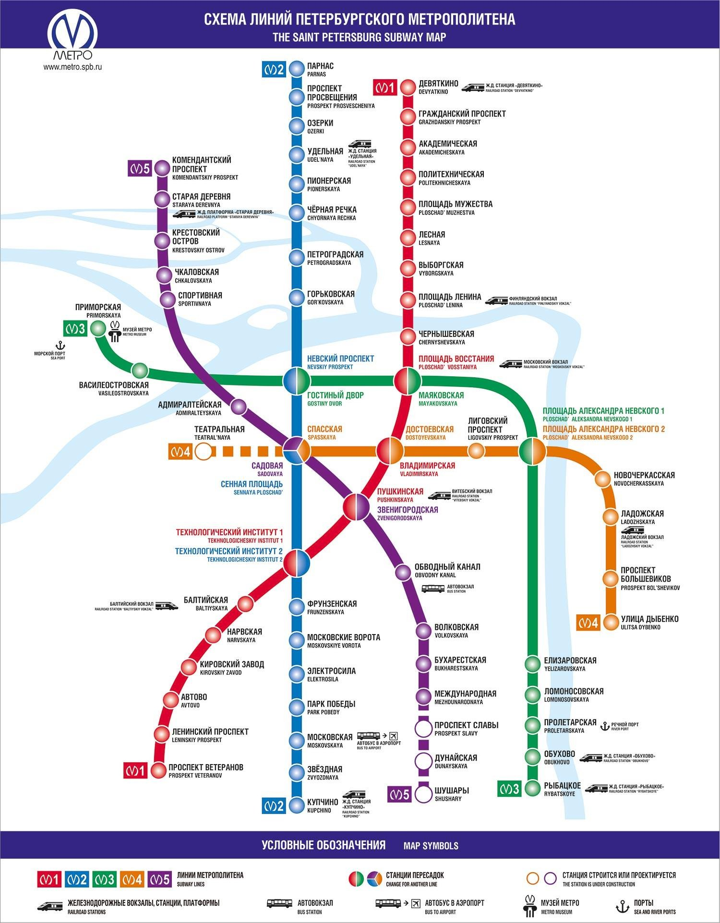

Pic. 1. Scheme of Saint Petersburg metro

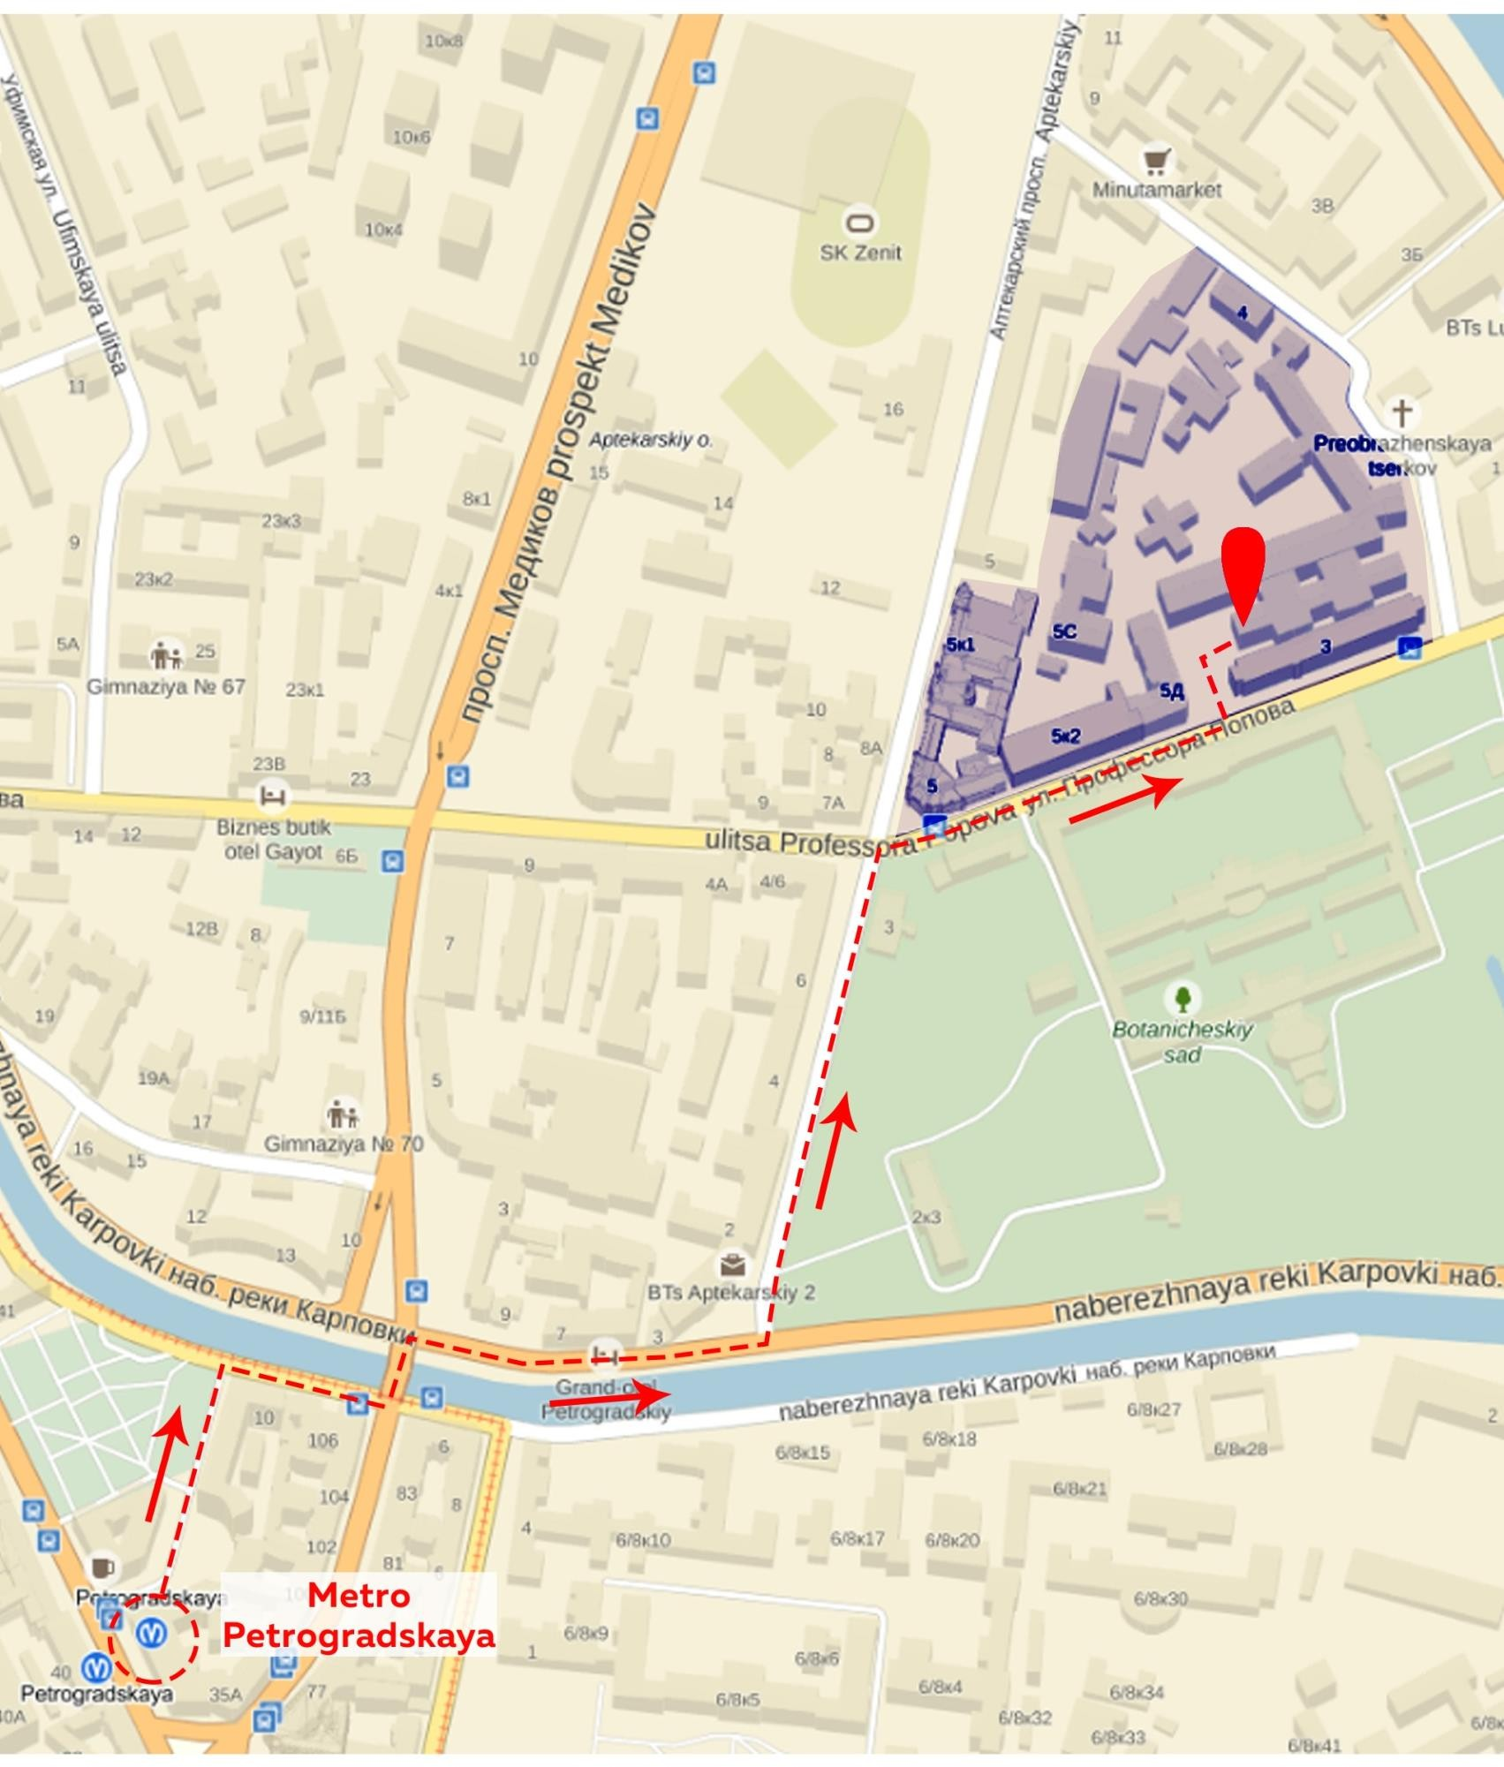
Pic. 2. ETU “LETI”. Professora Popova st., 5. Metro “Petrogradskaya” (Петроградская)

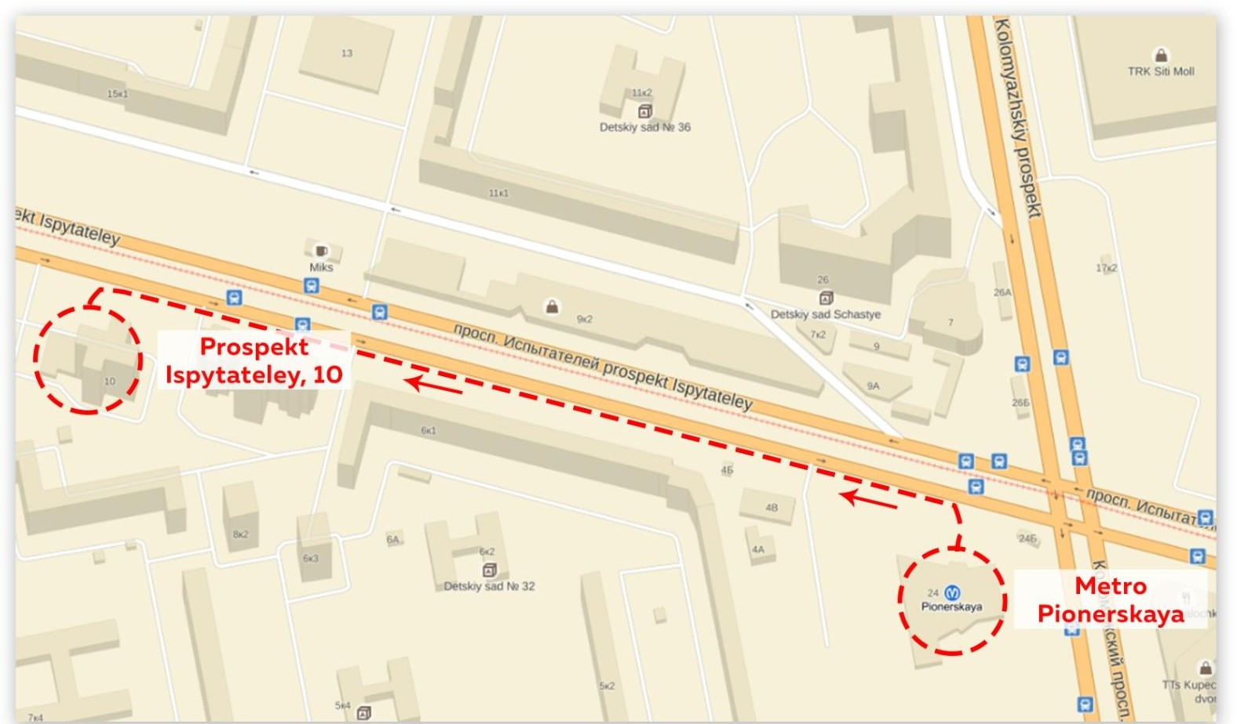
Pic. 3. Dormitory № 7. Ispitateley Prospect, 10. Metro “Pionerskaya” (Пионерская).
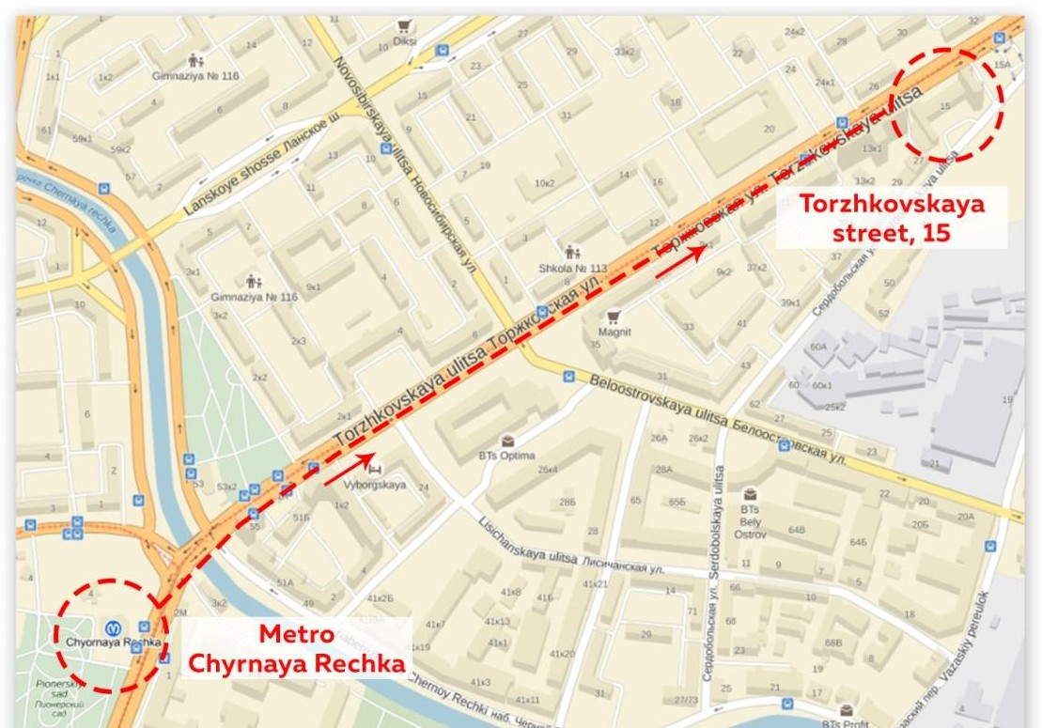

Pic. 4. Dormitory № 8. Address: Torzhkovskaya St., 15. Metro “Chernaya rechka” (Черная речка)

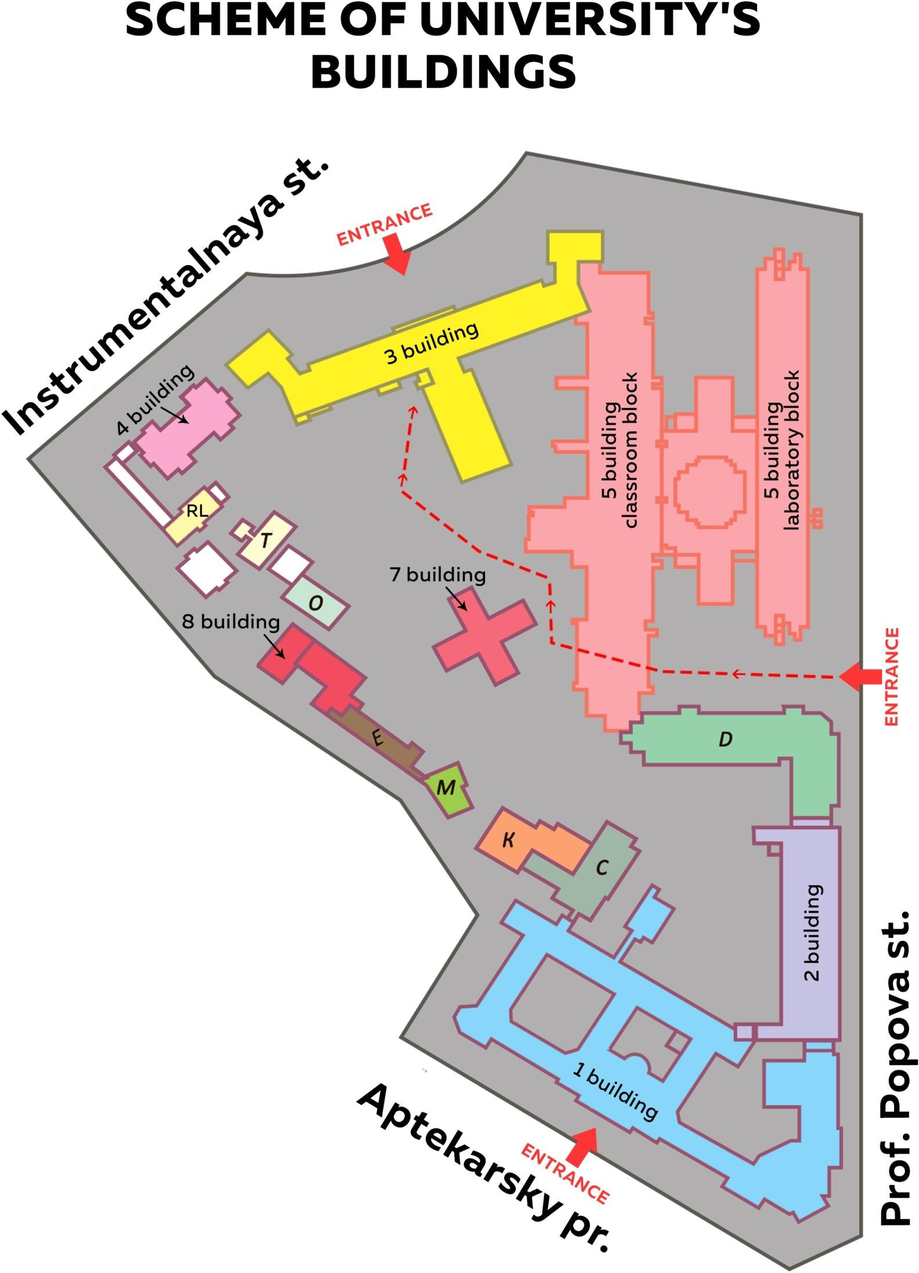

Pic. 5. Campus’ scheme

How to navigate
Numbers of classrooms and offices in academic buildings are formed as follows: the first figure - the number of the building, the second figure - the floor number, the third figure - the actual number of room itself. For example: room 3419, where 3 means the number of building, 4 – the floor, and 19 – is the room number.
NB: Please remember that in Russia, the first floor is always at ground level

1st building
1st floor
Library (Department of Bibliography, r. 1113)
Dean’s Office of the Faculty of Electrical Engineering and Automatics (r. 1162), at the entrance from Aptekarsky prospect)
Buffet (at the entrance from Aptekarsky Prospect) Rooms 1142, 1143, 1158

2nd floor
Library:
- Director's Office (r. 1251)
- Department of Educational Literature (r. 1248)
- Reading Room of Scientific Literature (r. 1249)
- Department of ETU Publications (r. 1239)
- Department of Scientific Literature (r. 1250)
- Reading Room of Open Access (r. 1201) Museum of A.S. Popov (r. 1252)
Rooms 1229-1233, 1244-1246

1st floor
Rooms 2106, 2114

2nd floor
Men’s and women’s toilets on 1st and 2nd floor

2nd building

Dean’s Office of the Faculty of Radio Engineering and Telecommunications (r. 2201) Dean’s Office of the Faculty of Computing Technologies and Informatics (r. 2224)

3rd floor
Rooms 2317, 2318, 2322, 2323, 2337

4th floor
Rooms 2401-2404, 2411-2420

1st floor

3rd building

Men’s and women’s toilets on 4th floor

Department of Physics (r. 3111) and laboratories Rooms 3107, 3132
Computer class of open access (r. 3138) Law Department (r. 3133)
Buffet
Between the first and second floors Cash desk
Accounting Department Accountant on Scholarships Contract Training Department
Passage in the Center of Cultural and Educational Work

2nd floor
Administration
Department of Educational Programs Department of Education Organization (r. 3248) Department of International Relations (r. 3243)
Department of International Academic Mobility (r. 3245) Dispatching (r. 3235)
Department of Mathematics №1 (r. 3239)
Museum of ETU (the passage through the corridor of administration) Room 3238
Between the first and second floors Assembly Hall

3rd floor
Trade Union Committee of students and graduate students (r. 3304) Department of Foreign Languages (r. 3319)

Department of Mathematics №2 (r. 3312) Rooms 3301, 3302, 3308, 3311, 3313, 3324

4th floor
Department of Mathematical Support and Computers’ Use (r. 3401-3414) International Students Office (r. 3418)
- Visa and Registration Department (r. 3423-1)
- Service for recruitment and support of international students under Russian programs (r. 3418)
- Service for recruitment and support of international students under English programs (r. 3418) Department of Educational and Social Work (r. 3430)
Department of Social Work (r. 3429) Rooms 3417, 3421, 3422, 3425-3428

2nd floor
Rooms 4201-4203, 4209-4211

3rd floor
Students’ Chancellery
Rooms 4301-4303, 4308-4310

4th floor
Rooms 4401-4403, 4405, 4408, 4409

1st floor
Room 5143

2nd floor

4th building

5th building
Men's toilets on 3rd and 4th floors Women’s toilets on 1st and 3rd floors

Men's toilet on 4th floor Women’s toilet on 2nd floor

Dean’s Office of Faculty of Economics and Management (r. 5228) Shop (books, stationery, photocopying)
The passage in the block of canteens Rooms 5205, 5219, 5221, 5226, 5230, 5322
Department of Innovation Management (r. 5302-5307) Department of Applied Economics (r. 5203)

Note: the entrance to the rooms 5322, 5302-5307 is in the second floor

3rd floor
Dean’s Office of Faculty of Humanities 5328 Department of Cultural History, State and Law of 5325 Department of Philosophy 5329, 5330
Room 5333

4th floor
Rooms 5405, 5412, 5416, 5419, 5423, 5427

5th floor
Library (socio-economic literature with a reading room of open access) (r. 5512)
Men's toilet on 2nd floor Women’s toilets on 2nd and 4th floors

5th building, laboratory block
1st floor
Room 5183

3rd floor
Dean’s Office of Faculty of Electronics (r. 5373)
Dean’s Office of Faculty of Information, Measurement and Biotechnical Systems (r. 5364) Display class of Faculty of Electronics
Department of Applied Mechanics and Engineering Graphics (r. 5370) Room 5360

5th floor
Department of Physical Chemistry (r. 5559)
Men's toilets on the 1st and 6th floors Women's toilets on all floors

7th building
2nd floor
Library (Department of Fiction) (r. 7201)
Housing and Exploitation Department (r. 7207)

RL
Department of Russian Language

