Loan Approval Prediction
Data Analytics & Machine Learning Project Report
Dataset: loan_approval_dataset.csv | Records: 4,269 | Best Model: Random Forest (98.24% Accuracy)
September 2026

Table of Contents
1. Problem Statement
2. Dataset Overview
3. Data Cleaning & Preprocessing
4. Exploratory Data Analysis (EDA) — with Charts
5. Machine Learning Models — with Charts
6. Feature Importance — with Chart
7. Business Decisions
8. Conclusion & Recommendations

1. Problem Statement
Financial institutions process thousands of loan applications each year. Deciding which applicants to approve or reject is critical and high-stakes. Manual review is slow, expensive, and inconsistent due to human bias. A data-driven automated system enables banks to make faster, fairer, and more accurate decisions — reducing the risk of bad loans while minimising unnecessary rejections.

Objectives
- Analyze the key factors that influence loan approval decisions using real applicant data.
- Build and compare multiple machine learning classification models for predicting loan outcomes.
- Identify the most important features driving approval or rejection.
- Provide actionable, data-backed business recommendations to the lending institution.
- Deploy an interactive prediction interface using Streamlit for real-time use by loan officers.

2. Dataset Overview
The dataset loan_approval_dataset.csv contains 4,269 loan application records with 13 columns covering applicant demographics, financial details, asset information, credit score, and the final loan status. The dataset has no missing values and no duplicate rows.

Dataset Summary
Metric | Value | Notes
Total Records | 4,269 | Loan applications
Approved | 2,656 (62.2%) | Positive class
Rejected | 1,613 (37.8%) | Negative class
Feature Variables | 11 | After removing loan_id

Column Descriptions
Column Name | Data Type | Description
loan_id | Integer | Unique identifier — excluded from modeling
no_of_dependents | Integer | Number of financial dependents (0 to 5)
education | Categorical | Graduate or Not Graduate
self_employed | Categorical | Whether the applicant is self-employed (Yes/No)
income_annum | Integer | Annual income in Indian Rupees
loan_amount | Integer | Requested loan amount in Indian Rupees
loan_term | Integer | Loan repayment term in years (2–20, even values)
cibil_score | Integer | Credit bureau score (300–900)
residential_assets_value | Integer | Value of residential property owned
commercial_assets_value | Integer | Value of commercial property owned
luxury_assets_value | Integer | Value of luxury assets owned
bank_asset_value | Integer | Value of bank savings and deposits
loan_status | Categorical | TARGET — Approved or Rejected

3. Data Cleaning & Preprocessing
The following 7 steps were applied before analysis and model training:
Step 1 — Column & String Stripping: All column names and string values were stripped of leading/trailing whitespace (e.g. ' Graduate' → 'Graduate').
Step 2 — Missing Values: No missing values found across all 4,269 rows and 13 columns (0 nulls).
Step 3 — Duplicates: No duplicate rows found in the dataset.
Step 4 — Feature Removal: loan_id was dropped from features — it is a unique row identifier with no predictive value.
Step 5 — Label Encoding: education (Graduate=0, Not Graduate=1), self_employed (No=0, Yes=1), loan_status (Approved=0, Rejected=1).
Step 6 — Stratified Train/Test Split: 80% training (3,415 records) and 20% testing (854 records), random_state=42. Class proportions preserved in both sets.
Step 7 — Feature Scaling: StandardScaler applied only to Logistic Regression (sensitive to scale). Decision Tree, Random Forest, and XGBoost received raw values.

4. Exploratory Data Analysis (EDA)

4.1 Overall Approval and Rejection Rates
Out of 4,269 total applications, 2,656 were approved (62.2%) and 1,613 were rejected (37.8%). The dataset is moderately imbalanced — approvals outnumber rejections by approximately 1.65 to 1. This class distribution was preserved in both training and test sets via stratified splitting.
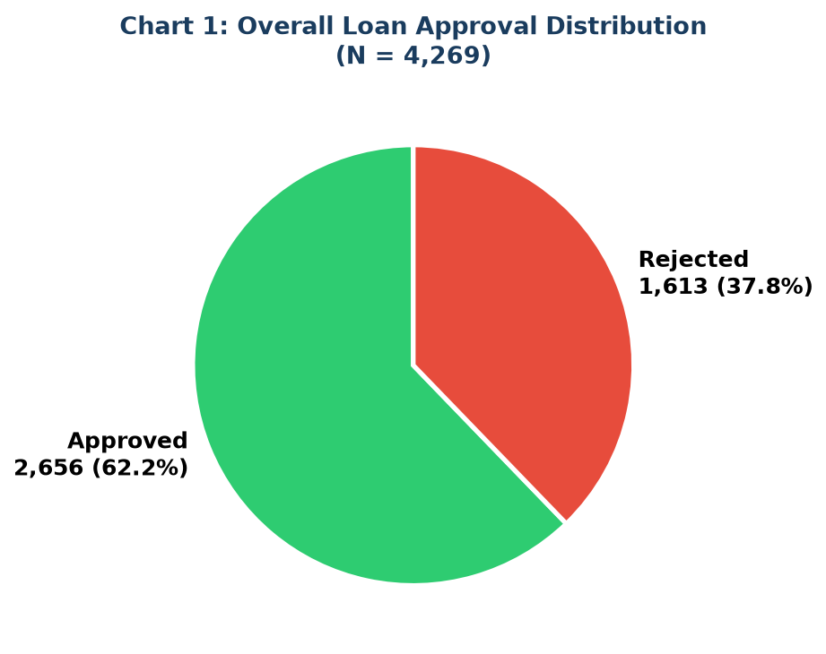
Chart 1: Overall Loan Approval Distribution (N = 4,269)
Key Finding: 62.2% of applicants were approved. The approval-to-rejection ratio is 1.65:1.

4.2 CIBIL Score Analysis
CIBIL score (India's credit bureau score, range 300–900) is the single most powerful predictor in this dataset. The distributions differ dramatically between approved and rejected applicants:
Loan Status | Mean CIBIL Score | Observation
Approved | 703.5 | Consistently in high-credit range (600–900)
Rejected | 429.5 | Consistently in poor-credit range (300–500)

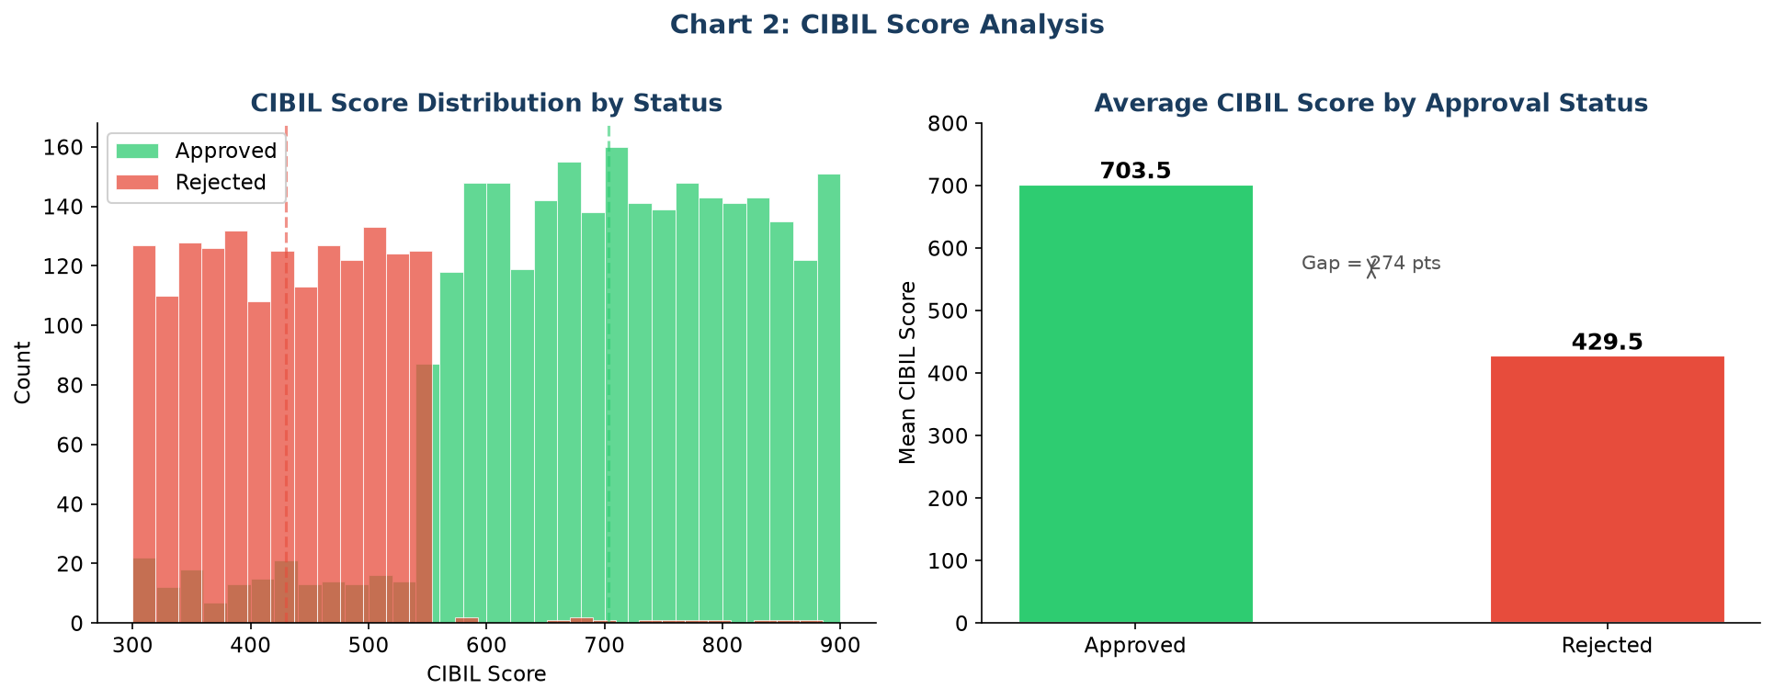
Chart 2: CIBIL Score Distribution (left) and Mean by Loan Status (right)
Key Finding: Approved applicants average CIBIL 703.5 vs Rejected 429.5 — a gap of 274 points. CIBIL accounts for 80.16% of Random Forest's predictive power.

4.3 Annual Income Analysis
Annual income shows a very marginal difference between approved and rejected applicants. Approved applicants average Rs.5.03M per year vs Rs.5.11M for rejected — almost identical. Income alone does not determine approval; CIBIL and financial structure matter more.
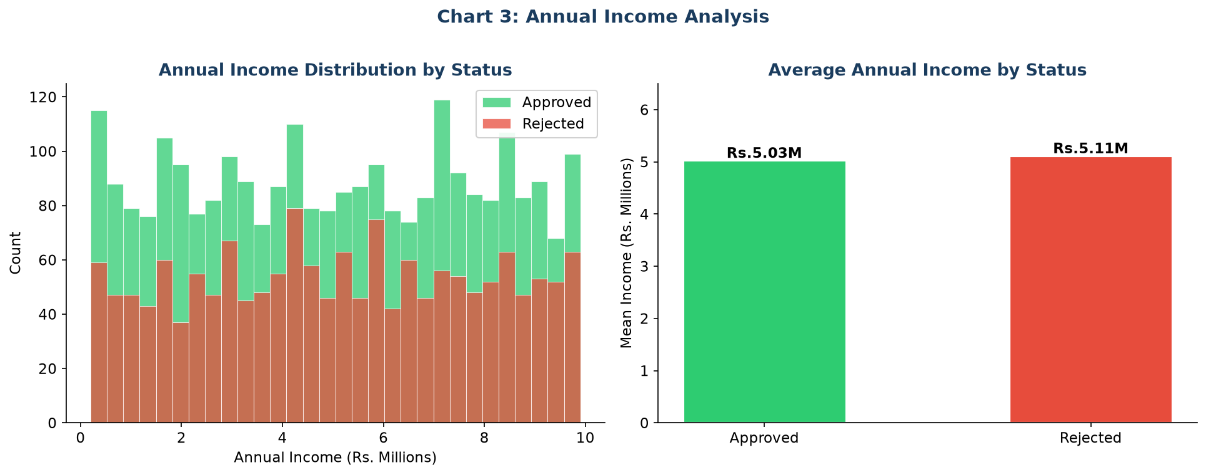
Chart 3: Annual Income Distribution (left) and Mean by Loan Status (right)
Key Finding: Income difference between approved and rejected is negligible (Rs.5.03M vs Rs.5.11M). Income is the 4th most important feature at 2.0% importance.

4.4 Education and Employment Analysis
Both education and employment type show virtually no difference in approval rates across groups. This is a key finding — these demographic factors have almost no direct influence on loan approval.
Feature | Category | Approval Rate
Education | Graduate | 62.5%
Education | Not Graduate | 62.0%
Employment | Salaried (Not Self-Emp.) | 62.2%
Employment | Self-Employed | 62.2%

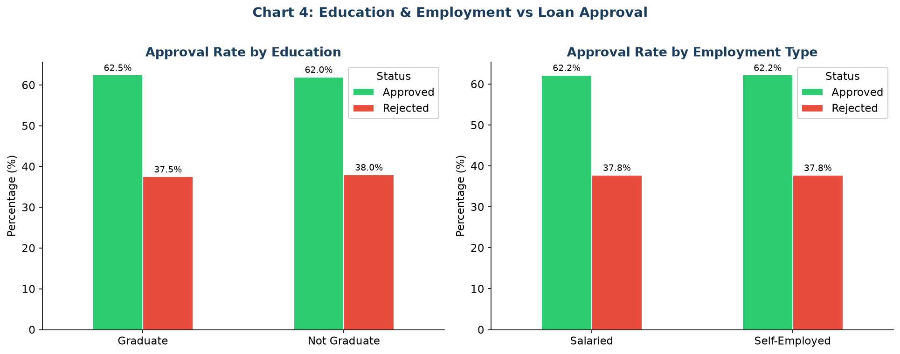
Chart 4: Approval Rates by Education (left) and Employment Type (right)
Key Finding: Education and employment type have near-zero impact on approval (feature importance <0.3% each). Using these as criteria would constitute discriminatory lending with no predictive benefit.

4.5 Number of Dependents Analysis
Applicants with zero dependents have the highest approval rate (64.2%), while those with 5 dependents have the lowest (60.3%). The spread is only 3.9 percentage points — a mild effect.
Number of Dependents | Approval Rate
0 | 64.2%
1 | 61.7%
2 | 62.3%
3 | 62.9%
4 | 61.8%
5 | 60.3%
Overall | 62.2%

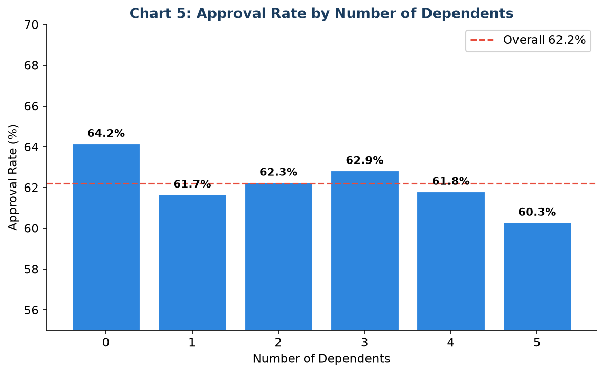
Chart 5: Approval Rate by Number of Dependents (red dashed = overall rate 62.2%)
Key Finding: Dependents have a mild negative effect. Feature importance: 0.84% — notable but not dominant.

4.6 Asset Value Analysis
Asset values show almost no difference between approved and rejected applicants. Rejected applicants even show marginally higher average residential, luxury, and bank assets. This confirms that raw asset values are not primary drivers — CIBIL dominates.
Asset Type | Approved Mean (Rs.M) | Rejected Mean (Rs.M)
Residential Assets | 7.40 | 7.59
Commercial Assets | 5.00 | 4.93
Luxury Assets | 15.02 | 15.31
Bank Assets | 4.96 | 5.00
Total (All Assets) | 32.38 | 32.83

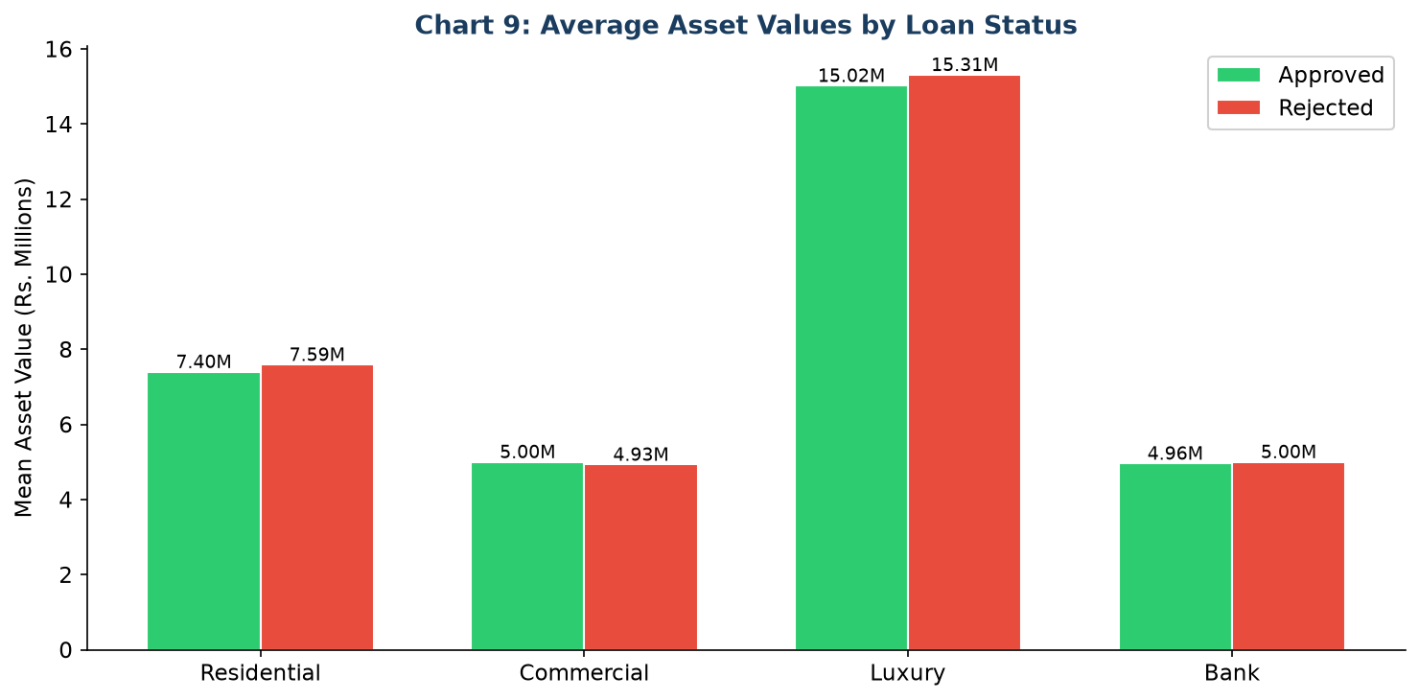
Chart 6: Average Asset Values by Loan Status (Rs. Millions)
Key Finding: Asset values are nearly identical between approved and rejected. CIBIL score overrides asset wealth as a predictor.

5. Machine Learning Models
Four classification models were trained and evaluated on the same 80/20 stratified split. All evaluation metrics are from the held-out 20% test set (854 records) only.

5.1 Model Descriptions
Logistic Regression: Linear baseline model. Requires StandardScaler. Provides probability estimates and interpretable coefficients. Max iterations: 1,000.
Decision Tree: Rule-based non-linear classifier. Max depth: 8 to prevent overfitting. Scale-invariant. Produces human-readable decision rules.
Random Forest (Best): Ensemble of 200 decision trees using bagging. Scale-invariant, handles non-linear patterns, provides feature importances. Selected as best model.
XGBoost: Gradient-boosted ensemble of 200 trees. Highly accurate, robust to outliers, handles complex patterns. Second best overall.

5.2 Model Performance Results
All scores evaluated on the 854-record test set. Green row = best model.
Model | Accuracy | Precision | Recall | F1-Score
Logistic Regression | 92.27% | 91.59% | 87.62% | 89.56%
Decision Tree | 97.89% | 99.35% | 95.05% | 97.15%
Random Forest ★ BEST | 98.24% | 99.04% | 96.28% | 97.65%
XGBoost | 98.01% | 98.42% | 96.28% | 97.34%

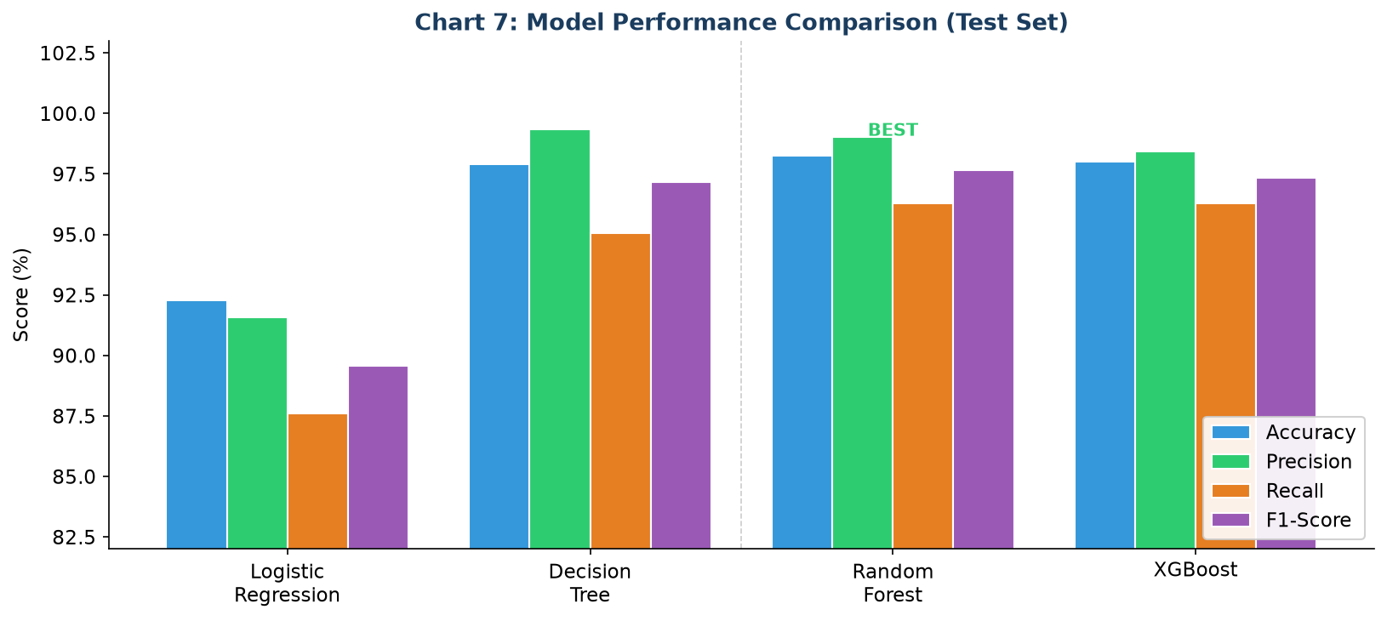
Chart 7: Model Performance Comparison — Accuracy, Precision, Recall, F1-Score (Test Set)
Key Finding: Random Forest is the best model with 98.24% accuracy and 97.65% F1-Score. It outperforms all others on every metric except Precision (where Decision Tree scores 99.35%).

5.3 Confusion Matrix — Best Model (Random Forest)
The confusion matrix shows how the Random Forest classified the 854 test records:
 | Predicted: Approved | Predicted: Rejected | Row Total
Actual: Approved | 528 (True Positive) | 3 (False Negative) | 531
Actual: Rejected | 12 (False Positive) | 311 (True Negative) | 323
Column Total | 540 | 314 | 854

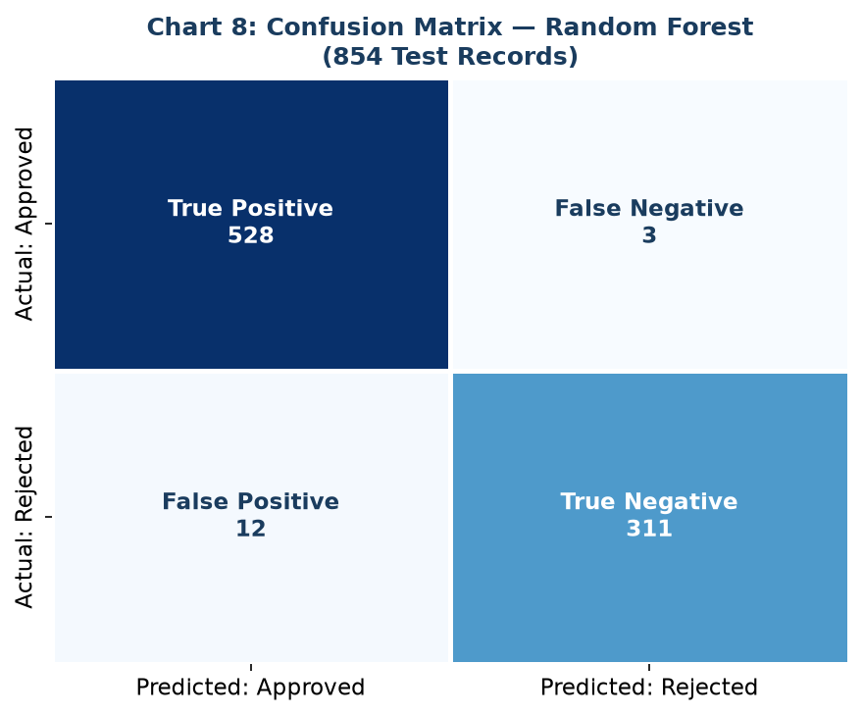
Chart 8: Confusion Matrix — Random Forest (854 Test Records)
Interpretation: 839 of 854 records were correctly classified. Only 15 errors: 3 false negatives (approved loans predicted as rejected — lost business) and 12 false positives (rejected loans predicted as approved — potential bad loans). The false positive rate of 1.4% is exceptionally low.

6. Feature Importance
Feature importance was extracted from the trained Random Forest model. It measures the average reduction in Gini impurity contributed by each feature across all 200 decision trees.
Rank | Feature | Importance | Interpretation
1 | cibil_score | 80.16% | Dominant predictor — primary credit filter
2 | loan_term | 6.48% | Repayment duration affects default risk
3 | loan_amount | 3.05% | Larger loans carry higher risk
4 | income_annum | 2.00% | Repayment capacity indicator
5 | luxury_assets_value | 1.91% | Collateral proxy
6 | commercial_assets_value | 1.83% | Business asset backing
7 | residential_assets_value | 1.73% | Home ownership as collateral
8 | bank_asset_value | 1.49% | Savings and liquidity signal
9 | no_of_dependents | 0.84% | Financial obligation proxy
10 | self_employed | 0.27% | Income stability (minimal impact)
11 | education | 0.24% | Minimal direct impact in this dataset
— | TOTAL | 100.00% | —

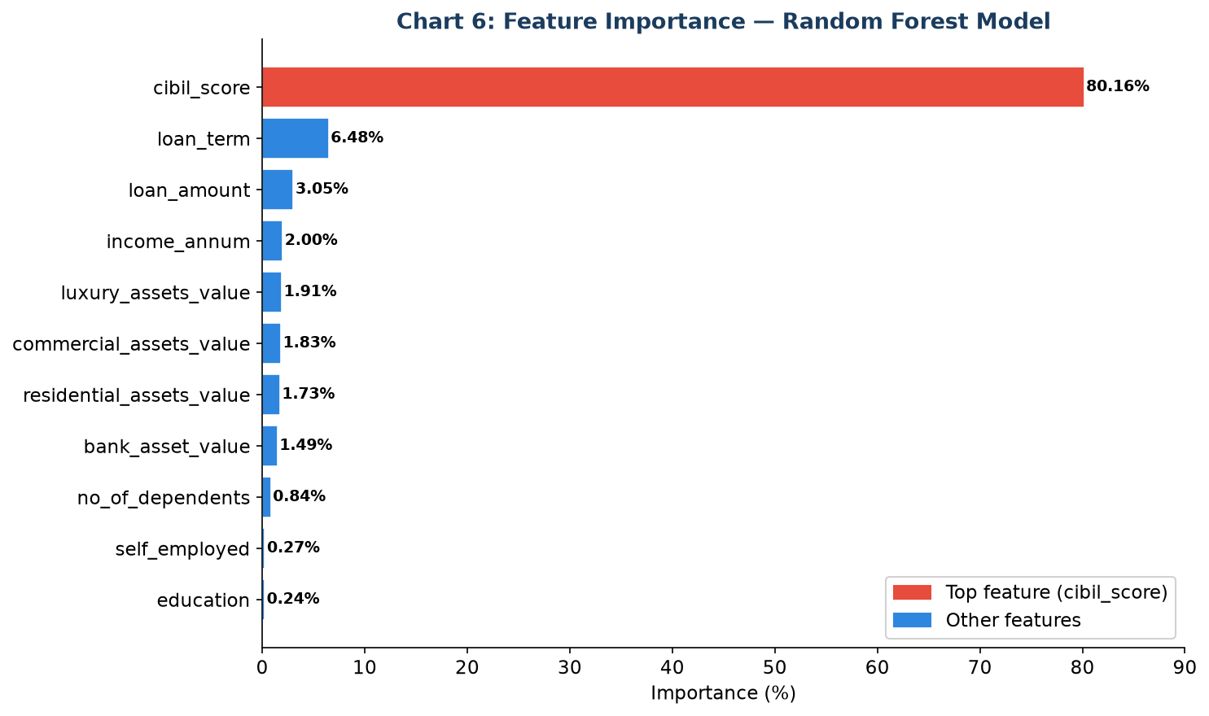
Chart 9: Feature Importance — Random Forest Model (red bar = dominant feature)
Key Finding: CIBIL score alone accounts for over 80% of model decisions. The top 4 features (CIBIL, loan_term, loan_amount, income_annum) explain over 91% of variance. Education and employment type contribute less than 0.3% each.

7. Business Decisions
Five actionable decisions derived directly from the data findings:

Decision 1: Adopt CIBIL Score as the Primary Eligibility Gate
Data Finding: Approved applicants average CIBIL 703.5 vs Rejected 429.5 — a 274-point gap. CIBIL accounts for 80.16% of model power.
Recommended Action: Establish a minimum CIBIL threshold (580–620) below which applications are auto-flagged for review. Applications above 700 should be fast-tracked if other criteria are met.

Decision 2: Restructure Loan Terms to Manage Risk
Data Finding: Loan term is the 2nd most important feature (6.48% importance). Term structure significantly affects default risk.
Recommended Action: For borderline applicants (CIBIL 500–620), offer shorter terms (2–6 years) to reduce exposure. Reserve longer terms (14–20 years) for applicants with CIBIL above 700 and proven repayment capacity.

Decision 3: Remove Education and Employment from Eligibility Criteria
Data Finding: Graduate vs Non-Graduate: 62.5% vs 62.0%. Salaried vs Self-Employed: both 62.2%. Feature importance <0.3% each.
Recommended Action: Remove education and employment type from primary criteria to avoid bias and comply with fair lending regulations. These factors have no meaningful predictive power.

Decision 4: Deploy a Three-Tier Automated Decision System
Data Finding: Random Forest achieves 98.24% accuracy and 97.65% F1-Score with only 15 errors on 854 test records.
Recommended Action: Tier 1 — Auto-Approve: predicted probability ≥85%. Tier 2 — Human Review: probability 30%–85%. Tier 3 — Auto-Decline: probability <30% (appeal option available).

Decision 5: Schedule Regular Model Retraining
Data Finding: Model performance is based on historical data. Economic conditions and credit profiles evolve.
Recommended Action: Monitor model accuracy quarterly. Retrain every 6–12 months. Trigger early retraining if accuracy falls below 95% on recent production decisions.

8. Conclusion & Recommendations
This project delivered a complete end-to-end data analytics and machine learning pipeline for loan approval prediction — from raw data exploration through to an interactive Streamlit dashboard with real-time predictions.

Key Findings Summary
- CIBIL score is the dominant factor, accounting for over 80% of model predictive power. The average approved CIBIL is 703.5 vs 429.5 for rejected — a gap of 274 points.
- Income and asset values have minimal direct impact. Approved and rejected applicants have near-identical incomes and total asset values. Creditworthiness (CIBIL) matters far more than raw wealth.
- Education and employment type are not meaningful predictors. Both groups show approval rates within 0.5% of each other. These factors should not be used as lending criteria.
- Loan term is the second most important feature (6.48%), reflecting that repayment structure influences risk more than loan amount alone.
- The Random Forest model is the best performer: 98.24% accuracy, 97.65% F1-Score, with only 15 errors on 854 test records and a false positive rate of just 1.4%.

Final Recommendation
Deploy the Random Forest model as the primary automated loan screening engine. Use CIBIL score as the first and most heavily weighted eligibility criterion. Implement the three-tier decision system (auto-approve / human review / auto-decline) to balance efficiency with oversight. Retire education and employment type from eligibility criteria. Schedule quarterly performance monitoring with retraining every 6–12 months.

Technology Stack
Library | Purpose
Pandas | Data loading, cleaning, and manipulation
NumPy | Numerical operations and array handling
Matplotlib / Seaborn | Data visualization and chart generation
Scikit-learn | Preprocessing, model training, and evaluation metrics
XGBoost | Gradient boosting classification model
Streamlit | Interactive web application and live prediction interface
Python-docx | Word report generation with embedded charts

— End of Report —

