EXT: Ratings
Extension Key: ratings
Copyright 2007-2009, Netcreators BV, <extensions@netcreators.com>

This document is published under the Open Content License
available from http://www.opencontent.org/opl.shtml

The content of this document is related to TYPO3
- a GNU/GPL CMS/Framework available from www.typo3.com

Table of Contents
EXT: Ratings 1
Introduction 1
What does it do? 1
Screenshots 1
Users manual 2
Rating pages 2
Rating tt_news items 2
FAQ 2
Adminstration 2
FAQ 3
Configuration 3
FAQ 4
Ratings PHP API 4
Terms 5
Accessing API 5
API reference 5
Known problems 5
To-Do list 5
Translating the extension 6
ChangeLog 6

Introduction

What does it do?
This extension provides:
- A frontend plugin for displaying and adjusting ratings
- An AJAX-based voting (extremely fast!)
- A highly customizable look for ratings (template and/or css file)
- Several image sets for ratings
- An API for other extensions to integrate ratings into their records (for photos, news, articles, comments, etc)
- A set of hooks to popular extensions to enable the rating functionality inside of them
The extension requires PHP 5.1 or newer. It will not work with PHP 5.0 or older versions. There is no direct dependency on the TYPO3 version but bugs are not accepted if the TYPO3 version is older than current official major TYPO3 version (4.1 in January 2008).
This extension was created by Dmitry Dulepov for Netcreators BV.

Screenshots
Default view, user did not vote yet:
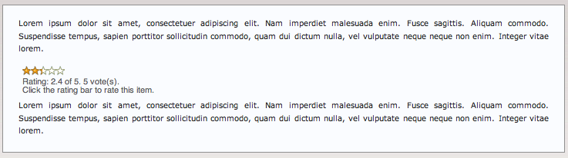
Default view, user already voted:
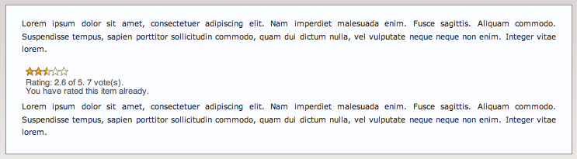
The following images are shipped with this extension to use in ratings:

The first image column describes the “not voted” state, second is “votes” and the images in third column appear when a visitor hovers over the voting bar. All these images are either licensed under GPL or the Creative Commons license. The respective Copyright information is provided in the CSS file that use these images. See the Configuration section for details.

Users manual

Rating pages
To use ratings for a page, the TS template of the ratings extension has to be added to the page. The extension will work out of the box with the default options. See the configuration section in this manual if any option needs to be adjusted.
As a next step, add the ratings plugin to the page. It is possible to override the storage page ID and template file location through the plugin. Now users can rate the pages!

Rating tt_news items
To use ratings for tt_news, the TS template of the ratings extension has to be added to the page. The extension will work out of the box with the default options, however if you need to modify the options, see the Configuration section for details.
Insert the ###TX_RATINGS### marker into your tt_news template. Web site visitors now can rate news items. If the rating should not appear on a particular news item, clear the corresponding box when editing a tt_news record.

FAQ
None yet

Adminstration
There is no special information for administrators.

FAQ
Non yet

Configuration
This section describes TypoScript configuration.

Property: | Data type: | Description: | Default:
storagePid | integer | Page uid where all the rating records are stored. | empty (value of {$plugin.tx_ratings_pi1.storagePid} constant)
templateFile | string | Template file for the plugin. Accepts either a site-relative path or an extension-related path (EXT: prefix) | EXT:comments/res/pi1_template.html (value of {$plugin.tx_ratings_pi1.templateFile} constant)
minValue | integer | Minimum rating value. This must not be changed once ratings are in use already. Changing this value also requires CSS adjustments (length of voting bar). | 1
maxValue | integer | Maximum rating value. This must not be changed once ratings are in use already. Changing this value also requires CSS adjustments (length of voting bar). | 5
ratingImageWidth | integer | Width of a single rating bar image. Must be adjustted if a non-default image is used. | 11
mode | auto or static | “auto” means that ratings will operate as they normally do on web sites (user votes and he cannot vote on this item any more). “static” means that the user will not be able to vote: ratings will be read-only. | auto
disableIpCheck | boolean | Disables the IP address check for votings. If this check is disabled, users may vote any number of times on the item (useful for testing). Notice: users will have to reload the page to vote again! | 0
additionalCSS | string | Allows to change the appearance of ratings without changing template. Typically ratingImageWidth needs to be changed too.  There are several predefined CSS files that can be reused:  - komodeomedia.css (width=30px)  Copyright © Rogie King, KOMODEO MEDIA, http://komodomedia.com/blog/index.php/2006/01/09/css-star-rating-part-deux/  - masugadesign.css (width=30px)  Copyright © Ryan Masuga, ryan@masugadesign.com (http://www.masugadesign.com/the-lab/scripts/unobtrusive-ajax-star-rating-bar/)  - yvoschaap.css (width=25px)  Copyright © Yvo Schaap, http://www.yvoschaap.com/index.php/weblog/css_star_rater_ajax_version/  Original CSS and images © KOMODEO MEDIA  See the Screenshots section for examples of images. Other royalty free images can be included (send them to me by e-mail).

FAQ
Q: I disabled IP check but after I rate the item, I cannot rate it again!
A: You need to reload page to rate again. This is a technical limitation due to the usage of AJAX.
Q: I included another CSS but the images are cut or clicks do not work properly
A: You forgot to adjust the ratingImageWidth parameter. See the Configuration section.
Q: I try to use the extension with TYPO3 3.x/4.0 but...
A: Sorry, but this extension is not tested and will not be supported under any TYPO3 version below 4.1.
Q: I try to use the extension but PHP errors show up
A: Your PHP version is lower than 5.1. The ratings extension does not work with PHP versions lower than 5.1.
Q: Can each content item on the page be rated?
A: Not out of the box. This feature can be added if you'd like to sponsor it (665€).

Ratings PHP API
This section is meant for extension developers who want to integrate the ratings functionality into their extensions. The frontend plugin of the ratings extension itself is actually a simple wrapper around this API.

Terms
This section defines some terms used by the API.
Term | Data type: | Description:
Element | N/A | Any item to rate. It can be a page, content element, article, image or any other item that can be identified in any way.
Reference | string | Unique identifier of the element. It must uniquely identify an element among any other element within TYPO3. The Ratings API does not care about the format of the reference as soon as it can be saved into a varchar(255) database field. However it is strongly recommended to use the standard TYPO3 “group” format for it, which consists of the table name, an underscore and the uid of the item (for example, “tt_content_10”, “pages_20” or “tx_myext_data_88”).
Configuration | array | In order to calculate or display ratings, the API needs to know certain configuration parameters. If supplied by the caller, it expects an array with parameters described in the “Configuration” section of this manual. If the configuration is not supplied by the caller, the API will use “plugin.tx_ratings_pi1” from the TypoScript setup of the current page. If none of these two is available, the results of the API will be unpredictable. If there is no configuration, the API will result in an error.

Accessing The API
The ratings extension provides PHP class, which implements a set of functions to find the rating for the element or display the attached ratings. The rating modification feature is built into this display feature.
To access the API class, include a class definition into your own plugin class:
if (t3lib_extMgm::isLoaded('ratings')) {
require_once(t3lib_extMgm::extPath('ratings', 'class.tx_ratings_api.php');
}
Notice the usage of t3lib_extMsg::isLoaded(). This allows you not to have any hard dependency on the ratings extension in your own extension but rather a service that is used if the extension is installed.
As a next step, instantiate the API class in the place where you need to use it:
$ratingsAPI = t3lib_div::makeInstance('tx_ratings_api');
It is important to use t3lib_div::makeInstance() for instantiating the API class. Avoid using the PHP operator “new” for this purpose.
When the class is instantiated, it is ready to be called. There is no futher initialization necessary. All functions are independent and can be called in any order.

API Reference
This section describes each function and parameters in detail. Please make sure to have read the Terms chart in this chapter before reading the section below.

getDefaultConfig
Parameter: | Data type: | Description: | Default:
return value | array | Default configuration

getRatingValue
Parameter: | Data type: | Description: | Default:
$ref | string | Reference to the element
$conf | array | API configuration. If not provided, the default will be used. | null
return value | float | Rating value in percent (from 0 to 100)

getRatingDisplay
Parameter: | Data type: | Description: | Default:
$ref | string | Reference to the element
$conf | array | API configuration. If not provided, the default will be used. | null
return value | string | HTML generated by for this element

Known problems
None yet

To-Do list
- Implement a backend module to explore recorded ratings

Translating the extension
Translation of the extension happens exclusively through the main TYPO3 translation server. If you do not know what the translation server is, read about it here.

ChangeLog
See the ChangeLog file inside the extension.

