Talos Origins

Game Design Document

COMP376

Eric Provencher 26543731

Hu Ningge

Eric Philiponna 26225497

# Overview

## Executive summary

Talos Origins is a two-dimensional procedurally generated action-exploration RPG in a sci-fi setting that focuses on increasing your character’s abilities to unravel the mystery behind his journey.

## Project Description:

With each level being an increasingly large and challenging procedurally generated maze, players will never see the same stage twice. Traversing each maze involves using the breadcrumb mechanic which lets players know where they’ve been, along with the grapple which allows them to effortlessly navigate vertically.

Each stage is filled with a random assortment of enemies that, when killed, release collectible resources that can be spent on improving and expanding the protagonist’s repertoire of abilities, to better serve him on his quest to find his creator, and aid him in conquering the God-like bosses that stand in his path.

## Theme / Setting / Genre

The story a work of Science Fiction that takes place in the middle of a rebellion attempting to destroy a long-standing galactic empire.

The game itself is a two-dimensional roguelike role-playing game that involves platforming, action and strategically managing resources in an effort to progress as far as possible.

## Core Gameplay Mechanics Brief

- Procedurally generated mazes

- Grapple assisted platforming for maze navigation

- Upgradable weapons

- Breadcrumb system to facilitate maze navigation

## Targeted platforms

- PC

- Android/iOS (End of development)

## Influences (Brief)

### - <Game> Super Metroid

Super Metroid was the first 16-bit entry of the series, featuring vast worlds to explore, with complex power-ups to be gained along the adventure. The game’s story is told in small pieces, but the purpose of the adventure is largely shrouded in mystery. Talos Origins will have a very similar feature a very similar upgrade system, with Super Metroid serving as a strong inspiration for atmosphere, platforming and overall feel.

### - <Book> Foundation

The Foundation series built an incredibly detailed tale of a galactic empire with morally gray opposing characters. This series will serve as an inspiration for our game’s plot forks, that will allow the player to make decisions that will shape the fate of the galaxy.

### - <Game> The Binding of Isaac

This game features a procedurally generated collection of rooms, filled with randomly placed enemies and boss battles, along with a complex item system. It is a needlessly difficult game, but it works because the player improves and can make their way further on each play through. Due to the RPG nature of Talos Origins, the player won’t be as severely punished on death, but the difficulty will certainly ramp up in a similar fashion.

### - <Game/Comic> Spiderman

Spiderman’s motion, momentum and swinging are incredibly interesting as gameplay mechanics and went a long way towards inspiring the movement and feel of Talos’ motion and grapple mechanics.

# What sets this project apart?

- <Reason #1>

Having procedurally generated levels means players will never see the same maze twice

- <Reason #2>

Having procedurally generated levels means players will never see the same maze twice

- <Reason #3>

Having procedurally generated levels means players will never see the same maze twice

- <Reason #4>

Having procedurally generated levels means players will never see the same maze twice

## Core Gameplay Mechanics (Detailed)

### - 2D Projectile Combat

- <Details>

The game is based around combat between Talos and multiple types of enemies. Talos can fire bullets at the enemies in order to afflict damage upon them. Defeating an enemy Talos is rewarded with currency and also contributes to the player’s game progression.

- <How it works>

Talos is equipped with a blaster gun which is his only mode of defence against enemies and ammunition is unlimited.

Once Talos defeats an enemy, it will ooze currency which when collected by the player can be used towards upgrade (see “Upgrades System” below).

### - Navigation of randomly generated cave maze

- <Details>

Each map is randomly generated allowing for a new experience every time the player plays the game. A new map allows for a longer lifecycle for the game but also adds a difficulty component since the player will not be able to “learn” the maps layout.

- <How it works>

Each level will feature a never before seen randomly generated map. Moreover as the player advances in the game, the maps will grow in order to accommodate for the extra enemies.

### - Grapple Hook

- <Details>

Talos is equipped with a grapple hook in order to allow him to navigate through each cave with ease no matter the size. It can serve as an “elevator” to climb up the maze, or as a swing explore quickly or even to avoid enemies.

Together with the large open spaces found in the cave, the grapple hook allows for some exciting battle scenes.

- <How it works>

Talos can hook his grapple onto any wall or meteorite given that it is within a certain distance. The player can also reel himself up or down, swing side to side, release, or jump release from the grapple at any time.

We are currently in discussion on whether we want to control this mechanic by implementing a recharge bar which would temporarily disable the grapple after too many usages within a given time frame.

### - Upgrades System

- <Details>

At any time during the game Talos can hop on board his ship and shop for upgrades. Upgrades include larger bullets, explosive bullets, rage mode (damage multiplier), a force field shield, health packs, increased max health, increased jumping, breadcrumbs and a longer grapple.

- <How it works>

Once bought, upgrades can be deployed at any moment in the game and have a defined lifespan. Each upgrade’s price will be scaled according to how effective it is.

## Story (Brief)

After years of searching, Talos has tracked down his creator who is building an army to overthrow the peaceful Galactic Empire he helped build with his robotic overseers.

## Story (Detailed)

Talos is robot whose only purpose has been to serve the will of his benevolent masters. Amid the increasing unrest spawned from calculated attacks throughout the great Galactic Empire, the Overseers have sent Talos out into the Galaxy, on a search to find the source of these attacks, and put an end to the uprising.

After years of searching, the game begins with our protagonist’s arrival in the Aeos System, where he must traverse the Hieran Asteroid field and find and stop the growing rebellious army. Talos doesn’t know that their leader is in fact his creator, and the very same person who created the Overseers that control Galactic Empire.

Throughout his quest, our protagonist will face many God-like entities who will reveal their motivations for standing against the will of the Overseers, and each such encounter will lead Talos to question his motivations, such that by the time he finally discovers his creator, he will have to make a decision that will shape the future of the Galaxy.

## Player Composites

## 

## World

The game takes place in the Aeos System, during unrest caused by calculated attacks throughout the great Galactic Empire. Talos has been sent here by the overseers to bring peace to the galaxy by finding the source of these attacks and put an end to the uprising.

The game take place more specifically in the Hieran Asteroid field the home of many hostile creatures who are destined to protect their creator (the leader of the rebellion attacks). In order to fulfill his mission, Talos must find his way through a maze of portals which will eventually lead him to his master.

## Characters

## 

## Progression Graph

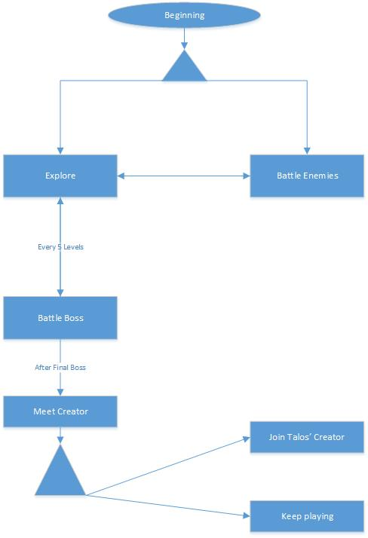

## Art Direction

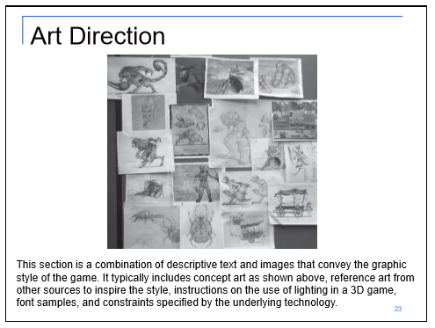

## - 2D

- Textures

- Environment Textures

- Heightmap data (If applicable)

- List required data required - Example: DEM data of the entire UK.

- Etc.

## - Sounds

Talos:

* Pressing buttons on keypad
* Charging up

Grapple tether:

* Firing grapple
* Grapple hiting squishy enemy
* Grapple thumping on misc surface
* Grapple hitting wall

Portal:

* Entering a portal
* Exiting a portal
* Portal opening and closing

Laser blast:

* Laser blast firing out
* Laser blast hitting target squishy exploding enemy
* Laser hitting wall
* Laser blast swishing on misc surface

Enemy:

* Crawling bug creature sound
* Flying beast (not sure yet what this even is)
* Stupid walking enemy

## - Animation

- Environment Animations

- Example

- etc.

- Character Animations

- Player

- Example

- etc.

- NPC

- Example

- etc.

## UI Storyboards

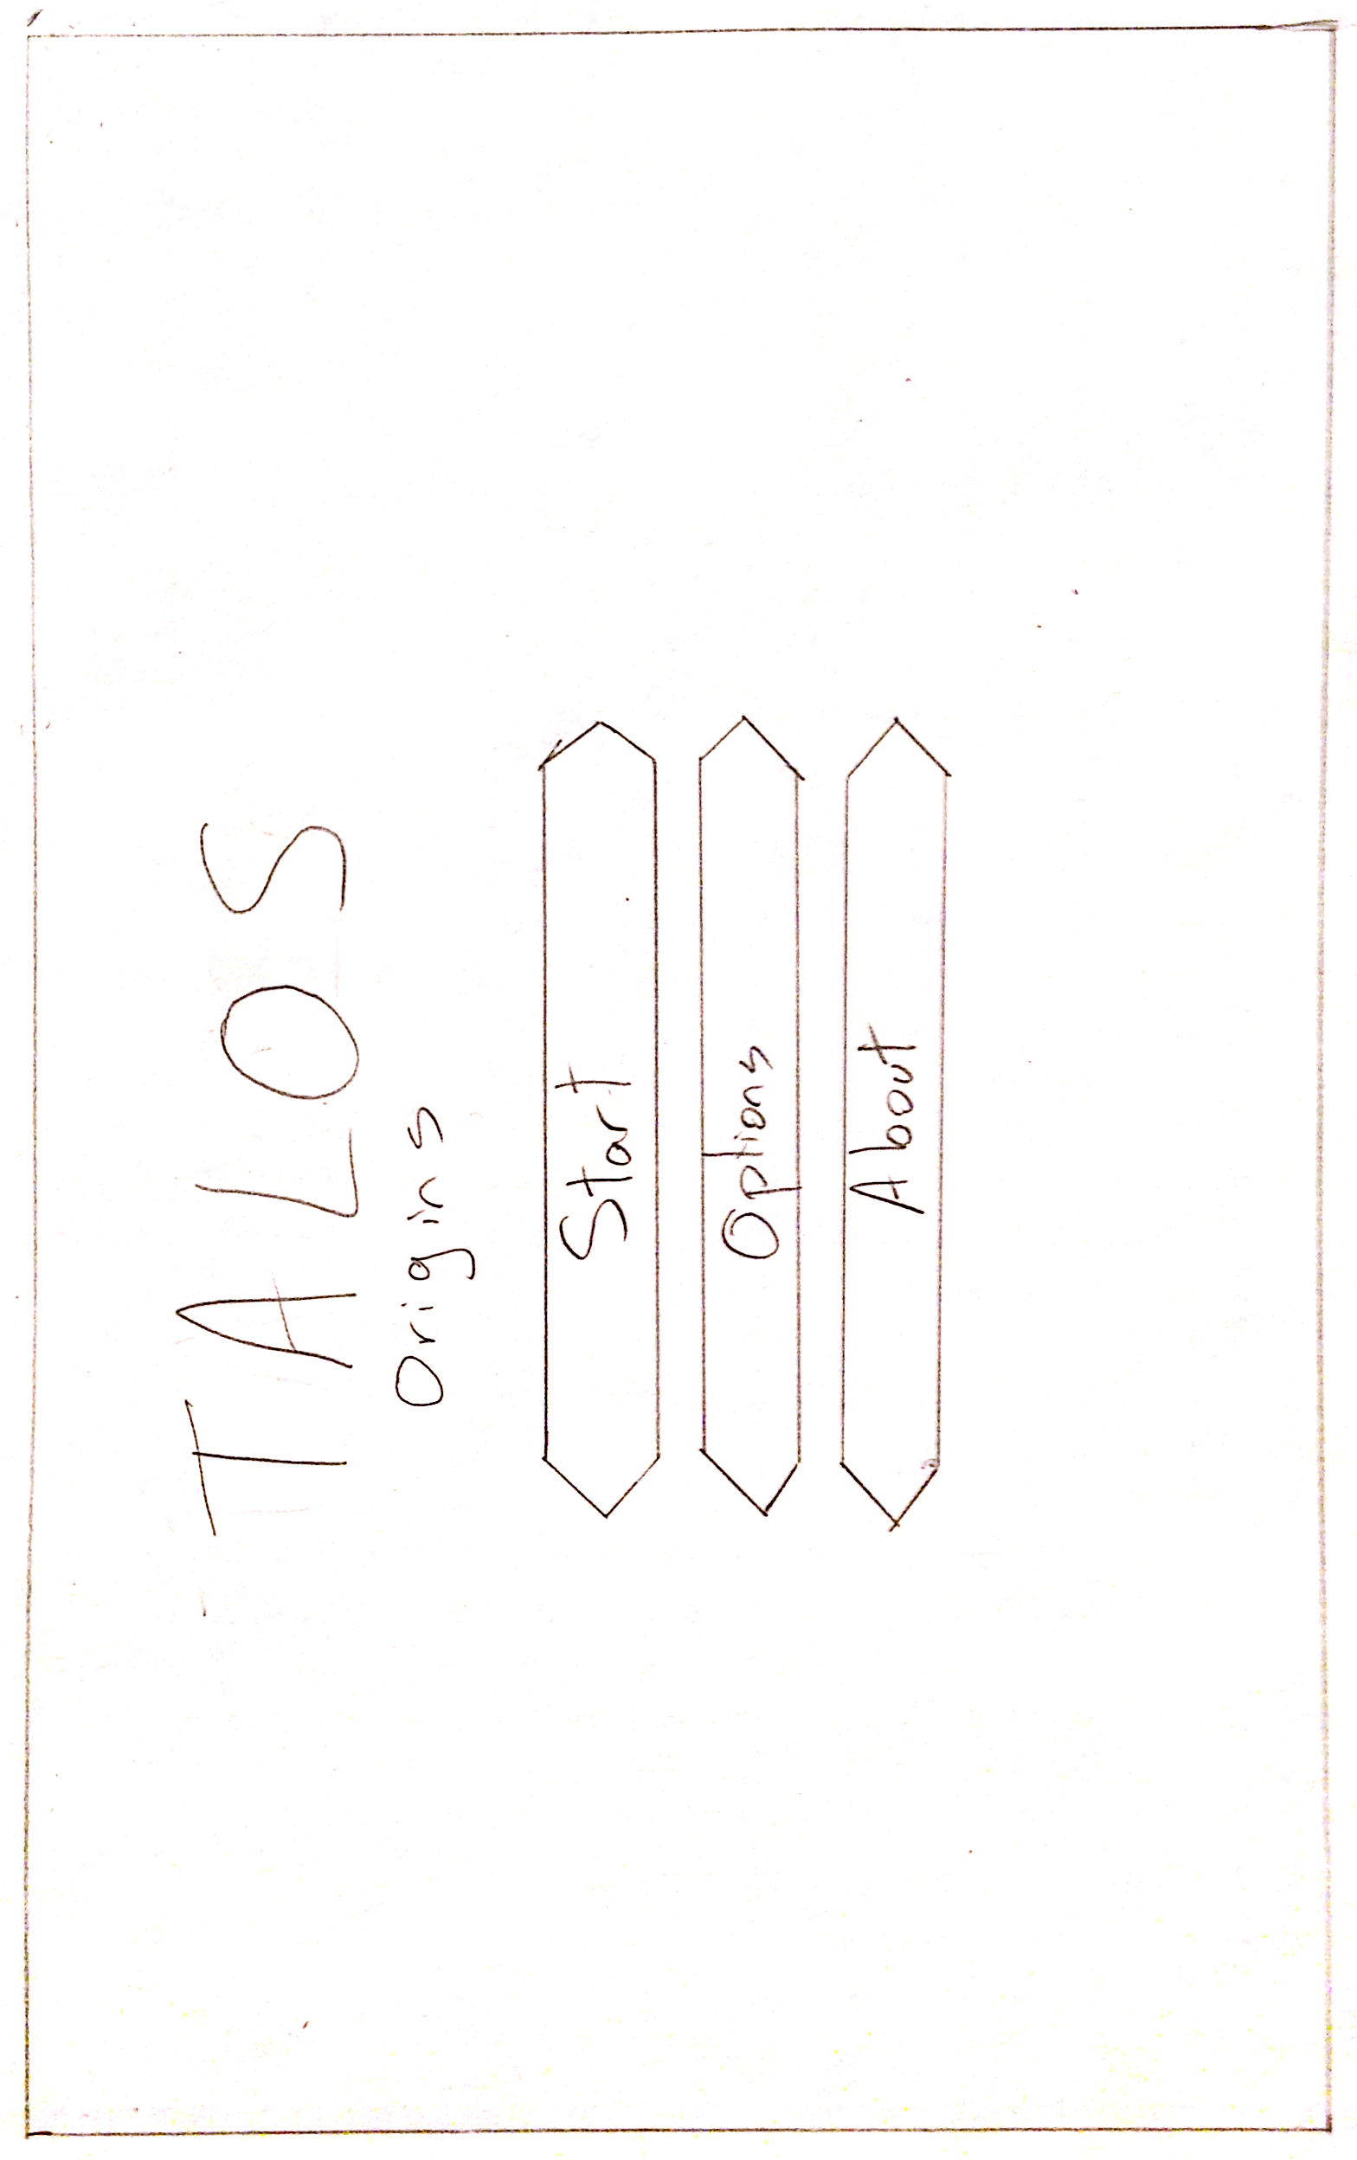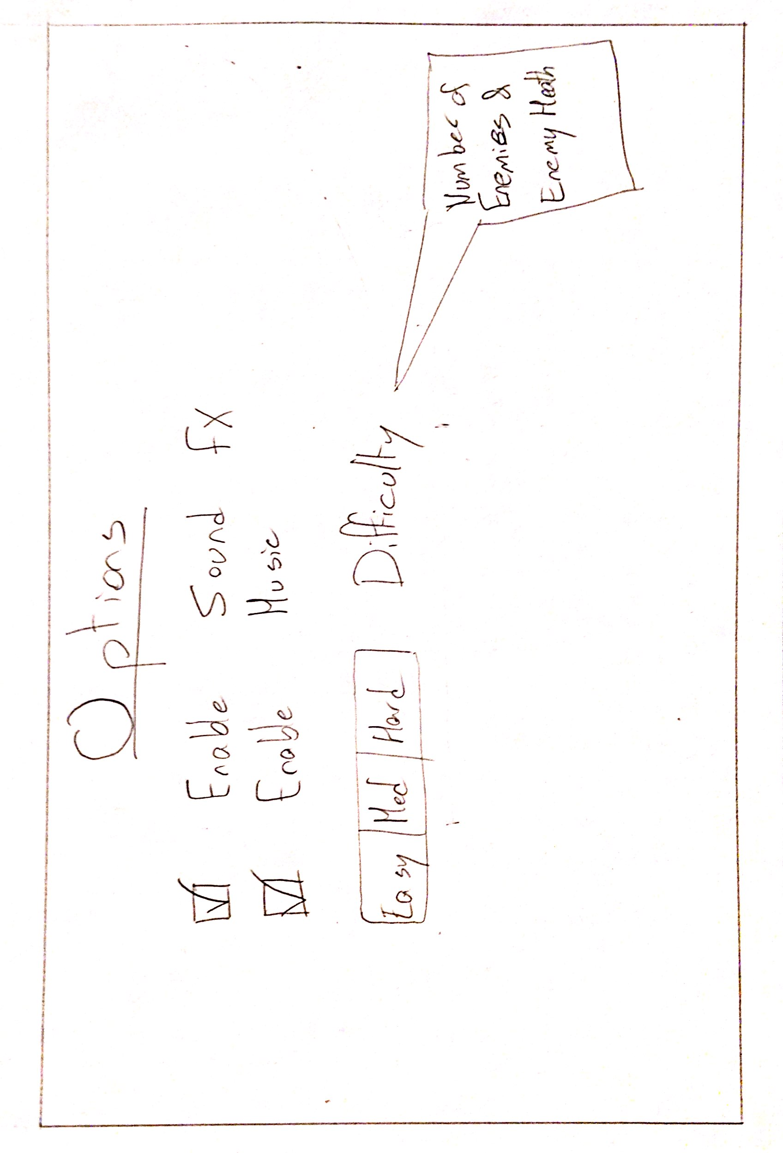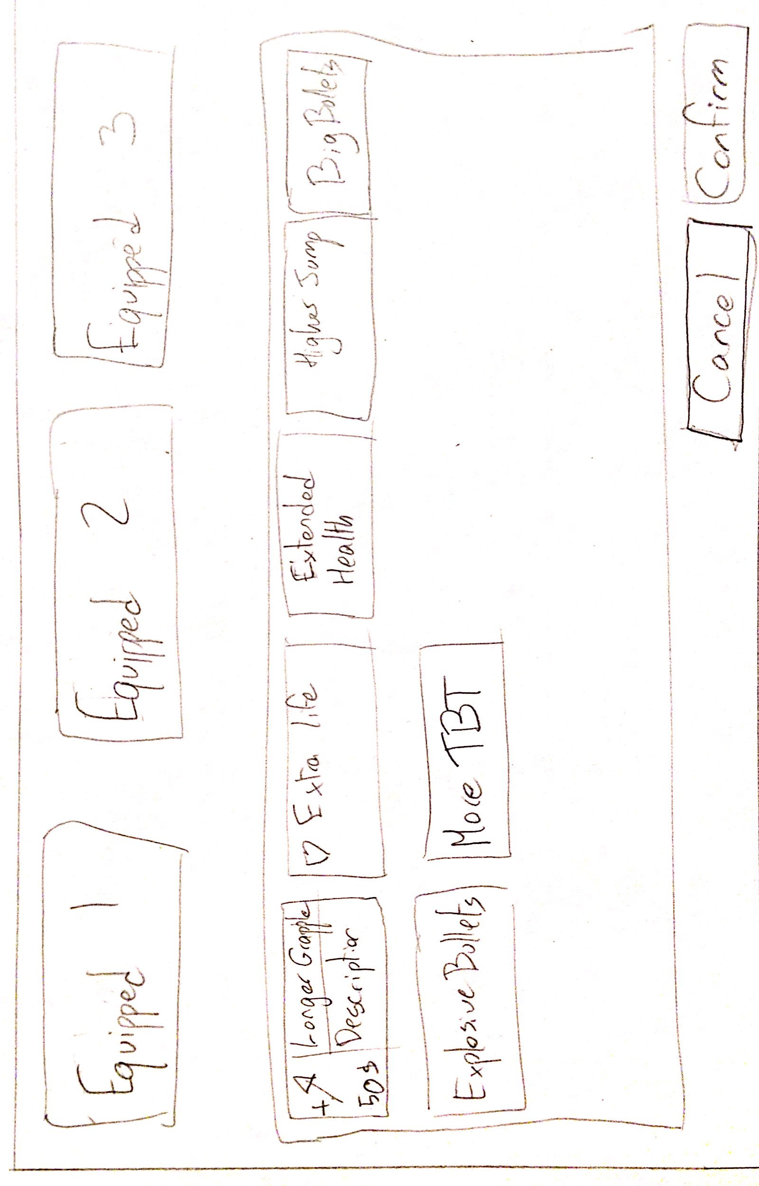

## Tags and dialogue

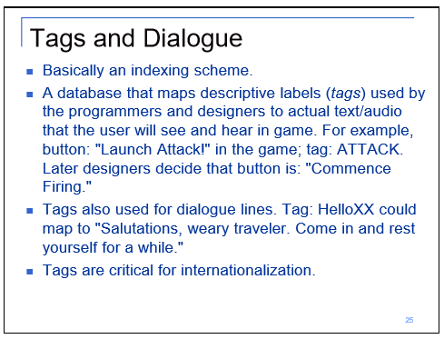

## Technology Plan

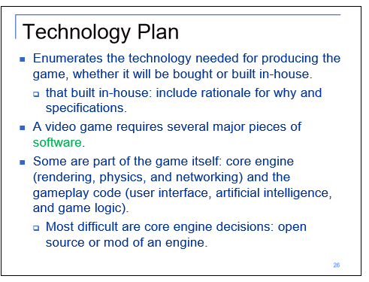

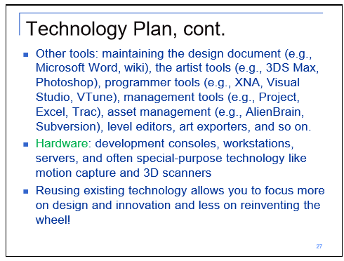

## Software Architecture

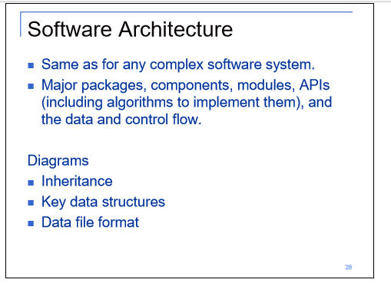

## - Code

- Character Scripts

<Grapple Handling>

<Weapon Handling>

<Character Controller>

- Map Generation Scripts

<Maze generation>

* + - Random path and explortation tunnels
    - Treasure, Asteroid and Enemy Generation
    - Start and Exit Handling

<Mesh generation>

Marching Squares algorithm for generation of cavern from bit array

- NPC Scripts

- Enemy AI Controller (Handles all organization for enemy types)

## Controls

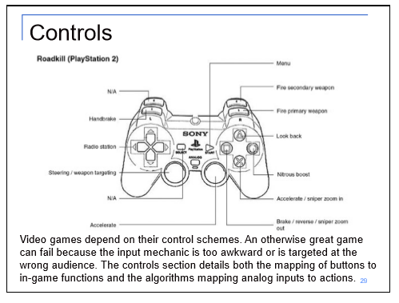

## Level Design

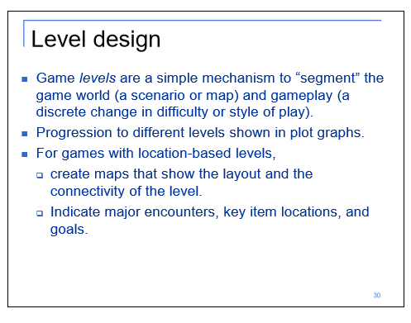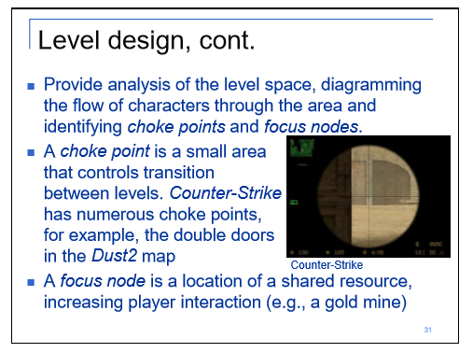

## Mechanic Analysis

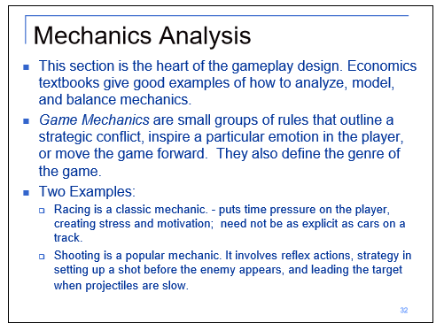

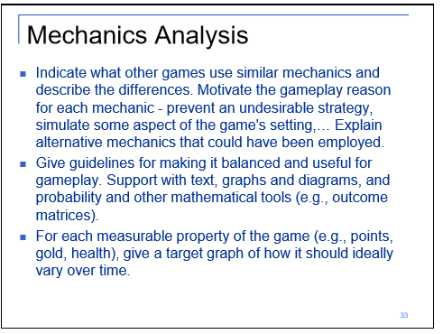

## Schedule

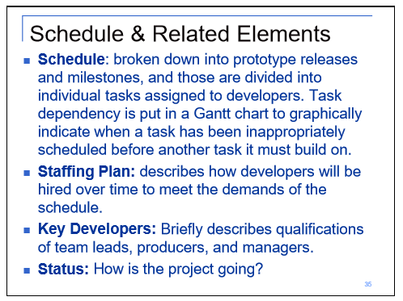

### - <Object #1>

- Time Scale

- Milestone 1

- Milestone 2

- Etc.

### - <Object #2>

- Time Scale

- Milestone 1

- Milestone 2

- Etc.

### - <Object #3>

- Time Scale

- Milestone 1

- Milestone 2

- Etc.

### - <Object #4>

- Time Scale

- Milestone 1

- Milestone 2

- Etc.

## Issue Tracking

Talos Origins is setup on a private GitHub Repository in order to facilitate development progress and ensure that we can always access functional builds of the game by reverting faulty commits if necessary.   
  
The screenshots below showcase our issue tracking, which allows us to assign team members with specific tasks, along with openly offering feedback for specific changes.

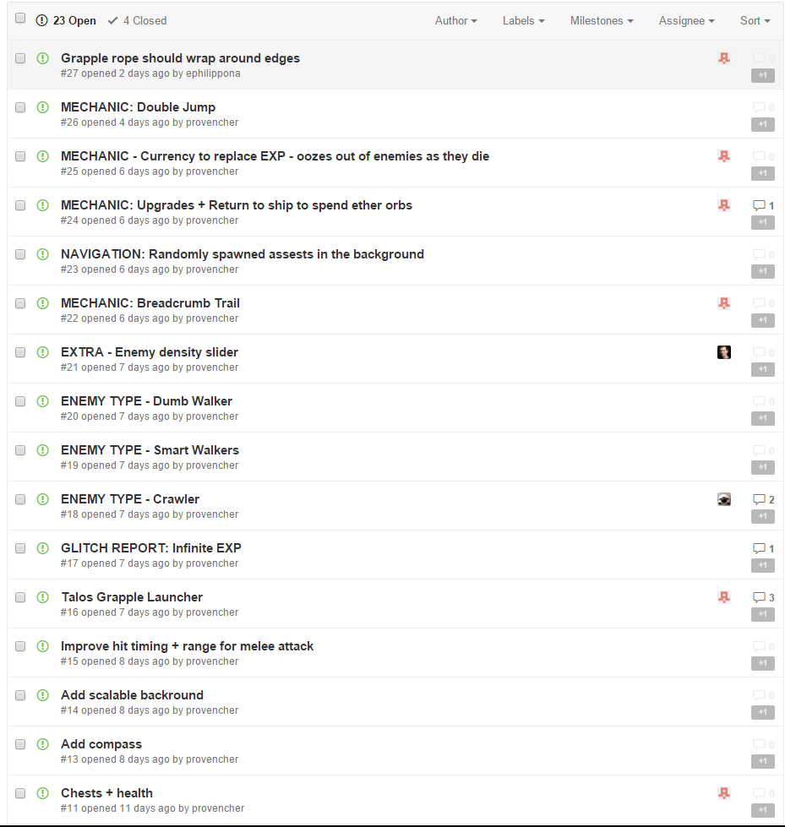

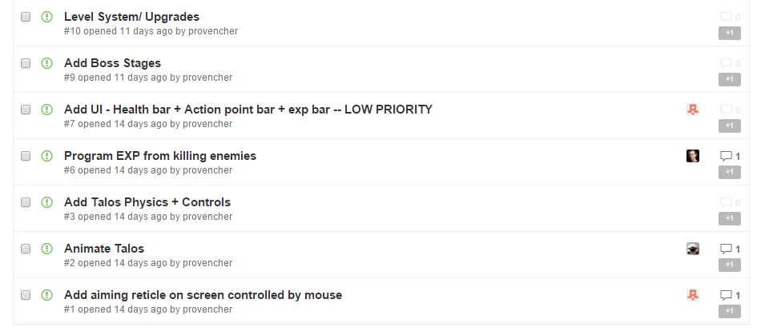

## Change Log

