Talos Origins

Game Design Document

COMP376

Eric Provencher 26543731

Hu Ningge

Eric Philiponna

# Overview

## Executive summary

Talos Origins is a two-dimensional procedurally generated action-exploration RPG in a sci-fi setting that focuses on increasing your character’s abilities to unravel the mystery behind his journey.

## Project Description:

With each level being an increasingly large and challenging procedurally generated maze, players will never see the same stage twice. Traversing each maze involves using the breadcrumb mechanic which lets players know where they’ve been, along with the grapple which allows them to effortlessly navigate vertically.

Each stage is filled with a random assortment of enemies that, when killed, release collectible resources that can be spent on improving and expanding the protagonist’s repertoire of abilities, to better serve him on his quest to find his creator, and aid him in conquering the God-like bosses that stand in his path.

## Theme / Setting / Genre

The story a work of Science Fiction that takes place in the middle of a rebellion attempting to destroy a long-standing galactic empire.

The game itself is a two-dimensional roguelike role-playing game that involves platforming, action and strategically managing resources in an effort to progress as far as possible.

## Core Gameplay Mechanics Brief

- Procedurally generated mazes

- Grapple assisted platforming for maze navigation

- Upgradable weapons

- Breadcrumb system to facilitate maze navigation

## Targeted platforms

- PC

- Android/iOS (End of development)

## Influences (Brief)

### - <Game> Super Metroid

Super Metroid was the first 16-bit entry of the series, featuring vast worlds to explore, with complex power-ups to be gained along the adventure. The game’s story is told in small pieces, but the purpose of the adventure is largely shrouded in mystery. Talos Origins will have a very similar feature a very similar upgrade system, with Super Metroid serving as a strong inspiration for atmosphere, platforming and overall feel.

### - <Book> Foundation

The Foundation series built an incredibly detailed tale of a galactic empire with morally gray opposing characters. This series will serve as an inspiration for our game’s plot forks, that will allow the player to make decisions that will shape the fate of the galaxy.

### - <Game> The Binding of Isaac

This game features a procedurally generated collection of rooms, filled with randomly placed enemies and boss battles, along with a complex item system. It is a needlessly difficult game, but it works because the player improves and can make their way further on each play through. Due to the RPG nature of Talos Origins, the player won’t be as severely punished on death, but the difficulty will certainly ramp up in a similar fashion.

### - <Game/Comic> Spiderman

Spiderman’s motion, momentum and swinging are incredibly interesting as gameplay mechanics and went a long way towards inspiring the movement and feel of Talos’ motion and grapple mechanics.

# What sets this project apart?

- <Reason #1>

- <Reason #2>

- <Reason #3>

- <Reason #4>

- <etc.>

## Core Gameplay Mechanics (Detailed)

### - <Core Gameplay Mechanic #1>

- <Details>

/Describe in 2 Paragraphs or less/

- <How it works>

/Describe in 2 Paragraphs or less/

### - <Core Gameplay Mechanic #2>

- <Details>

/Describe in 2 Paragraphs or less/

- <How it works>

/Describe in 2 Paragraphs or less/

### - <Core Gameplay Mechanic #3>

- <Details>

/Describe in 2 Paragraphs or less/

- <How it works>

/Describe in 2 Paragraphs or less/

### - <Core Gameplay Mechanic #4>

- <Details>

/Describe in 2 Paragraphs or less/

- <How it works>

/Describe in 2 Paragraphs or less/

# 

## Story (Brief)

After years of searching, Talos has tracked down his creator who is building an army to overthrow the peaceful Galactic Empire he helped build with his robotic overseers.

## Story (Detailed)

Talos is robot whose only purpose has been to serve the will of his benevolent masters. Amid the increasing unrest spawned from calculated attacks throughout the great Galactic Empire, the Overseers have sent Talos out into the Galaxy, on a search to find the source of these attacks, and put an end to the uprising.

After years of searching, the game begins with our protagonist’s arrival in the Aeos System, where he must traverse the Hieran Asteroid field and find and stop the growing rebellious army. Talos doesn’t know that their leader is in fact his creator, and the very same person who created the Overseers that control Galactic Empire.

Throughout his quest, our protagonist will face many God-like entities who will reveal their motivations for standing against the will of the Overseers, and each such encounter will lead Talos to question his motivations, such that by the time he finally discovers his creator, he will have to make a decision that will shape the future of the Galaxy.

## Player Composites

## 

## World

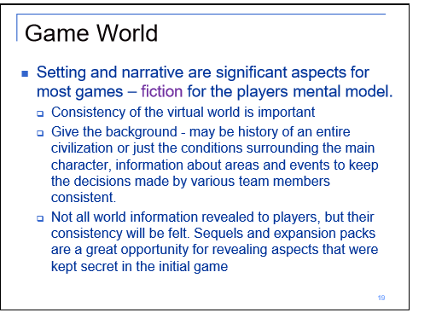

## Characters

## 

## Progression Graph

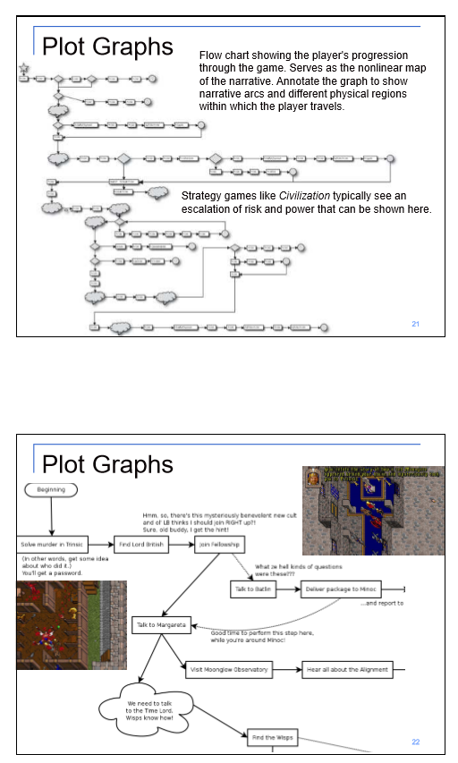

## Art Direction

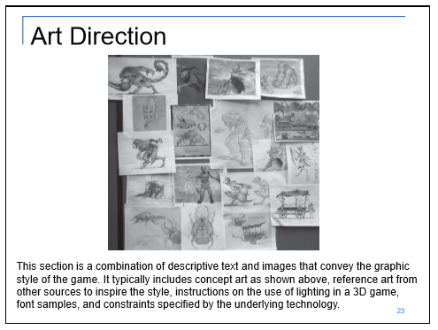

## - 2D

- Textures

- Environment Textures

- Heightmap data (If applicable)

- List required data required - Example: DEM data of the entire UK.

- Etc.

## - Sounds

Talos:

* Pressing buttons on keypad
* Charging up

Grapple tether:

* Firing grapple
* Grapple hiting squishy enemy
* Grapple thumping on misc surface
* Grapple hitting wall

Portal:

* Entering a portal
* Exiting a portal
* Portal opening and closing

Laser blast:

* Laser blast firing out
* Laser blast hitting target squishy exploding enemy
* Laser hitting wall
* Laser blast swishing on misc surface

Enemy:

* Crawling bug creature sound
* Flying beast (not sure yet what this even is)
* Stupid walking enemy

## - Animation

- Environment Animations

- Example

- etc.

- Character Animations

- Player

- Example

- etc.

- NPC

- Example

- etc.

## UI Storyboards

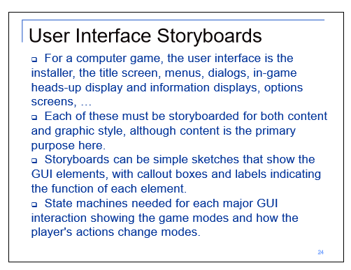

## Tags and dialogue

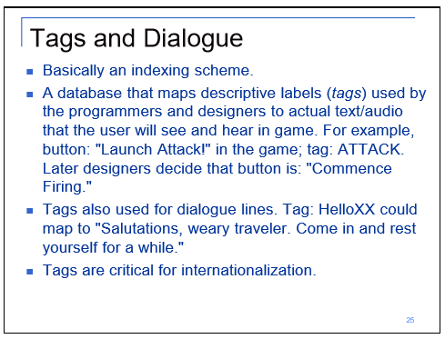

## Technology Plan

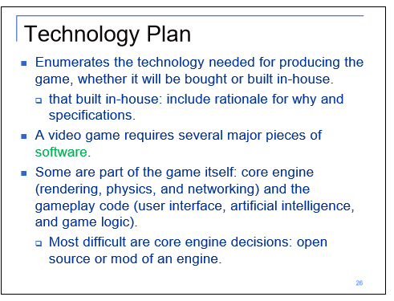

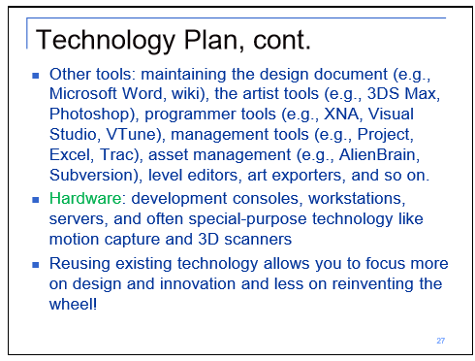

## Software Architecture

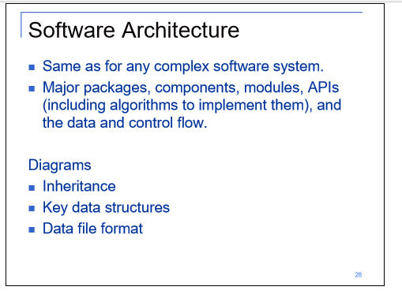

## - Code

- Character Scripts (Player Pawn/Player Controller)

- Ambient Scripts (Runs in the background)

- Example

- NPC Scripts

- Example

- etc.

## Controls

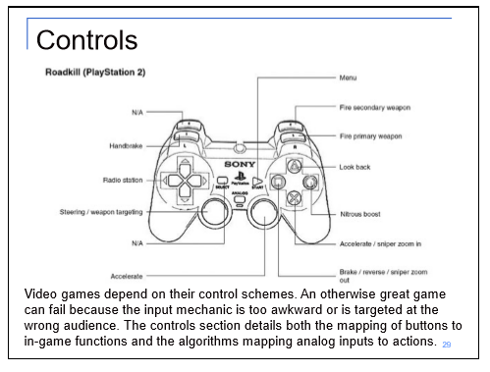

## Level Design

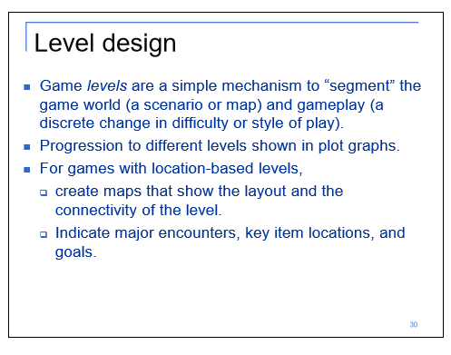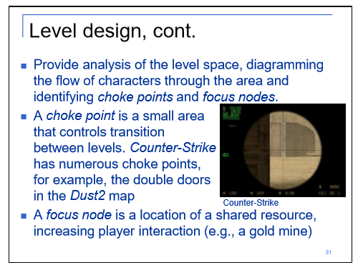

## Mechanic Analysis

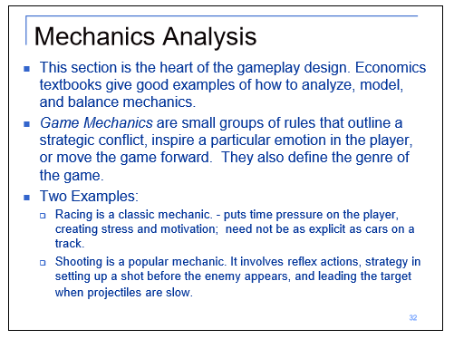

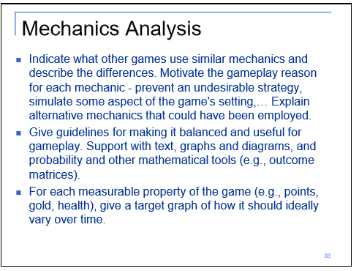

## Schedule

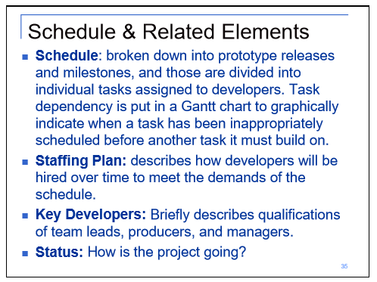

### - <Object #1>

- Time Scale

- Milestone 1

- Milestone 2

- Etc.

### - <Object #2>

- Time Scale

- Milestone 1

- Milestone 2

- Etc.

### - <Object #3>

- Time Scale

- Milestone 1

- Milestone 2

- Etc.

### - <Object #4>

- Time Scale

- Milestone 1

- Milestone 2

- Etc.

## Issue Tracking

Talos Origins is setup on a private GitHub Repository in order to facilitate development progress and ensure that we can always access functional builds of the game by reverting faulty commits if necessary.   
  
The screenshots below showcase our issue tracking, which allows us to assign team members with specific tasks, along with openly offering feedback for specific changes.

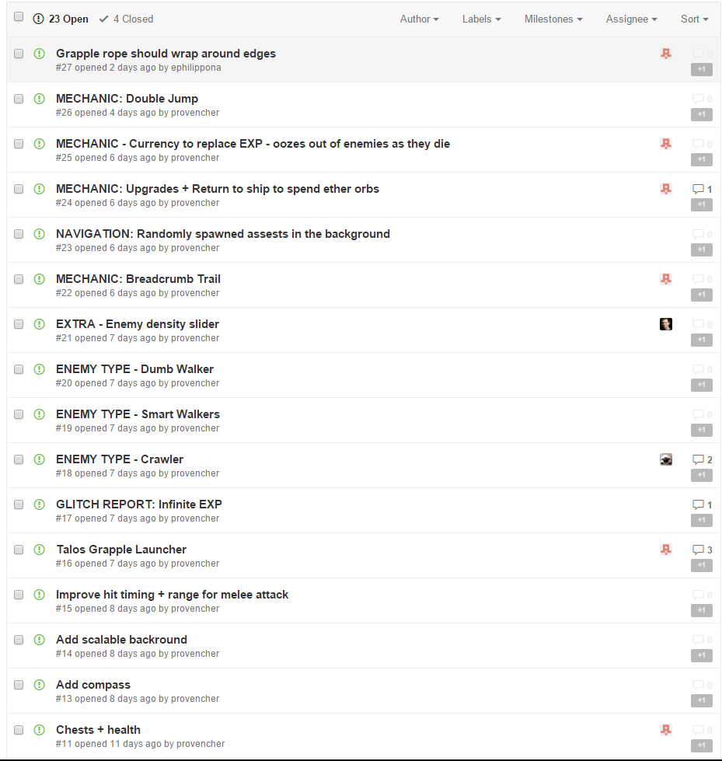

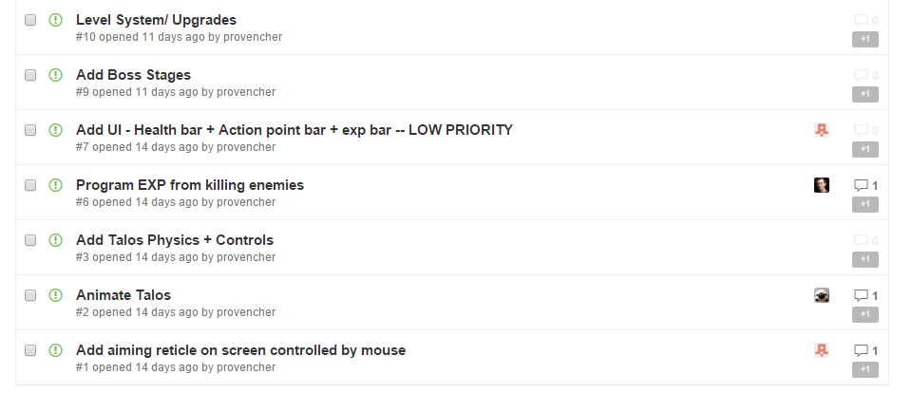

## Change Log

