创建数据库

CREATE DATABASE CarParking;

展示数据库

show databases;

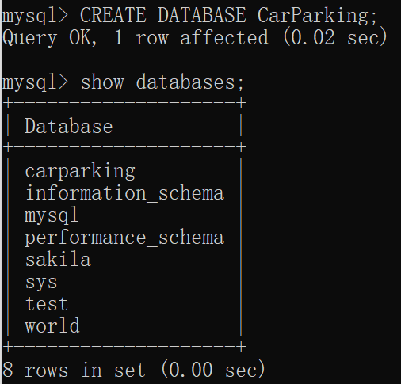

Table登录Login

|  |  |  |
| --- | --- | --- |
| carId | Vachar(20) | Not null(primary key) |
| password | Vachar(20) | Not null |
| note | Vachar(20) |  |
| name | Vachar(20) | Not null |
| phone | Vachar(20) | Not null |
| rewards | Int(5) | Not null |

Table停车位Parking

|  |  |  |
| --- | --- | --- |
| parkId | Int(10) | Not null(primary key) |
| isEmpty | boolean | Not null |
| carId | Int(10) |  |

Table停车情况CarPark

|  |  |  |
| --- | --- | --- |
| Id | Int(10) AUTO_INCREMENT | Not null(primary key) |
| parkId | Int(10) | Not null(foreign key) |
| carId | Vachar(20) | Not null(foreign key) |
| timeIn | Datetime | Not null |
| timeOut | Datetime |  |
| cost | Int(10) |  |

Table自助洗车Washing

|  |  |  |
| --- | --- | --- |
| Id | Int(10) | Not null(primary key) |
| parkId | Int(10) | Not null(foreign key) |
| carId | Vachar(20) | Not null(foreign key) |
| timeWash | date | Not null |
| cost | Int(10) | Not null |

Table新建Login

Use carparking;

CREATE TABLE IF NOT EXISTS `Login`(

`carId` VARCHAR(20) NOT NULL,

`password` VARCHAR(20) NOT NULL,

`note`VARCHAR(20),

`name` VARCHAR(20) NOT NULL,

`phone` VARCHAR(20) NOT NULL,

`rewards`INT(5)NOT NULL,

PRIMARY KEY ( `carId` )

)ENGINE=InnoDB DEFAULT CHARSET=utf8;

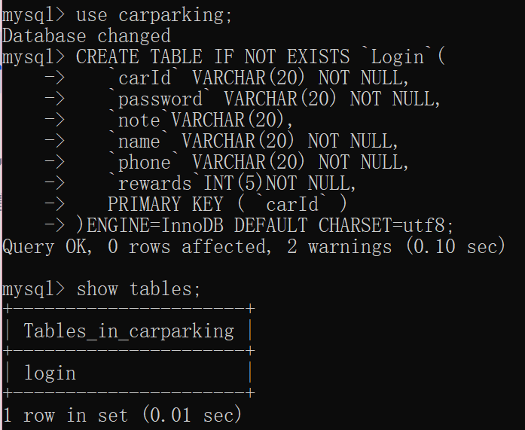

Table新建Parking

Use carparking;

CREATE TABLE IF NOT EXISTS `Parking`(

`parkId` INT(10) NOT NULL,

`IsEmpty`BOOLEAN NOT NULL,

`carId`VARCHAR(20),

PRIMARY KEY ( `parkId` )

)ENGINE=InnoDB DEFAULT CHARSET=utf8;

Table新建CarPark

Use CarParking;

CREATE TABLE IF NOT EXISTS `CarPark`(

`Id` INT(10) AUTO_INCREMENT NOT NULL,

`timeIn` DATETIME NOT NULL,

`timeOut`DATETIME,

`carId` VARCHAR(20) NOT NULL,

`parkId` INT(10) NOT NULL,

`cost`INT(10),

PRIMARY KEY ( `Id` ),

Foreign Key (carId) references Login(carId) ON DELETE CASCADE ON UPDATE CASCADE,

Foreign Key (parkId) references Parking(parkId) ON DELETE CASCADE ON UPDATE CASCADE

)ENGINE=InnoDB DEFAULT CHA RSET=utf8;

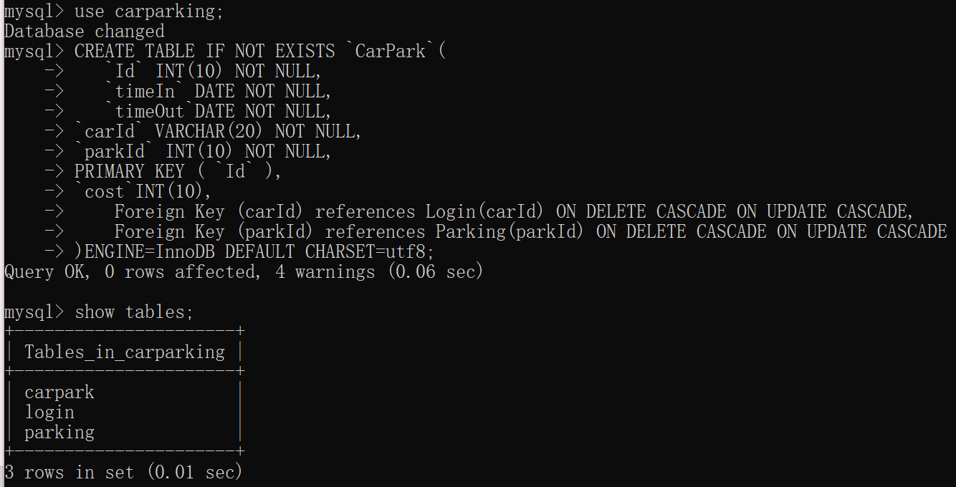

Table新建Washing

Use CarParking;

CREATE TABLE IF NOT EXISTS `Washing`(

`Id` INT(10) NOT NULL,

`timeIn` DATE NOT NULL,

`timeOut`DATE NOT NULL,

`carId` VARCHAR(20) NOT NULL,

`parkId` INT(10) NOT NULL,

PRIMARY KEY ( `Id` ),

`cost`INT(10),

Foreign Key (carId) references Login(carId) ON DELETE CASCADE ON UPDATE CASCADE,

Foreign Key (parkId) references Parking(parkId) ON DELETE CASCADE ON UPDATE CASCADE

)ENGINE=InnoDB DEFAULT CHARSET=utf8;

INSERT车位

Insert into Parking values (1,false,null);

Insert into Parking values (2,false,null);

Insert into Parking values (3,true,”京GO9822”);

Insert into Parking values (4,false,null);

Insert into Parking values (5,false,null);

Insert into Parking values (6,false,null);

Insert into Parking values (7,false,null);

insert into login values("粤AS3038","123234","vip","刘虎","19989768787","0");

insert into login values("京VC4536","123234","普通","王虎","10878768787","0");

触发器

CREATE TRIGGER trig1 AFTER INSERT

ON `carpark` FOR EACH ROW

UPDATE

login

SET

rewards = rewards+1

WHERE

New.carId = carId;

CREATE TRIGGER trig2 AFTER INSERT

ON `carpark` FOR EACH ROW

UPDATE

PARKING

SET

isEmpty = true,

carId = new.carId

WHERE

New.parkId = parkId;

CREATE TRIGGER trig3 AFTER UPDATE

ON `carpark` FOR EACH ROW

UPDATE

PARKING

SET

isEmpty = false,

carId = null

WHERE

New.parkId = parkId;

CREATE TRIGGER trig1 AFTER UPDATE

ON `carpark` FOR EACH ROW

UPDATE

LOGIN

SET

Rewards=rewards+new.cost

WHERE

New.carId = carId;