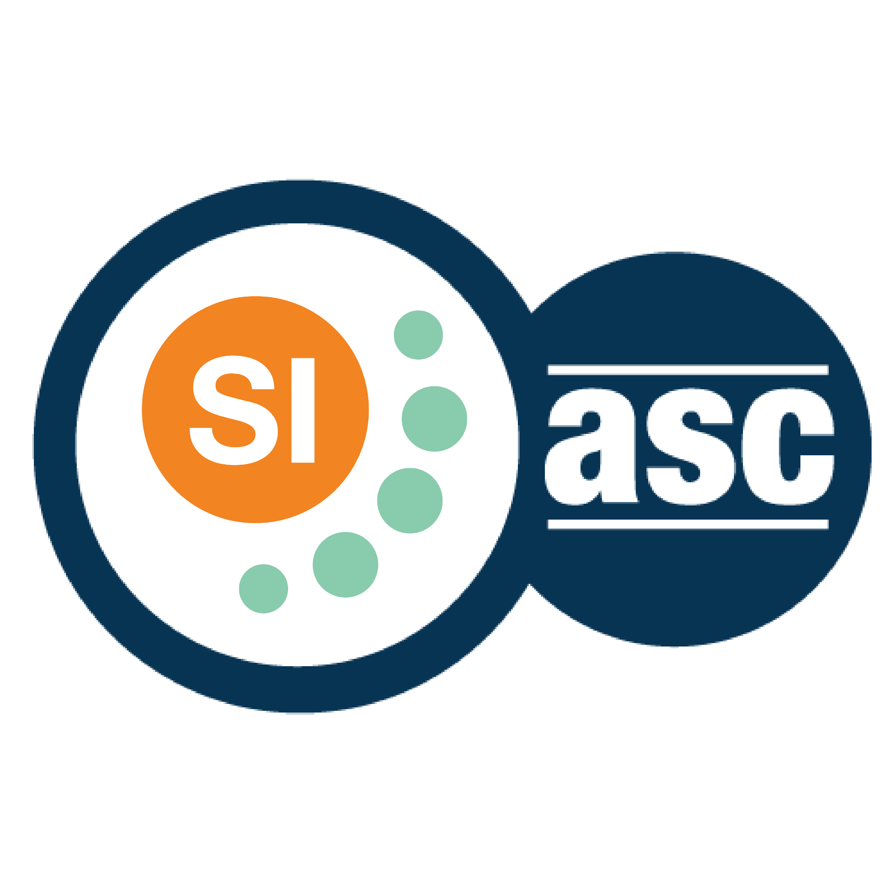

**SI SESSION PLAN**

|  |  |  |  |
| --- | --- | --- | --- |
| SI Leader: | Alex Iacob | Session Date: | 11/7/22 |
| Week #: | 12 | Session Letter: | B |
| Course & Section: | CSCI 141 Section 7 | Course Instructor: | Steele |
| Planning Date: | 11/7/22 | Planning Time: | 4:50 - 5 |

**Beginning reminders:**

1. Is the room set up in a way conducive to collaborative learning?
2. Is the agenda posted to the board for participants to see?
3. Do you have your attendance sheet up to record your attendance?
4. Do you have any other documents/resources up and ready to go for your session?

If you are all set with the reminders, then go have fun and good luck!

**Main concepts student should feel more comfortable with:**

* Exam 2

|  |  |  |
| --- | --- | --- |
| **Topics to cover** | **Process to use*:** | **Time** |
| **Opener:** Exam talk | Show them my exam and ask if they have questions about it that they want to go over | Variable time |
| Talk with the students | Nothing much planned, just talk with them for the hour | Remaining time |
| **Closer:** Shout out SI | Talk about what it is like being a SI for a little bit | 2-3 |

*\*Possible processes: puzzles, informal quiz, think-pair-share, paired problem solving, graphic organizers, cheat sheets, collaborative questioning, student summaries, reviewing notes, work at the board, vocabulary…*

**Ending reminders:**

1. Did you check everyone in?
2. Did you remind everyone of the next session and any upcoming tests or quizzes or due dates?

**What is one thing you want to emphasize during this session?** Please be specific.

* The exam is only worth a relatively small amount of the whole grade, so not doing as well as you may have hoped for is okay, try and do your best on the homework and labs.

**After session thoughts:** How did the session go? Is there anything you would like to keep/drop/change for next time and how?

* The session went very nicely. The students that came say they did pretty well on the exam and we mostly just talked about the CS1 class and other Freshman related things for the whole session.

**Bi-Weekly Question:** Is there anything you wish you knew before you joined the SI Program?

* I wish I knew how easy it was to forget to do paperwork, sorry PA’s ☹