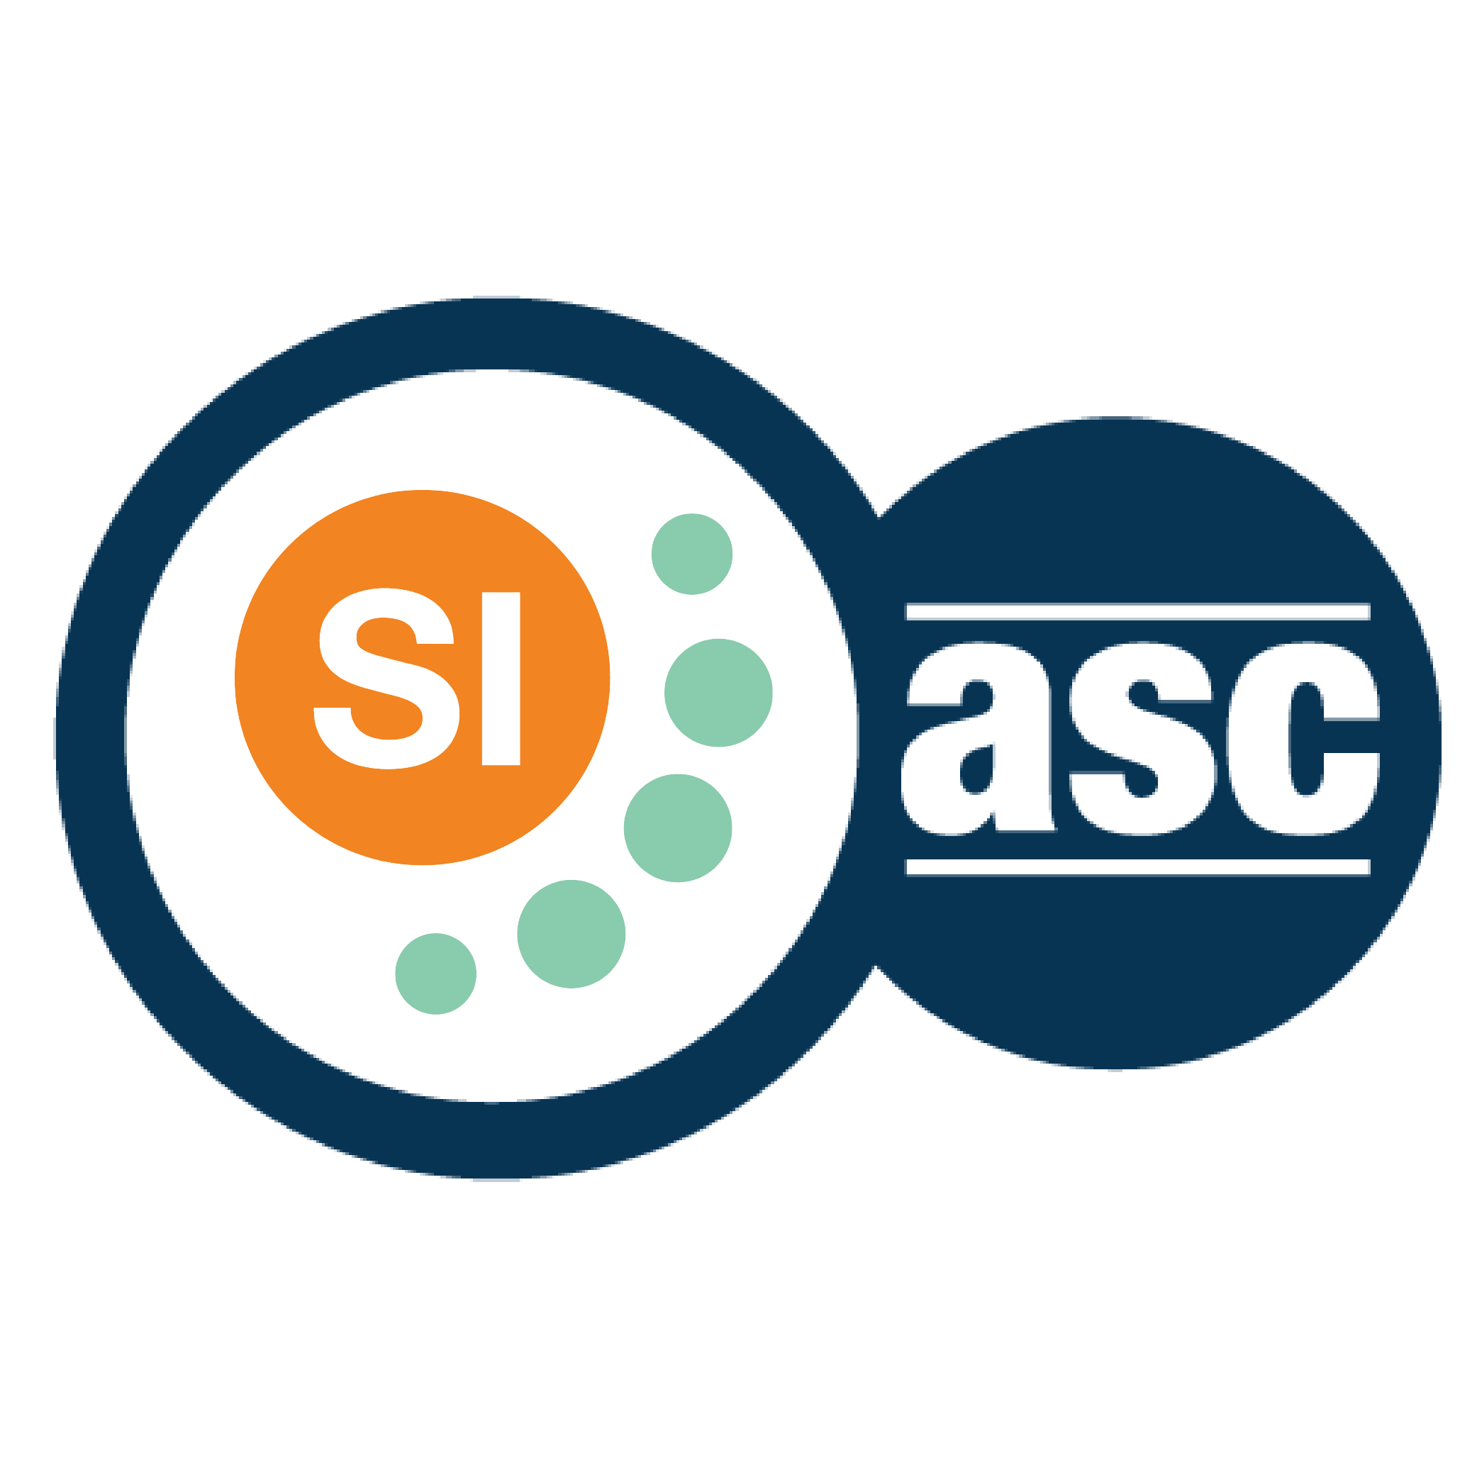

**SI SESSION PLAN**

|  |  |  |  |
| --- | --- | --- | --- |
| SI Leader: | Alex Iacob | Session Date: | 8/28/22 |
| Week #: | 2 | Session Letter: | A |
| Course & Section: | CSCI 141 – Section 7 | Course Instructor: | Steele |
| Planning Date: | 8/28/22 | Planning Time: | 12:40 - 1 |

**Beginning reminders:**

1. Is the room set up in a way conducive to collaborative learning?
2. Is the agenda posted to the board for participants to see?
3. Do you have your attendance sheet up to record your attendance?
4. Do you have any other documents/resources up and ready to go for your session?

If you are all set with the reminders, then go have fun and good luck!

**Main concepts student should feel more comfortable with:**

* Turtle movements: forward, backward, left, right, penUp, penDown, etc
* Basic python function definition and when to use them

|  |  |  |
| --- | --- | --- |
| **Topics to cover** | **Process to use*:** | **Time** |
| **Opener:** Short intros and the SI Constitution | I told my roommate that I had a SI session today and he said “hey you should parody the Preamble of the US Constitution as the intro, it should get some interesting feedback.  “ We the students of RIT’s CS department, in order to form a more perfect codebase, establish good formatting, ensure few errors, provide for the common student, promote the knowledge of Computer Science, and secure the blessings of the graders, do ordain and establish the class for Ben Steele's CS1 section. ” – The Founding SI’s (probably)  Name, where you are from, one fun fact about yourself.  Hey I’m Alex, I was born in New York City, and I can legally marry people & operate a forklift. (Depending on the responses I get I might give short anecdotes of attaining such roles) | 5-10 |
| Shout out SI once again | Review what my role is as the SI leader and what I can and cannot do.  I can:  Create two sessions outside of class time  Create exam review sessions  Participate during lecture and lab sessions  Promote peer facilitation to help students get to the answer  I cannot:  Provide answers for homework or lab assignments  Re-lecture everyone about the given topic(s) | 2-3 |
| Brain dump with python turtles | Review how to create a short, running python script of creating a simple shape and trying to shorten it using function definitions.  Probably the best way to get interaction here is to have each person say a consecutive line and create the program line-by-line and make adjustments afterwards.  I know a lot of them had issues with filling in shapes, so whatever shape they decide to create will just be filled in with an arbitrary color. | 35-40 |
| Show how methods are meant to work using cards | (Kudos to Asha for showing this during Saturday’s CS cohort meeting; she made everyone give her two markers (of different colors) and give us back one marker of a different color).   I have a deck of cards and I am going to give each person two cards, make them come up one by one, and give them back a new card. By subtracting the values of each card, this shows defining a function and using parameters to create a fruitful function. | 5-10 |
| **Closer:** Reminder of the next SI session | Mondays in Monroe 2030 from 5 to 6 It will be based on the content of the next lecture. | 2-3 |

*\*Possible processes: puzzles, informal quiz, think-pair-share, paired problem solving, graphic organizers, cheat sheets, collaborative questioning, student summaries, reviewing notes, work at the board, vocabulary…*

**Ending reminders:**

1. Did you check everyone in?
2. Did you remind everyone of the next session and any upcoming tests or quizzes or due dates?

**What is one thing you want to emphasize during this session?** Please be specific.

* Where to find resources, like the tutoring center, the SLIs, the cs1 website, and the internet.

**After session thoughts:** How did the session go? Is there anything you would like to keep/drop/change for next time and how?

* Jon Cruz has NRH 1250 right before me, so I got to peek in and see how his session was going; kudos to him to getting that many students day 1 for GCIS!  
    
  The session went pretty well, a little less students came than I expected, but that is fine, it just means that I can focus more on each individual student. There was a lot of brain-dump which I am going to keep on using since it made some conversations start up.

**Bi-Weekly Question:** How did your introduction to faculty and students go?

* Prof. Steele remembered me well enough from last yet so my intro to him was a short handshake and sharing anecdotes of the previous year. Last year’s intro went better than this year’s. Steele gave me a short intro and as soon as I got up to give my intro to everyone, my brain forgot everything that I had prepared; I fumbled over my words a few times but still got the important points across.