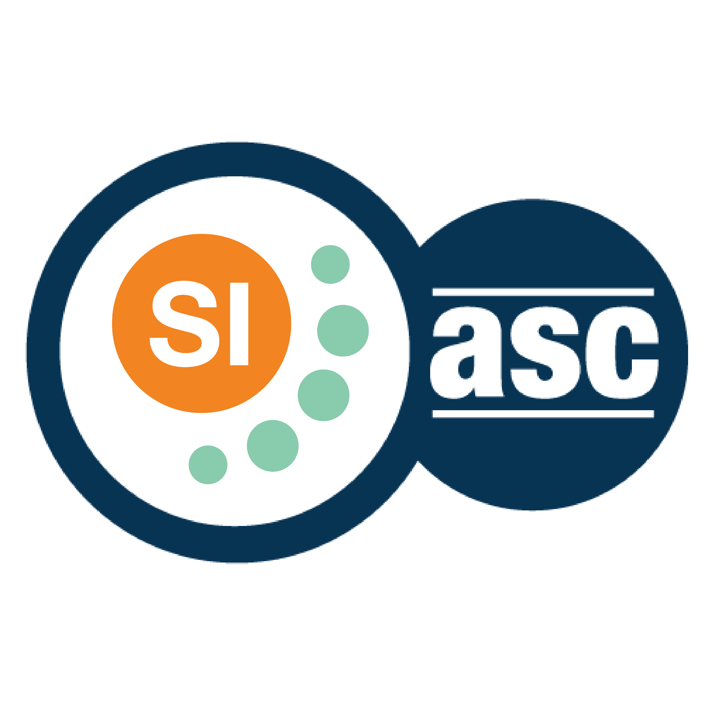

**SI SESSION PLAN**

|  |  |  |  |
| --- | --- | --- | --- |
| SI Leader: | Alex Iacob | Session Date: | 8/29/22 |
| Week #: | 2 | Session Letter: | B |
| Course & Section: | CSCI 141 Section 7 | Course Instructor: | Steele |
| Planning Date: | 8/29/22 | Planning Time: | 4:40 - 5 |

**Beginning reminders:**

1. Is the room set up in a way conducive to collaborative learning?
2. Is the agenda posted to the board for participants to see?
3. Do you have your attendance sheet up to record your attendance?
4. Do you have any other documents/resources up and ready to go for your session?

If you are all set with the reminders, then go have fun and good luck!

**Main concepts student should feel more comfortable with:**

* Execution Diagram
* Call stacks
* If name == main
* If statements and conditionals

|  |  |  |
| --- | --- | --- |
| **Topics to cover** | **Process to use*:** | **Time** |
| **Opener:** Being specific | Make any sandwich you want with a painful amount of detail. This reminded me of the common “Give me the steps to make a PBJ sandwich” where the only correct answer is to have the first step as “Create the universe”  This emphasizes the need to be extremely specific with the code, since the computer will listen to you *exactly*. | 10-15 |
| Conditionals with cards | Review if, elif, and else statements using playing cards.  Emphasize the syntax exactly. I assume there are going to be students who forget to indent, forget to put the colon, or maybe even forget the elif part.  Write a short program such that if the given card is under 10, it goes in one pile, exactly 12 goes into another pile, then everything else goes into a third pile  (using parenthesis around the condition isn’t necessary in python but it is a good habit to get into cause other languages require it)  if (card > 12):  print(‘first pile’)  elif (card == 12):  print(‘second pile’)  else:  print(‘third pile’) | 10-15 |
| Steele’s love for the non-programming aspects of this course | From experience, Steele loves putting a bunch of non-programming questions on his exams, like diagramming and definitions, so getting them used to his early will help them on exams.  The two that were reviewed this week were Call Stacks and Execution Diagrams.  Call stacks are pretty easy, they are just the order in which functions are called in a stack format, where execution diagrams are checking the design of the program on paper.  It is important to emphasize that these diagrams are here to catch potential issues with the program before it is even written. I can probably talk about some co-op experience with the number of hours I could have saved if I made specific diagrams to help instead of just making diagrams for the sake of making them. | 15-20 |
| **Closer:** The stick figure stack | Make a stick figure using turtle and then create a call stack based from how you made the stick figure. This will vary from person to person.  One can look like:  |draw_legs() |  |draw_arms() |  |draw_body() |  |draw_head() |  |main() | | 10-15 |

*\*Possible processes: puzzles, informal quiz, think-pair-share, paired problem solving, graphic organizers, cheat sheets, collaborative questioning, student summaries, reviewing notes, work at the board, vocabulary…*

**Ending reminders:**

1. Did you check everyone in?
2. Did you remind everyone of the next session and any upcoming tests or quizzes or due dates?

**What is one thing you want to emphasize during this session?** Please be specific.

* Where to find resources, Tutoring Center, the SLIs, the CS1 website, and the internet

**After session thoughts:** How did the session go? Is there anything you would like to keep/drop/change for next time and how?

* I had a one-on-one session for the first time, it was pretty awkward to say the least since I haven’t had one before, though I tried to maintain conversation as well as I could. I was also coughing a bit during the session so that was fun and luckily for me I tested positive for Covid the day after :) .

**Bi-Weekly Question:** What is one thing you are looking forward to this semester with your SI class?

* I’m mainly looking forward to getting a few regulars like I had last year who actively reached out during Lab sessions. I had 2 main regulars since the beginning of the semester last year who always began conversation whenever they saw me. Now honestly, the class is dead silent all the time. Before I was given the gift of Covid by campus, I would try to talk to as many groups as possible, but I haven’t been able to go in person for Wednesday and Friday since I still tested positive. It sucks that I missed two solid days of interaction and likely the two sessions as well.