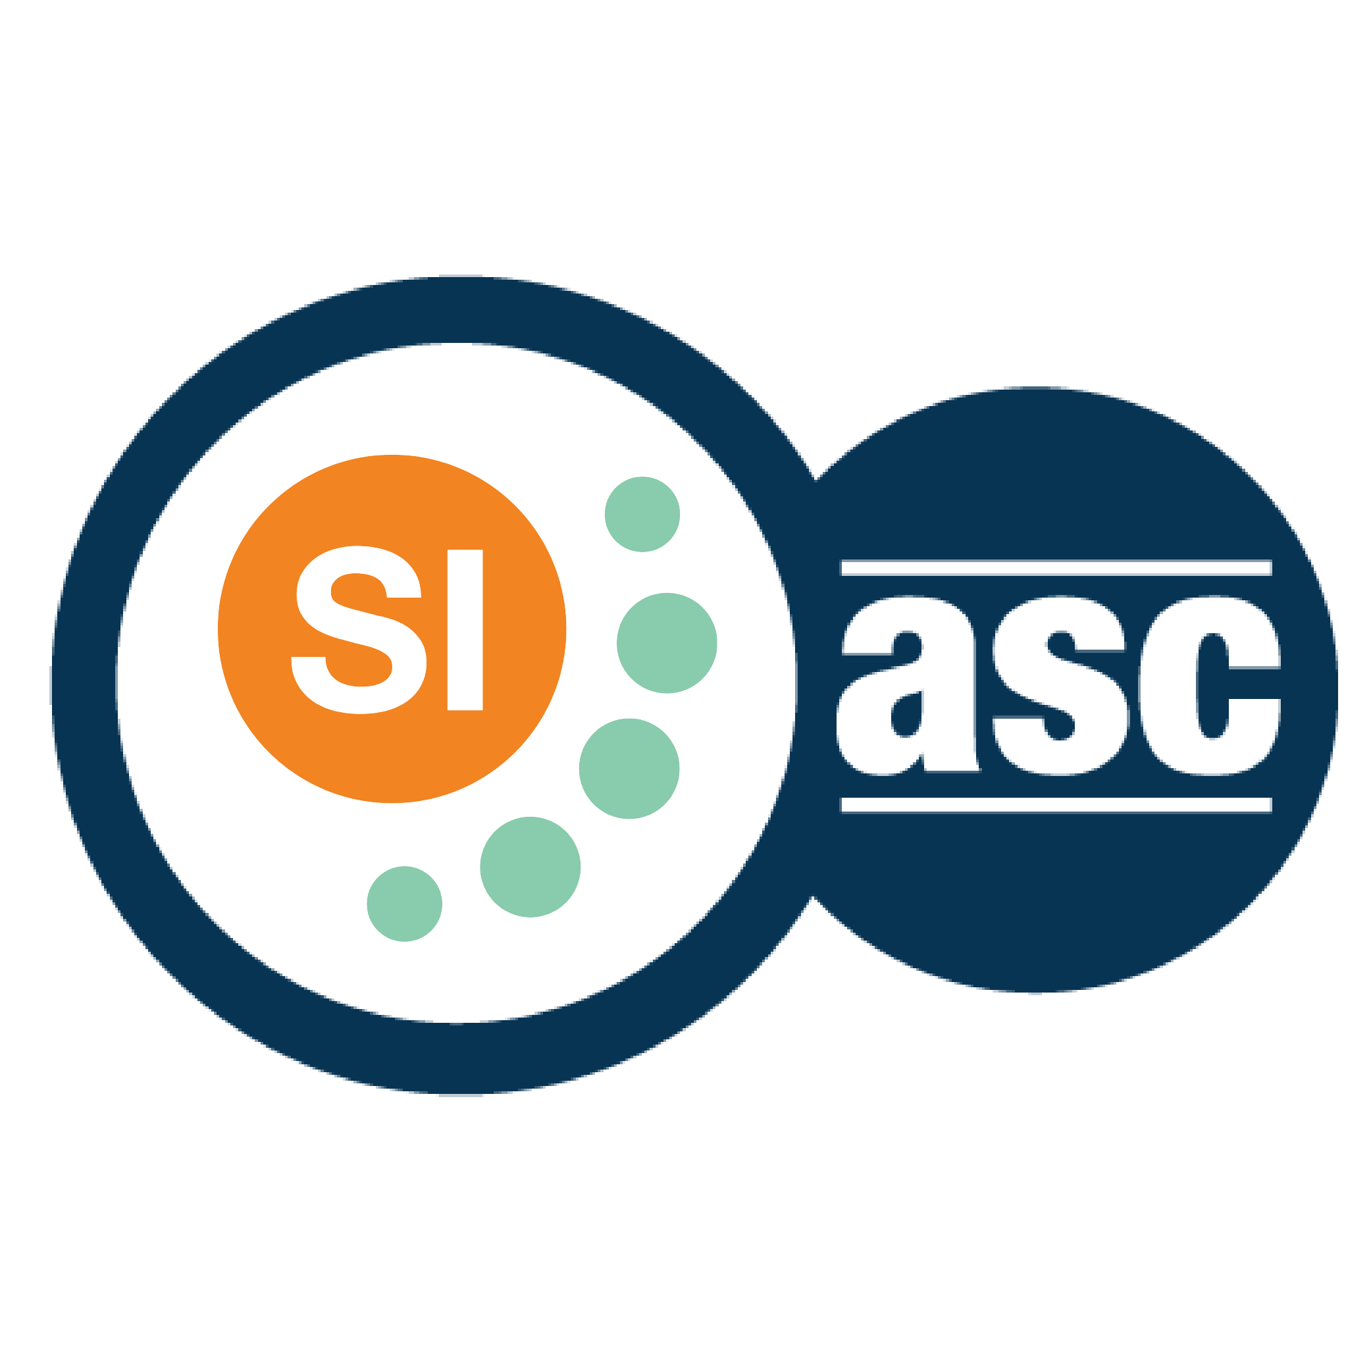

**SI SESSION PLAN**

|  |  |  |  |
| --- | --- | --- | --- |
| SI Leader: | Alex Iacob | Session Date: | 10/2/22 |
| Week #: | 7 | Session Letter: | A |
| Course & Section: | CSCI 141 Section 7 | Course Instructor: | Steele |
| Planning Date: | 10/2/22 | Planning Time: | 12:45 - 1 |

**Beginning reminders:**

1. Is the room set up in a way conducive to collaborative learning?
2. Is the agenda posted to the board for participants to see?
3. Do you have your attendance sheet up to record your attendance?
4. Do you have any other documents/resources up and ready to go for your session?

If you are all set with the reminders, then go have fun and good luck!

**Main concepts student should feel more comfortable with:**

* Every topic on the exam

|  |  |  |
| --- | --- | --- |
| **Topics to cover** | **Process to use*:** | **Time** |
| **Opener:** Musician’s top 5 | A causal opener to guess the artist’s current top 5 songs from Spotify | 10-15 |
| Review tough concepts and questions on the exam | I’ll show them my exam and we can review any concepts or questions that they want to go over | 30-40 |
| **Closer:** Sorting sneak peek | Show a short demo of merge sort, quick sort, and insertion sort | 10-15 |
|  |  |  |

*\*Possible processes: puzzles, informal quiz, think-pair-share, paired problem solving, graphic organizers, cheat sheets, collaborative questioning, student summaries, reviewing notes, work at the board, vocabulary…*

**Ending reminders:**

1. Did you check everyone in?
2. Did you remind everyone of the next session and any upcoming tests or quizzes or due dates?

**What is one thing you want to emphasize during this session?** Please be specific.

* One single exam is not the “end-all-be-all”, if they feel that they did not do that well,

**After session thoughts:** How did the session go? Is there anything you would like to keep/drop/change for next time and how?

* There wasn’t really a lot to go over, since they haven’t gotten their test back yet, so this session was casual.

**Bi-Weekly Question:** Do you have any feedback to share about the SI program? Improvements on paperwork? Attendance? Marketing? Weekly Trainings? Share all ideas!

* The SI program brings a lot of other light into the week, as I get to talk with more groups of people on a daily/weekly basis. Friday trainings are enjoyable and a nice way to end the week.
* Probably the only negative thing I have to say about SI is how easily forgettable the paperwork is. I can usually just have some mental notes of what things I want to cover for the session.