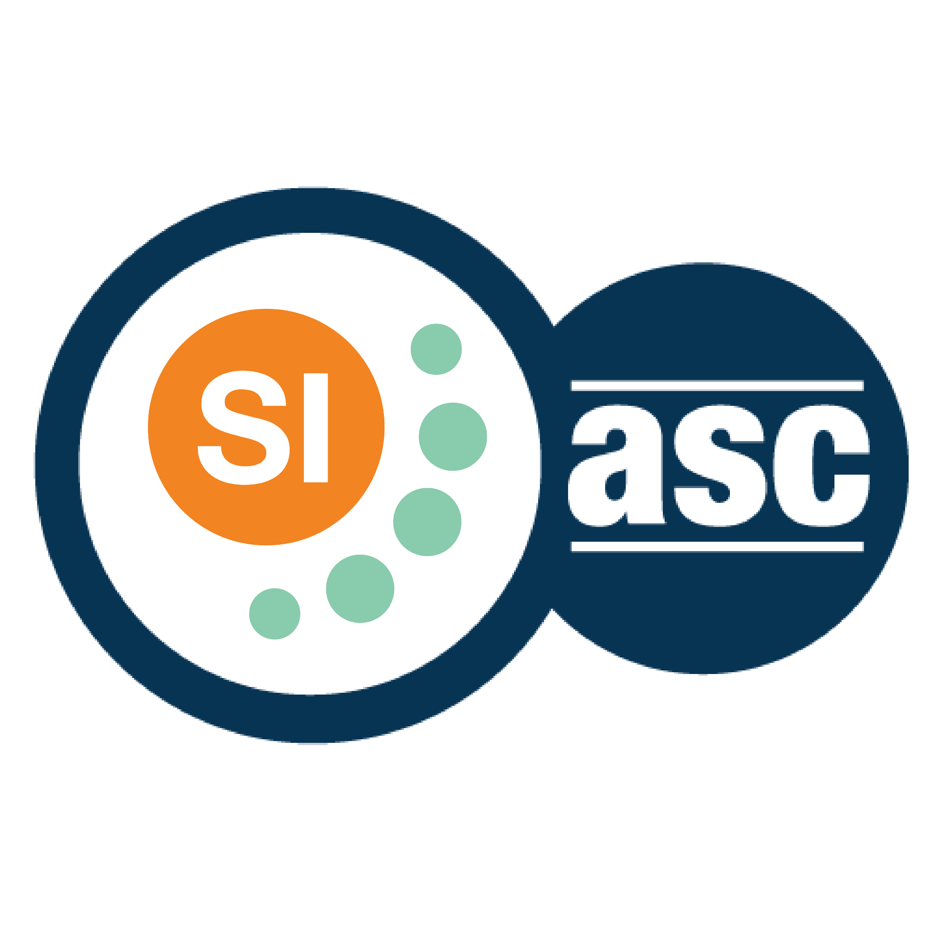

**SI SESSION PLAN**

|  |  |  |  |
| --- | --- | --- | --- |
| SI Leader: | Alex Iacob | Session Date: | 10/3/22 |
| Week #: | 7 | Session Letter: | B |
| Course & Section: | CSCI 141 Section 7 | Course Instructor: | Steele |
| Planning Date: | 10/3/22 | Planning Time: | 4:45 - 5 |

**Beginning reminders:**

1. Is the room set up in a way conducive to collaborative learning?
2. Is the agenda posted to the board for participants to see?
3. Do you have your attendance sheet up to record your attendance?
4. Do you have any other documents/resources up and ready to go for your session?

If you are all set with the reminders, then go have fun and good luck!

**Main concepts student should feel more comfortable with:**

* Exam topics

|  |  |  |
| --- | --- | --- |
| **Topics to cover** | **Process to use*:** | **Time** |
| **Opener:** As for opinions | As everyone what they thought of the exam and practical. | 2-3 |
| Review the exam | Look over the exam and review problems that they had issues with now that they have it back.  Open entirely to the students | 25-30 |
| Review the practical | Look over the practical and get their opinions on how they think they did  Again open entirely to the students | 25-30 |
| **Closer:** Where to get help | Prof. Steele, the SLIs, the tutoring center, the internet, and each other. | 2-3 |

*\*Possible processes: puzzles, informal quiz, think-pair-share, paired problem solving, graphic organizers, cheat sheets, collaborative questioning, student summaries, reviewing notes, work at the board, vocabulary…*

**Ending reminders:**

1. Did you check everyone in?
2. Did you remind everyone of the next session and any upcoming tests or quizzes or due dates?

**What is one thing you want to emphasize during this session?** Please be specific.

* The exam and practical are only a small portion of the whole grade, it is not the end of everything if you feel that you did not do that well.

**After session thoughts:** How did the session go? Is there anything you would like to keep/drop/change for next time and how?

* I had two new people come to the session. Both of them came in the exam review session and they mentioned that they wish that they had come to ones before, which was very nice to hear.

**Bi-Weekly Question:** What resources are available for students in your course outside of SI? Have you encouraged students to utilize resources that may be beneficial for them?

* I have probably ended every session with having my students recite places they can get help. This includes the internet, Prof Steele’s office hours, the tutoring center, the SLIs, and each other.