Alex Iacob

Prof. Kinsman

CSCI 431

September 15, 2022

***Question 3:***

*I am not very photogenic and my hair is currently a mess*

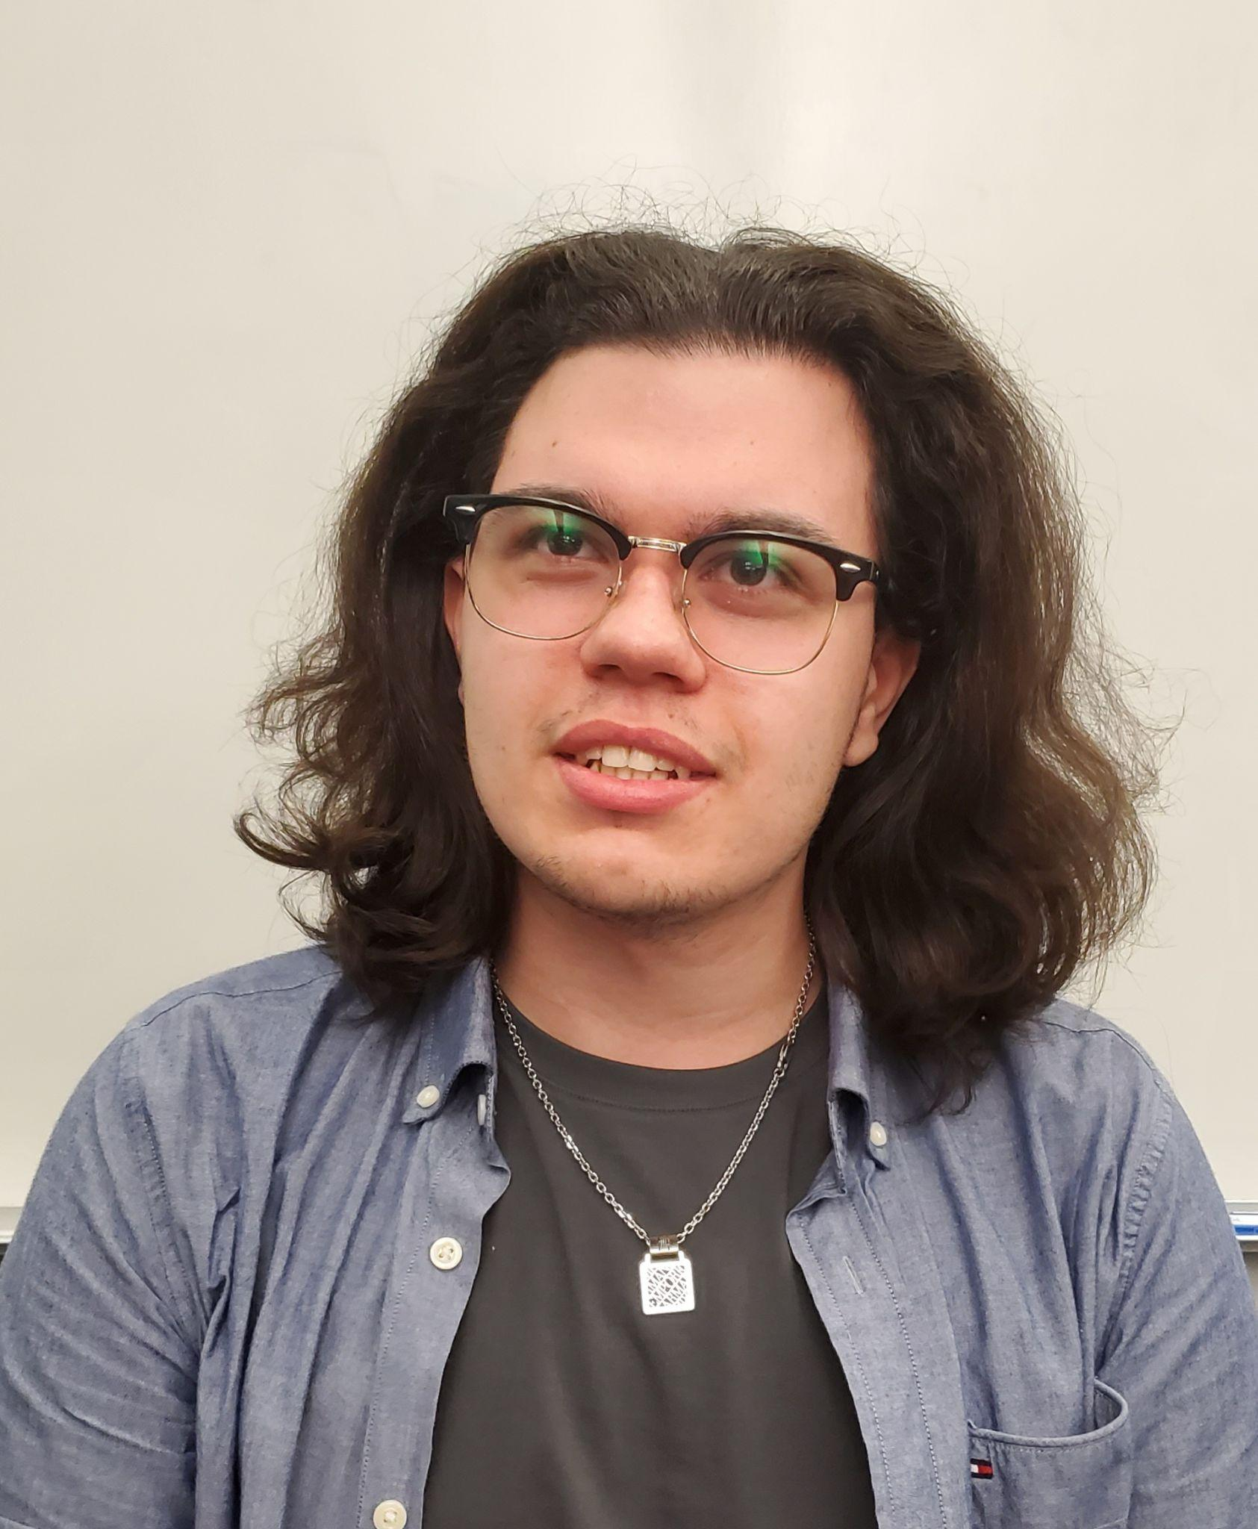

***Question 6:***

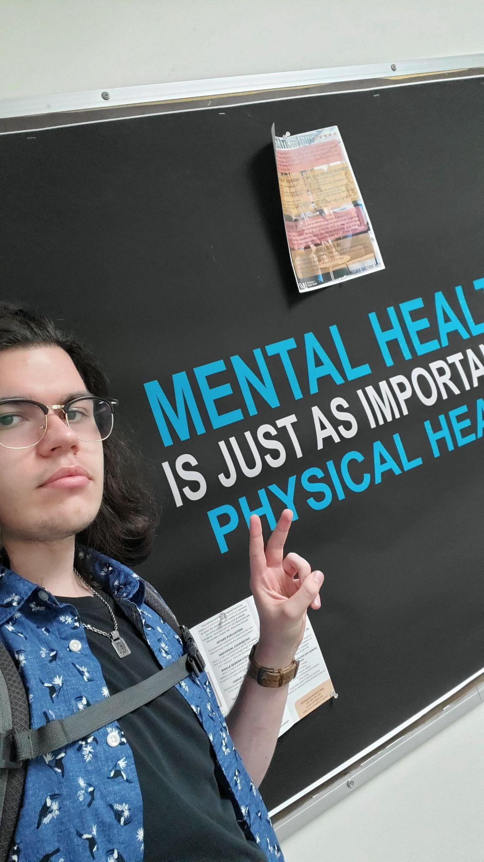

Question 7:

To make an appointment, you can call 585-475-2261

For emergencies, you can call