Alex Iacob

Prof. Kinsman

CSCI 420

September 18, 2022

Homework 1: Otsu’s Method

***Question 1:***

1. Although I personally don’t really have many ethical issues with it, a good consensus is when police officers notice someone is going over the limit, but not enough to warrant a speeding ticket. In most cases, this is usually when a person is driving < 10 miles over the speed limit. However there is also the case when people drive faster to follow the flow of the road, such as having a cluster of vehicles over the speed limit. Given this, if current police officers do not stop entire hordes of cars due to them driving slightly over the speed limit, then I do not have ethical issues with doing so.
2. My ethical considerations would not change since this is basically a more advanced speed trap. Reckless drivers pose a threat to other drivers and they would get caught by speed traps already in the area regardless.
3. The calculated ideal speed threshold is 62.
4. The calculated minimum mixed variance is 7.558.
5. The program would handle ties by utilizing a different calculation method.
6. 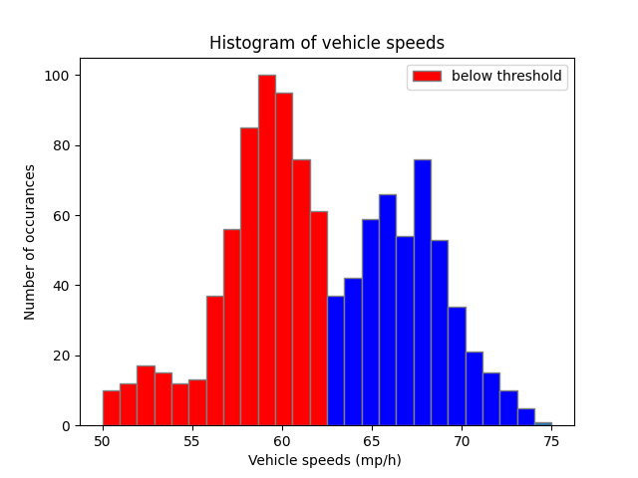

***Question 2:***

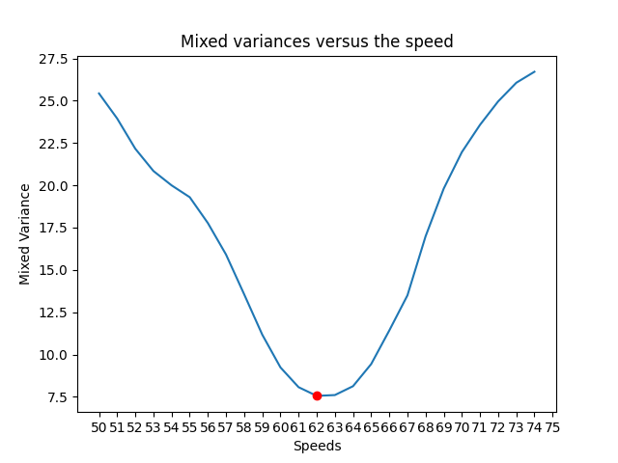

***Question 3:***

The regularization method leads to a very slight difference in the variance and threshold. The variance is approximately within 7% of each other while the thresholds are one off of each other. This leads me to believe that these two methods produce nearly identical results

OTSU: the variance is: 7.558354575262905

OTSU: the threshold is: 62

REGULARIZATION: the variance is: 8.071363511327327

REGULARIZATION: the threshold is: 61

***Conclusion:***

Throughout this assignment I revisited Python for the first time in a year or so. It was a pretty pleasant experience in comparison to writing only in Java/Dart during my co-op. I did have to rely quite heavily on external libraries to get the main functionality going, however I quickly picked up on NumPy and some Pandas. Though most of the assignment was implementing the given pseudocode, the devil was in the details. The pseudocode didn't mention actually formatting the giant array that we needed to get working prior nor mention specific plotting details. I honestly thought it was a nice way to increase some code diversity.

I started off by easily reading in the information file using part of the pandas library. After I got this data, I decided to use a dictionary to store this information such that the key was the unique speed and the values were every instance of that given speed. This allowed me to more easily run the regularization and Otsu’s method on them. Running Otsu’s method on them allowed me to easily split the array and then compute their weights and variances. When later calculating for the ideal threshold, I ran into an issue where I was not able to plot the appropriate histogram of the speeds. I remembered previously that I had the unique speeds saved in my original dictionary. Most of the difficulties of this was the initial understanding of how to implement the methods, to which I solved by spending an hour or so planning everything out on a few whiteboards. After completing, I had learned that the regularization method and the otsu method returned nearly identical results.

I got to work with Benson Yan and Nick Chen for this assignment. We were able to discuss the ideas and help each other work bugs out of our code. Collaborating with them allowed me to find issues with my code that I would not have resolved in a reasonable amount of time. Just as a general comment, I am very glad that it is directly mentioned in the assignment to look over at each other’s work while still doing your own; most other professors would never even think to say something like this and it significantly helped my understanding of the material. More classes should encourage working together like this instead of treating any degree of collaboration as a taboo.