Alex Iacob

Prof. Kinsman

CSCI 420

September 25, 2022

***Question 1:***

Looking at the given graph in the writeup, I first notice that we are able to plot multiple plots in a single graph to more accurately see the relationship between them. I also noticed that there were parts of the graph that avidly overlapped. This shows that it is possible to drive aggressively at a lower speed and drive safely at a higher speed.

***Question 2:***

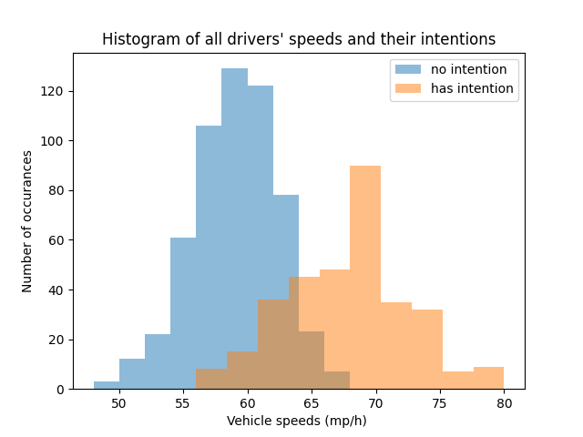

Looking at this graph, we can say that the mixture is crisp, as a person is either speeding or not, they cannot be “partly speeding” or “partly not speeding”. Choosing the threshold of 64 mp/h resulted in the least amount of false positives and false negatives. This is resulted by the driver’s intention to speed or not, though regardless of their intention, they are ultimately not speeding or speeding

***Question 3:***

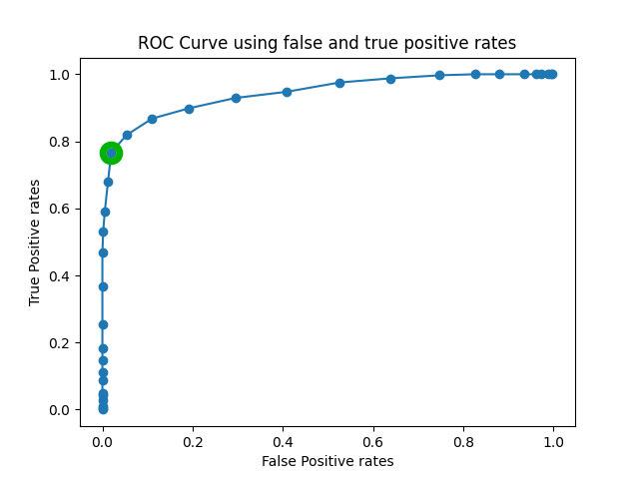

The ROC graph shows a pretty noticeable ideal point. I highlighted it in green as my last name starts with an I.

***Conclusion:***

Throughout this assignment, I firstly noticed the similarities between what we were currently doing and Otsu’s method. I was also pretty surprised to learn that you can plot multiple histograms on the same graph, as shown in the histogram of every driver’s speed and their intention. Also speaking with others about this, many have said that this histogram can be labeled as a crisp graph and just as many said that it could be a fuzzy graph. I personally said that the data was crisp as ultimately, the entire population could only have one distinct classification, whether they were speeding or not.

Many have argued that it is possible for this data to be fuzzy as due to the overlap in data, it was possible to say that a safe driver can drive at higher speeds and a reckless driver can drive at lower speeds. Though in the case of a police officer/ticketing system, they cannot tell for absolute sure of the driver’s intentions. For example, a safe driver can argue that their high speed was perfectly fine, though an officer/ticketing system cannot guarantee this as the driver could lie to the officer. Also in the opposite scenario, any reckless driver pulled over/fined can argue that their infraction was not warranted as their speed was under the limit, considering that they actually were under the limit.

The main challenging aspect of this assignment was learning how to format the data the first way through to avoid significant confusion later on. The first iteration of everything was extremely messy and wrong, as I did not maintain my data correctly and this made my ROC curve fall entirely into the coin toss line. I learned that for the ROC curve it would be easiest to maintain a dictionary of the true/false positive rates and their given threshold.