Alex Iacob

Prof. Kinsman

CSCI 431

September 7, 2022

Homework 1

***Question 1:***

Matlab version = 9.12.0.2009381 (R2022a) Update 4

Matlab License number = 364896

MATLAB Version 9.12 (R2022a)

Image Processing Toolbox Version 11.5 (R2022a)

***Question 2:***

The person’s nose seems to be around Column 530 and Row 400.

Column = 531.9905

Row = 397.0564

***Question 3:***

The worst channel is the Blue channel. Some of the background has the Moire effect going on, a strong white outline all around the person, and there is text that was unseen in the other channels that says “Greetings fellow earthlings!” and “Iron this shirt!”. Upon a bit of research, this is referred to as steganography, where a message is hidden in the artifacts of a larger image.

***Question 4:***

I am clearly very photogenic (sarcasm) and my hair was in perfect condition (more sarcasm).



***Question 5:***

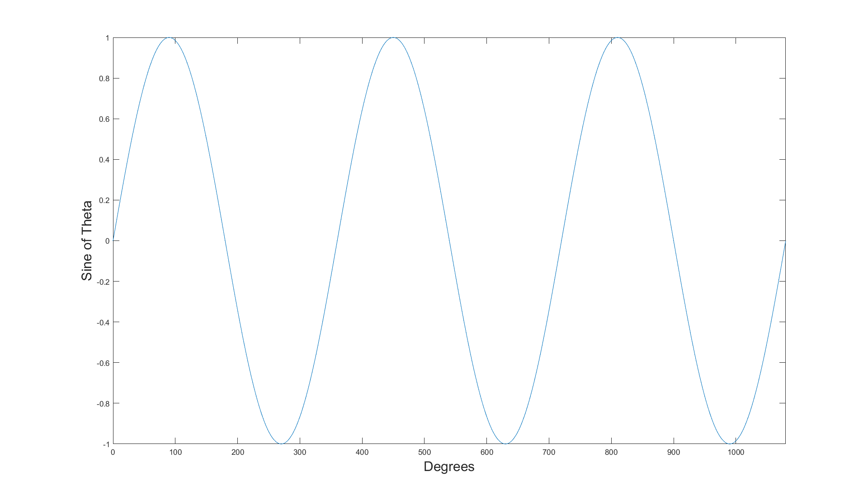

***Conclusion***

During this assignment, I had learned more of the Matlab methods that were used in the first homework assignment. For example, utilizing the function *imwrite()* to save an updated image, like the one in question 4. I also learned how to more accurately use *ginput()* to get the user’s direct mouse input. I wanted to remove the guesswork of having to approximate where the bounds should be for the sliced image so I remembered during a lecture when Prof. Kinsman used *ginput(n)* and I applied it in my code. The biggest obstacle was simply getting the coordinates to work correctly, as I forgot that Matlab considers the top left corner the origin rather than the bottom left, as I was accustomed to from years of mathematical graphing.

With the third question, I had learned about the concept of steganography, which is the ability to hide a secret message in plain sight. In this case, there was text hidden in the student’s shirt and background that was only seen in the blue channel. Upon doing a little research on this topic, a reasonable way to accomplish a task as such is to subtly change the pixels on the blue channel just enough to where it is indiscernible when the full image is shown. A video on this topic used an image of a tree to hide Shakespeare’s work by only manipulating the last two bits in each pixel. It seems like an interesting topic to continue researching into.