Alex Iacob

Prof. Kinsman

CSCI 431

September 25, 2022

***Question 1:***

Matlab version = 9.12.0.2009381 (R2022a) Update 4

Matlab License number = 364896

MATLAB Version 9.12 (R2022a)

Image Processing Toolbox Version 11.5 (R2022a)

***Question 2:***

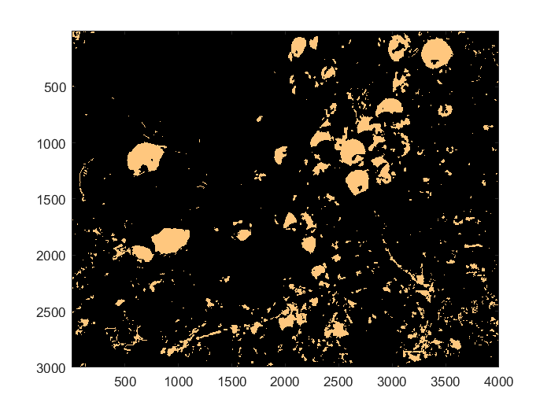

I used the a* layer from using *rgb2lab()*. Then from there I thresholded the function to remove some of the noise from the image. At that point, I still realized that there was a lot of noise, so I used the median filtering function that I used previously to clean up some noise.

***Question 3:***

1. The picture was taken September 6th, 2022 at 7:05 PM
2. The aperture value is 5.3750 and the FNumber is 6.3
   * Learned about a relationship between the two values:   
     ApertureValue = 2 * log₂(FNumber)
3. The ISOSpeedRating is 3200
4. The Components configuration is ‘YCbCr’
5. A flash was fired off in this image.
6. There was a focal length of 51.

***Question 4:***

According to a few papers about psychology, the Stroop effect is the time difference between “automatic and controlled processing of information.” The given image shows Prof. Kinsman’s wife wearing a shirt that displays an example of this effect. The shirt has the words “RED, GREEN, BLUE, YELLOW” all printed with different colors, for example the word RED is colored yellow. This can show the Stroop effect because we could be asked to read off the colors and how our automatic processing would first read the word then determine the color of the written word. I personally don’t see how this would complicate the homework because this situation only arises with our own brains since a computer does not have a delay in reaction time unless explicitly programmed to do so.

***Question 5:***

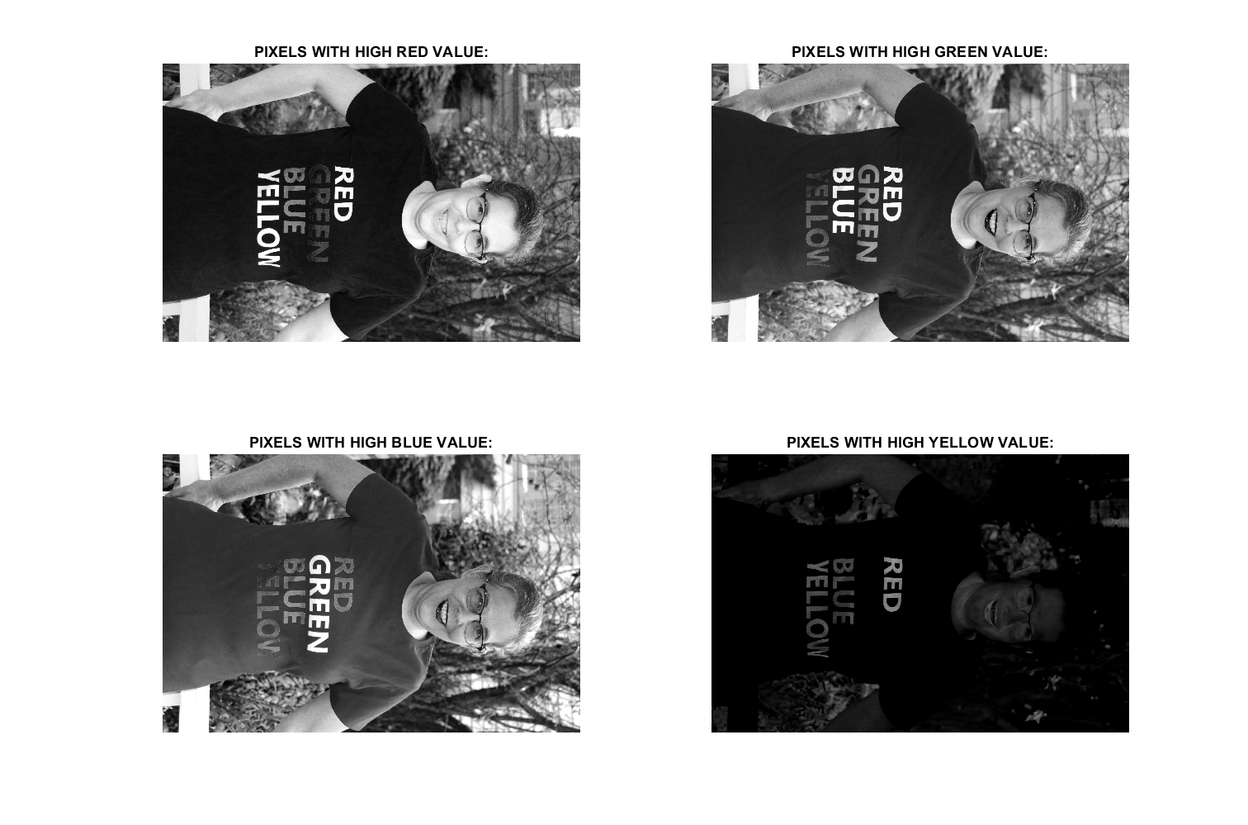

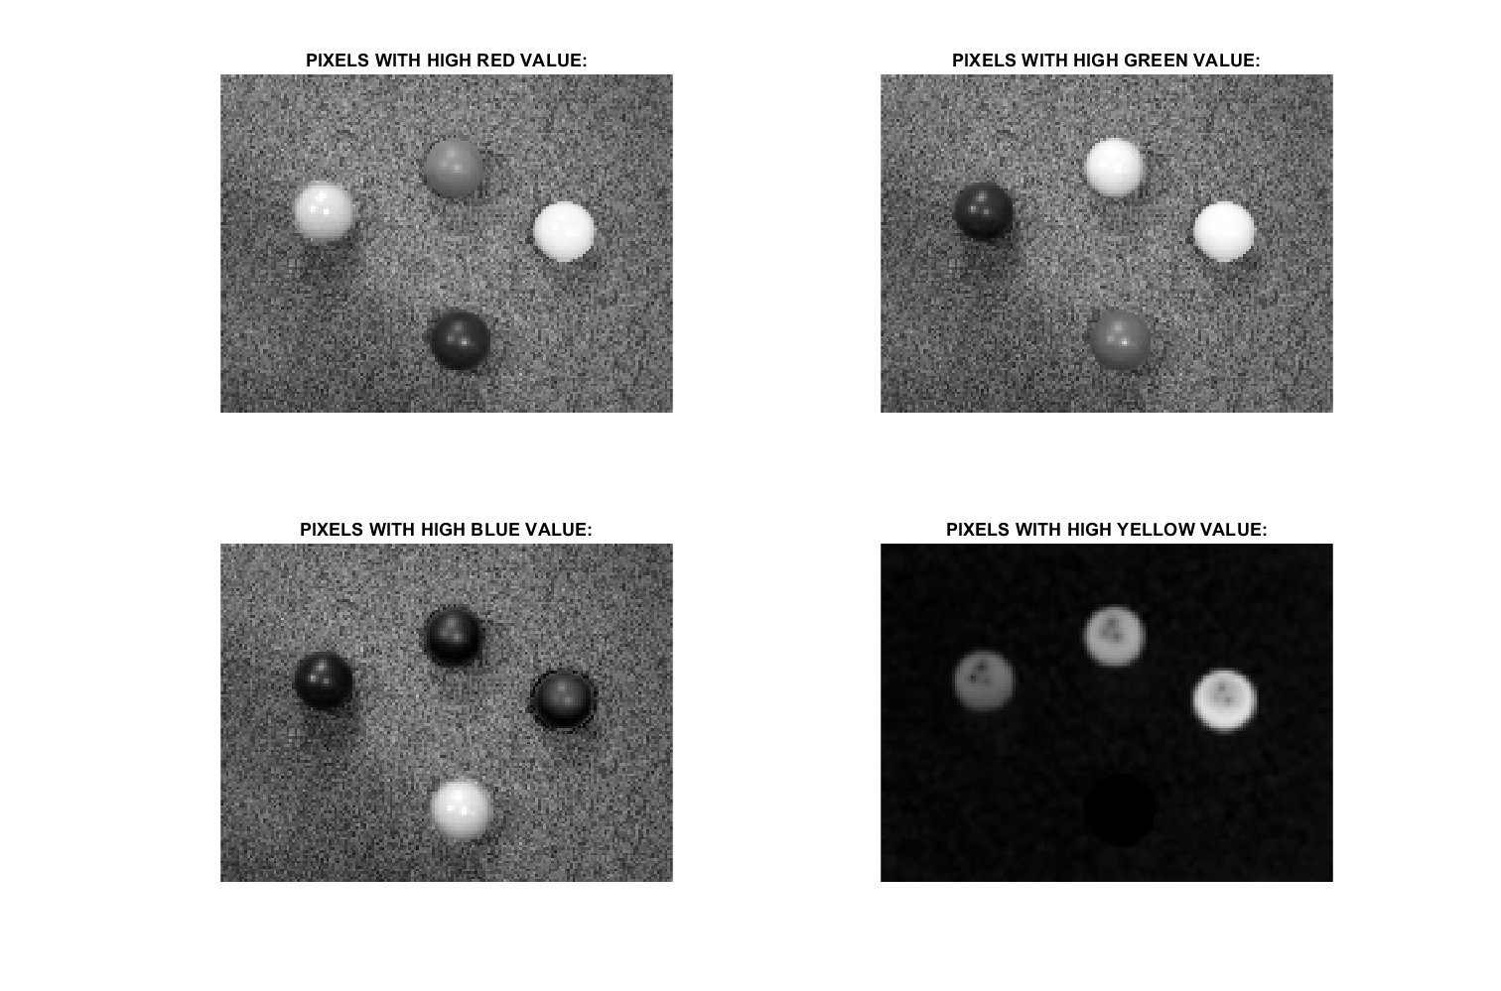

***Conclusion:***

There were parts of this homework that really proved to be a hurdle. It also turns out that starting very early on these assignments usually means that you don’t have all of the available information yet. I spent two days trying to figure out the second question just to find out that a possible solution would include using the materials learned in Thursday’s lecture, using the LAB sheet. I kept trying to use histogram equalizations and inverses of channels when I could have just used a FAR simpler solution had I just waited.

I also got to learn how to get more information from an image using *imfinfo()*. I never actually knew that the camera’s information and time of capture is stored in the picture’s metadata. This is a pretty cool thing to just know about for future reference to learn about what different aspects of a camera lead to which differences in the image. From there I learned about using subplots to see all of the available channels in the image to save time instead of viewing each channel separately.

Most of the things that were easier was understanding the Stroop effect and manipulating the channels through subplots. The Stroop effect was a concept that I learned about a few years ago but never learned the name. The shirt that Prof. Kinsman’s wife was wearing the ideal type of shirt for this effect. The different colors in the shirt allowed for a pretty clear understanding of the effect. I would say that overall the understanding of the concepts was not too bad since they were pretty straight forward and that trying to get everything done on the first day is probably going to mean that there are concepts that are going to be used in the homework that have not been taught just yet.