Alex Iacob

Prof. Kinsman

CSCI 431

November 15, 2022

*1. What 3x3 matrix did you use to fix your code?*

The only changed matrix was the matrix that held the original data points for the four corners of the sign.

*2. Why did you pick the resulting output image size and location? What research did you do? What did you consider?*

A very large majority of the code used was given by Prof. Kinsman and all that had to be changed was some coordinate values and the cropping aspect at the end.

*3. Show your fixed image in your write-up.*

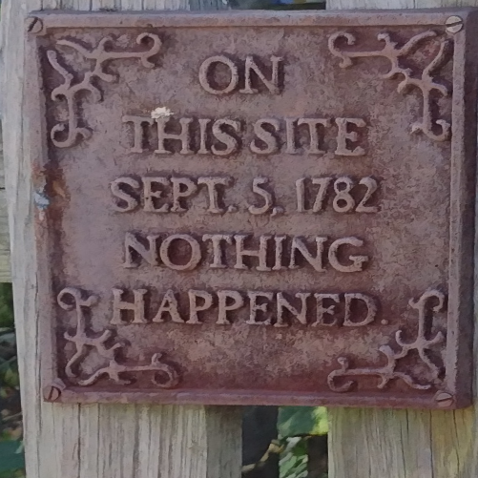

*4. Does your fixed image have holes or missing pixels in it?*

Luckily the image does not.

*5. Did the rectification process need to “invent” any pixels by using interpolation?*

Yes because the image must be stretched in certain areas. This stretching artificially creates more pixels in certain areas.

*6. Remember that you are trying to recover the fixed aspect ratio.*

Would there be an advantage of creating a smaller version of the resulting image?

A smaller version of the resulting image would have a more forgiving aspect ratio.

*7. Why might this be used before doing optical character recognition on a license plate?*

This can be used to get a skewed image to be straight again to more easily read the content of the license plate.

*8. Would it also help in understanding a Sudoku?*

I went and completed the Sudoku with a friend, because why not.

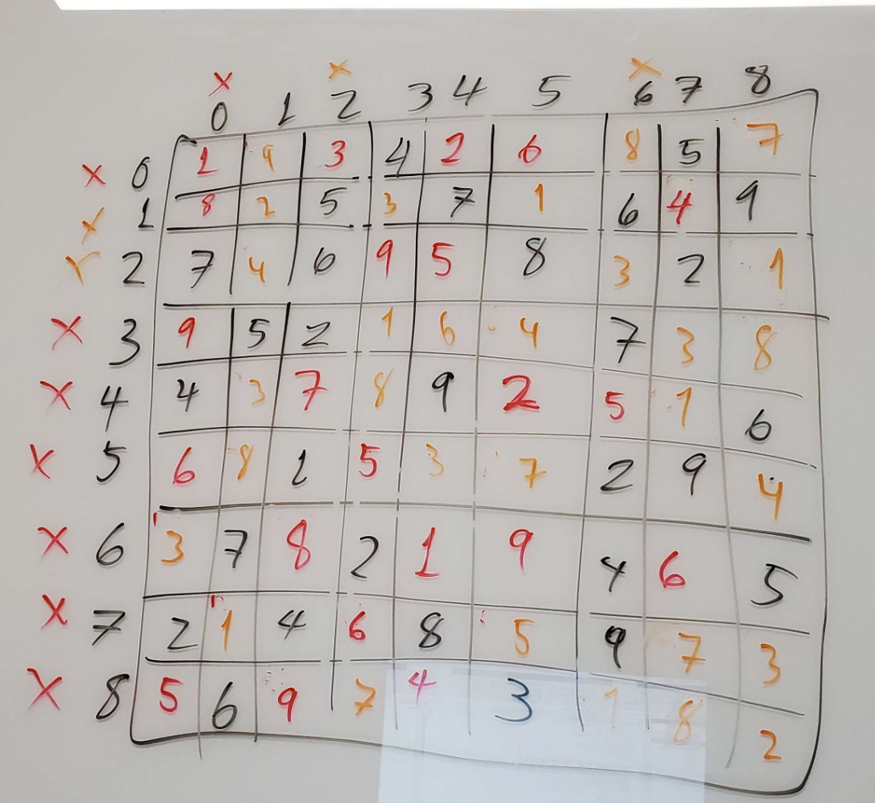

*9. What can you conclude?*

This was one of the assignments that felt very daunting originally, though the starter code provided a lot of starting potential. This led to a pretty quick resolution of the assignment. I got to learn about a few more Matlab functions that I did not know about before. For example, we used *fitgeotrans()* and *imwarp()* to set up the un-warping of the image. After unwarping the image, all that was left was to crop the image to show the results adequately. The image was saved and that was it. This assignment felt significantly lighter and doable mainly because of the starter code that Prof. Kinsman provided.