Alex Iacob

Prof. Childs

CSCI 471

September 28, 2022

Resume Assignment

**Thank You Letters:**

* *To HR*

Good morning <Name of person at HR>,

Thank you so much for your time today during the interview. I greatly appreciate the laid-back feeling you gave the entire process and how you were understanding of some of my oddities!

There were questions I wanted to ask during the interview but ran out of time, so here they are.

* What is the tech stack/what technologies are commonly used?
* If I relocate, are there any places that <Company name>interns are recommended to go?
* Can you give an example of a back-end intern's project?
* What is the balance of solo and group work for an average day for <Company name> interns?

Thank you and I look forward to hearing from you,

--

Alex Iacob

Computer Science '23 | Rochester Institute of Technology

alexiacob28@gmail.com

ai9388@rit.edu

* *To other Software Engineers*

Good morning <Name of person at the SWE team>

Thank you for taking the time to interview me! I appreciate the time you spent explaining the technologies used at <Company name> and how to solve the given problem when I was having some difficulties understanding. I believe that the scope and understanding of this role matches with my professional experiences and that I would be a great addition to the team.

I wanted to ask some more questions about what would be going on at <Company name>

* How strict are deadlines at <Company name> and how would you approach your manager about extending a deadline?
* What brought you to <Company name> and how have you enjoyed your experience here thus far?
* What other skills should I begin investing in to strengthen my work at <Company name>?

Thank you and I look forward to hearing from you,

--

Alex Iacob

Computer Science '23 | Rochester Institute of Technology

alexiacob28@gmail.com

ai9388@rit.edu

**Part 2:**

One thing that I took was ending the Thank You letters with some form of “good will.” For example, you have the option of ending the email with saying something like “Thank you” versus saying “Thank you for your time and I look forward to hearing from you.” The latter shows more interest in hearing back from the other person while also making yourself seem more amiable. From this, I have adapted my current endings to match this “good will” format.

**Cover Letter and Resume:**

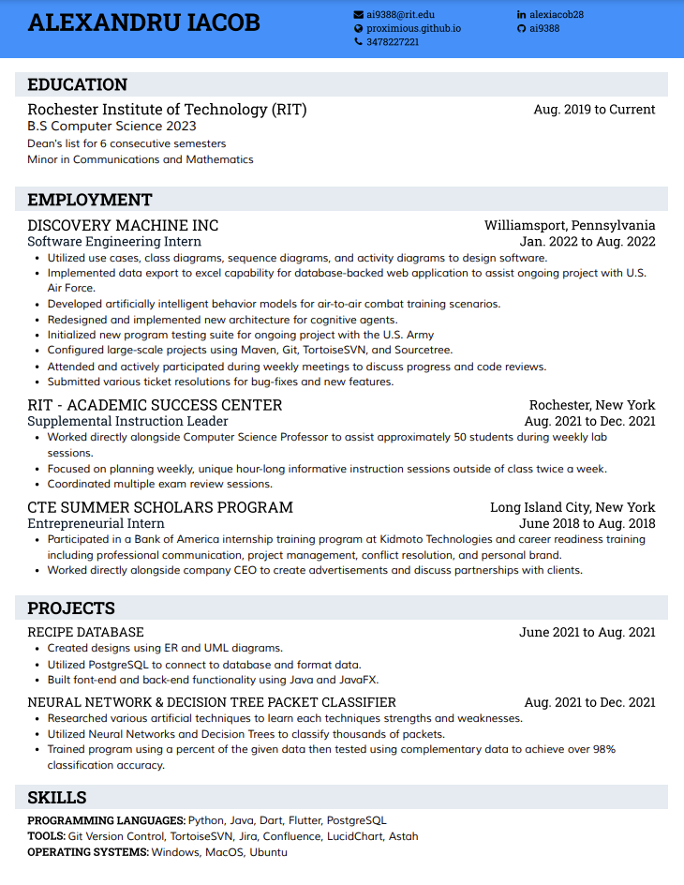

Dear HubSpot Recruiter,

Please consider my application for a software engineering position, as promoted on LinkedIn. I am currently a senior at Rochester Institute of Technology and will be graduating in December 2023 with a Bachelor’s Degree in Computer Science. My academic advisor encouraged me to apply to any software engineering or developer position within reach.

As you can see in my attached resume, I have a wide range of viable skills that would be an asset to the workplace. I also have avid experience with team projects and workplace communication. I have worked with Python and Java code adequately throughout college and have picked up databases recently. To populate these databases, I learned PostgreSQL and became more proficient as time passed. Upon completing this database project, I feel confident that I can provide great additions to the company’s database-driven motive. Also, while I was learning all of these new concepts, I was getting a fair share of web development experience using HTML, CSS, JavaScript, jQuery, and PHP. There is also a new position that I have picked up on my campus that would allow me to grow into a better technical leader. This position will allow me to liaise between the professor and the students while providing after-hour assistance to said students and provide assistance .

I have also recently had the pleasure of having experience on the field for a few months with Discovery Machine Inc. During this time, I was placed on an active team associated with an on-going project with the U.S. Air Force with the goal of exporting & formatting large amounts of data while also designing & creating separate UI elements using Dart and Flutter. I was able to learn the entire software engineering process down to the “nooks and crannies” of design documentation and specific style guidelines.

As a full-time student for nearly three straight years with no significant breaks, time management and organization have been areas that have constantly been improving. With the addition of managing classwork and technical work, I hope to develop my time management further. Also, during this management, I hope to partake in more individual and group projects to continue my personal growth as a developer.

I have honed my computer science skills from various classes and projects that I have completed for the past few years. Along with my skills in computer science, I have worked on a Minor in communication and mathematics to round my skill set even more. Although I am still learning, I can efficiently address the masses and the intrapersonal in and out of the workplace. I am confident that I will be able to fit into the position quickly and get accustomed rapidly.

If my application meets your requirements, please reach out via my phone number or email.

Sincerely,

Alexandru “Alex” Iacob

1-347-822-7221

[ai9388@rit.edu](mailto:ai9388@rit.edu)

alexiacob28@gmail.com