Tim Hsu

Professional Software Engineer

# Summary

Worked in software development for 18+ years. Started in Silicon Valley, then moved to HK. Majority time was a C++ developer but moved to C# .NET. Consider myself a fullstack developer focusing on financial markets.

Web [http://yeehsu.freeshell.org](http://yeehsu.freeshell.org/)

Email [zaken520@gmail.com](mailto:zaken520@gmail.com)

Phone 852 9273 7829

Address Yau Ma Tei. Hong Kong

# Professional Skills

C++ / C# .NET

OOP & Design Patterns

Data Structures & Algorithms

WPF, API, MVC, MVVM

Agile, CI/CD, TDD, SCRUM

IPC & Multi-threading

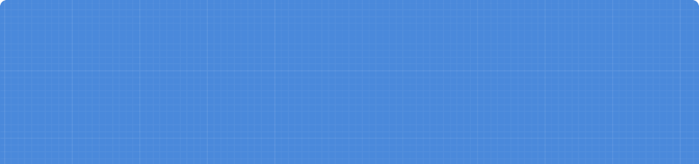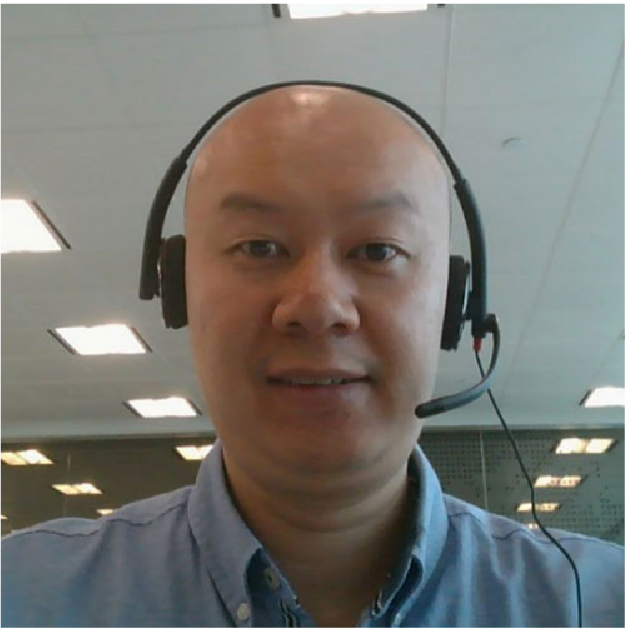

# Work Experience

Senior .NET Contractor [Randstad Hong Kong Ltd](https://www.randstad.com.hk/) - [Temus Ltd. FWD Hong Kong Ltd.](https://www.fwd.com/en/)

May 2023 - January 2024

Responsible for WebApi serverless backend development in C# .NET 6 for client FWD Implementation of all WebApi using AWS Cloud, RDS, S3, Api Gateway/Lambda, and Redis Cache Implementation of all related Engagement (Insurance) related activities on FWD OMNE App Requirements gathering, full SDLC on Agile, and full support on every sprint release

Senior Software Engineer [10kM Trading Ltd.](https://www.10km.com/)

April 2022 - November 2022

Lead agile team to develop high freqency-low latency Market Making services/strategies Lead the development of Market Data, OMS, FIX connectivity, WebUI, etc in C# .Net Core Developed quant and algorithms for real-time automated trading/hedging for Spot/Futures Developed in house hedger/executor for traders in C# WPF to easily liquidate crypto assets

Senior System Analyst [Sharp Point Ltd.](http://www.sharppoint.com.hk/)

January 2019 - March 2022

Developed new derivatives trading platform in C# .NET Core, WPF, Prism MVVM Developed FIX4.2 connectivity with brokers written in C++11, Boost ASIO

Wrote various micro-services in both C++/C#, C++/CLI, scripts

Implemented web services, web sockets, web api, windows services, AWS Secret Manager

Senior .NET Consultant [Avanade](https://www.avanade.com/en)

November 2017 - December 2018

Provided .NET consultancy to various fortune 500 clients, including Accenture

Used C# Web API 2.0, MVC, Message Queue, Asynchronous calls, MSSQL, MSUnit Worked in Agile/SCRUM methods including CI/CD, TDD, BDD, SpecFlow, refactoring Helped in DevOps, releases, Jenkins, JIRA, Confluence, Selenium, Microsoft Azure

Lead Analyst Programmer [Concord Pacific Satellite Technologies Ltd.](http://www.lead-fortune.com/)

November 2015 - June 2017

Lead cross-regional Agile team to develop GPS Fleet Management SAAS solution

Lead front-end development team using Javascript, JQuery, AngularJS, JSON, Bootstrap Revamped SOA backend using C# .NET, MySQL, TCP/IP sockets, threads, SOAP & WCF APIs Introduced to team: Agile, TDD, NUnit, MantisBT, SVN, GIT, Skype, Google Maps

Contrator / Developer [Global Talent Services Ltd.](http://www.global-talents.com/) - [Unisys Hong Kong Ltd.](https://www.unisys.com.hk/)

January 2015 - November 2015

Independant contractor implemented banking Signature Web Viewer Verification system Fullstack using VB/C# .NET, WCF, HTML5, CSS3, AngularJS, JQuery, AJAX, REST, MSSQL Part of full SDLC in various phases, staging, SIT, UAT, then LIVE

Software Engineer [Sungard Global Trading Ltd.](http://www.sungard.com/)

August 2011 - December 2014

Participated in development of real-time trading platform in WIN32 C++

Worked with various teams OMS, FIX, Market Data, Market Access, and Exchange PMs Debugged trading algorithms, strategies on cash, equities and derivative market

Cross functional teams using Agile, TDD, and daily SCRUM to meet sprint targets

Sr. Software Engineer [QVIVO Ltd.](http://www.qvivo.com/)

October 2010 - August 2011

Developed cross platform media player in standard C++/STL, Boost library, threads Integrated Facebook API, cURL, AWS Cloud, IPC and memory sharing libraries Used Agile, TDD, Google unit testing, FFMpeg, Scaleform GFX, DirectX, OpenGL

Sr. Software Engineer [Concord Pacific Satellite Technologies Ltd.](http://www.cpstl.com.hk/)

November 2008 - October 2010

Web Traffic & GPS related fleet management software control

Embedded media player development using WinCE C++ MFC, WIN32, COM, HTTP, FTP Developed backend in C Linux, sockets, POSIX threads, MySQL tunning

Sr. Software Engineer [OPSWAT, Inc.](http://www.opswat.com/)

April 2005 - October 2008

Part of team to develop Antivirus/Antispyware/Firewall SDK

Implemented API library in OOP C++, C#, Java, PHP, HTTP/FTP/SMTP, XML, STL Integrated computer security, encryption, hashing MD5, SHA256, digital signatures

# Education

Bachelor of Computer Science [San Francisco State University](https://www.sfsu.edu/)

1996 - 2002

Focused on System and Software Design. Network Communications. Integrated Circuits, Engineering. Data Flow Automata. Discrete and Complex Analysis.