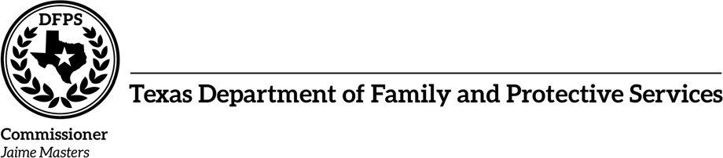

<letter_date>

**SENT BY EMAIL**

<addressee_name>

<addressee_title>

<resource_legal_name>

RE: <PREV_FYXXXX> Notice of Performance Remedy – Safe in Care Contract # <AAID> <SCOR>

Dear <addressee_greeting>:

The Texas Department of Family and Protective Services (DFPS), Residential Child Care Contracts Division conducted a Review for Fiscal Year <PREV_FY_end> on the Performance Remedy – Safe in Care, for the time span of September 1, <PREV_FY_start> through August 31, <PREV_FY_end>. As stated in the DFPS Vendor Supplemental, Special & Programmatic Conditions Section II (H) 7:

Beginning March 1, 2019, and in accordance with Texas Human Resources Code §40.058(f), DFPS will collect financial remedies in instances where Contractor fails to meet the target of 100% for Performance Measure Outcome #1.

This Contract has been identified as having at least one disposition of Reason to Believe (RTB) for abuse, neglect or exploitation of a Child/Youth while in your care and DFPS has determined financial remedies as identified in the attached Form 8102 Request for Payment to DFPS have been assessed.

This calculation accounts for the 10% cap of the contract utilization amount that DFPS paid to Contractor under this Contract for the period specified. If you disagree with the identified findings and associated collection of remedies due to more recent information regarding results of an Administrative Review, you as the Contractor can request a contract review by the Director of Residential Contracts. To request a review, submit an email within 10 calendar days from the date of this notice to DFPSResident@dfps.state.tx.us. Provide any documentation or justification that demonstrates why a remedy should not be assessed.

**701 W. 51st Street • P. O. Box 149030 • Austin, Texas 78714-9030 • 512-438-4800 • www.dfps.state.tx.us**

***An Equal Opportunity Employer and Provider***

In the event that all dispositions of RTB associated with a Child/Youth who experienced an incidence of abuse, neglect or exploitation, are subsequently overturned, DFPS will return the collected remedy to the Contractor upon receipt of a complete and accurate request.

To request a return, submit an email within 30 calendar days from the date stated on the notification letter for an Administrative Review that resulted in the RTB being overturned to DFPSresident@dfps.state.tx.us. The following information must be included in the request for return:

* Name of organization;
* Identify the Children/Youth that were involved as victims of the RTB that was

overturned;

* Provide the date that the <PREV_FYXXXX> payment was originally submitted to DFPS

Accounts Receivable and a copy of the 8102 that was submitted with the payment;

* Name of contact person regarding questions on funds/payments and mailing

address; and

* Attach a copy of all associated Administrative Review notification letter(s)

indicating the disposition of all RTBs having been overturned.

Payment is due within 30 days from the date of this <PREV_FYXXXX> Notice of Performance Remedy. Failure to submit timely payment may result in a payment hold by DFPS.

If you have any questions regarding the monitoring process, please reduce those concerns to a written document directed to your assigned RCM, <RCM_signature> at <RCM_email>.

Sincerely,

<RCM_signature>

<RCM_print_name> <RCM_title>

CC:

DFPS Accounting Department <CC1_Name> <CC1_Title> <CC2_Name> <CC2_Title> <CC3_Name> <CC3_Title>

**701 W. 51st Street • P. O. Box 149030 • Austin, Texas 78714-9030 • 512-438-4800 • www.dfps.state.tx.us**

***An Equal Opportunity Employer and Provider***