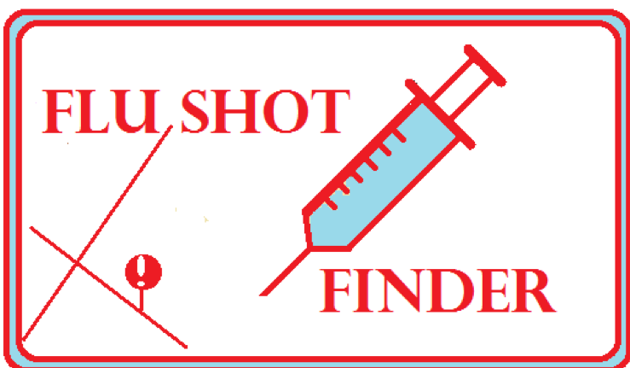

**Stephanie Cass, Robert Hernandez, Patrick Paxson, Kevin Resler, Ata Tafazoli Yadzi**

|  |  |
| --- | --- |
| **Background:** The flu infects hundreds of thousands of people every year. This past year, a record-breaking 80,000 people died due to the virus in the United States. Every season, companies need to scramble to get work done before the holidays as more and more people become infected and take sick leave, and the elderly must become increasingly more careful with each passing year. Vaccination is currently our best defense against the flu and other infectious disease, but many people do not get their flu shots every year. Our project revolves around raising awareness and providing incentives for getting vaccinated.  **Proposal:** Our application is designed to locate pharmacies and other locations near you to get vaccinated. It allows you to filter by grocery store, price range, and perks or offers for the optimal place to get vaccinated. On top of providing this service, our app is  need to find the best place near them.    ***Figure 1:*** *Example of simple UI*  One final purpose of this app is to simplify the process of being verified as immunized for employment purposes. In an ever-increasing digital world and with high-quality cameras in our pockets, we decided that allowing users to capture a copy of their flu vaccination record to save locally or to a cloud server would help reduce waste and | designed to provide digital verification that you got vaccinated, without storing that information on our application.  We designed our app around security; you can’t be hacked if you don’t store any hack-worthy information. The only user data we collect is a postal code, a question of whether a patient needs to pay for flu shots, and a favorite grocery store. This data is stored locally, and is completely anonymous.  Another central part of our app is its simplicity. There are no logins, no large files, and no hinderances to the core purposes of the application. We wanted to cater our user interface to elderly people especially because the flu or other viruses can be deadly to weaker immune systems. Building around simple questions and inputs makes the app much more effective not only for elderly patients, but also for people in a hurry and  open up the app for potential expansion in the future as a verification service.  **Future Plans:** There are a wide variety of features that we would like to add to make this app more efficient. The first is expanding from iOS to Android, and perfecting the features we currently have. The |