## Multi-AP Configuration

### AP Auto Configuration

Auto configuration flow target is to configure all the SSID's and BSSID's per agent radio. Configuration include SSID name, BSSID MAC address, Authentication type, Encryption type, Network key and BSSID service type (bSTA, bBSS, fBSS). Auto configuration flow starts from radio agent after the controller discovery iscomplete. One impotent note on the flow is that the M2 message is encrypted with the public key provided in M1 message. M1 public key generation and M2 message decrepit will be done using OpenSSH <https://github.com/krzyzanowskim/OpenSSL/blob/master/include-macos/openssl/dh.h> "DH" helper functions. OpenSSH is in Intel open source white list  <https://whitelisttool.amr.corp.intel.com/view.php?id=4116>

[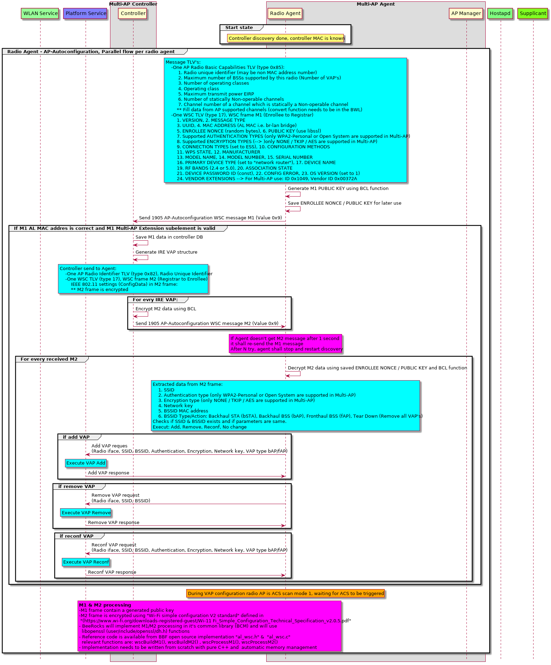](https://polarion.imu.intel.com/polarion/module-attachment/BEER/Architecture/BeeRocks_v1_4_Architecture/MAP_Autoconfiguration.png?revision=187089)