Beerocks v1.4 MultiAP Channel Selection Design Review

Contents

[Introduction and overview 3](#_Toc527451667)

[Beerocks Components 4](#_Toc527451668)

[Acronyms & Abbreviations 4](#_Toc527451669)

[References 4](#_Toc527451670)

[General Requirements 6](#_Toc527451671)

[Channel Selection non DFS Requirements 6](#_Toc527451672)

[Channel Selection DFS Requirements 7](#_Toc527451673)

[Design Assumptions 10](#_Toc527451674)

[High Level Design 12](#_Toc527451675)

[CMDU messages and Tlv: 12](#_Toc527451676)

[multiAp channel selection flows: 12](#_Toc527451677)

[DFS-flow – GW only – Radar Hit: 14](#_Toc527451678)

[Channel selection state machine (controller): 15](#_Toc527451679)

[Channel selection Agent modifications: 16](#_Toc527451680)

[Unit tests 16](#_Toc527451681)

[Gw only – non-DFS 16](#_Toc527451682)

[GW-only – DFS – fall to fail safe (no DFS reentry): 16](#_Toc527451683)

[GW-only – DFS – with DFS reentry: 16](#_Toc527451684)

[General 16](#_Toc527451685)

[Appendix 16](#_Toc527451686)

[Used Tlv’s: 16](#_Toc527451687)

[Channel Preference TLV: 16](#_Toc527451688)

[Channel Selection Response TLV: 17](#_Toc527451689)

[Operating channel Report TLV: 18](#_Toc527451690)

[Basic standard sub flows: 19](#_Toc527451691)

[Channel Preference Query and Report 19](#_Toc527451692)

[Channel Selection Request and Report 20](#_Toc527451693)

[GW boot 21](#_Toc527451694)

# Introduction and overview

Channel selection is a Multiap core module responsible for selecting AP channels dynamically, using Beerocks and Wi-Fi (WAVE) algorithms, controlling the DFS protocol flows and updating the Beerocks database with relevant channel selection data.

Conceptually channel selection logic of Multi-AP R1.0 is similar to BeeRocks v1.2. Flows are slightly different as Multi-AP splits the flows into two parts - channel preference and channel selection. Other than this difference the content of the messages is similar. Channel selection flow ends after all radios have selected a channel and are beaconing. EasyMesh uses IEEE operating classes to describe supported channels where Hostapd uses channel number / frequency and bandwidth.   
Multi-AP agent is responsible for converting operating classes to operating channels and vice-versa.

# Beerocks Components

In its default operating mode, Beerocks consists of two main components: Controller & Agent.   
In addition Beerocks contains the following support libraries: BML, BPL, and BWL.

1. **Controller** - this is the logical entity which controls and is responsible for the vast majority of the algorithms that are included in Beerocks. It is completely abstract and has no contact with any platform or system APIs, and as such, can also theoretically be run on a remote machine.
2. **Agent** - This is a group of components, which consist of a main Beerocks agent process which holds the Backhaul Manager and Platform Manager threads, as well as a separate agent entity for every radio interface, which also consists of a Monitor and AP Manager entity, which are responsible for abstracting low-level radio related operations.
3. **BML** – Beerocks management library, Beerocks external interface, expose API’s to manage Beerocks.
4. **BTL** – Beerocks transport library, enable CMDU 1905.1 message from one device to another.

# Acronyms & Abbreviations

|  |  |
| --- | --- |
| AP | Access Point |
| VAP | Virtual Access Point |
| STA | Station |
| fAP | Multi-AP Front AP, e.g. access-point that only 3-addr (non WDS) client are allowed to connect to |
| bAP | Multi-AP Back AP, e.g. Access point that only **one** 4addr (WDS) client is allowed to connect to. |
| bSTA | Multi-AP Back Station, e.g. 4addr (WDS) client (AKA Repeater/Extender) |
| VSIE | Vendor Specific Information Element |
| fBSS | Multi-AP Fronthaul Basic Service Set (AKA fAP) |
| bBSS | Multi-AP Backhaul Basic Service Set (AKA bAP) |
| DFS | Dynamic frequency selection |
| ACS | Automatic channel selection |
| CSA | Channel switch announcement |
| CAC | Channel availability check |
| Radar hit | Radar detected on DFS channel in use |
| Sub band DFS | Radar hit detected on a part of the band |
| Fail safe channel | When Radar hit on the whole band, AP and connected station will move to pre-configured fail safe channel |
| Restricted channel | Beerocks restricted channel configured to AP can’t be selected by Wi-Fi ACS algorithm |
| AP activity mode | Defined threshold from AP traffic activity |
| DFS reentry | beerocks triggering ACS from fail safe channel after radar detection |
| Slave activated | DB flag, indicating if AP/Radio is operational |
| IEEE operating classes | EasyMesh way to describe supported channels |

# References

* BeeRocks v1.4 Architecture - <https://polarion.imu.intel.com/polarion/#/project/BEER/wiki/Architecture/BeeRocks_v1_4_Architecture>
* Multi-AP HLD - <https://polarion.imu.intel.com/polarion/#/project/IRE/wiki/Design/Intel%20MultiAP%20infrastructure%20HLD>
* Beerocks 1.2 Application Notes  
  <https://polarion.imu.intel.com/polarion/#/project/BEER/wiki/Architecture/BeeRocks_v1-2_Architecture>
* WDS\_Connectivity\_Application\_Notes  
  <https://polarion.imu.intel.com/polarion/#/project/IRE/wiki/Specifications/WDS_Connectivity_Application_Notes>
* IEEE 1905.1a-2014 standard
* Multi-AP technical specification – 180420c

# Design Notes

1. According to BEER-1494 - BeeRocks shall adopt and implement channel selection flows as defined by Easy Mesh R1 while keeping Intel enhancements optional
   * BeeRocks controller & agent shall be modified accordingly
   * Nonstandard BeeRocks v1.2 enhancements shall be maintained (DFS Reentry, AP IDLE).
   * User shall have the option to enabled / disable BeeRocks enhancements
2. The channel selection flow will be implemented in two phases due to external dependencies:
   * Channel preference report:
3. First phase - Supported channels will be ranked as maximum (15), and not supported as 0.
4. Second phase - WLAN should add support for EasyMesh standard channel score as part of the ACS report. This will replace current BWL ACS command with Channel Switch command to a specific channel.
   * Controller channel selection without ACS (channel switch only):
     1. First phase – Not supported, as ACS is required by the WAVE WLAN.
     2. Second phase - Controller will trigger channel switch according to channel preference scores, without preforming ACS first.
5. M2 will start the CS flow for a radio ID with X second delay (configurable – default - 3 second), since an Agent may retransmit M1 and reset the entire flow.
6. Channel selection will restart (if already running) on auto-configuration M1 event.
7. If Channel Selection task does not receive synchronic message, Agent will be removed from controller, and will be expected to initiate the AutoConfig sequence.
8. Static channel is not covered by EasyMesh Standard, and will be implemented as one channel preference on the Channel Preference Report TLV.
9. Failsafe Channel configuration is not supported by EasyMesh standard and shall be defined on Agent configuration.

Open Issues

1. OPTIONAL - Generic mechanism of messages timeout and retries will be implemented due to 1905.1 reliability issues. (No reliability transport mechanism like TCP).
   * Timeout handled by task infrastructure or to be part from generic solution which currently isn’t implemented?
   * Retries will be implemented in channel selection(because some of the messages should be changed before retry)
2. This Design is based on EasyMesh R1. Does we need to update flows according R2?
3. AP IDLE Activity is not supported by EasyMesh, but exist in Beerocks proprietary messages.

# High Level Design

CMDU messages and Tlv:

1. *CHANNEL\_PREFERENCE\_QUERY\_MESSAGE: 0x8004 (does not include TLV)*

#### CHANNEL\_PREFERENCE\_REPORT\_MESSAGE: 0x8005 (include Channel Preference TLV –type 0x8B).

* 1. *MAC Address*
  2. *Operating classes list*
     1. *Channel*
     2. *Flags*
        1. *Channel score(0 – not valid , 1-14 preference , 15 most preference)*
        2. *Reason code(example DFS state : radar detection CAC completed)*

#### CHANNEL\_SELECTION\_REQUEST\_MESSAGE: 0x8006 (include Channel Preference TLV –type 0x8B).

* 1. *Channel preference TLV.*

#### CHANNEL\_SELECTION\_RESPONSE\_MESSAGE: 0x8007 (include Channel Selection Response TLV –type 0x8E)

* 1. *Mac address*
  2. *Reason code (accept or decline – reason…)*

***Note: This Message only notes to the controller that the agent supports the requested channel without actually move to it.***

1. *OPERATING\_CHANNEL\_REPORT\_MESSAGE: 0x8008 (include Operating channel Report TLV - 0x8F )*
   1. *Mac address*
   2. *Operating classes list.*

***Note: This Message only notes to the controller that the agent switched to the requested channel successfully.***

# Channel selection Agent modifications:

*1. Handling preference query message – sending back preference report.*

*a. First phase – all unsupported channel will get marked as 0(no operable), supported 15(most preferred).*

*b. Second phase – channel preferences will be determent according to ACS report.*

*2. Handling channels selection request – sending back response and internal actions:*

*a. First phase – Agent will perform restricted channel, fail safe (Intel) configuration and ACS according to request message.*

*B. Second phase - Agent could perform channel switch instead of ACS.*

*3. Notify controller and send operation channel report when channel/Bandwidth changes.*

*4. Notify controller and send channel preference report when channel preference changes.*

*A. for example: DFS status change (Radar detection, CAC completed and DFS channel availability).*

# Channel selection state machine (controller):



# 

# DFS Flows Notes/Explanation:

Old flow contain three events which could have been received on IDLE state, If the AP is on DFS channel.  
These events merged into on event (UNEXPECTED\_CHANNEL\_PREFERENCE\_REPORT) which contain reason field which imply to each one of the previous events:

1. RADAR\_DETECTION – If the AP moved to sub-band DFS we will get to operational. Else we will be on failsafe channel and wait there until the AP will be on idle mode (low traffic) and there are usable dfs channels.  
   DFS Channel can be divided into 3 categories:  
   - Usable: controller support this channel and did not received radar hits on it in the past 30 minutes.  
   - Unusable: controller received radar hit on that channel. After 30 minutes, AP will send event that channel is usable again.  
   - Available: Usable channel that was actively clean during 1 minute (CAC).

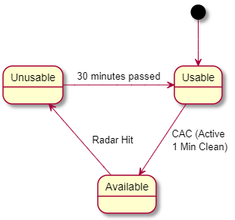

1. DFS\_CHANNEL USABLE\_EVENT – Controller will received this event from AP after 30 minutes.
2. AP\_ACTIVITY\_IDLE\_EVENT – Monitor will send this event if there is low traffic.

Event 2,3 could retrigger DFS flow if it hasn’t completed on the last radar hit event.

Yotams OLD PR for reference:

https://gts-chd.intel.com/projects/SW\_UGW/repos/beerocks/compare/commits?sourceBranch=refs%2Fheads%2FWLANRSYS\_5500\_channel\_request\_response&targetBranch=refs%2Fheads%2Fmaster

https://gts-chd.intel.com/projects/SW\_WAVE/repos/multiap\_common/compare/diff?targetBranch=refs%2Fheads%2Fmaster&sourceBranch=refs%2Fheads%2FWLANRSYS\_5500\_channel\_request\_response&targetRepoId=3197#beerocks/bcl/source/son/son\_wireless\_utils.cpp

*Channel selection initial flow:*

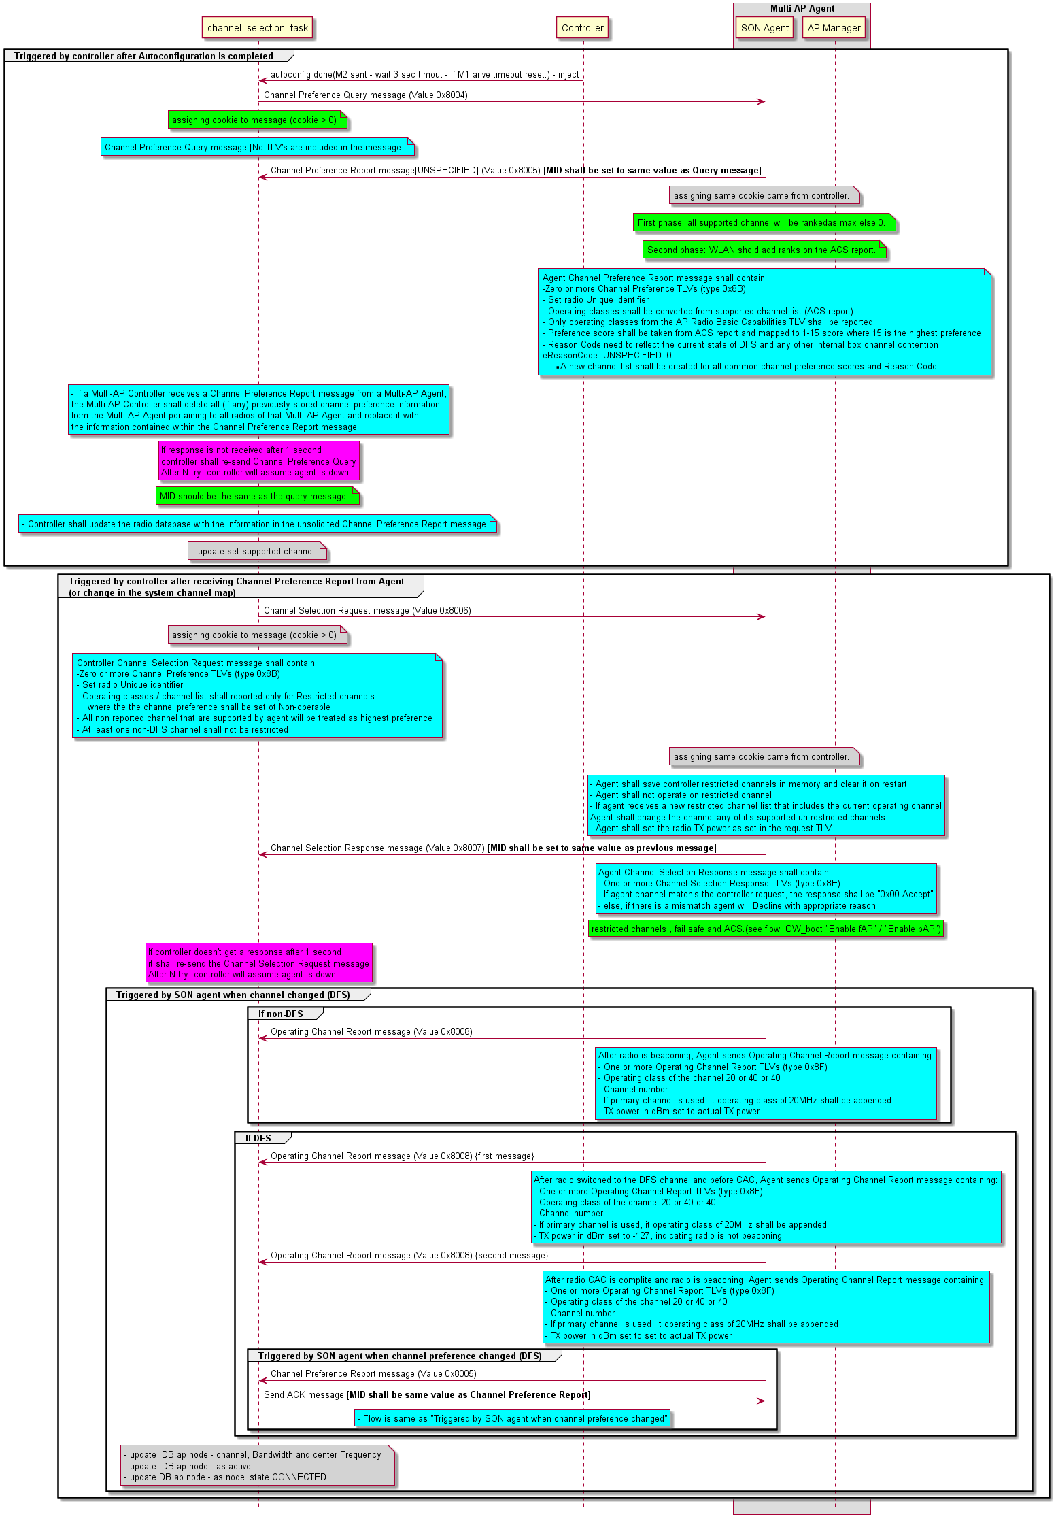

DFS-flow – GW only – Radar Hit:

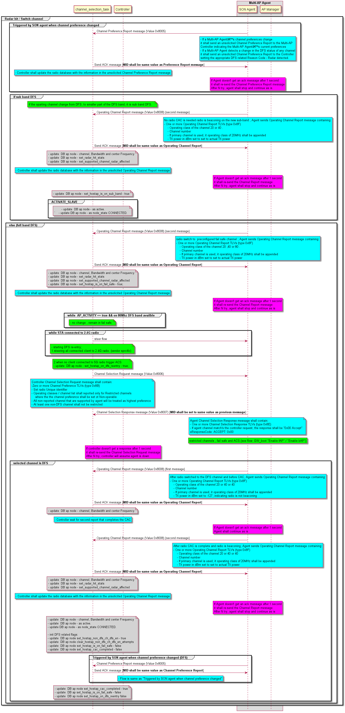

# Unit tests

Gw only – non-DFS

1. *Bring up platform, all channel selection messages are sent properly.*
2. *Timeout and Retries mechanism works properly.*
3. *Proper channel is assign to Agent, database and actual radio parameters are aligned.*

GW-only – DFS – fall to fail safe (no DFS reentry):

1. *Bring up platform, proper DFS channel is selected.*
2. *Simulate radar hit, channel is switched to fail safe channel.*

GW-only – DFS – with DFS reentry:

1. *Simulate radar, proper DFS reentry (with no client).*
2. *Simulate radar, proper DFS reentry (with client).*

## General

1. *Compare operation class conversion between Intel and third party Agent.*

# Appendix

## Used Tlv’s:

### Channel Preference TLV:

tlvChannelPreference:

\_type: class

type:

\_type: eTlvTypeMap

\_value\_const: TLV\_CHANNEL\_PREFERENCE

length: uint16\_t

radio\_uid: sMacAddr

operating\_classes\_list\_length:

\_type: uint8\_t

\_length\_var: True

operating\_classes\_list:

\_type: sOperatingClass

\_length: [ operating\_classes\_list\_length ]

sOperatingClasses:

\_type: struct

operating\_class: uint8\_t

channel\_list\_length:

\_type: uint8\_t

\_length\_var: True

channel\_list:

\_type: uint8\_t

\_length: [ channel\_list\_length ]

flags: sFlags

sFlags:

\_type: struct

\_bit\_field: uint8\_t

preference:

\_bit\_range: [7,4]

\_comment: |

0 : non-operable

1-14 : preference score

15 : most preferred

reason\_code:

\_bit\_range: [3,0]

\_bit\_field\_enum: eReasonCode

eReasonCode:

\_type: enum

UNSPECIFIED: 0

PROXIMATE\_NON\_802\_11\_INTERFERER\_IN\_LOCAL\_ENVIRONMENT: 1

INTRA\_NETWORK\_802\_11\_OBSS\_INTERFERENCE\_MANAGEMENT: 2

EXTERNAL\_NETWORK\_802\_11\_OBSS\_INTERFERENCE\_MANAGEMENT: 3

REDUCED\_COVERAGE\_LIMITED\_TRANSMIT\_POWER: 4

REDUCED\_THROUGHPUT\_LIMITED\_CHANNEL\_BANDWIDTH: 5

IN\_DEVICE\_INTERFERER\_WITHIN\_AP: 6

OPERATION\_DISALLOWED\_DUE\_TO\_RADAR\_DETECTION\_ON\_A\_DFS\_CHANNEL: 7

OPERATION\_WOULD\_PREVENT\_BACKHAUL\_OPERATION\_USING\_SHARED\_RADIO: 8

IMMEDIATE\_OPERATION\_POSSIBLE\_ON\_A\_DFS\_CHANNEL\_CAC\_HAS\_BEEN\_RUN\_\_CHANNEL\_HAS\_BEEN\_CLEARED\_FOR\_USE: 9 (cac completed, channel is clean)

DFS\_CHANNEL\_STATE\_UNKNOWN\_CAC\_HAS\_NOT\_RUN: 10 (channel is now usable)

### Channel Selection Response TLV:

tlvChannelSelectionResponse:

\_type: class

type:

\_type: eTlvTypeMap

\_value\_const: TLV\_CHANNEL\_SELECTION\_RESPONSE

length: uint16\_t

radio\_uid: sMacAddr

response\_code: eResponseCode

eResponseCode:

\_type: enum

\_enum\_storage: uint8\_t

ACCEPT: 0x00

DECLINE\_VIOLATES\_CURRENT\_PREFERENCES: 0x01

DECLINE\_VIOLATES\_MOST\_RECENTLY\_REPORTED\_PREFERENCES: 0x02

DECLINE\_PREVENT\_OPERATION\_OF\_BACKHAUL\_LINK: 0x03

### Operating channel Report TLV:

tlvOperatingChannelReport:

\_type: class

type:

\_type: eTlvTypeMap

\_value\_const: TLV\_OPERATING\_CHANNEL\_REPORT

length: uint16\_t

radio\_uid: sMacAddr

operating\_classes\_list\_length:

\_type: uint8\_t

\_length\_var: True

operating\_classes\_list:

\_type: sOperatingClasses

\_length: [ operating\_classes\_list\_length ]

current\_transmit\_power:

\_type: uint8\_t

\_comment: |

Current Transmit Power EIRP representing the current nominal transmit power.

The field is coded as a 2's complement signed integer in units of decibels relative to 1 mW (dBm).

This value is less than or equal to the Maximum Transmit Power specified in the AP Radio Basic Capabilities TLV for the current operating class.

sOperatingClasses:

\_type: struct

operating\_class: uint8\_t

channel\_number: uint8\_t

## Basic standard sub flows:

### Channel Preference Query and Report

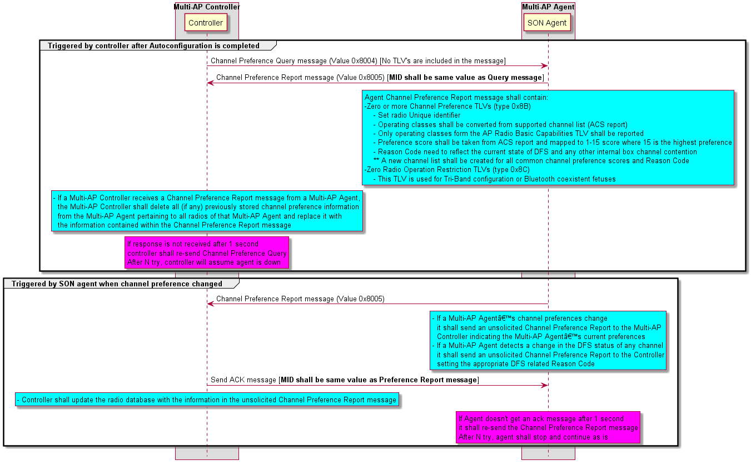

### Channel Selection Request and Report

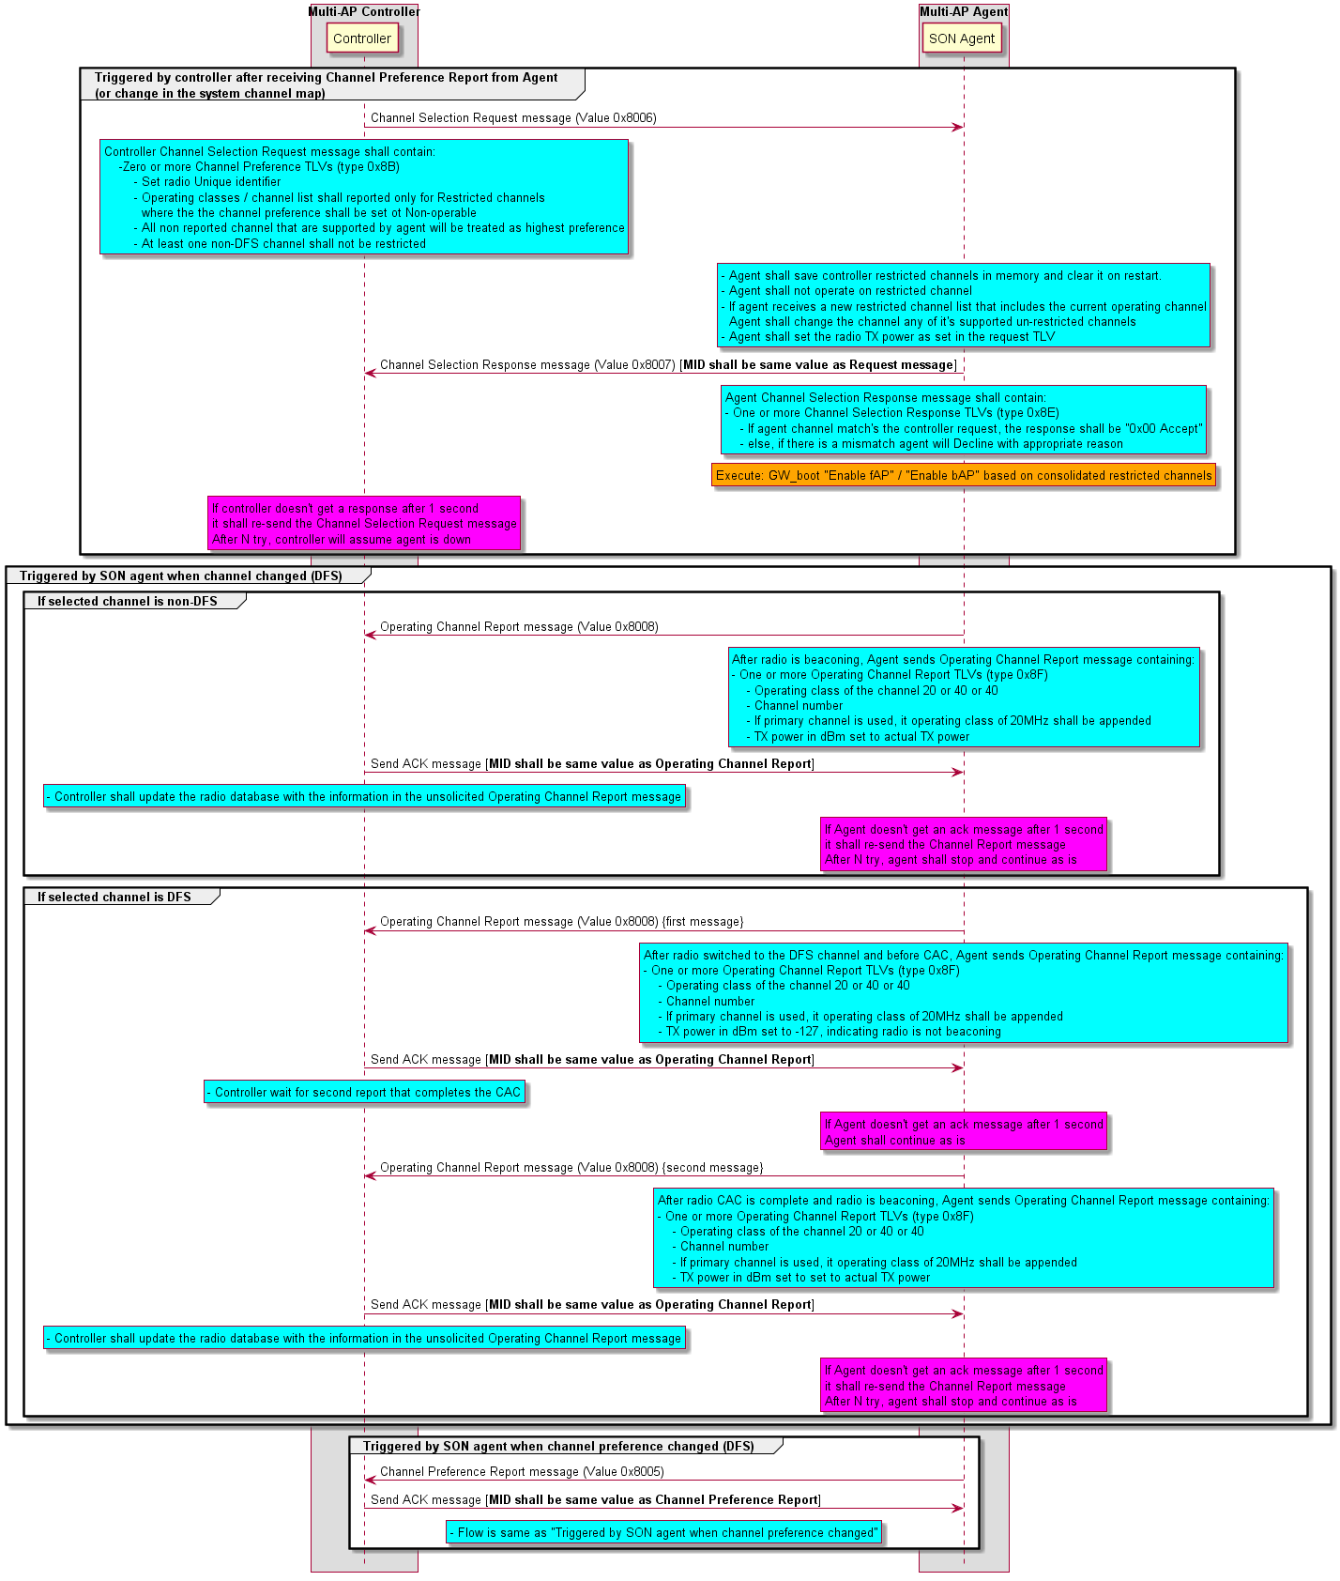

### GW boot

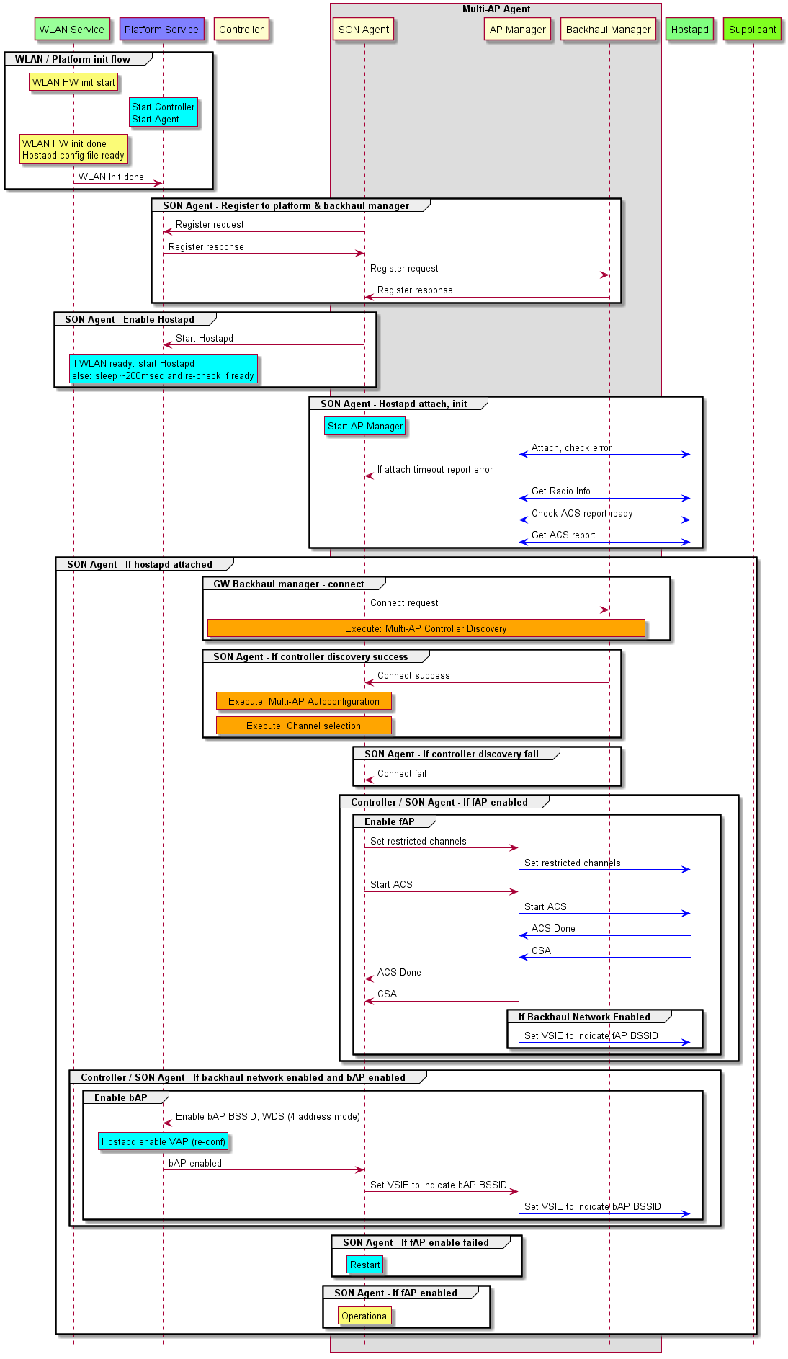

Beeocks 1.2 requirements

BEER-1494 - **BeeRocks shall adopt and implement channel selection flows as defined by Easy Mesh R1 while keeping Intel enhancements optional**

1. BeeRocks controller & agent shall be modified accordingly
2. Nonstandard BeeRocks v1.2 enhancements shall be maintained.
3. User shall have the option to enabled / disable BeeRocks enhancements
4. New channel selection flow shall be implemented as defined by BeeRocks architecture document.

BEER-1385  
BEER-1387

BEER-499 - **Triggering Channel Selection**: Channel Selection shall be triggered upon occurrence of any of the following events:  
·         GW power up  
·         Reception of IRE joined notification  
·         Detection of radar hit

Reception of channel switch notification due to interference/other reasons.

BEER-500 - **Restricted Channels**: Beerocks master shall provide ACS with a list of “restricted channels”.

BEER-501 - **Restricted Channels**: Once ACS selects a channel for GW/IRE, Beerocks shall add the selected channel to the “restricted channel list” to exclude the same channel from being used by other IREs.

BEER-510 - **Concurrent Operation Dual-band IRE**: If a dual band IRE is connected on 5GHz/2.4GHz on the backhaul, front radio shall operate on 2.4 GHz/5GHz, respectively, if feasible.

BEER-511 - **2,4GHz Operation:** On IRE/GW fronthaul, 2.4GHz radio shall be always available and use different channels as possible.

BEER-514 - **Concurrent Operation:** When feasible Beerocks shall avoid concurrent operation of multiple IREs on same (channel, BW) combination. If there are no distinct 80MHz channels available, Beerocks shall split the 80 MHz channel into two 40MHz channels dynamically by setting non overlapping primary channels . Beerocks shall NOT consider splitting the channel beyond 40MHz.

BEER-714 - **Serialized ACS operation**: Channel selection shall start one ACS at a time, a new ACS can start only after previous has ended + CSA has been received and master DB has been updated.

BEER-886 - **IRE Scan report:**IRE BH shall support supplicant scan request and scan response to enable optimized channel selection.

Channel Selection non DFS Requirements

BEER-715 - **non-DFS GW**:

1. Channel selection task shall run ACS after clearing the restricted channels and setting fail-safe to zero.
2. When IRE joins the GW, channel selection shall restrict the GW channels to the current operating sub-band.

BEER-723 - **non-DFS IRE** Channel selection needs to set IRE AP channel while considering IRE scan results RSSI values.

BEER-718 - **non-DFS IRE** If a single active AP that is not on the scan list and channel reuse is set in master config file or that it’s DL RSSI value is bellow configured value in master config file (set to -85dBm). Disable option shall also be added. Channel selection shall set IRE-X AP restricted channels to include all active AP’s except the low RSSI AP channels and trigger ACS.

BEER-724 - **non-DFS IRE**For 2.4GHz,If no free channels are available, channel selection shall run ACS on all channels except one used by GW.

BEER-721 - **non-DFS IRE**For 2.4GHz and 5Ghz, channel selection shall set unused channel to IRE as long as possible.

BEER-719 - **non-DFS IRE** For 5GHz,If all channels are occupied by 80MHz AP’s, channel selection shall select the least occupied 80MHz channel and trigger slave FAPI channel switch command (NOT ACS) to set IRE channel so that the primary channel at the open site side of the existing active channel.

Channel Selection DFS Requirements

BEER-503 - **GW Channel in Europe/US zwDFS mode**: In Europe configuration domain, or in US bypass mode, when one or more IREs have joined, GW shall choose a low sub-band channel.   
Background: In Europe regulatory plan there is no non-DFS channel in high sub-band. If the GW selects a high sub-band channel, upon radar hit IRE backhaul and fronthaul channels will be all operating in the low sub-band until GW clears the DFS channel. This concurrent operation causes loss of capacity (See more details in Channel Selection document).  
Note that in GW-only system (no IREs), there is no restriction on choosing channels from the allowed list.

BEER-505 - **Concurrent Operation**: Beerocks shall avoid concurrent operation of front haul and backhaul on the same band, with the exception of radar hit on DFS channel when the only available fail-safe channel is the same as backhaul channel.

BEER-512 - **Concurrent Operation:** If non-concurrent operation is not feasible (e.g. DFS mitigation), backhaul and fronthaul shall be on the same channel (i.e., repeater mode).

BEER-513 - **Adjacent DFS channel restriction:** System operator shall be able to set a flag to discourage the combination of CH 106 for IRE backhaul and CH 58 for IRE fronthaul, depending on HW restriction. Flag shall be set to disable by default.  
Background: Due to higher level of interference between CH 58 and CH 106. (HW testing required).

BEER-519 - **US/Europe Region Code**: Master shall detect region code as “US” or “EU” based on the channel list. If no non-DFS channels are present in high sub-band, the region code shall be set to EU, else region code shall be set to US.

BEER-515 - **US zwDFS Mode**: In US, Master shall allow the configuration of a zwDFS\_enable flag (values: TRUE/FALSE; default: FALSE) to indicate if zwDFS may be used:

* If zwDFS\_enable is set to TRUE (and) IRE has the bypass and sniffing hardware capability, zwDFS may be used.
* Else, if zwDFS\_enable is FALSE (or) IRE bypass and sniffing capability is not supported in hardware, zwDFS mechanism shall not be used (fixed filter mode).

Background: There are two assembly options for IRE-220: a) fixed filters, no bypass switches, no sniffer antenna; b) fixed filters, bypass switches, and sniffer antenna. In EU domain, the zwDFS mechanism is enabled by default and may be used when needed. In the US, both assembly options are supported. The choice of whether to use zwDFS in US domain is indicated via zwDFS\_enable flag, after ensuring hardware support. If the flag is set and IRE capability for zwDFS exists, then it may be used when needed.

BEER-516 - **Steering for DFS**: When it becomes necessary to steer clients to a different radio, steering shall only happen when data activity is low on the radio (client activity is below a threshold).   
Background: GW/IRE may need to steer the clients in order to clear a radio for CAC after radar hit, and to steer the clients back after CAC cleared the DFS channel.

BEER-517 - **Fail safe Channel in US (fixed filter mode):** In the US regulatory domain, master shall configure the fail-safe channel as:

* **Fail safe Channel on GW**: If one or more IREs are present in the system, master shall configure the GW fail-safe channel to be in the same sub band as the serving channel.
* **Fail-safe Channel on IRE:** Master shall configure the IRE fail-safe channel to be in the same sub band as the operating channel

Background: An IRE has two 5GHz radios for high-band and low-band each. When IREs have joined the GW, fail-safe channel should be in the same sub-band as serving channel in order to avoid switching radios on the IRE backhaul. In EU, there is no non-DFS channel on high sub-band, however, GW serving channel in Europe is always set to the low sub-band (See Req. BEER-503 for Europe configuration). In the absence of any IREs (GW-only system), there are no restrictions on the serving and fail-safe channels at the GW, i.e., serving channel can be in either sub-band and fail-safe channel can also be in either sub-band.

BEER-518 - **Fail-safe Channel in Europe/US zwDFS mode**: In the European regulatory domain, or in US zwDFS mode, master shall configure the fail-safe channel as:

* **Fail-safe channel on GW:** shall be set to be a non-DFS channel in the same sub-band as the operating channel (if one or more IREs have joined the GW).
* **Fail-safe channel on IRE:** shall be set to be the same as the backhaul channel.
  + - If backhaul channel is a DFS channel, after radar hit when IRE switches to this channel, failsafe shall be set to be the same as backhaul channel's failsafe.
    - If backhaul channel is 2.4GHz, master shall set the fail-safe channel to non-DFS (low sub-band).
    - If backhaul channel changes (e.g. due to radar hit on the backhaul) IRE failsafe shall be updated accordingly.

BEER-520 - **DFS** **Channel**: Upon radar hit detection Beerocks master shall update the restricted channel list by adding the DFS channel to the restricted channel list (until it is cleared).

BEER-521 - **DFS Blacklist**: If the number of radar hits detected on a DFS channel over a given duration exceeds a threshold, master shall add that channel to “Blacklist”.

BEER-522 - **DFS Blacklist**: A DFS channel that is blacklisted, shall be cleared from the blacklist after expiry of a timer (default timer value: 12 hours).

BEER-523 - **DFS Blacklist**: Channels that are blacklisted shall be added to the restricted channel list, until timer expiry.

BEER-524 - **GW DFS Mitigation**: When radar hit is detected on GW service channel, GW shall clear the 5G radio to perform CAC by steering the clients based on optimal path.

BEER-525 - **IRE DFS Mitigation in US (fixed filter)**: If (region code ==US) and (mode== fixed filter), when radar hit is detected on IRE service channel, IRE shall clear the radio to perform CAC by steering the clients (restricting the current operating radio and running optimal path).  
Background: Clients may be steered to 2.4GHz radio or to the other sub-band radio or to other IREs/GW in the system according to optimal path logic. If there is a child IRE (cascade topology), child IRE switches the backhaul to 2.4GHz to avoid concurrent operation on parent/child IRE. See Req. BEER-528 for details.

BEER-526 - **DFS Re-entry**: After DFS channel is successfully cleared subsequent to radar hit, GW/IRE shall steer the clients back to the DFS channel.

BEER-674 - **IRE DFS Mitigation in Europe**: If (region code == EU) and radar hit is detected on IRE service channel in high sub-band, IRE shall move the backhaul connection to high radio operating in bypass mode [Backhaul manager]. IRE shall use the 5GHz low radio’s zwDFS sniffing mechanism for CAC (by enabling sniffer filter and antenna).

BEER-527 - **IRE DFS Mitigation in Europe:** If (region code == EU) and radar hit is detected on IRE service channel in high sub-band, after zwDFS has cleared the high sub-band channel, IRE shall move the backhaul connection to low radio [backhaul manager].Reviewed, [BeeRocks V1.4](file:///\\\\tlvsdn50.lantiq.com\\polarion\\" \l "/project/BEER/plan?id=BeeRocks_V1_4" \t "_blank)

BEER-528 - **DFS Mitigation in Cascade Topology**: In a cascaded configuration, if there is radar hit on the backhaul and the parent is an IRE, slave shall switch the backhaul to 2.4GHz  [Backhaul Manager]

BEER-529 - **DFS Multiple Radar hit:**:  If backhaul is hit with radar while re-entry on the front radio is going on, Beerocks shall defer the backhaul radio CAC procedure, and vice versa.

BEER-673 - **CAC on Backhaul Radio in zwDFS mode:** In the European regulatory domain, when IRE is operating on DFS channel:

* [WLAN] If IRE backhaul is on DFS channel, IRE backhaul radio (STA mode) shall also clear the channel and monitor for radar hits.
* If IRE backhaul radio detects radar hit on IRE backhaul channel, master shall switch the backhaul channel to failsafe and follow the same procedure as when GW detects radar hit.

Background: In zwDFS mode the IRE failsafe channel is set to be the same as GW operating channel. If the GW operating channel is DFS, we should ensure that not only GW is clearing the channel but also IRE backhaul radio (STA mode) is monitoring the channel for radar hit. Note that even though GW has already cleared the channel since IRE and GW are physically located apart, IRE needs to independently perform CAC and cannot rely on GW CAC. In the scenario that IRE serving channel is hit by radar, IRE front radio (AP mode) will immediately switch to failsafe, hence we need to ensure the failsafe channel has been already cleared by the IRE.

BEER-675 - **When IRE failsafe channel is DFS**: In zwDFS, after radar hit detection, if IRE switches to failsafe =backhaul (DFS) and now radar hit is detected on IRE service channel, IRE shall switch to failsafe and master shall instruct GW to switch to failsafe as well.  
Background: Even though the radar signal is detected on IRE service channel, GW shall switch too because IRE is in repeater mode.

BEER-1385 - **Radar detection/DFS mitigation - IRE AP on high band DFS channel, bypass switches not available**When the IRE AP is operating on a 5GHz high band DFS channel and Radar is detected, the system shall vacate the band by either steering the clients to the 5GHz low band, sharing the channel with the backhaul, or steering them to the 2.4GHz band.When no clients remain on the 5GHz high band radio, it shall be used to perform CAC on the DFS channel. After CAC is completed and Non Occupancy timer expires, the system shall steer clients back to the DFS channel on the 5GHz high band. Notes:

1. In the US regulatory zone channel plan there is a fail safe (non-DFS) channel available in the 5GHz high band. Therefore it is expected that the AP will seamlessly switch to this channel and clients that support such channel switch won't be disconnected. The band steering will occur after this channel switch
2. In the EU regulatory zone channel plan there is no fail safe (non-DFS) channel available in the 5GHz high band. Therefore it is expected that the clients may lose connection once the radar is detected and before they are steered to 2.4GHz channel.
3. BEER-1384 - **Radar detection - IRE AP on high band DFS channel, bypass switches available**When the IRE AP is operating on a 5GHz high band DFS channel in the EU regulatory zone and Radar is detected, the system shall activate the filter bypass switches of the 5GHz high band WiFi radio and switch the WiFi channel to the same low 5GHz band shared with the backhaul. The system then shall vacate the other 5GHz radio by steering the backhaul to the STA mode of this same radio.  Then, the dedicated sniffer antenna on the other 5GHz WiFi radio shall be activated (using the dedicated switch) and used to perform CAC on the DFS channel.  After CAC is completed and Non Occupancy timer expires, the system shall clear the DFS channel on the 5GHz high band and revert to the same configuration as before the radar detection.   
   Notes:

* As soon as the radar detected, the DFS mechanism of the WiFi AP will switch to the fail safe channel. In US regulatory zone this can be on the 5GHz high sub-band, while in the EU regulatory there is no fail safe channel on the high 5GHz band. Therefore it is necessary to by-pass the high pass filters in order to switch to the available fail safe channel on the low 5GHz band. This will be performed by the WiFi AP, without BeeRocks control.
* The DFS mitigation mechanism described in this feature will be invoked by BeeRocks after the WiFi AP makes the switch to the fail safe channel.

BEER-1386 - **Radar detection - IRE on low band DFS channel**When the IRE AP is operating on a 5GHz low band DFS channel and Radar is detected, the system shall vacate the band by either steering the clients to the 5GHz high band, sharing the channel with the backhaul, or steering them to the 2.4GHz band. After CAC is completed and Non Occupancy timer expires, the system shall steer clients back to the DFS channel on the 5GHz low band.   
When no clients remain on the 5GHz low band radio, it shall be used to perform CAC on the DFS channel.Note: in such case, it is expected that the AP will seamlessly switch to the low band fail safe channel and clients that support such channel switch won't be disconnected. The band steering will occur after this channel switch.

BEER-1387 - **Initial channel selection**.  
The BeeRocks system shall control the Auto Channel Selection mechanism of the WiFi radios such that the same WiFi channel shall not be selected in more than one WiFi AP in the system except if there are more APs in the system than available WiFi channels.Notes:  This feature is not contradicting the WiFi DFS restriction If there are more APs than available channels (e.g. some channels blocked by DFS, DFS channels are disabled or, too many IREs in the system), it is allowed to reuse channel.

BEER-1382 - **Tri-band IRE, backhaul is connected on STA mode of a 5GHz radio**On a tri-band IRE, when the IRE backhaul is connected on STA mode of one of the 5GHz WiFi radios (low or high band), the clients shall be generally connected to the AP on the other 5GHz WiFi radio or on the 2.4GHz WiFi, except in scenarios explicitly defined elsewhere in this document