<http://aws.randheerprakash.online/>

<http://temp.randheerprakash.online/>

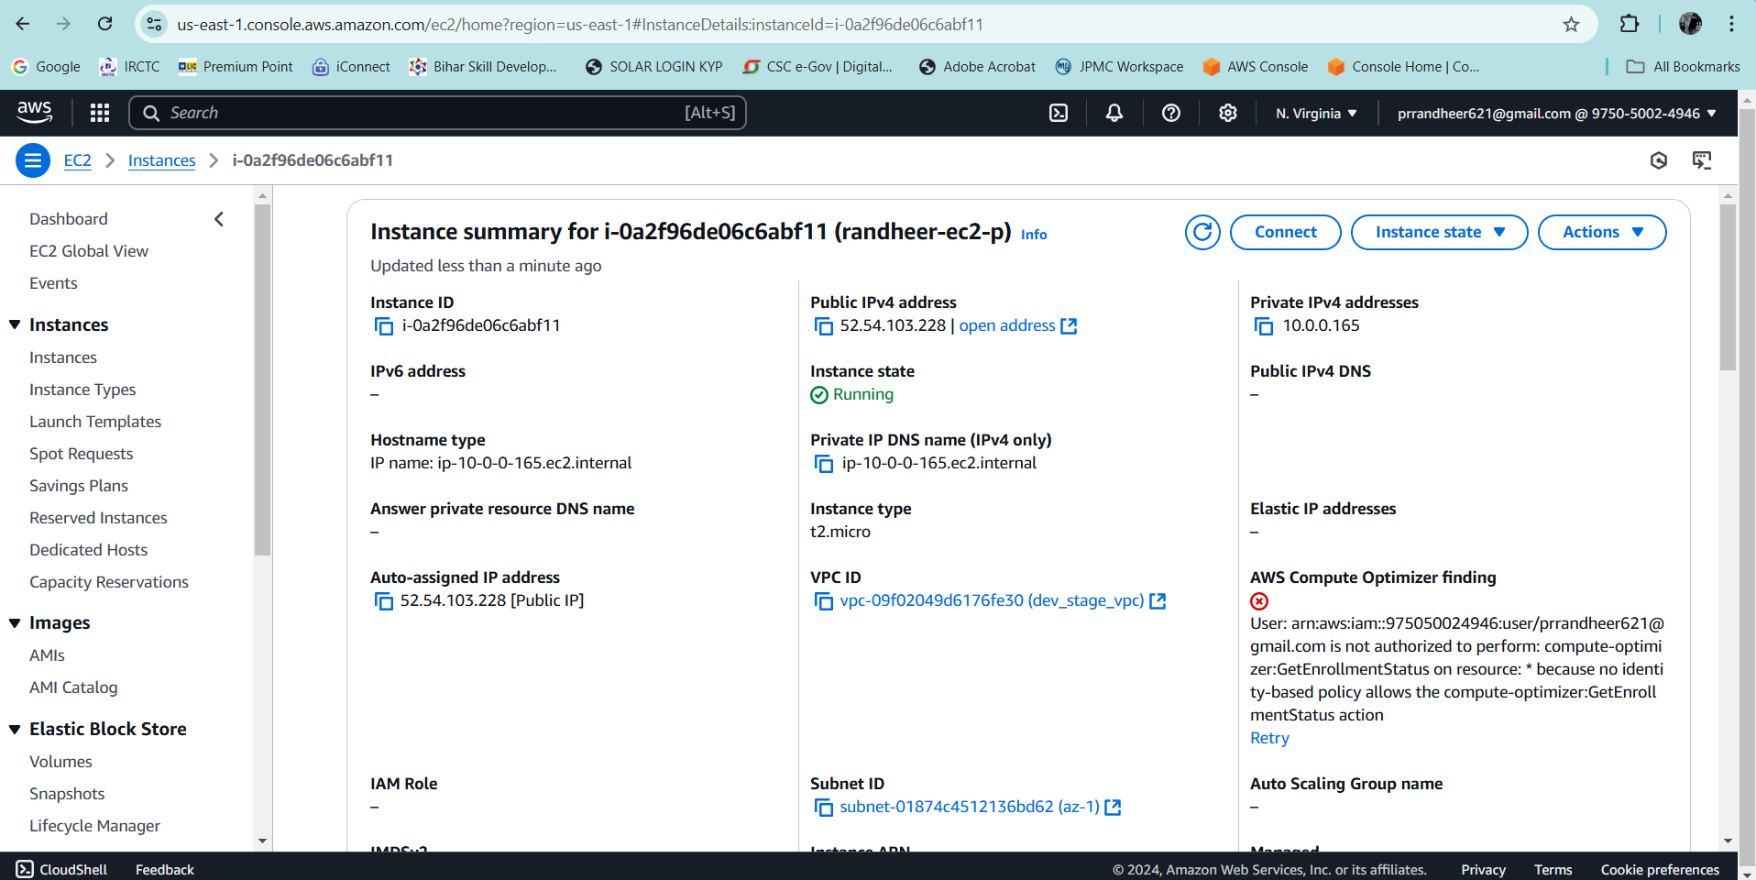

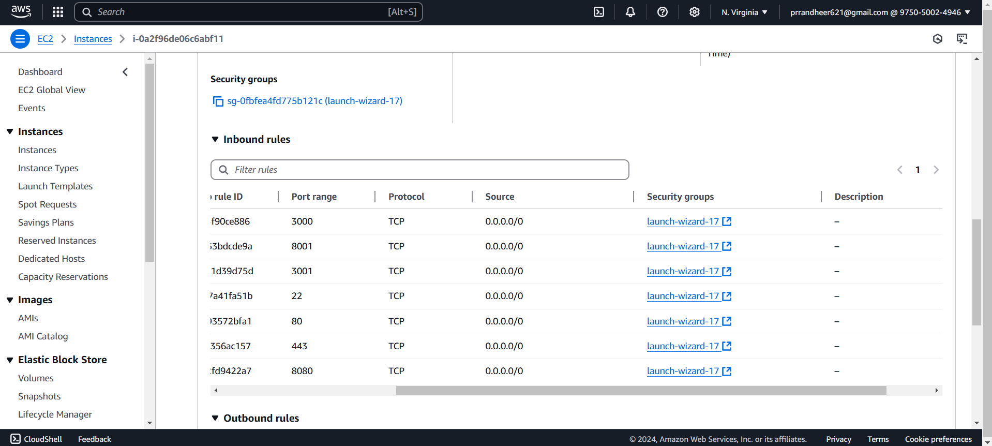

Installed git on ec2

Then cloned Travel Memory git repo to ec2

Installed nodejs, npm, nginx

Goto backend, do **npm i**

Created .env file, added PORT, MONGO_URI in it.

# Node.js server configuration

PORT=3000 # The port your backend server will run on

MONGO_URI="mongodb+srv://<username>:<password>@randheercluster0.i9wwz.mongodb.net/travelmemory"

Then started the node js server, **node index.js**

Then went to frontend folder, created .env file.

Added Backend URL in .env file

Run **‘npm i’** in frontend folder too.

**#!/bin/bash**

**# Get the server's IP address dynamically**

**IP_ADDRESS=$(curl http://checkip.amazonaws.com | awk '{print $1}')**

**# Write to the .env file**

**cat <<EOL > .env**

**REACT_APP_BACKEND_URL="http://$IP_ADDRESS:3000"**

**PORT=3001**

**EOL**

**echo ".env file updated with IP: $IP_ADDRESS"**

Added this bashfile, and gave execution permission to create .env file

Updated start scripts in package.json

**"start": "bash createEnvFile.sh && react-scripts start --port 3001",**

Start the frontend server, **npm start**

**Nginx** Configuration:

**server {**

**listen 80;**

**server_name localhost;**

**location / {**

**proxy_pass http://localhost:3001;**

**proxy_http_version 1.1;**

**proxy_set_header Upgrade $http_upgrade;**

**proxy_set_header Connection 'upgrade';**

**proxy_set_header Host $host;**

**proxy_cache_bypass $http_upgrade;**

**}**

**}**

Add the above script in sites-available, with any name, e.g **travel**

Delete default from sites-enabled, and add a symbolic link of travel created above.

**sudo ln -s /etc/nginx/sites-available/travel /etc/nginx/sites-enabled/**

