Project Structure
flask_mongo_app/
app.py # Main Flask application
data.json # Backend data file for /api route
requirements.txt # Python dependencies (flask, pymongo, dnspython)
templates/
index.html # Form page
success.html # Success page after form submission

Part 1 — /api Route

Data.json file
[
{
"id": 1,
"name": "Alice Johnson",
"email": "alice@example.com",
"role": "Developer"
},
{
"id": 2,
"name": "Bob Smith",
"email": "bob@example.com",
"role": "Designer"
},
{
"id": 3,
"name": "Carol White",
"email": "carol@example.com",
"role": "Manager"
}
]

Screenshot — /api Response in Browser
Visiting http://localhost:5000/api returns the JSON list read from data.json:
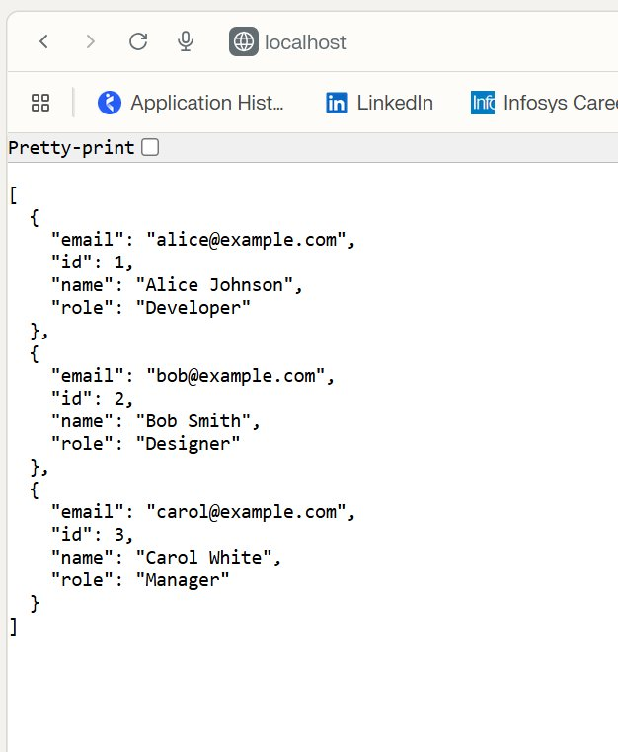

Part 2 — MongoDB Form Submission

app.py — Form & MongoDB Code
from flask import Flask, jsonify, request, render_template, redirect, url_for
from pymongo import MongoClient
from pymongo.errors import PyMongoError
import json
import os

app = Flask(__name__)

# ─── MongoDB Atlas Connection ────────────────────────────────────────────────
MONGO_URI = os.environ.get(
"MONGO_URI",
"--"
)

client = MongoClient(MONGO_URI)
db = client["flask_assignment"]
collection = db["submissions"]

# ─── Part 1: /api route – reads from data.json and returns JSON ──────────────
@app.route("/api")
def api():
data_file = os.path.join(os.path.dirname(__file__), "data.json")
with open(data_file, "r") as f:
data = json.load(f)
return jsonify(data)

# ─── Part 2: Frontend form ───────────────────────────────────────────────────
@app.route("/", methods=["GET"])
def index():
return render_template("index.html", error=None)

@app.route("/submit", methods=["POST"])
def submit():
name = request.form.get("name", "").strip()
email = request.form.get("email", "").strip()
message = request.form.get("message", "").strip()

if not name or not email or not message:
return render_template("index.html", error="All fields are required.")

try:
collection.insert_one({"name": name, "email": email, "message": message})
return redirect(url_for("success"))
except PyMongoError as e:
return render_template("index.html", error=f"Database error: {str(e)}")

@app.route("/success")
def success():
return render_template("success.html")

if __name__ == "__main__":
app.run(debug=True)

Screenshot — Successful Form Submission
After filling out the form and clicking Submit, the user is redirected to the success page:
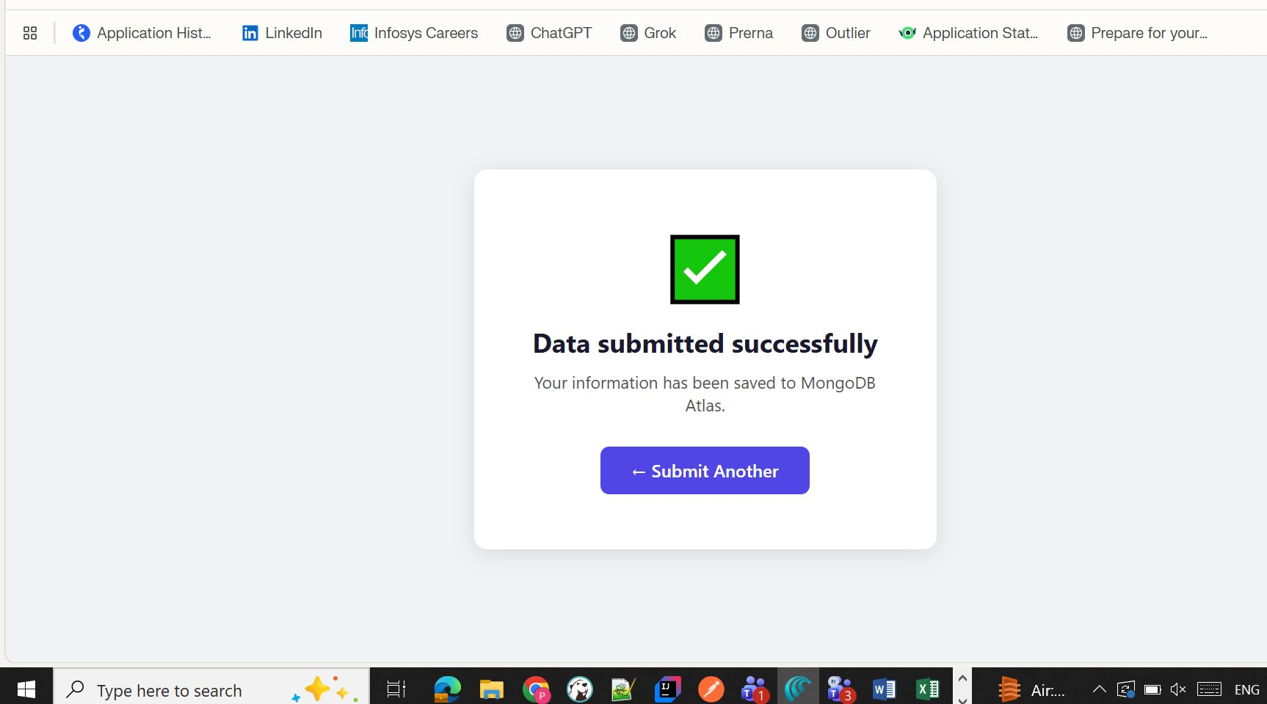

Screenshot — Data in MongoDB Atlas
The submitted document is visible in the MongoDB Atlas Data Explorer under flask_assignment > submissions:
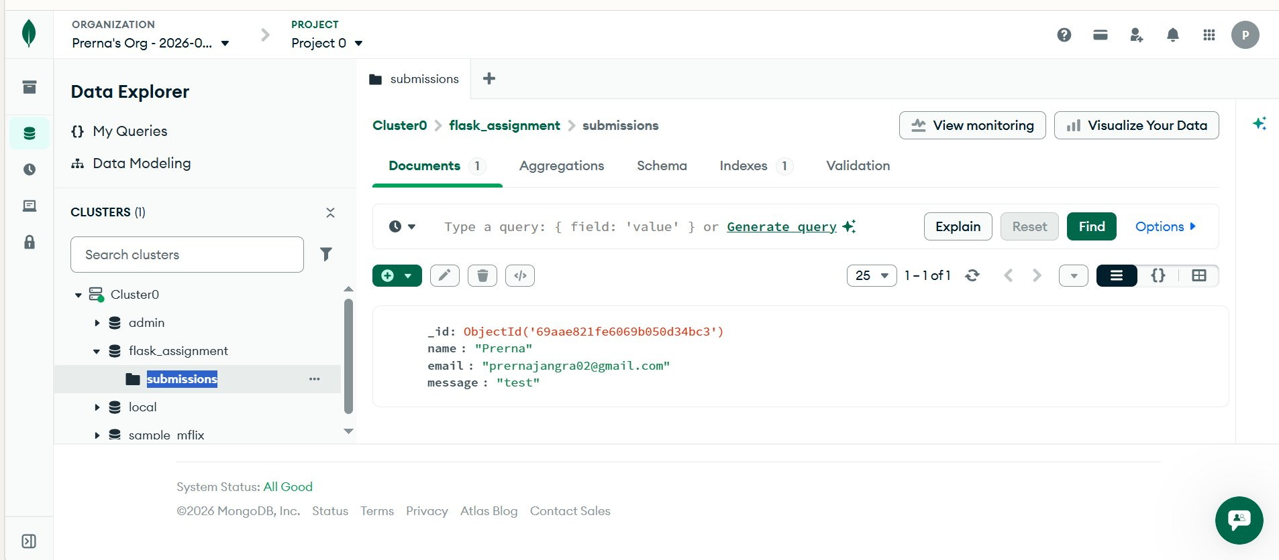

Setup & Run Instructions

1. Install Dependencies
pip install -r requirements.txt

2. Set MongoDB URI in app.py
MONGO_URI = "mongodb+srv://<user>:<pass>@cluster0.xxx.mongodb.net/flask_assignment"

3. Run the Flask App
python app.py

4. Access the App
- Form page: http://localhost:5000/
- API route: http://localhost:5000/api
- Success pg: http://localhost:5000/success

Route Summary
Route | Method | Description
/ | GET | Displays the submission form
/submit | POST | Handles form submission, inserts into MongoDB
/success | GET | Shows 'Data submitted successfully'
/api | GET | Returns JSON list read from data.jon

