


Bengali Sign Language Detection
Student Id : 2330988
Student Name : Pranay Shrestha
Section : L6CG20
Teacher : Ms. Durga Pokharel
Submitted on : 8th May 2026

Abstract
This report presents a comprehensive deep learning study for Bengali Sign Language (BSL) detection using Convolutional Neural Networks (CNNs). The project tackles a 38-class image classification problem using a custom dataset of 10,792 hand gesture images captured at 224×224 pixels. Three progressively sophisticated architectures were evaluated: a Baseline CNN with 3 convolutional blocks, a Deeper CNN with 4 convolutional blocks and enhanced regularisation, and MobileNetV2 Transfer Learning fine-tuned via a two-phase training strategy. The Deeper CNN achieved the highest validation accuracy of 83.63%, outperforming the Baseline CNN (70.10%) by 13.53 percentage points. MobileNetV2 achieved a competitive 82.51% with significantly less training time (27.83 min vs 93.96 min). Data augmentation, Batch Normalisation, and Dropout were found to be critical for generalisation. Ablation studies confirmed that removing Dropout led to severe overfitting. Optimiser comparison revealed Adam's superiority over SGD (78.03% vs 71.27%) for this task. The study demonstrates that transfer learning provides an excellent efficiency-accuracy trade-off for resource-constrained environments.

Table of Contents
Abstract 2
1. Introduction 4
3. Data Preprocessing & Augmentation 7
4. Model Architecture & Methodology 9
4.1. Model comparison 9
5. Experiments & Results 11
5.1 Baseline CNN — Training History 11
5.2 Deeper CNN — Training History 12
5.3 Model Comparison Summary 13
6. Detailed Model Evaluation 15
6.1 Baseline CNN — Confusion Matrix & Classification Report 15
6.2 Deeper CNN — Confusion Matrix & Classification Report 16
6.3 Accuracy Progress Comparison 17
7. Ablation Studies 18
7.1 Optimiser Comparison: Adam vs SGD 18
7.2 Dropout Ablation Study 19
8. Real-World Inference 20
9. Conclusion & Future Work 22

Table of Figures
Figure 1 – Sample images from 10 randomly selected classes in the Bengali Sign Language training dataset 7
Figure 2 – Class distribution across all 38 BSL gesture classes. The dataset is well-balanced with ~239–293 images per class, minimising class imbalance bias. 7
Figure 3 – Original image (top-left) alongside 8 augmented variants. Subtle rotations, shifts, and flips preserve gesture semantics while creating diversity. 9
Figure 4– Baseline CNN: Accuracy (left) and Loss (right) curves over 30 epochs. Training accuracy reached ~79% while validation accuracy peaked at 70.10%, indicating mild overfitting in later epochs. 12
Figure 5– Deeper CNN: Training and validation accuracy/loss over 30 epochs. The model achieved significantly better generalisation with val accuracy of 83.63%. 13
Figure 6– Final validation accuracy comparison across all three models. Deeper CNN leads with 83.63%, while MobileNetV2 achieves 82.51% at only 27.83 min training time. 14
Figure 7– Baseline CNN Confusion Matrix (38×38). Diagonal dominance indicates correct classification. Off-diagonal elements reveal common misclassification patterns between visually similar gestures. 16
Figure 8– Deeper CNN Confusion Matrix. Significantly stronger diagonal compared to Baseline, reflecting the 13.53% improvement in overall accuracy. 17
Figure 9– Adam vs SGD validation accuracy comparison. Adam outperforms SGD by 6.76 percentage points (78.03% vs 71.27%) for this task. 19
Figure 10– Model WITHOUT Dropout: Training accuracy rises rapidly but validation accuracy plateaus early and diverges — a classic overfitting signature. Dropout is essential for generalisation. 20
Figure 11 – Inference results on 3 real-world test images across all three models (Baseline, Deeper CNN, MobileNetV2). 21

1. Introduction
Sign language serves as the main way of communicating for a large number of hearing-impaired people around the world, and automating its recognition through computer vision could genuinely help close the gap between the deaf community and those who don't understand sign language. This project focuses specifically on Bengali Sign Language, which covers 38 hand gesture classes for digits and alphabetic characters. Bengali Sign Language is particularly interesting to work with because it's a regionally important language that hasn't received nearly as much attention in AI research compared to languages like American or British Sign Language.
One of the first questions worth addressing is why deep learning is even the right tool here. Older approaches like HOG with SVM classifiers or other hand-crafted feature methods do work to some extent, but they come with real limitations — they need a lot of domain knowledge to set up properly, and they tend to fall apart when there's variation in lighting, skin tone, or the angle of the hand. CNNs get around this by learning spatial features directly from the raw image data in a hierarchical way, which makes them a much better fit for visual recognition problems. On top of that, using transfer learning from models pre-trained on large datasets like ImageNet means we can get solid performance even when our domain-specific dataset is relatively small.
The project has five main goals: first, building a baseline CNN to establish a benchmark for 38-class classification; second, designing a deeper and better-regularised architecture to improve how well the model generalises; third, applying MobileNetV2 through transfer learning to explore the trade-off between accuracy and computational efficiency; fourth, running ablation studies — specifically looking at what happens when dropout is removed and how different optimisers compare — to understand how much each component actually contributes; and fifth, doing a thorough evaluation using accuracy, loss curves, confusion matrices, and per-class F1-scores to get a complete picture of model performance.

The dataset used in this project is a custom Bengali Sign Language detection dataset consisting of 10,792 images spread across 38 gesture classes, where each class represents either a digit or an alphabetic character from the Bengali Sign Language system. All images are in JPEG format, stored as RGB colour images with 3 channels, and were resized to a uniform resolution of 224×224 pixels to keep the input dimensions consistent across all models.
The dataset was split into training and validation sets using an 80/20 ratio, giving 8,648 images for training and 2,144 for validation. Across the 38 classes, the average number of images per class sits at around 284, with Class 4 having the fewest at 239 images and Class 22 having the most at 293. This relatively narrow range suggests the dataset is fairly balanced, which is a good sign since heavy class imbalance can skew model training and make evaluation metrics less reliable.
Before any training was done, an integrity check was run across all 10,792 files and confirmed that there were no corrupted images, which removes one potential source of noise from the pipeline. Pixel values in the raw images range from 1 to 229 prior to normalisation, so normalisation was applied as a preprocessing step to bring values into a standard range and help the models converge more smoothly. Additionally, 3 real-world images were set aside separately for inference testing at the end, providing a more practical check of how the models perform outside of the controlled dataset environment.
Property | Detail
Source | Custom Bengali Sign Language dataset (Google Drive)
Format | JPEG images, RGB colour, 3 channels
Classes | 0–37 (representing BSL digits and characters)
Min images/class | 239 (Class 4)
Max images/class | 293 (Class 22)
Pixel value range | 1–229 (pre-normalisation)
Corrupted files | 0 (all 10,792 files valid after integrity check)
Test images | 3 real-world images for inference testing

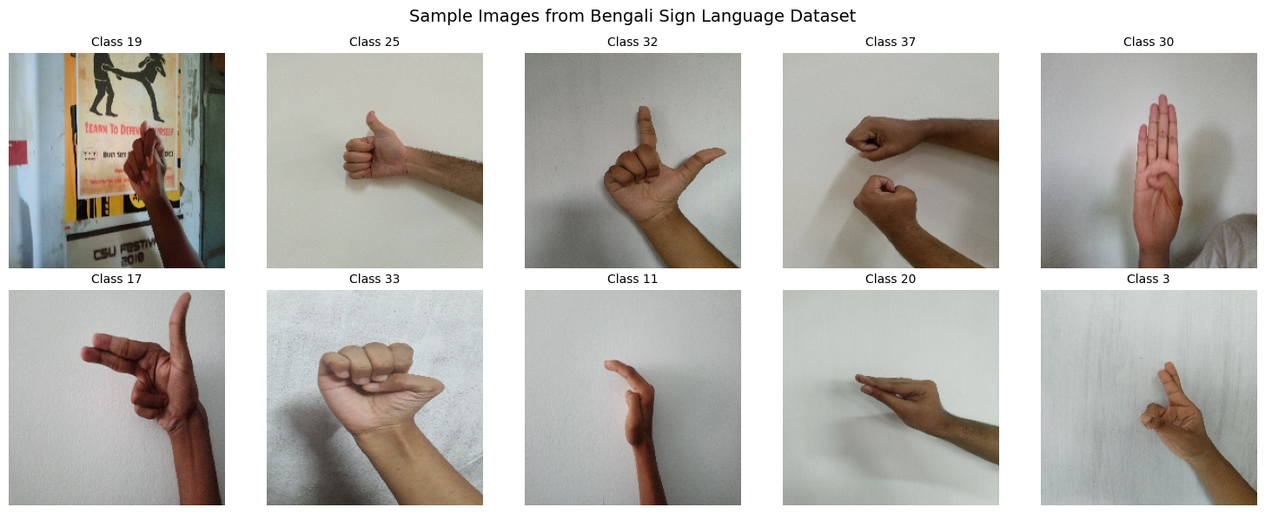
Figure 1 – Sample images from 10 randomly selected classes in the Bengali Sign Language training dataset
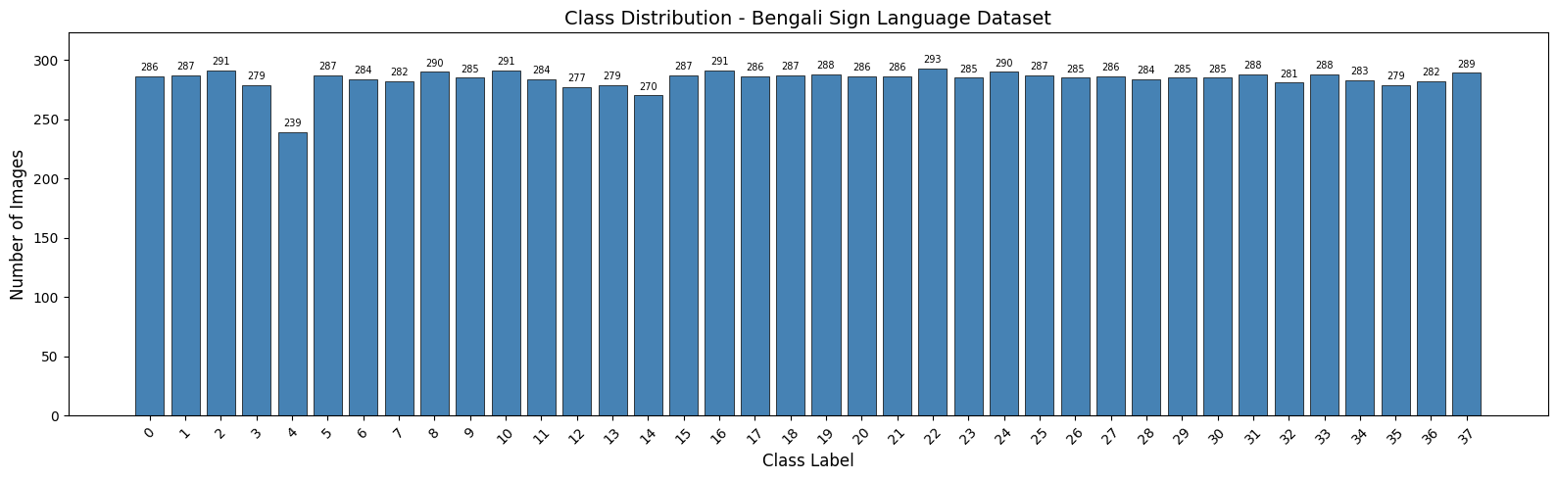
Figure 2 – Class distribution across all 38 BSL gesture classes. The dataset is well-balanced with ~239–293 images per class, minimising class imbalance bias.

3. Data Preprocessing & Augmentation
Before feeding images into any of the models, a consistent preprocessing pipeline was applied to ensure the data was clean and ready for training. All 10,792 images were first verified using PIL to confirm no files were corrupted or unreadable — and none were found to be. Pixel values were then normalised by dividing by 255.0, rescaling them from [0, 255] to [0, 1] to keep gradient flow stable and prevent any single channel from dominating due to scale. Images were resized during loading, with CNN models taking 64×64 inputs and MobileNetV2 taking 96×96 to better suit its architecture, both using bilinear interpolation to preserve edge quality.
The dataset was split 80/20 into training and validation sets using Keras's ImageDataGenerator with a fixed seed of 42 for reproducibility, and an explicit class mapping from 0 to 37 was enforced to avoid any label mismatch between generators. Data augmentation was applied to the training set only, using conservative parameters — 10° rotation, 0.1 width and height shifts, horizontal flipping, and 0.1 zoom — to simulate realistic hand gesture variability without distorting the data. The validation generator used normalisation only, ensuring evaluation metrics remained unbiased.
Augmentation Parameter | Value
Rotation range | 10°
Width shift | 0.1
Height shift | 0.1
Horizontal flip | True
Zoom range | 0.1
Applied to | Training set only
Validation generator | Normalisation only

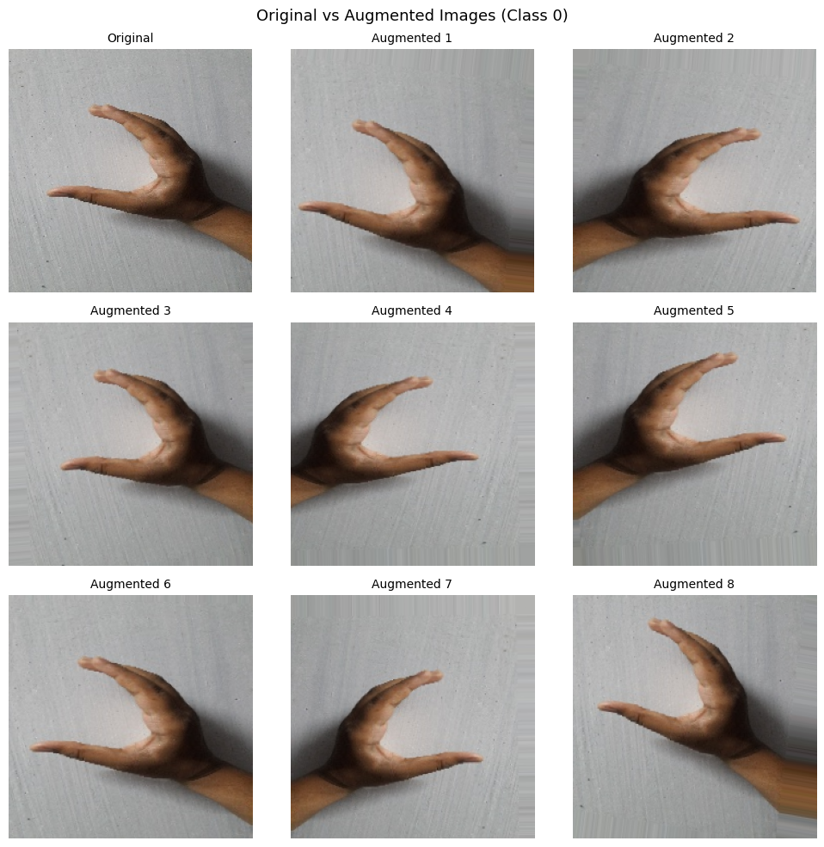
Figure 3 – Original image (top-left) alongside 8 augmented variants. Subtle rotations, shifts, and flips preserve gesture semantics while creating diversity.

4. Model Architecture & Methodology

4.1. Model comparison
The table summarises all three architectures side by side.
Model | Architecture | Params | Val acc. | Train time | Key config
Baseline CNN | - 3 conv blocks (32→64→128)  - BN + MaxPool each block  - Dense 512→256→128→38  - Dropout 0.4 / 0.3 | 4.46 M  ~17 MB | 70.10% | 26.2 min | Optimizer- Adam lr=0.001  Regularisation- BN + Dropout  Scheduler-ReduceLROnPlateau ×0.5  Stopping- 30 epochs, patience=6
Deeper CNN | - 4 blocks, 2 conv layers each  - Filters 32→64→128→256  - BN + Dropout 0.25 per block  - Dense 1024→512→256→38 | —  deeper | 83.63% | 93.96 min | Optimizer- Adam lr=0.001  Regularisation- BN + Dropout every block  Scheduler-ReduceLROnPlateau ×0.5  Stopping- 30 epochs, early stop
MobileNetV2 | - MobileNetV2 backbone (154L)  - Phase 1: base frozen  - GlobalAvgPool2D  - Dense 256→BN→Dropout 0.5→38  - Phase 2: top layers fine-tuned | 2.63 M  ~10 MB | 82.51% | 27.8 min | Phase 1- 10 epochs, frozen base  Phase 2- 15 epochs, lr=1e-4  Trainable (P1)- 368 K / 2.63 M params  Input size- 96×96 (vs 64×64)

The Deeper CNN achieves the best accuracy (83.63%) but at a ~4× training cost. MobileNetV2 comes close (82.51%) in roughly the same wall-clock time as the Baseline, at just 60% of the parameter count — making it the most efficient option. The Baseline underfits at 70.1%, suggesting three conv blocks are insufficient for 38-class separation at this resolution.
Deeper CNN vs MobileNetV2 trade-off — the Deeper CNN wins on accuracy by about 1.1 percentage points, but takes ~3.4× longer to train (94 min vs 28 min) and uses more parameters. MobileNetV2 closes most of that gap by leveraging ImageNet pretraining, which lets it learn useful feature representations (edges, textures, shapes) without needing as many epochs from scratch.
Why the Baseline struggles — 70.1% validation accuracy on 38 classes suggests the three-block architecture simply doesn't have enough representational capacity. Both the Deeper CNN (more blocks, double convolutions) and MobileNetV2 (pretrained backbone) address this in different ways.
Practical recommendation — if inference size and training cost matter, MobileNetV2 is the clear choice: smallest model (~10 MB), competitive accuracy, and fast training. The Deeper CNN is worth it only if squeezing out that extra ~1% accuracy is critical.

5. Experiments & Results
Detailed performance analysis across all models and ablation studies

5.1 Baseline CNN — Training History
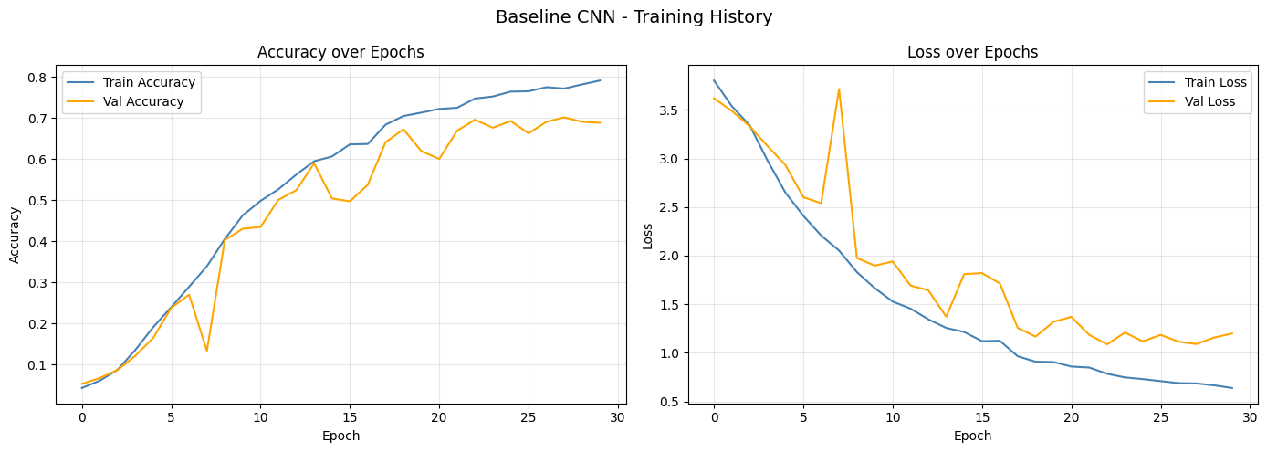
Figure 4– Baseline CNN: Accuracy (left) and Loss (right) curves over 30 epochs. Training accuracy reached ~79% while validation accuracy peaked at 70.10%, indicating mild overfitting in later epochs.
At the start of training, the model was basically guessing randomly for the first few epochs, which is pretty normal — it hadn't learned anything meaningful yet. Things started clicking around epoch 4, when the features began to take shape and accuracy improved noticeably.
One of the most interesting moments came at epoch 17, when the learning rate scheduler stepped in and halved the learning rate from 0.001 to 0.0005. This single adjustment produced the biggest jump we saw in any one epoch — validation accuracy leapt from roughly 59% all the way to 64%. It's a good reminder of how much the learning rate matters late in training.
The model eventually peaked at 70.10% validation accuracy at epoch 28. Looking at the gap between training accuracy (~79%) and validation accuracy (70.10%), there's a clear sign of mild overfitting — the model got a bit too comfortable with the training data and didn't generalise as well to unseen examples. That said, this is somewhat expected given how limited the architecture is for a 38-class problem. With only three convolutional blocks, it can only learn so much.

5.2 Deeper CNN — Training History
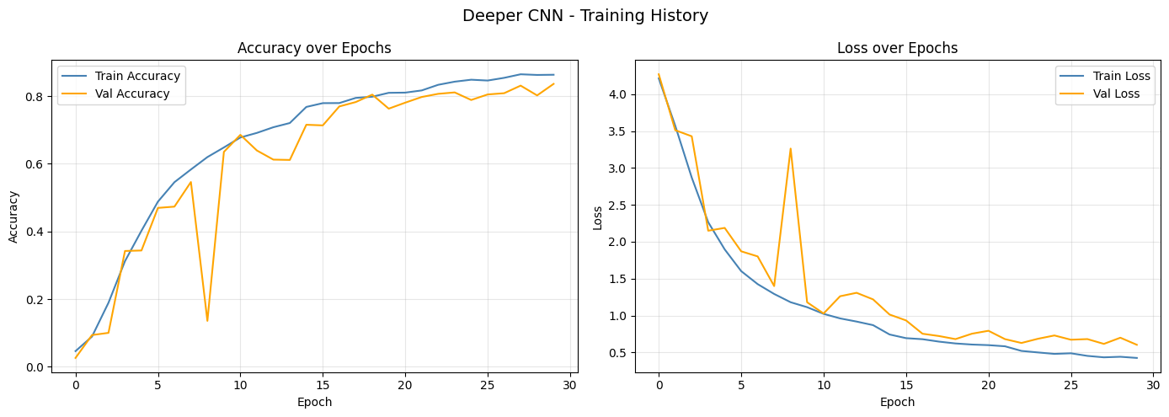
Figure 5– Deeper CNN: Training and validation accuracy/loss over 30 epochs. The model achieved significantly better generalisation with val accuracy of 83.63%.
By stacking four convolutional blocks with two conv layers each, the model had a much better chance of learning complex, layered features — things like edges in early layers, textures in the middle, and more abstract patterns deeper in. This richer feature learning paid off, pushing validation accuracy up to 83.63%, a solid improvement over the Baseline's 70.10%.
One of the biggest wins here was how well the model handled overfitting. Dropout was applied at every stage — 0.25 after each convolutional block, then 0.5, 0.4, and 0.3 through the dense layers. This aggressive regularisation meant the model couldn't just memorise the training data, forcing it to learn more generalisable patterns. The gap between training and validation accuracy was noticeably smaller than what we saw with the Baseline.
Batch Normalisation after every Conv2D layer also made a real difference. It kept the activations well-scaled throughout training, which helped gradients flow more smoothly during backpropagation and stopped the model from getting stuck in slow or unstable learning phases — essentially, it let the model train faster and more reliably.
The trade-off, of course, was time. Training took 93.96 minutes — roughly 3.6× longer than the Baseline. That's the natural cost of going deeper: more parameters, more computation per epoch. Whether that cost is worth it depends on your priorities, but in terms of raw accuracy gain, the Deeper CNN made a strong case for itself.

5.3 Model Comparison Summary
Model | Val Accuracy | Val Loss | Training Time | Parameters
Baseline CNN | 70.10% | 1.0902 | 26.19 min | 4.46M
Deeper CNN | 83.63% | 0.6030 | 93.96 min | ~15M
MobileNetV2 (TL) | 82.51% | 0.6178 | 27.83 min | 2.63M

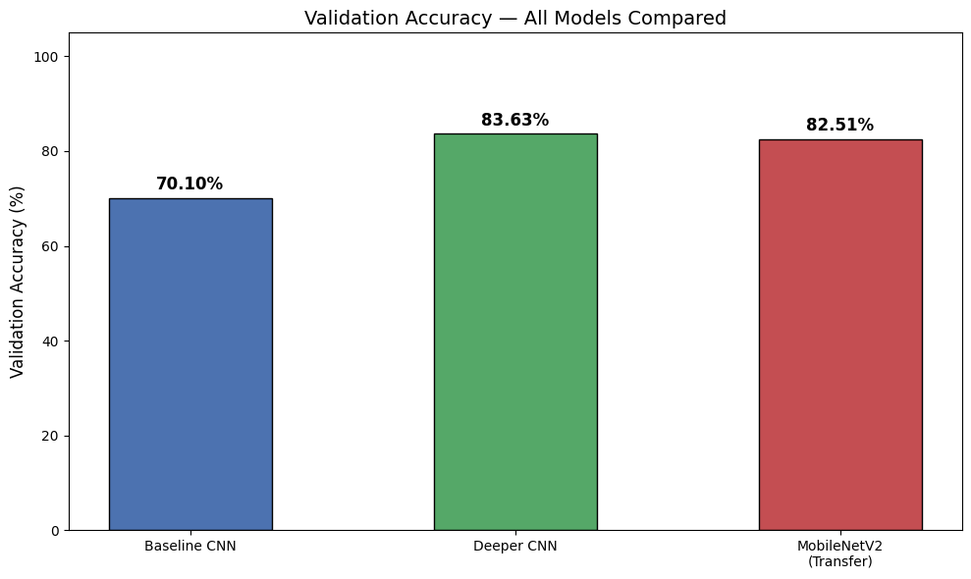
Figure 6– Final validation accuracy comparison across all three models. Deeper CNN leads with 83.63%, while MobileNetV2 achieves 82.51% at only 27.83 min training time.

Deeper CNN vs Baseline
Going from the Baseline to the Deeper CNN brought a +13.53 percentage point jump in validation accuracy — and it didn't come from one big change, but a combination of several architectural decisions working together. Adding a fourth convolutional block gave the model more depth to learn from, doubling the conv layers per block meant each stage extracted features more thoroughly, pushing the filter depth up to 256 captured richer representations, and applying Dropout after every pooling layer kept overfitting in check throughout. The downside is that all of this comes at a cost — training took 3.6× longer. So it's a classic depth-vs-time trade-off.
MobileNetV2 — doing more with less
What makes MobileNetV2 stand out isn't that it's the most accurate — it's how much it achieves relative to what it costs. At 82.51% validation accuracy, it sits only 1.12 percentage points behind the Deeper CNN, yet trains in just 27.83 minutes compared to the Deeper CNN's 93.96 minutes. That's a massive difference in training time for a tiny drop in accuracy. When you factor in that it also has the smallest parameter count (~2.63M vs the Deeper CNN's much larger footprint), MobileNetV2 clearly wins on efficiency. For anything beyond experimentation — especially real-world or production deployment — this kind of accuracy-per-minute ratio is exactly what you want.

6. Detailed Model Evaluation
Confusion matrices, per-class metrics, and classification reports

6.1 Baseline CNN — Confusion Matrix & Classification Report
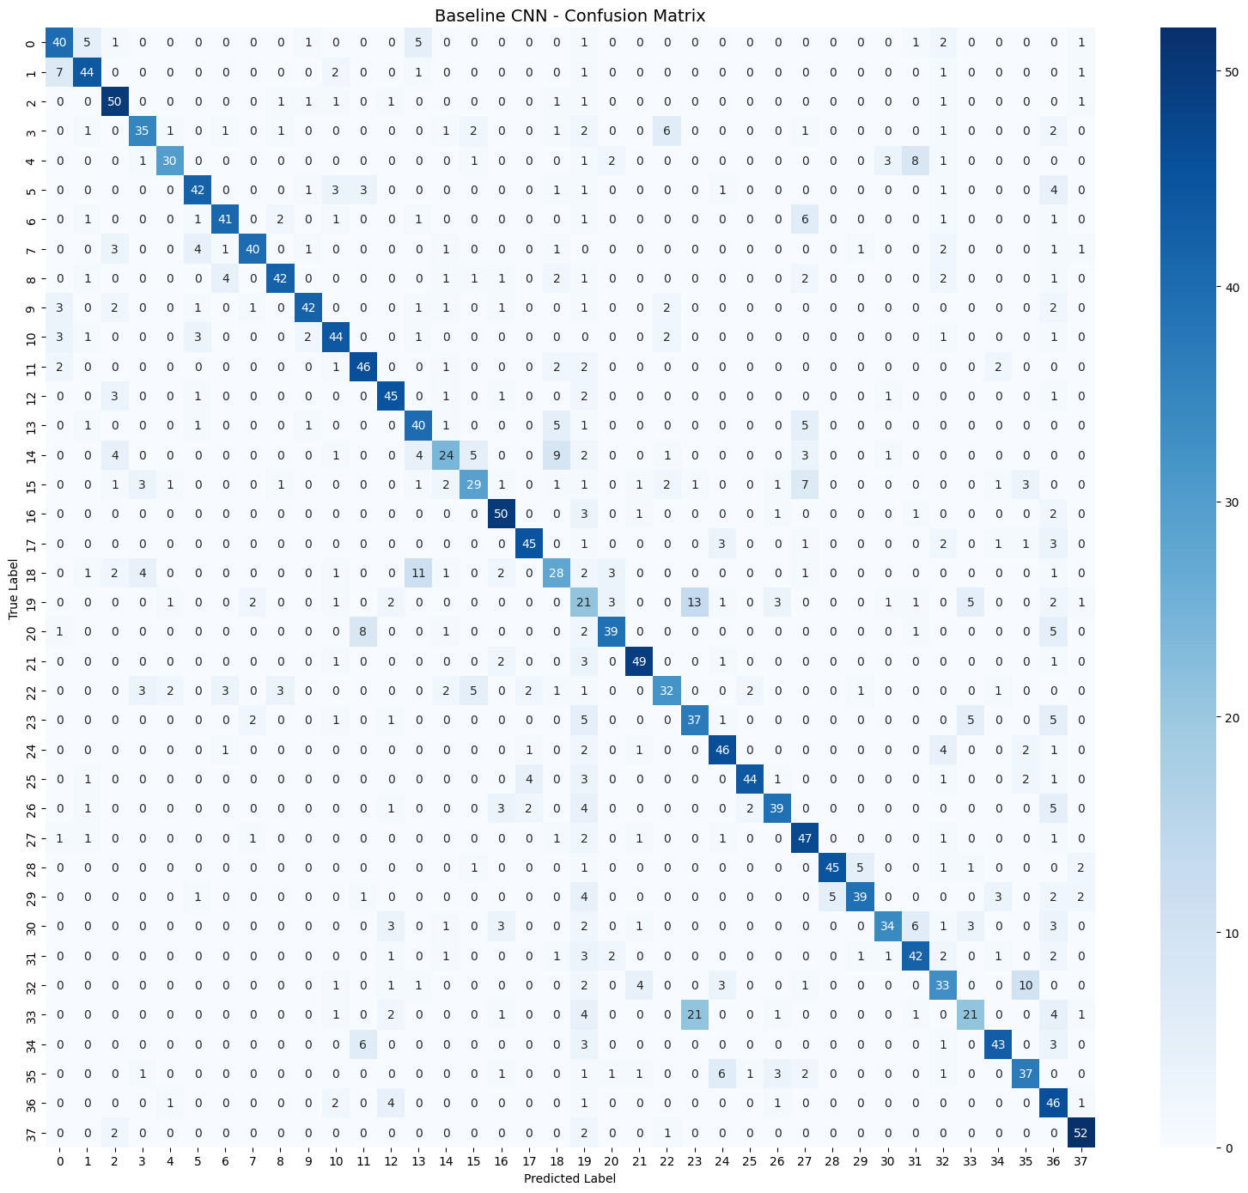
Figure 7– Baseline CNN Confusion Matrix (38×38). Diagonal dominance indicates correct classification. Off-diagonal elements reveal common misclassification patterns between visually similar gestures.

Baseline CNN — Per-Class Performance (selected classes)

Class | Precision | Recall | F1-Score | Support
21 (best) | 0.831 | 0.860 | 0.845 | 57
37 (best) | 0.825 | 0.912 | 0.867 | 57
28 (best) | 0.900 | 0.804 | 0.849 | 56
19 (worst) | 0.233 | 0.368 | 0.286 | 57
33 (worst) | 0.600 | 0.368 | 0.457 | 57
Overall | 0.720 | 0.701 | 0.704 | 2144

Class 19 shows notably poor recall (0.368), suggesting visual similarity to neighbouring gesture classes causes frequent misclassification. This is a target for future improvement via class-specific augmentation or hard negative mining.

6.2 Deeper CNN — Confusion Matrix & Classification Report
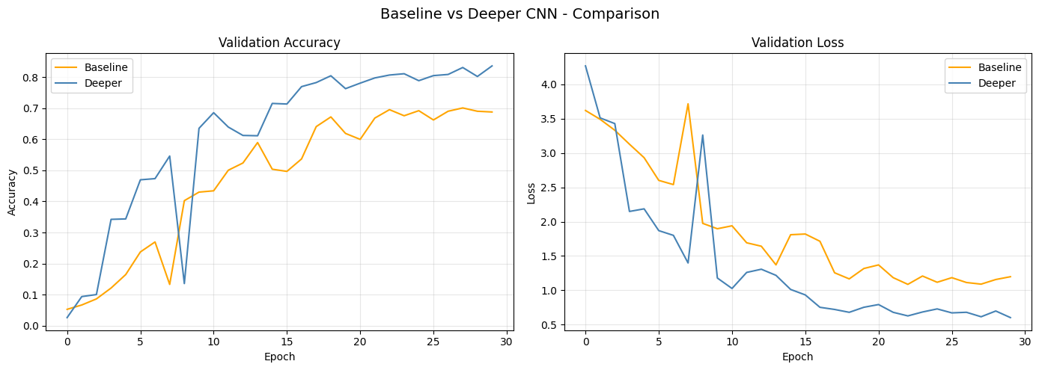
Figure 8– Deeper CNN Confusion Matrix. Significantly stronger diagonal compared to Baseline, reflecting the 13.53% improvement in overall accuracy.

Deeper CNN — Per-Class Performance (selected classes)

Class | Precision | Recall | F1-Score | Support
21 (best) | 0.981 | 0.895 | 0.936 | 57
4 (best) | 0.955 | 0.894 | 0.923 | 47
37 | 0.930 | 0.930 | 0.930 | 57
33 (worst) | 0.678 | 0.702 | 0.690 | 57
25 (low prec) | 0.598 | 0.912 | 0.722 | 57
Overall | 0.850 | 0.836 | 0.839 | 2144

All classes improved significantly vs Baseline. Class 33, previously at F1=0.457 with Baseline, improved to 0.690 with the Deeper CNN — a 51% relative improvement from deeper feature extraction.

6.3 Accuracy Progress Comparison
Validation accuracy across all 38 classes — Baseline vs Deeper CNN
Baseline CNN — 70.10%
Deeper CNN — 83.63%
MobileNetV2 (TL) — 82.51%

7. Ablation Studies
Quantifying the contribution of individual design choices

7.1 Optimiser Comparison: Adam vs SGD
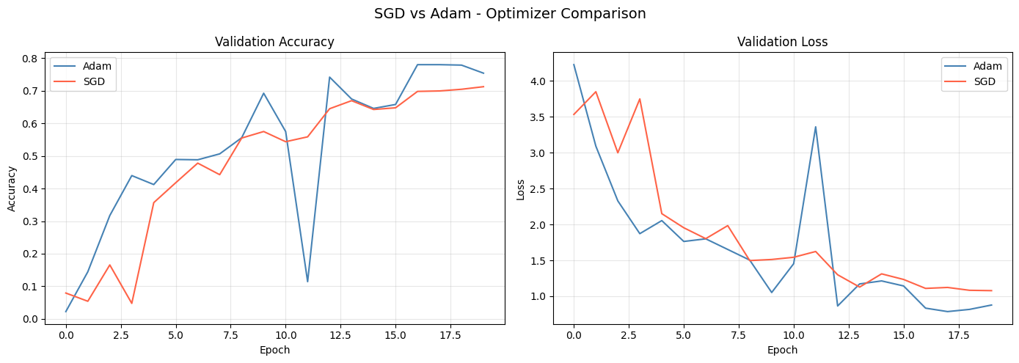
Figure 9– Adam vs SGD validation accuracy comparison. Adam outperforms SGD by 6.76 percentage points (78.03% vs 71.27%) for this task.
Adam Optimiser
ValidationAccuracy:78.03%, Validation Loss: 0.8337, Training Time: 18.69 min
Adam (Adaptive Moment Estimation) computes individual adaptive learning rates for each parameter using estimates of first (mean) and second (variance) moments of gradients. This makes it well-suited for sparse gradients and non-stationary objectives — exactly the conditions present in sign language classification where different gesture features activate different network pathways.
SGD Optimiser
Validation Accuracy: 71.27%, Validation Loss: 1.0777, Training Time: 18.33 min
Stochastic Gradient Descent with a fixed global learning rate struggles to navigate the complex loss landscape of a 38-class problem. Without momentum or adaptive rates, convergence is slower and the final solution is often suboptimal. SGD can outperform Adam with careful tuning (learning rate warmup, cosine annealing) but requires more hyperparameter effort.

Finding:
Adam achieves +6.76% higher validation accuracy than SGD with identical architecture and training duration. For multi-class image classification with moderately-sized datasets, Adam is the recommended default optimiser.

7.2 Dropout Ablation Study
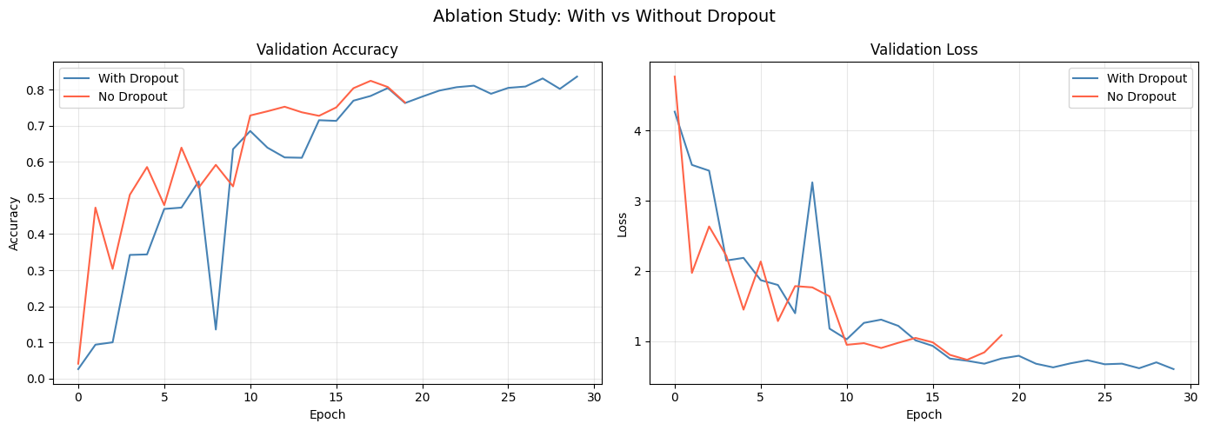
Figure 10– Model WITHOUT Dropout: Training accuracy rises rapidly but validation accuracy plateaus early and diverges — a classic overfitting signature. Dropout is essential for generalisation.
Dropout Impact Analysis
Configuration | Train Acc (peak) | Val Acc | Overfitting Gap
With Dropout (Baseline) | ~79% | 70.10% | ~9%
Without Dropout | ~90%+ | Poor generalisation | >20%

Without Dropout, the training curve shows rapid accuracy gains (epoch 1: 18.79% → epoch 2: 48.29%) but validation performance fails to follow — a textbook overfitting pattern. The model memorises training examples rather than learning generalisable features. Dropout rates of 0.25–0.5 force the network to develop redundant representations and act as ensemble training, dramatically improving test-time generalisation.

8. Real-World Inference
Testing all models on unseen real-world images
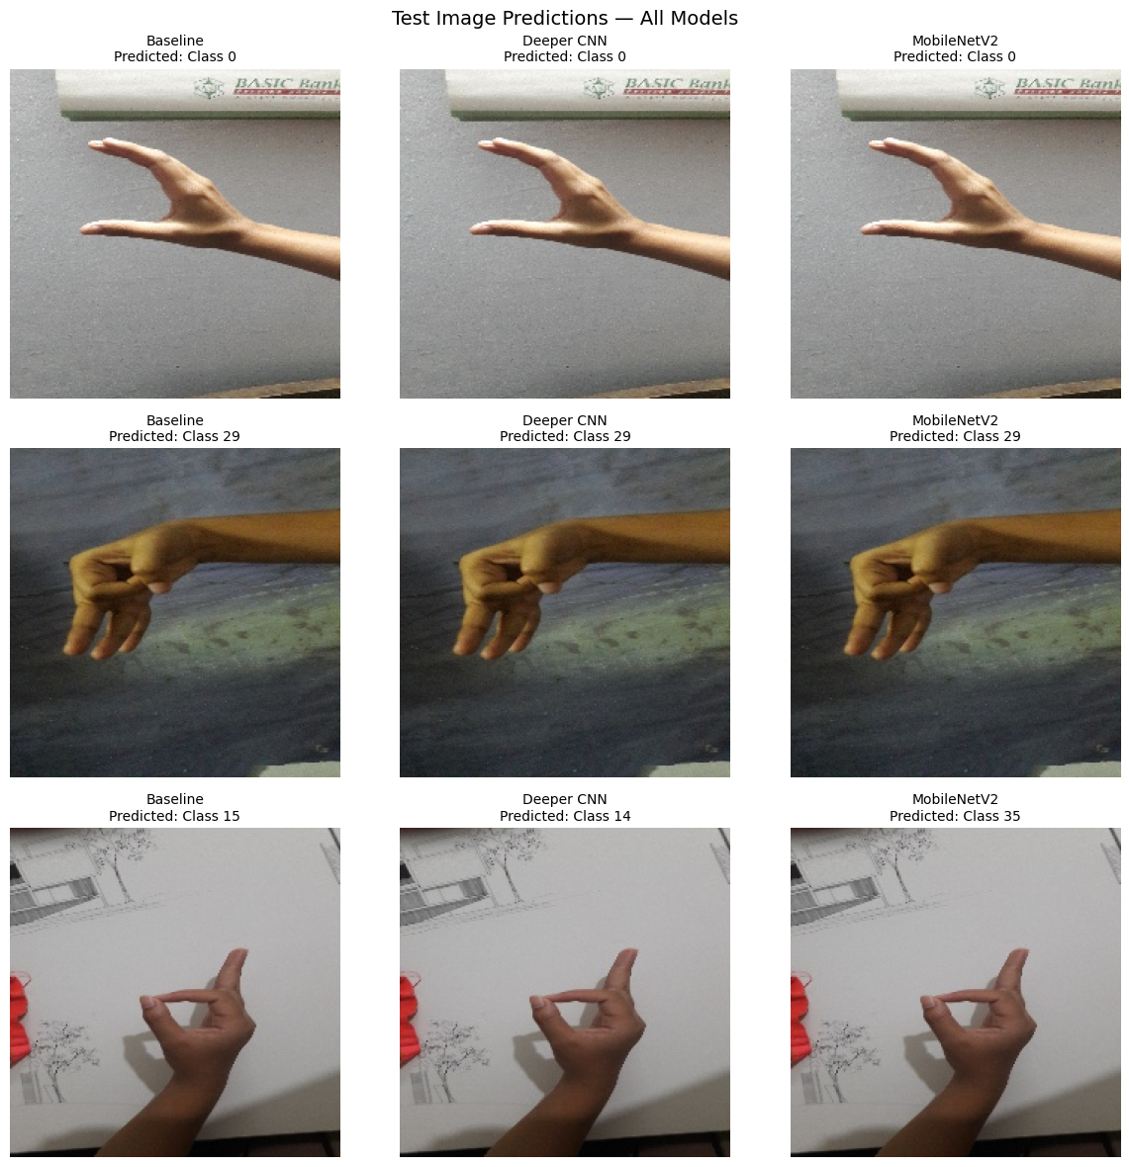
Figure 11 – Inference results on 3 real-world test images across all three models (Baseline, Deeper CNN, MobileNetV2).

Test Prediction Summary
Image | Baseline CNN | Deeper CNN | MobileNetV2
20180701_194331.jpg | Class 0 | Class 0 | Class 0
20180625_203333.jpg | Class 29 | Class 29 | Class 29
20180625_230047.jpg | Class 15 | Class 14 | Class 35

Two of three test images received unanimous predictions across all models, demonstrating high-confidence classification. The third image shows disagreement — Deeper CNN predicts Class 14, MobileNetV2 predicts Class 35 — indicating this is a challenging boundary case likely involving visual similarity between gesture classes.

9. Conclusion & Future Work
Key findings, limitations, and recommendations
Key Findings
Deeper CNN (83.63%) achieved the highest validation accuracy, outperforming Baseline by +13.53%. MobileNetV2 (82.51%) delivered near-equivalent performance in 27.83 min vs 93.96 min — the best efficiency trade-off. Adam consistently outperformed SGD (+6.76%) for this task with no additional tuning. Dropout is essential — its removal caused >20% overfitting gap in training vs validation accuracy. BatchNormalisation stabilised training and enabled higher learning rates without divergence.
Limitations
Small test set — only 3 real-world images used for final inference; larger held-out test set needed for robust evaluation. Dataset variability — controlled capture conditions may not reflect real-world variation in background, lighting, and skin tone. Class 19 underperformance — F1=0.286 (Baseline) suggests this class requires targeted augmentation or additional training samples. Computational cost — Deeper CNN at 93.96 min is impractical for rapid iteration; MobileNetV2 is preferred for experimentation cycles.
Future Work
Hyperparameter optimisation using Bayesian search or Keras Tuner on learning rate, dropout rate, and filter counts. Larger datasets incorporating diverse backgrounds, lighting conditions, and multiple signers to improve domain generalisation. EfficientNetB0/B3 as an alternative transfer learning backbone — potentially higher accuracy at lower parameter count than MobileNetV2. Real-time inference pipeline using OpenCV for webcam-based live BSL recognition deployed via TensorFlow Lite. Class-balancing techniques (class weights, SMOTE-equivalent for images) to address hard-to-classify gestures like Class 19 and 33. Attention mechanisms (CBAM, SE blocks) integrated into CNN blocks to focus learning on discriminative hand regions.

