# Hate Speech Detection in Tweets using RNN, LSTM, and Word2Vec Embeddings

Abstract

This project addresses the critical problem of detecting hate speech in social media content, specifically focusing on racist and sexist tweets. The task involves binary classification of tweets into racist/sexist or non-racist/sexist categories using deep learning approaches. Three neural network architectures were implemented and compared: Simple Recurrent Neural Networks (RNN), Long Short-Term Memory (LSTM) networks, and LSTM models enhanced with pretrained Word2Vec embeddings. The dataset used consists of 31,962 tweets with significant class imbalance. Experimental results demonstrate that all three models achieved comparable overall accuracy around 94%, with LSTM showing slightly better performance in terms of F1-score (57.72%) compared to RNN (53.37%). Interestingly, the Word2Vec-enhanced model achieved the highest precision (71.24%) but suffered from low recall (36.17%), indicating a conservative classification approach. The study highlights the challenges of hate speech detection, including class imbalance, ambiguous language, and the limitations of current architectures in capturing nuanced context. These findings suggest that while deep learning models show promise for automated hate speech detection, further improvements are needed through techniques such as bidirectional processing, fine-tuned embeddings, and data augmentation.

1. Introduction

1.1 Problem Statement
The proliferation of social media platforms has led to an unprecedented increase in user-generated content, including harmful and offensive language. Hate speech, specifically racist and sexist content, poses significant challenges to online communities and content moderation systems. This project focuses on developing automated text classification systems to identify hate speech in tweets, categorizing them as either racist/sexist or non-racist/sexist.
1.2 Significance
Effective hate speech detection is crucial for maintaining safe online environments, protecting users from harassment, and assisting content moderators in managing large volumes of user-generated content. Manual moderation is impractical at scale due to the sheer volume of posts, making automated classification systems essential. Deep learning approaches, particularly recurrent neural networks, offer promising solutions for handling the sequential nature of text data and capturing contextual dependencies.
1.3 Background and Related Work
Text classification has evolved from traditional machine learning approaches such as Naive Bayes and Support Vector Machines to deep learning architectures. Recurrent Neural Networks (RNNs) have been widely adopted for sequence modeling due to their ability to process sequential data. However, standard RNNs suffer from the vanishing gradient problem, limiting their effectiveness on longer sequences. Long Short-Term Memory (LSTM) networks address this limitation through gated memory cells, enabling better long-term dependency learning.
Word embeddings, particularly Word2Vec, have revolutionized natural language processing by providing dense vector representations that capture semantic relationships between words. Pretrained embeddings trained on large corpora can improve model performance, especially when training data is limited.
Previous studies in hate speech detection have demonstrated the effectiveness of deep learning approaches, with LSTM networks consistently outperforming traditional RNN architectures. However, challenges remain, including handling class imbalance, detecting sarcasm and irony, and understanding context-dependent language.

2. Dataset
2.1 Data Source
The dataset used in this project is the Twitter hate speech detection dataset (train_racist.csv), containing tweets labeled for hate speech content. The dataset was obtained from a public source commonly used for sentiment analysis and hate speech detection research.
2.2 Data Characteristics
Total Samples | 31,962 tweets
Classes | Binary classification (0 = non-racist/sexist, 1 = racist/sexist)
Class Distribution | - Non-racist/sexist (Class 0): 29,720 tweets (93.0%)  - Racist/sexist (Class 1): 2,242 tweets (7.0%)
The dataset exhibits significant class imbalance, with the majority class representing approximately 93% of the data. This imbalance poses challenges for model training and evaluation, as models may achieve high accuracy by predominantly predicting the majority class.
2.3 Data Preprocessing
Several preprocessing steps were applied to clean and prepare the text data:
Step | Preprocessing Technique | Description
1 | Text Normalization | Conversion of text to lowercase to ensure consistency
2 | Contraction Expansion | Expansion of contractions (e.g., “don't” → “do not”) using the contractions library
3 | URL Removal | Elimination of hyperlinks using regular expressions
4 | Mention Removal | Removal of user mentions (@username)
5 | Hashtag Removal | Removal of hashtag symbols (#)
6 | Special Character Removal | Elimination of non-alphabetic characters
7 | Stopword Removal | Removal of common English stopwords using NLTK
8 | Lemmatization | Reduction of words to their base or dictionary form using WordNet Lemmatizer

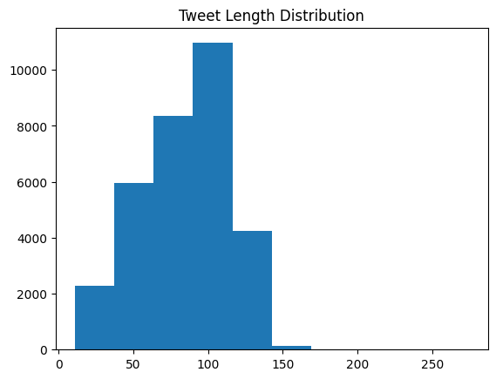
After preprocessing, the vocabulary size was determined to be 10,000 words, and the maximum sequence length was set to 11 tokens based on the 95th percentile of tweet lengths.

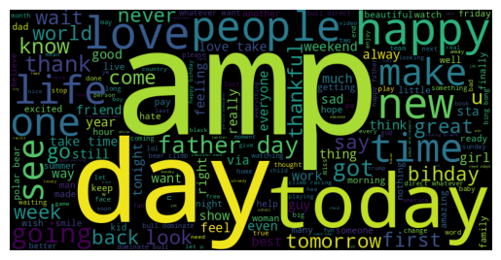
3. Methodology
3.1 Text Preprocessing Pipeline
The text preprocessing pipeline implemented in this project follows a systematic approach to transform raw tweet text into a format suitable for deep learning models. The process begins with basic cleaning operations including lowercase conversion, contraction expansion, and removal of URLs, mentions, hashtags, and special characters. Subsequently, stopwords are removed to focus on content-bearing words, and lemmatization is applied to reduce words to their canonical forms, which helps in reducing vocabulary size and improving generalization.
The preprocessed text is then tokenized using Keras Tokenizer with a vocabulary size of 10,000 words. Sequences are padded to a fixed length of 11 tokens to ensure uniform input dimensions for the neural networks. The dataset is split into training (80%) and testing (20%) sets using stratified sampling to maintain class distribution.
3.2 Model Architectures
3.2.1 Simple RNN
The Simple Recurrent Neural Network architecture consists of:
Layer | Configuration | Description
1 | Embedding Layer | 64-dimensional trainable word embeddings
2 | SimpleRNN Layer | 64 recurrent units for sequential text processing
3 | Dense Output Layer | Single neuron with sigmoid activation for binary classification
The RNN processes sequences sequentially, maintaining a hidden state that captures information from previous tokens. However, standard RNNs are limited in their ability to learn long-range dependencies due to the vanishing gradient problem.
3.2.2 LSTM Network
The Long Short-Term Memory network architecture includes:
Layer | Configuration | Description
1 | Embedding Layer | 64-dimensional trainable word embeddings
2 | LSTM Layer | 64 memory cells with gated architecture for sequence learning
3 | Dense Output Layer | Single neuron with sigmoid activation for binary classification

LSTM networks address the limitations of standard RNNs through the use of input, forget, and output gates that regulate information flow. This architecture enables the model to selectively retain or forget information over longer sequences, making it more effective for capturing contextual dependencies in text.
3.2.3 Word2Vec-Enhanced LSTM
The Word2Vec-enhanced model incorporates pretrained embeddings:
Layer | Configuration | Description
1 | Embedding Layer | 50-dimensional pretrained GloVe embeddings (frozen during training)
2 | LSTM Layer | 64 memory cells for sequence learning
3 | Dense Output Layer | Single neuron with sigmoid activation for binary classification
This model leverages the GloVe-Wiki-Gigaword-50 pretrained embeddings, which were trained on a large corpus and capture semantic relationships between words. The embedding layer is initialized with these pretrained weights and frozen during training to preserve the learned semantic knowledge.
3.3 Loss Function and Optimizer
All models use binary cross-entropy as the loss function, which is appropriate for binary classification tasks. The loss function measures the difference between predicted probabilities and actual labels, guiding the optimization process.
The Adam optimizer was selected for training all models due to its adaptive learning rate and good performance across a wide range of deep learning applications. Adam combines the advantages of AdaGrad and RMSProp optimizers, providing efficient optimization with minimal hyperparameter tuning.

3.4 Hyperparameters
The following hyperparameters were used across all models:
Parameter | Value | Description
Learning Rate | 0.001 | Default learning rate used by the Adam optimizer
Batch Size | 32 | Number of samples processed in each training batch
Epochs | Maximum of 5 | Training performed with early stopping (patience = 2)
Vocabulary Size | 10,000 words | Maximum number of unique words used in tokenization
Embedding Dimension | 64 / 50 | 64 for trainable embeddings and 50 for pretrained GloVe embeddings
Maximum Sequence Length | 11 tokens | Maximum length of padded input sequences
Recurrent Units | 64 | Number of units used in RNN/LSTM layers

Early stopping was implemented to prevent overfitting by monitoring validation loss and terminating training when no improvement is observed for two consecutive epochs.
4. Experiments and Results
4.1 RNN vs. LSTM Performance Comparison
The performance of Simple RNN and LSTM models was evaluated on the test set. Both models were trained for a maximum of 5 epochs with early stopping.
Model | Training Result | Description
RNN | Completed in 3 epochs | Training stopped early due to early stopping criteria
LSTM | Completed in 3 epochs | Training stopped early due to early stopping criteria

Test Set Performance:
Model | Accuracy | Precision | Recall | F1-Score
RNN | 94.37% | 65.81% | 44.88% | 53.37%
LSTM | 94.48% | 64.10% | 52.51% | 57.72%
The LSTM model demonstrated slightly better overall performance compared to the Simple RNN, achieving higher accuracy (94.48% vs 94.37%) and significantly better F1-score (57.72% vs 53.37%). The improvement in F1-score is primarily driven by better recall (52.51% vs 44.88%), indicating that LSTM is more effective at identifying positive (hate speech) instances. The slightly lower precision of LSTM (64.10% vs 65.81%) suggests that it makes more false positive predictions but captures more true positives overall.
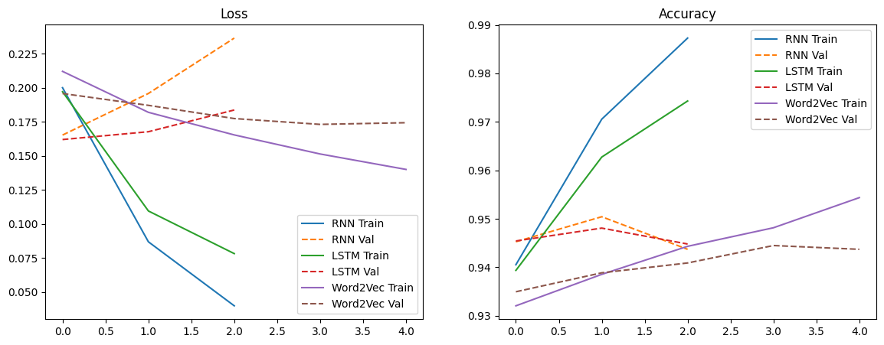
The superior performance of LSTM can be attributed to its gated architecture, which enables better handling of long-range dependencies and more effective gradient flow during training. This is particularly important for text classification where the meaning of words often depends on distant context.
4.2 Computational Efficiency
Training time and computational efficiency were analyzed across the three models:
Model | Training Time | Description
RNN | Approximately 57 seconds | Model training completed in 3 epochs
LSTM | Approximately 54 seconds | Model training completed in 3 epochs
Word2Vec LSTM | Approximately 46 seconds | Model training completed in 5 epochs

The Word2Vec-enhanced model trained for more epochs (5 vs 3) but still completed faster overall, likely due to the frozen embeddings reducing the number of trainable parameters. The LSTM model showed comparable training time to the RNN, despite its more complex architecture, suggesting that the additional computational overhead of the gated cells is offset by faster convergence.
All experiments were conducted using Google Colab's GPU resources, which significantly accelerated training compared to CPU-only execution. The use of early stopping helped reduce unnecessary computation once models stopped improving.
4.3 Performance with Different Embeddings
The impact of embedding strategy on model performance was evaluated by comparing trainable embeddings (RNN and LSTM) with pretrained Word2Vec embeddings.
Embedding Type | Model | F1-Score
Random Embeddings (Trainable) | RNN | 53.37%
Random Embeddings (Trainable) | LSTM | 57.72%
Pretrained Word2Vec Embeddings | Word2Vec LSTM | 47.98%
Contrary to expectations, the model with pretrained Word2Vec embeddings achieved the lowest F1-score (47.98%), primarily due to poor recall (36.17%). However, it achieved the highest precision (71.24%), indicating that when it predicts hate speech, it is more likely to be correct.
The underperformance of the Word2Vec model may be attributed to several factors:
Issue | Description
Frozen Embeddings | The embeddings were not fine-tuned during training, preventing adaptation to the specific domain of hate speech
Vocabulary Mismatch | The GloVe vocabulary may not adequately cover slang, abbreviations, and domain-specific terms common in tweets
Dimensionality Reduction | The 50-dimensional embeddings may be insufficient to capture the nuanced semantics required for hate speech detection
Out-of-Vocabulary Words | Words not present in the GloVe vocabulary were represented as zero vectors, resulting in the loss of potentially important information

These findings suggest that while pretrained embeddings can be beneficial, they should be fine-tuned or combined with trainable embeddings for optimal performance in domain-specific tasks.
4.4 Model Evaluation Metrics
Multiple evaluation metrics were used to assess model performance comprehensively:
Evaluation Aspect | Analysis
Accuracy | All models achieved similar accuracy of approximately 94%, mainly due to strong performance on the majority class (non-hate speech)

Confusion Matrix Analysis:

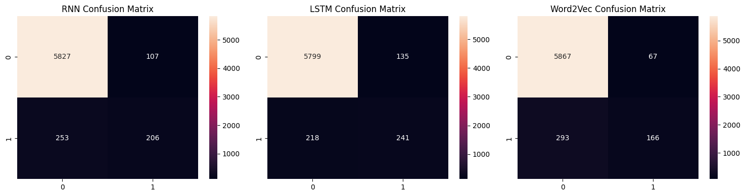

The confusion matrices reveal that:
- All models correctly classify the majority of non-hate speech tweets (true negatives)
- The LSTM model shows the best balance between true positives and false positives
- The Word2Vec model has the fewest false positives but misses many true positives (high precision, low recall)

Precision, Recall, and F1-Score:
Precision measures the proportion of predicted hate speech that is actually hate speech. The Word2Vec model achieved the highest precision (71.24%), making it the most conservative classifier. This means it rarely misclassifies non-hate speech as hate speech but misses many actual hate speech instances.
Recall measures the proportion of actual hate speech that is correctly identified. The LSTM model achieved the best recall (52.51%), indicating it is more effective at capturing hate speech instances, though at the cost of more false positives.
F1-score provides a harmonic mean of precision and recall, giving a balanced view of performance. The LSTM model achieved the highest F1-score (57.72%), indicating the best overall balance between precision and recall.
The significant difference between accuracy and F1-scores highlights the importance of using multiple metrics, especially for imbalanced datasets. While accuracy appears high, the F1-scores reveal that models struggle with the minority class (hate speech).

5. Error Analysis
An examination of misclassified tweets revealed several patterns:
Example | Prediction Result
“h p p” | Predicted as hate speech (Actual: non-hate speech)
“wi book full algerian rhetoric w issue pity” | Predicted as hate speech (Actual: non-hate speech)
“color human skin matter lot system come judgement call” | Predicted as hate speech (Actual: non-hate speech)

Possible Reasons for Misclassification:
Possible Reason | Explanation
Short or Ambiguous Text | Very short tweets without clear context are difficult to classify accurately. For example, “h p p” lacks sufficient information for meaningful classification.
Context-Dependent Language | Words that may appear in hate speech contexts can have innocent meanings in different situations. Terms related to race or identity may be used in non-hateful discussions.
Sarcasm and Irony | Sarcastic or ironic statements are difficult for models to detect because they require understanding of tone, intent, and contextual meaning beyond literal text.
Out-of-Vocabulary Words | Slang, misspellings, and newly created words may not be properly represented in the vocabulary or embeddings, reducing model understanding.
Class Imbalance | The severe imbalance in the dataset (93% non-hate vs 7% hate speech) may bias the model toward the majority class, making it less effective at identifying minority-class samples.

Model Limitations:
Limitation | Description
Sequence Length Limitation | The maximum sequence length of 11 tokens may truncate longer tweets, potentially causing the loss of important contextual information.
Unidirectional Processing | The models process text only in a left-to-right direction, missing contextual information that could be captured through bidirectional understanding.
Frozen Embeddings | The Word2Vec model uses frozen embeddings, preventing the embeddings from adapting to the specific hate speech detection domain during training.
Lack of Attention Mechanism | The models do not apply attention mechanisms to emphasize important words or phrases, which could improve performance by focusing on key contextual terms.

6. Conclusion and Future Work
6.1 Key Findings
This project investigated the application of deep learning models for hate speech detection in tweets using RNN, LSTM, and Word2Vec embeddings.The experimental results demonstrate that LSTM networks outperformed Simple RNNs in hate speech detection, achieving a higher F1-score of 57.72% compared to 53.37%, highlighting the advantage of gated architectures in capturing sequential dependencies in text data. Although all models achieved a similar overall accuracy of around 94%, this performance was strongly influenced by the highly imbalanced dataset, where non-hate speech constituted 93% of the data. The pretrained Word2Vec embedding model achieved the highest precision of 71.24% but suffered from the lowest recall of 36.17%, resulting in the lowest F1-score of 47.98%. This indicates that frozen pretrained embeddings may not adapt effectively to domain-specific tasks such as hate speech detection without fine-tuning. Furthermore, the severe class imbalance posed a major challenge, as models tended to favor the majority class while struggling to correctly identify minority-class samples. Error analysis also revealed that many misclassifications involved short or ambiguous tweets and context-dependent language, which require deeper semantic and contextual understanding for accurate classification.

6.2 Limitations
Several limitations were identified in this study. First, the severe class imbalance in the dataset may have biased both model training and evaluation, suggesting the need for techniques such as oversampling, undersampling, or class weighting to improve minority class detection. Second, the maximum sequence length of 11 tokens may not be sufficient to capture the complete context of longer tweets, potentially leading to information loss. Third, the use of unidirectional RNN and LSTM architectures restricts the models from utilizing contextual information from both past and future words within a sequence. Additionally, the Word2Vec model employed frozen embeddings, which prevented the embeddings from adapting to the specific characteristics of hate speech data. Finally, the models were evaluated on only a single dataset, limiting the generalizability and robustness of the findings across different hate speech detection datasets and real-world scenarios.
6.3 Future Work
Based on the findings and identified limitations, several directions for future work are recommended to improve hate speech detection performance. First, bidirectional architectures such as Bidirectional LSTM or GRU models could be implemented to capture contextual information from both past and future words within a sequence. Additionally, incorporating attention mechanisms may help models focus on the most relevant words and phrases during classification. Fine-tuning pretrained embeddings during training could also improve adaptation to the hate speech domain compared to using frozen embeddings. To address the severe class imbalance problem, techniques such as SMOTE (Synthetic Minority Over-sampling Technique), class weighting, and focal loss could be applied to improve minority-class detection. Data augmentation methods including synonym replacement, back-translation, and random insertion may further increase the effective size and diversity of minority-class samples. Future studies could also explore ensemble methods that combine predictions from multiple models to improve robustness and classification performance. Training and evaluating models on larger and more balanced datasets would likely improve generalization across different contexts. Moreover, subword tokenization techniques such as Byte Pair Encoding (BPE) or WordPiece could better handle out-of-vocabulary words, slang, and morphological variations commonly found in social media text. Transformer-based architectures such as BERT and RoBERTa should also be investigated, as they have demonstrated state-of-the-art performance across various natural language processing tasks. Finally, incorporating explainable AI techniques such as attention visualization or SHAP values could improve the interpretability of model predictions and provide deeper insight into the features influencing classification decisions.
6.4 Practical Application
To demonstrate the practical utility of the developed models, a web-based interface was created using the Gradio library. This interface allows users to input custom tweets and receive real-time predictions from the trained LSTM model. The application applies the same preprocessing pipeline used during training, including text cleaning, tokenization, and padding, before passing the input through the model for classification.
The interface provides a user-friendly way to interact with the hate speech detection system, making it accessible to non-technical users such as content moderators or researchers. Users can test the model with various text inputs to understand its behavior and limitations in real-time scenarios.
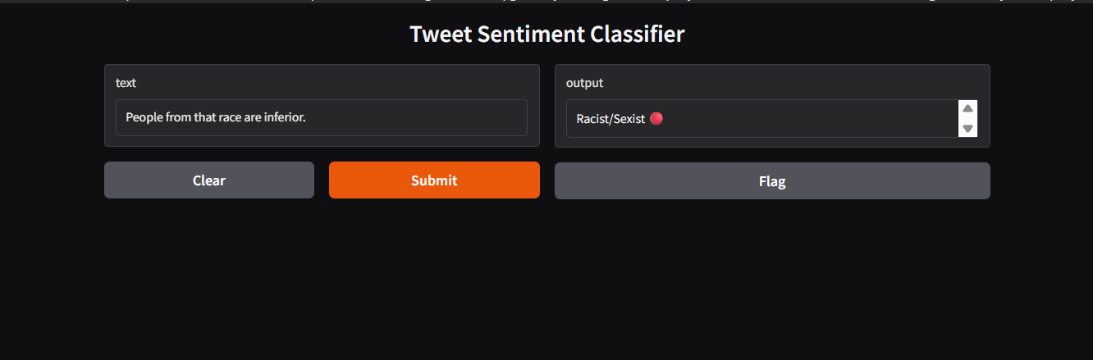
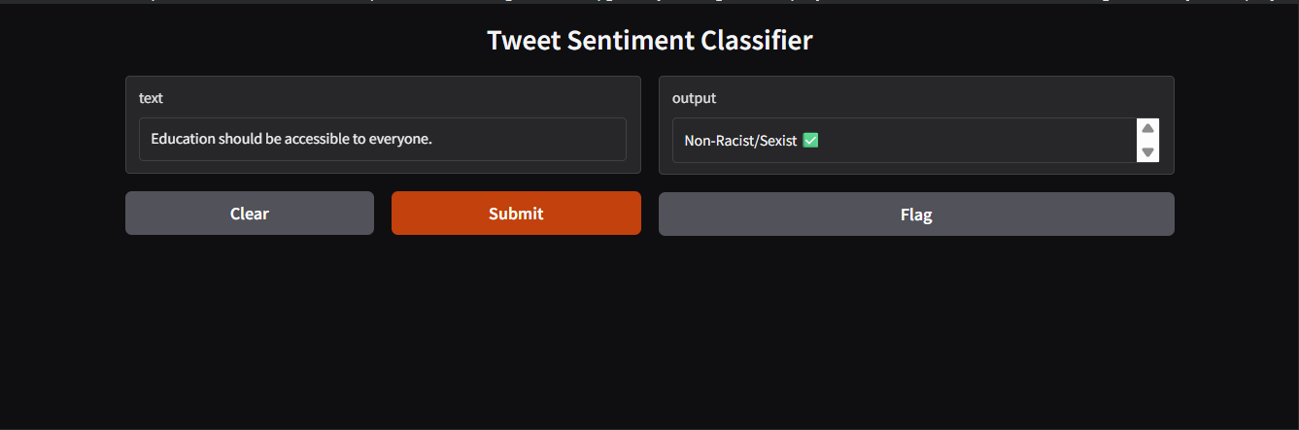
This practical implementation demonstrates the transition from model development to deployment, highlighting the potential for integrating such systems into social media platforms for automated content moderation. The interface also serves as a valuable tool for educational purposes, allowing users to explore how deep learning models make predictions on text data.

6.5 Conclusion
This project demonstrates that deep learning models, particularly LSTM networks, show promise for automated hate speech detection in social media content. While overall accuracy is high, the performance on the minority class (hate speech) remains modest, highlighting the challenges of this task. The comparison between RNN and LSTM confirms the theoretical advantages of LSTM's gated architecture for sequential data processing. The mixed results with pretrained Word2Vec embeddings suggest that embedding strategy requires careful consideration and may benefit from fine-tuning or hybrid approaches.
The findings underscore the importance of using multiple evaluation metrics beyond accuracy, especially for imbalanced classification tasks. Future work should focus on addressing class imbalance, incorporating bidirectional processing and attention mechanisms, and exploring more advanced architectures to improve hate speech detection performance. As social media continues to grow, developing robust and accurate automated moderation systems remains an important area of research with significant practical implications.

