Mutual Fund Analytics
End-to-End Data Engineering and Analytics
Capstone Project
Prepared by
Prateek Raj
Tech Stack
Python • Pandas • NumPy
• SQLite • Power BI • GitHub

Executive Summary
The Mutual Fund Analytics project is an end-to-end data engineering and analytics capstone that demonstrates the complete lifecycle of a real-world data product — from raw data ingestion through validation, cleaning, exploratory analysis, business intelligence dashboarding, and finally to a working fund recommendation engine.
The project was designed to simulate the workflow of a data analytics team operating within the asset management / investment research domain. Using publicly structured mutual fund datasets (scheme master data, historical NAVs, AUM, SIP inflows, portfolio holdings, and benchmark indices), a robust pipeline was engineered using Python, Pandas, NumPy, Scikit-learn, Matplotlib, and Seaborn, with the final business-facing layer delivered through Power BI.
The deliverables of this project include:

- A fully validated and cleaned mutual fund dataset, ready for analytical consumption.
- Ten distinct exploratory data analysis (EDA) modules covering category distribution, expense ratios, risk grades, ratings, performance, and correlations.
- A rule-based fund recommendation engine that filters and ranks funds based on investor-defined criteria.
- A master execution script (run_pipeline.py) that automates the entire pipeline from raw data to recommendations.
- A five-page interactive Power BI dashboard suite covering executive overview, fund performance, investor behaviour, portfolio analysis, and recommendations.
This report documents the architecture, methodology, findings, limitations, and future roadmap of the project, and is intended both as an internship submission and as a portfolio-grade technical document.

Introduction
The mutual fund industry generates enormous volumes of data on a daily basis — net asset values (NAVs), assets under management (AUM), systematic investment plan (SIP) inflows, portfolio holdings, and fund ratings. For investors, analysts, and fund houses alike, the ability to convert this raw data into actionable insight is a critical competitive advantage.
This project, Mutual Fund Analytics, was conceived as a capstone exercise to demonstrate proficiency across the full data analytics value chain: ingesting heterogeneous datasets, validating their quality, cleaning and standardizing them, performing rigorous exploratory analysis, visualizing results through an interactive business intelligence layer, and ultimately building a decision-support tool in the form of a fund recommendation engine.
The project follows industry-standard practices including version control via Git/GitHub, modular notebook-based development, a well-organized project directory structure, and a reproducible pipeline script that ties all stages together.

Problem Statement
Retail investors and analysts are often confronted with thousands of mutual fund schemes across dozens of fund houses, each with differing risk profiles, expense ratios, historical performance, and ratings. Manually comparing and shortlisting funds is time-consuming, error-prone, and lacks consistency.
There is, therefore, a need for:

- A centralized, validated, and cleaned dataset that consolidates scheme information, performance history, AUM trends, SIP behaviour, and portfolio composition.
- Analytical tooling that surfaces patterns — such as which categories or fund houses consistently outperform, how expense ratios relate to returns, and how ratings correlate with consistency.
- A simple, transparent, and explainable recommendation mechanism that can shortlist funds based on an investor’s stated preferences (category, risk appetite, cost sensitivity, and rating threshold).
- A visual reporting layer that allows non-technical stakeholders (e.g., relationship managers, investors) to explore the data interactively.
The Mutual Fund Analytics project addresses each of these needs through a structured, end-to-end pipeline.

Objectives
The key objectives of this capstone project are:

- Data Ingestion — Consolidate multiple raw mutual fund datasets (AMFI scheme master, historical NAV, AUM, SIP inflows, portfolio holdings, benchmark indices) into a unified working environment.
- Data Validation — Systematically assess data quality across all datasets, identifying duplicates, missing values, datatype mismatches, and structural inconsistencies.
- Data Cleaning — Transform raw, inconsistent data into a clean, analysis-ready format through imputation, standardization, deduplication, and feature engineering.
- Exploratory Data Analysis — Conduct ten focused analyses to uncover patterns in fund categories, fund houses, expense ratios, risk grades, ratings, performance, and correlations between key variables.
- Recommendation Engine — Design and implement a rule-based system that recommends funds based on category, risk grade, expense ratio, and Morningstar rating.
- Pipeline Automation — Build a master execution script that orchestrates the entire workflow from raw data to final recommendations in a single run.
- Dashboarding — Develop a five-page Power BI dashboard suite to communicate findings to both technical and non-technical audiences.
- Documentation — Produce a professional final report summarizing methodology, findings, limitations, and future scope.

Tech Stack
The project leverages a combination of programming languages, libraries, and tools commonly used in modern data analytics workflows.

Category | Tools / Technologies | Purpose
Programming Language | Python | Core language for data processing, analysis, and modeling
Data Manipulation | Pandas, NumPy | Cleaning, transformation, and numerical computation
Visualization (Python) | Matplotlib, Seaborn | Static charts for EDA notebooks
Machine Learning | Scikit-learn | Supporting utilities for the recommendation engine and potential future ML extensions
Business Intelligence | Power BI | Interactive dashboards for business users
Version Control | Git, GitHub | Source control and collaboration
Development Environment | VS Code | Primary IDE for scripts and notebooks
Notebook Environment | Jupyter Notebooks | Modular, exploratory development of validation, cleaning, and EDA stages

This stack was selected because it mirrors the toolset commonly used by data analytics and data engineering teams in the financial services sector, making the project directly relevant to real-world internship and job requirements.

Project Architecture

Directory Structure
The project follows a modular and industry-standard directory layout, separating raw data, processed data, exploratory notebooks, production scripts, dashboards, and reports.
MutualFundAnalytics/
│
├── data/
│ ├── raw/ # Original, unmodified source datasets
│ └── processed/ # Cleaned and transformed datasets
│
├── notebooks/
│ ├── 01_data_validation.ipynb # Data quality assessment
│ ├── 02_data_cleaning.ipynb # Cleaning and preprocessing
│ └── 03_eda.ipynb # Exploratory data analysis
│
├── scripts/
│ ├── recommender.py # Rule-based recommendation engine
│ └── run_pipeline.py # Master orchestration script
│
├── powerbi/ # Power BI dashboard files (.pbix)
│
├── reports/ # Generated reports and exports
│
├── README.md # Project documentation
└── requirements.txt # Python dependencies

Architectural Principles
The architecture was designed around three guiding principles:

- Separation of Concerns — Raw data is never modified directly; all transformations produce new artifacts in the processed/ directory, preserving the original source data for auditability.
- Modularity — Each notebook and script handles a single, well-defined responsibility (validation, cleaning, EDA, or recommendation), making the codebase easier to test, debug, and extend.
- Reproducibility — The run_pipeline.py script ties together all stages into a single, repeatable execution flow, ensuring that the entire analysis can be regenerated from raw data with one command.

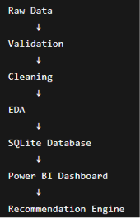

Data Sources
The project consolidates six distinct datasets, each contributing a different dimension to the overall analysis.

# | Dataset | Key Fields | Purpose
1 | AMFI Schemes Dataset | AMFI code, scheme name, fund house, category | Master reference for all mutual fund schemes
2 | Historical NAV Dataset | Date, NAV value, scheme code | Time-series performance tracking
3 | AUM Dataset | Fund house, scheme, AUM value, period | Fund size and growth analysis
4 | SIP Inflows Dataset | Scheme, month, SIP amount | Investor behaviour and inflow trends
5 | Portfolio Holdings Dataset | Scheme, stock/instrument, weight (%) | Portfolio composition and diversification
6 | Benchmark Index Dataset | Index name, date, index value | Performance benchmarking

Dataset Descriptions
AMFI Schemes Dataset: This serves as the master/reference table for the entire project. It contains the unique AMFI code for each scheme, the scheme name, the fund house (AMC) that manages it, and the broad category (e.g., Equity, Debt, Hybrid). Nearly every other dataset is joined back to this table using the AMFI code.
Historical NAV Dataset: Contains time-series Net Asset Value records for each scheme, forming the basis for return calculations, trend analysis, and performance comparisons across categories and fund houses.
AUM Dataset: Captures the Assets Under Management for each scheme over time, used to assess fund size, growth trajectory, and investor confidence.
SIP Inflows Dataset: Tracks monthly Systematic Investment Plan contributions per scheme, providing insight into retail investor behaviour and sentiment trends.
Portfolio Holdings Dataset: Details the underlying instruments (stocks, bonds, etc.) held by each scheme along with their portfolio weights, enabling diversification and concentration analysis.
Benchmark Index Dataset: Provides historical values for relevant benchmark indices, allowing fund performance to be assessed on a relative (alpha) basis rather than in isolation.

Data Validation
Before any transformation was applied, each dataset was subjected to a structured validation process to establish a baseline understanding of data quality. This stage was implemented in 01_data_validation.ipynb.

Validation Checks Performed
- Duplicate Detection — Each dataset was scanned for fully duplicated rows as well as duplicates based on key identifier columns (e.g., AMFI code + date combinations in the NAV dataset).
- Missing Value Analysis — Column-wise null counts and percentages were computed to identify which fields required imputation or removal.
- Datatype Checking — Columns expected to be numeric (NAV values, AUM, SIP amounts, expense ratios) were checked for incorrect string formatting, embedded currency symbols, or inconsistent date formats.
- Null Value Identification — Beyond simple counts, the pattern of nulls was examined — for example, whether missing NAV values clustered around specific date ranges or specific schemes (often indicative of newly launched or discontinued funds).
- Data Quality Assessment — A consolidated data quality scorecard was produced for each dataset, summarizing completeness, consistency, and uniqueness metrics.

Key Observations from Validation

  - The AMFI Schemes Dataset was largely complete, with minor inconsistencies in category naming conventions across fund houses (e.g., “Large Cap” vs “Large-Cap” vs “Large Cap Fund”).
  - The Historical NAV Dataset contained missing values concentrated around scheme launch dates and a small number of holiday-related gaps.
  - The AUM and SIP Inflows datasets had occasional formatting issues where numeric values were stored as strings with commas or currency symbols.
  - The Portfolio Holdings Dataset contained a small percentage of duplicate holding entries, likely due to data refresh overlaps.
  - Several numeric fields (expense ratio, Morningstar rating) were stored as object/string types and required explicit conversion.
This validation stage was critical in scoping the cleaning effort and ensuring that downstream analyses would not be skewed by data quality issues.

Data Cleaning
Building on the findings from the validation stage, a comprehensive cleaning process was implemented in
02_data_cleaning.ipynb to transform the raw datasets into analysis-ready form.

Cleaning Operations Performed

Handling Missing Values
Numeric fields with a small proportion of missing values (e.g., expense ratio) were imputed using category-wise median values, preserving the distributional characteristics within each fund category.
Time-series gaps in the NAV dataset were handled using forward-fill, appropriate for financial time series where the last known value remains valid until the next update.
Records with missing critical identifiers (e.g., missing AMFI code) were dropped, as no reliable mapping could be established.

Removing Duplicates
Exact duplicate rows were dropped across all datasets.
Composite-key duplicates (e.g., same scheme and date in the NAV dataset) were resolved by retaining the most recently recorded entry.

Standardizing Columns
Column names were converted to a consistent snake_case format across all datasets.
Categorical values (fund category, risk grade) were standardized to a controlled vocabulary, eliminating variants such as “Large Cap” vs “Large-Cap”.
Fund house names were standardized to their official registered names to enable accurate grouping.

Datatype Conversion
Date columns were converted to proper datetime objects to enable time-series operations.
Numeric columns stored as strings (with commas, currency symbols, or percentage signs) were cleaned and cast to float/int types.
Categorical columns were cast to category dtype for memory efficiency and faster groupby operations.

Feature Preparation
  - Derived features were engineered to support EDA and the recommendation engine, including:
    - Trailing returns (1-month, 3-month, 1-year) calculated from the cleaned NAV time series.
    - A normalized expense ratio score (relative to category average).
    - A composite “quality score” combining Morningstar rating and risk grade for use in the recommendation engine.

Output
The cleaning stage produced a set of processed datasets stored in data/processed/, which serve as the single source of truth for all subsequent EDA, dashboarding, and recommendation tasks.

Exploratory Data Analysis
The exploratory data analysis stage, implemented in 03_eda.ipynb, comprises ten focused analyses designed to surface meaningful patterns within the mutual fund universe. Each analysis is described below along with the insights derived.

Fund Category Distribution
This analysis examined the distribution of funds across broad categories (Equity, Debt, Hybrid, Index/ETF, Solution-Oriented, etc.) using count plots and pie charts.
Insight: Equity funds represent the largest share of the overall fund universe, followed by Debt and Hybrid categories. This reflects the broader market trend of asset management companies launching a higher number of equity-oriented products to capture growth-seeking retail investors, while debt and hybrid offerings cater to more conservative segments.

Fund House Distribution
This analysis grouped schemes by fund house (AMC) to understand market concentration.

Insight: A relatively small number of large, established fund houses account for a disproportionately large share of total schemes, while a long tail of smaller fund houses offer a limited, niche product range. This concentration pattern is typical of mature asset management industries and has implications for competitive analysis.

Expense Ratio Analysis
Expense ratios were analyzed across categories using box plots and summary statistics.

Insight: Equity funds generally carry higher expense ratios than debt funds, reflecting the higher cost of active management and research required for equity selection. Within equity, smaller or more specialized categories (e.g., sectoral/thematic funds) tend to have higher expense ratios than broad large-cap funds, likely due to lower economies of scale and more specialized research requirements.

Risk Grade Analysis
The distribution of risk grades (e.g., Low, Moderate, Moderately High, High, Very High) was examined across categories.
Insight: As expected, equity categories cluster around “High” and “Very High” risk grades, while debt categories cluster around “Low” and “Moderate.” Hybrid funds occupy the middle ground, confirming that the risk classification system aligns logically with the underlying asset allocation of each category.

Morningstar Rating Distribution
The distribution of Morningstar ratings (1 to 5 stars) was analyzed across the fund universe.

Insight: Ratings approximately follow a bell-shaped distribution, with the majority of funds clustering around 3-star ratings, and progressively fewer funds at the 1-star and 5-star extremes. This is consistent with the relative nature of Morningstar’s rating methodology, which ranks funds against peers within the same category.

Category-wise Performance Analysis
Average trailing returns (1-year) were compared across fund categories.

Insight: Equity categories, particularly small-cap and mid-cap funds, exhibited higher average returns but also higher variance compared to large-cap and debt categories. This highlights the classic risk-return tradeoff: higher potential returns are accompanied by higher volatility, reinforcing the importance of risk-appropriate fund selection.

Top Fund Houses
Fund houses were ranked by average performance and total AUM to identify market leaders.

Insight: A subset of fund houses consistently appeared in the top rankings across both AUM and performance metrics, suggesting that scale and performance are correlated — likely due to better resources for research, fund management talent, and distribution networks. However, a few smaller fund houses also appeared among top performers in specific niche categories, indicating that smaller players can compete effectively in specialized segments.

Top-Performing Funds
Individual schemes were ranked by 1-year trailing returns within each category.

Insight: Top-performing funds were not concentrated in a single fund house, indicating that fund-level management quality, rather than fund house reputation alone, plays a significant role in outperformance. Several top performers also carried higher Morningstar ratings, suggesting some alignment between historical performance and rating outcomes.

Return Distribution
The overall distribution of 1-year trailing returns across all funds was visualized using histograms and density plots.
Insight: Returns were approximately normally distributed with a slight positive skew, driven by a smaller number of high-performing equity funds. A small cluster of funds with negative returns was also observed, predominantly in sectoral/thematic equity categories that experienced sector-specific downturns during the analysis period.

Correlation Analysis
A correlation matrix was computed across key numeric variables: expense ratio, AUM, Morningstar rating, risk grade (encoded numerically), and trailing returns.
Insight: A weak negative correlation was observed between expense ratio and trailing returns, suggesting that higher costs are not generally compensated by higher returns — an important finding for cost-conscious investors. A moderate positive correlation was found between Morningstar rating and trailing returns, validating the rating system’s predictive value to some extent. AUM showed minimal correlation with returns, indicating that fund size alone is not a reliable performance indicator.

Recommendation Engine

Overview
The recommendation engine, implemented in scripts/recommender.py, is a rule-based filtering and ranking system designed to shortlist mutual funds based on investor-specified preferences.

Parameters Considered
  - Fund Category — The investor specifies a desired category (e.g., Large Cap Equity, Debt - Short Duration, Hybrid - Aggressive).
  - Risk Grade — The investor specifies a maximum acceptable risk grade (e.g., “Moderate” or below).
  - Expense Ratio — The investor specifies a maximum acceptable expense ratio threshold.
  - Morningstar Rating — The investor specifies a minimum acceptable rating (e.g., 4 stars and above).

Logic Used
The engine applies a sequential filtering pipeline:

- Category Filter: The full fund universe is first filtered down to schemes matching the investor’s selected category.
- Risk Filter: From this subset, schemes exceeding the investor’s maximum acceptable risk grade are excluded.
- Cost Filter: Schemes with an expense ratio above the investor’s specified threshold are excluded.
- Quality Filter: Schemes with a Morningstar rating below the investor’s minimum threshold are excluded.

Filtering Approach
The filters are applied in a strict, sequential (AND-based) manner — a fund must satisfy all four conditions simultaneously to remain in the candidate pool. This conservative approach ensures that recommendations are highly aligned with the investor’s stated constraints, at the cost of potentially returning an empty result set if constraints are too narrow.

Recommendation Methodology
After filtering, the remaining candidate funds are ranked using a composite score, computed as a weighted combination of:
- Normalized 1-year trailing return (higher is better)
- Normalized Morningstar rating (higher is better)
- Normalized expense ratio (lower is better, so inverted in the score)

The top N funds (configurable, default = 5) by composite score are returned as the final recommendation list, along with key supporting metrics (returns, expense ratio, rating, risk grade) to allow the investor to understand why each fund was recommended.

Advantages

- Transparency: Because the logic is rule-based, every recommendation can be traced back to specific, explainable criteria — an important feature in financial advisory contexts where regulatory transparency is valued.
- Simplicity: The system is easy to implement, test, and maintain, requiring no model training or large labeled datasets.
- Customizability: Thresholds and weights can be easily adjusted to reflect different investor risk profiles or advisory house policies.

Limitations
- Static Thresholds: The rule-based approach relies on fixed thresholds that may not capture nuanced trade-offs between criteria (e.g., a fund slightly above the expense ratio threshold but with significantly higher returns would be excluded entirely).
- No Personalization Beyond Stated Inputs: The engine does not learn from investor behaviour over time or incorporate implicit preferences.
- Sensitivity to Category Definitions: Because filtering begins with category matching, any inconsistencies in category labeling (despite cleaning efforts) could exclude relevant funds.
- No Forward-Looking Signals: Recommendations are based entirely on historical data and do not incorporate forward-looking indicators such as fund manager changes or macroeconomic forecasts.

Pipeline Design
Master Execution Script: run_pipeline.py
The run_pipeline.py script serves as the single entry point for the entire Mutual Fund Analytics workflow. It orchestrates each stage of the pipeline in sequence, ensuring that the analysis can be reproduced end-to-end from raw data with a single command.

Pipeline Flow

Raw Data
│
▼ Validation
│
▼ Cleaning
│
▼
Exploratory Data Analysis
│
▼
Dashboard Data Preparation
│
▼
Recommendation Engine

Stage-by-Stage Workflow Explanation
- Raw Data Ingestion: The pipeline begins by loading all six raw datasets from data/raw/ into memory, performing basic schema checks to confirm that expected columns are present.
- Validation: The pipeline executes the validation logic developed in 01_data_validation.ipynb (refactored into reusable functions), generating a data quality report that flags any issues requiring attention before proceeding.
- Cleaning: The cleaning logic from 02_data_cleaning.ipynb is applied to each dataset, producing standardized, validated outputs written to data/processed/.
- Exploratory Data Analysis: The ten EDA analyses are executed programmatically, generating summary statistics and chart images that can be referenced in reports or used to populate dashboard tooltips.
- Dashboard Data Preparation: The processed datasets are transformed into the specific aggregated tables and views required by the Power BI dashboards (e.g., category-level summaries, fund house rankings, time-series aggregations for SIP trends).
- Recommendation Engine: Finally, the recommender.py module is invoked with default or configurable investor parameters to generate a sample recommendation output, validating that the end-to-end pipeline produces a usable result.

Benefits of This Design

  - Reproducibility: Running python run_pipeline.py regenerates all processed data, EDA outputs, and recommendations from scratch.
  - Auditability: Each stage logs its progress and key metrics (e.g., number of records processed, number of duplicates removed), creating an audit trail.
  - Extensibility: New stages (e.g., a machine learning model, an API layer) can be inserted into the pipeline with minimal disruption to existing stages.

Power BI Dashboard
A five-page interactive Power BI dashboard suite was developed to translate the cleaned data and analytical findings into a business-friendly visual format. Each page is described below; corresponding screenshots are intended to be inserted in the final formatted version of this report.

Page 1: Executive Overview Dashboard
This landing page provides a high-level snapshot of the entire mutual fund universe for senior stakeholders.

Key Components:

  - Total Funds — A KPI card displaying the total number of schemes covered in the analysis.
  - Average Expense Ratio — A KPI card showing the overall average expense ratio across all funds, with conditional formatting to highlight categories above the industry benchmark.
  - Average Rating — A KPI card displaying the average Morningstar rating across the fund universe.
  - Additional KPI Cards — Supplementary cards for total AUM, number of fund houses, and category count.

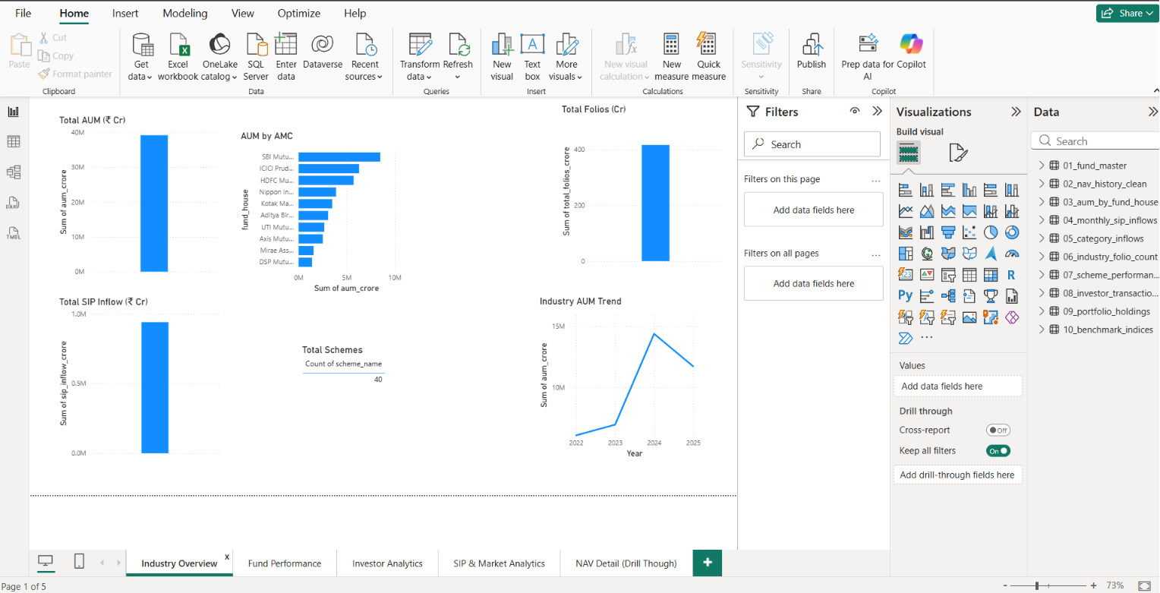

This page is designed to answer the question “How does the overall fund universe look?” within seconds, using large, easily scannable KPI tiles supported by a category-distribution donut chart.

Page 2: Fund Performance Dashboard
This page drills into performance metrics at both the fund and category level.

Key Components:

  - Top Performing Funds — A ranked table/bar chart of the top N funds by trailing return, filterable by category and time horizon.
  - Category Comparison — A grouped bar chart comparing average returns, expense ratios, and ratings across categories.
  - Fund House Analysis — A matrix visual showing average performance metrics broken down by fund house, with conditional formatting to highlight top and bottom performers.
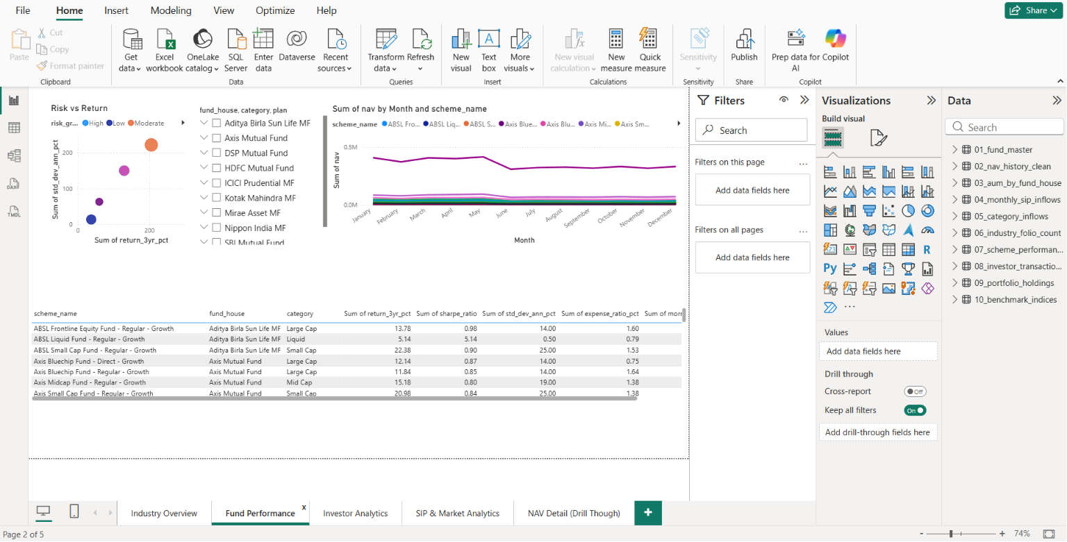

This page enables analysts to quickly identify which categories, fund houses, and individual schemes are driving (or dragging down) overall performance.

Page 3: Investor Behaviour Dashboard
This page focuses on SIP inflow patterns as a proxy for retail investor sentiment.

Key Components:

  - SIP-Related Analysis — Line and area charts showing monthly SIP inflow trends, both in aggregate and broken down by category.
  - Trend Visualizations — Month-over-month and year-over-year growth indicators, highlighting periods of accelerating or decelerating retail participation.
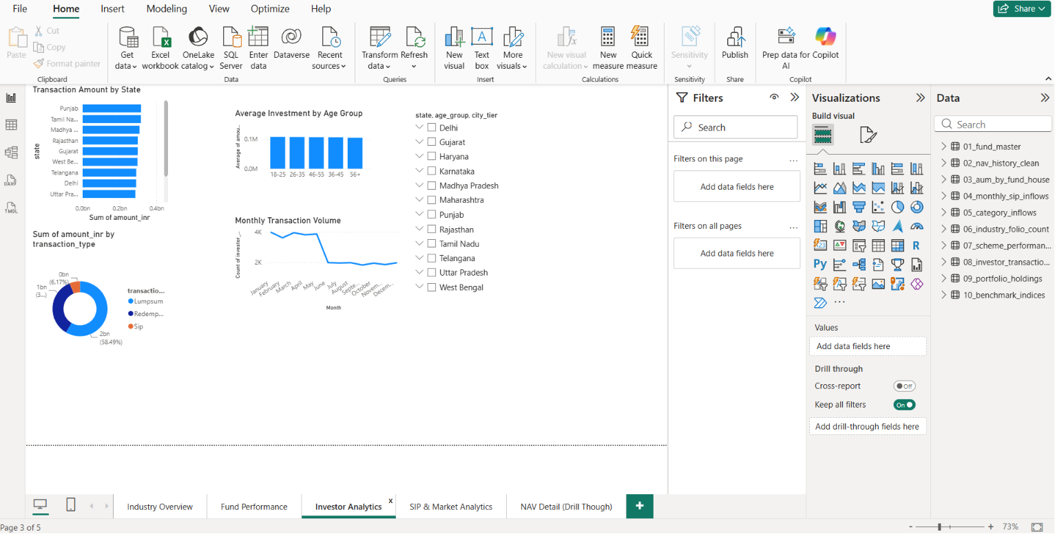
This page helps stakeholders understand how retail investor sentiment shifts over time and whether SIP flows correlate with market performance trends observed on Page 2.

Page 4: Portfolio Dashboard
This page examines the underlying composition of fund portfolios.

Key Components:
  - Holdings Analysis — A treemap or bar chart showing the top holdings (stocks/instruments) across selected funds, with drill-down by fund.
  - Diversification Insights — Concentration metrics (e.g., top-10 holdings as a percentage of total portfolio) to assess how diversified or concentrated each fund is.

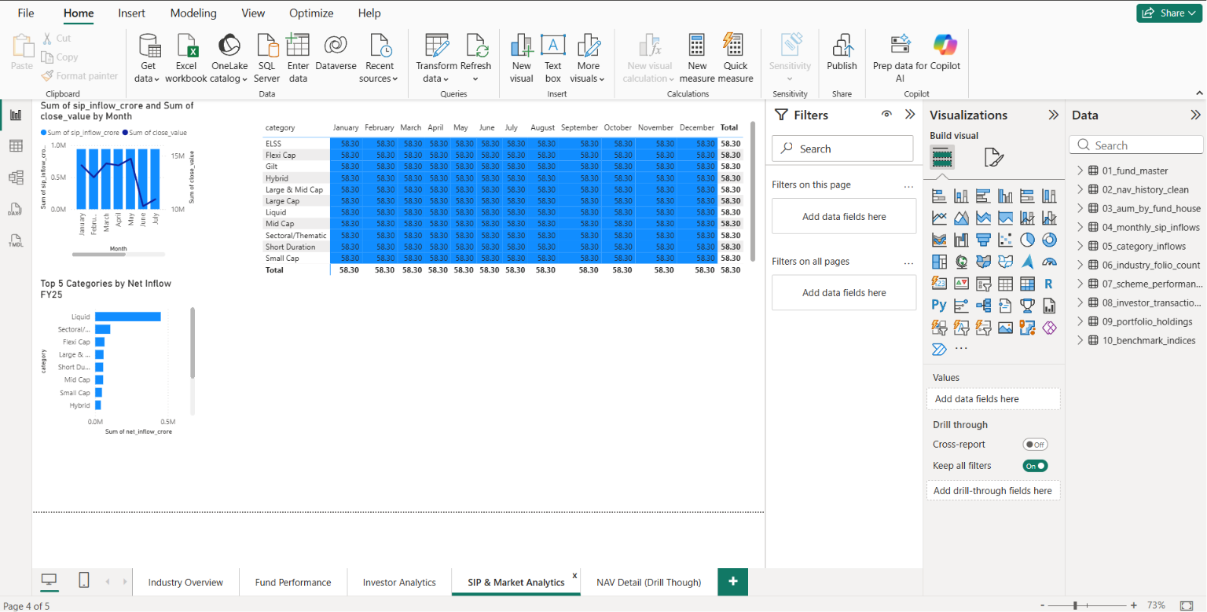

This page is particularly useful for risk teams seeking to understand concentration risk within individual schemes or across a fund house’s product range.

Page 5: Recommendation Dashboard
This final page operationalizes the recommendation engine within an interactive interface.

Key Components:

  - Interactive Filtering — Slicers allowing users to select category, maximum risk grade, maximum expense ratio, and minimum Morningstar rating.
  - Fund Recommendations — A dynamically updating table displaying the top recommended funds based on the selected filters, along with supporting metrics (return, expense ratio, rating, risk grade).

This page brings together the entire analytical pipeline into a self-service tool, allowing end-users to explore personalized fund shortlists without needing to interact with the underlying Python code.

Key Findings
The combined analysis across data validation, cleaning, EDA, and the recommendation engine surfaced several notable findings:
- Equity Funds Dominate the Market: Equity-oriented schemes constitute the largest share of the mutual fund universe by count, reflecting strong industry focus on growth-oriented retail products.
- Expense Ratio Influences Performance: A weak but consistent negative correlation between expense ratio and trailing returns suggests that, on average, higher costs are not systematically rewarded with higher returns — reinforcing the importance of cost-conscious fund selection.
- Highly Rated Funds Show Consistency: Funds with 4- and 5-star Morningstar ratings demonstrated more consistent (lower variance) returns within their respective categories compared to lower-rated peers, suggesting that the rating methodology captures a meaningful signal of risk-adjusted consistency.
- Certain Fund Houses Outperform Consistently: A subset of fund houses appeared repeatedly among top performers across multiple categories, suggesting structural advantages in research capability, fund management talent, or operational scale.
- Category-wise Differences Are Substantial: Returns, risk grades, and expense ratios vary significantly by category — small-cap and sectoral funds offer higher return potential but with materially higher volatility and cost, while large-cap and debt categories offer more stability at lower cost.
- SIP Inflows Reflect Broader Market Sentiment: Retail SIP contributions showed trend patterns that broadly mirrored overall market performance, with inflows accelerating during periods of strong equity performance and moderating during downturns.
- Portfolio Concentration Varies Widely: Some funds, particularly within sectoral and thematic categories, exhibited high concentration in their top-10 holdings, representing a meaningful diversification risk that may not be immediately apparent from category labels alone.
- AUM Is Not a Reliable Performance Predictor: Larger funds (by AUM) did not consistently outperform smaller funds, indicating that fund size alone should not be used as a primary selection criterion.

Limitations
While the Mutual Fund Analytics project successfully delivers an end-to-end analytics pipeline, several limitations should be acknowledged:
- Historical Data Only: All analyses and recommendations are based on historical data. Past performance, as is well understood in financial contexts, is not necessarily indicative of future results.
- No Real-Time Market Feed: The pipeline operates on static, periodically refreshed datasets rather than a live market data feed, meaning that the dashboards and recommendations reflect a snapshot in time rather than current market conditions.
- Rule-Based Recommendation Approach: The recommendation engine relies on fixed thresholds and a linear composite scoring formula. It does not account for complex, non-linear interactions between variables, nor does it adapt based on user feedback or behaviour over time.
- Limited External Economic Factors: The analysis does not incorporate macroeconomic indicators (interest rates, inflation, GDP growth, currency movements) that materially influence fund performance, particularly for debt and international funds.
- Category Standardization Dependency: The accuracy of category-based filtering and comparison depends heavily on the consistency of category labels across fund houses; despite cleaning efforts, edge cases may remain.
- Static Snapshot of Portfolio Holdings: Portfolio holdings data represents a point-in-time snapshot and does not capture intra-period turnover, which can be significant for actively managed funds.

Future Scope
Building on the current foundation, several enhancements are proposed to extend the project’s capabilities:

- Machine Learning Recommendation Engine: Replace or augment the rule-based system with a machine learning model (e.g., gradient boosting or collaborative filtering) trained to predict fund suitability scores based on historical investor outcomes, enabling more nuanced, non-linear recommendations.
- Streamlit Deployment: Develop an interactive Streamlit web application that exposes the recommendation engine and key EDA visualizations directly to end-users, lowering the barrier to access compared to Power BI desktop files.
- API Integration: Integrate live data feeds via APIs (e.g., AMFI’s official NAV API) to replace static CSV ingestion, enabling near real-time updates to the dashboards and recommendations.
- Portfolio Optimization: Extend the recommendation engine to support multi-fund portfolio construction using optimization techniques (e.g., mean-variance optimization) rather than single-fund recommendations.
- Predictive Analytics: Incorporate time-series forecasting models (e.g., ARIMA, Prophet, or LSTM-based models) to project future NAV trends and expected returns, supplementing the currently backward-looking analysis.
- Real-Time Data Ingestion: Build a streaming or scheduled ingestion pipeline (e.g., using Apache Airflow or a cloud-based scheduler) to automatically refresh raw data on a daily basis, keeping the entire pipeline current without manual intervention.
- Macroeconomic Integration: Incorporate external macroeconomic datasets to enrich the correlation analysis and improve the contextual relevance of fund performance comparisons.

Conclusion
The Mutual Fund Analytics capstone project successfully demonstrates the complete data analytics lifecycle applied to a real-world, financially meaningful domain. Starting from raw, heterogeneous datasets, the project established a rigorous validation and cleaning pipeline, conducted ten in-depth exploratory analyses that surfaced actionable insights about fund categories, costs, ratings, and performance, and culminated in a transparent, rule-based recommendation engine.
The accompanying five-page Power BI dashboard suite translates these technical outputs into a business-friendly format suitable for both analytical and advisory use cases, while the master run_pipeline.py script ensures the entire workflow is reproducible and extensible.
Beyond its immediate outputs, this project demonstrates proficiency across the core competencies expected of a data analyst or data engineer: data wrangling, exploratory analysis, visualization, basic recommendation system design, and pipeline orchestration — all built using an industry-standard, version-controlled toolchain.
The identified limitations and proposed future enhancements — particularly the transition toward machine learning-based recommendations, real-time data integration, and predictive analytics — provide a clear roadmap for evolving this capstone project into a production-grade analytics product. As such, Mutual Fund Analytics stands as both a comprehensive demonstration of current technical capability and a strong foundation for continued growth and learning.

