Lecture 48: Consumer-Introduction:

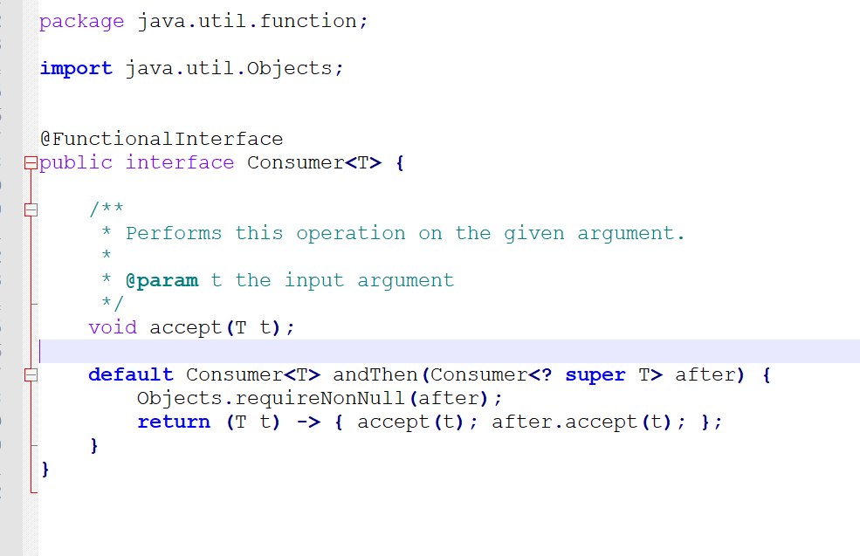

Example:

**package** com.durgaSoft.section7.lecture48;

**import** java.util.function.Consumer;

**public** **class** Example1 {

**public** **static** **void** main(String[] args) {

String message ="Hello";

Consumer<String> dispaly = consumerMessage -> System.***out***.println(consumerMessage);

dispaly.accept(message);

}

}

Lecture 49: Program to display movie information by using consumer:

**package** com.durgaSoft.section7.lecture49;

**import** java.util.ArrayList;

**import** java.util.function.Consumer;

**public** **class** Example1 {

**public** **static** **void** main(String[] args) {

ArrayList<Movie> moviesList=**new** ArrayList<Movie>();

*populateMovies*(moviesList);

Consumer<Movie> movieConsumer = movie -> System.***out***.println(movie);

**for** (Movie movie : moviesList) {

movieConsumer.accept(movie);

}

}

**private** **static** **void** populateMovies(ArrayList<Movie> moviesList) {

// **TODO** Auto-generated method stub

moviesList.add(**new** Movie("name1", "hero1", "heroine1"));

moviesList.add(**new** Movie("name2", "hero2", "heroine2"));

moviesList.add(**new** Movie("name3", "hero3", "heroine3"));

moviesList.add(**new** Movie("name4", "hero4", "heroine4"));

moviesList.add(**new** Movie("name5", "hero5", "heroine5"));

}

}

**class** Movie {

String name;

String hero;

String heorine;

**public** Movie(String name, String hero, String heorine) {

**super**();

**this**.name = name;

**this**.hero = hero;

**this**.heorine = heorine;

}

@Override

**public** String toString() {

**return** "name=" + name + ", hero=" + hero + ", heorine=" + heorine;

};

}

Lecture 50:

Combining Predicate, Function and Consumer.

In this example we will do the following:

* Check if the student marks are greater than 60;
* Display student information
* Aslo display the Grade of the student.

**package** com.durgaSoft.section7.lecture50;

**import** java.util.ArrayList;

**import** java.util.function.Consumer;

**import** java.util.function.Function;

**import** java.util.function.Predicate;

**public** **class** Example1 {

**public** **static** **void** main(String[] args) {

ArrayList<Student> studentList = **new** ArrayList<Student>();

*addStudent*(studentList);

Function<Student, String> gradeStudent = student -> {

**if**(student.marks >80 )

**return** "A[Distinction]";

**else** **if** (student.marks>=60) {

**return** "B[First Class]";

}**else** **if** (student.marks>=50) {

**return** "C[Second Class]";

}**else** **if** (student.marks>=35) {

**return** "D[Third Class]";

}**else** {

**return** "E[Failed]";

}

};

Predicate<Student> conditionCheck = student -> student.marks > 60;

Consumer<Student> displayStudent = student -> System.***out***.println(student);

**for** (Student student : studentList) {

**if**(conditionCheck.test(student)) {

System.***out***.print(gradeStudent.apply(student)+" ");

displayStudent.accept(student);

}

}

}

**private** **static** **void** addStudent(ArrayList<Student> studentList) {

// **TODO** Auto-generated method stub

Student student1 = **new** Student("Sunny", 100);

Student student2 = **new** Student("Bunny", 65);

Student student3 = **new** Student("Chinny", 55);

Student student4 = **new** Student("Vinny", 45);

Student student5 = **new** Student("Pinny", 25);

studentList.add(student1);

studentList.add(student2);

studentList.add(student3);

studentList.add(student4);

studentList.add(student5);

}

}

**class** Student {

String name;

**int** marks;

**public** Student(String name, **int** marks) {

**super**();

**this**.name = name;

**this**.marks = marks;

}

@Override

**public** String toString() {

**return** "name=" + name + ", marks=" + marks;

}

}

Lecture 51: Consumer Chaining: