***Assignment***

***Of***

***Computer Graphics***

**2020 -2021**

**BTech 5thrd Sem**

*Dr. Dhananjoy Bhakta (CSE)*



**भारतीय सूचना प्रौद्योगिकी संस्थान राँची**

**INDIAN INSTITUTE OF INFORMATION TECHNOLOGY, RANCHI**

(An Institution of National importance under act of Parliament)

(Ranchi - 834010), Jharkhand

***Department of Computer Science and Engineering***

***IN­­DEX***

|  |  |  |
| --- | --- | --- |
| **Sr. No.** | **Experiment** | **Date** |
| 1 | National Flag using DDA Algorithm |  |
| 2 | *Solar System using midpoint circle Algorithm* |  |
| *3* | *Sky with Cloud using Eclipse Generation Algorithm* |  |
| *4* | *Cloud Colouring with Fill Algorithm* |  |
| *5* | *National Flag using Fill Algorithm* |  |
| *6* | *Mickey Mouse shape by using DDA, and*  *Circle generation algorithm* |  |
|  |  |  |
|  |  |  |
|  |  |  |
|  |  |  |
|  |  |  |

***By Prithwiraj Samanta(2018UGCS002R)***

***ASSIGNMENT NO.1***

**Question**

Design our national flag using set of lines generated by DDA or Bresenham line drawing algorithm

**Program**

#include<bits/stdc++.h>

#include<graphics.h>

using namespace std;

int main(){

int gd=DETECT,gm;

initgraph(&gd,&gm, NULL);

//ORANGE RECTANGLE

int x1=40,x2=300;

for(int i=0;i<40;i++){

int y1,y2;

y1=y2=20+i;

int dx=x2-x1;

int dy=y2-y1;

int p = 2*dy;

int e = p - dx;

int y =y1;

for(int x=x1;x<=x2;x++){

putpixel(x,y,12); //12 is orange

//delay(1);

e+=p;

if(e>=0){

y++;

e-=2*dx;

}

}

}

//white RECTANGLE

for(int i=0;i<40;i++){

int y1,y2;

y1=y2=60+i;

int dx=x2-x1;

int dy=y2-y1;

int p = 2*dy;

int e = p - dx;

int y =y1;

for(int x=x1;x<=x2;x++){

putpixel(x,y,WHITE);

// delay(1);

e+=p;

if(e>=0){

y++;

e-=2*dx;

}

}

}

float a=170; //center

float b=79; //center

int r=21; //radius

setcolor(BLUE);

circle(a,b,r);

float PI = 3.14;

//spokes

for(int i=0;i<=360;i=i+15)

{

int x=r*cos(i*PI/180);

int y=r*sin(i*PI/180);

line(a,b,a+x,b-y);

}

//GREEN RECTANGLE

for(int i=0;i<40;i++){

int y1,y2;

y1=y2=100+i;

int dx=x2-x1;

int dy=y2-y1;

int p = 2*dy;

int e = p - dx;

int y =y1;

for(int x=x1;x<=x2;x++){

putpixel(x,y,GREEN);

// delay(1);

e+=p;

if(e>=0){

y++;

e-=2*dx;

}

}

}

delay(10000);

}.

**Output**

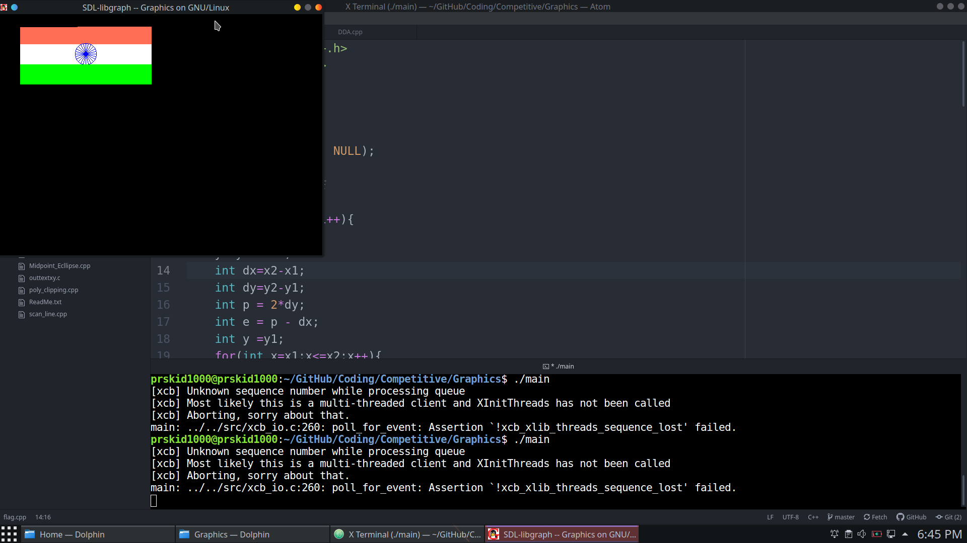

***ASSIGNMENT NO.2***

**Question**

Design a solar planet system using a set of circles generated by midpoint circle generation algorithm

**Program**

#include<bits/stdc++.h>

#include<graphics.h>

using namespace std;

void circlehe(int c,int r,int e,int f){

int x=0,y;

float d;

y = r ; d = 1.25 -r;

do

{

putpixel(e+x,f+y,c);

putpixel(e+x,f-y,c);

putpixel(e-x,f+y,c);

putpixel(e-x,f-y,c);

putpixel(e+y,f+x,c);

putpixel(e+y,f-x,c);

putpixel(e-y,f+x,c);

putpixel(e-y,f-x,c);

if(d<0)

{

x++;

y= y;

d= d+2*x+2;

}

else

{

x++;

y--;

d = d+2*x-2*y+1;

}

}while(x<y);

}

int main(){

int gd=DETECT,gm;

detectgraph(&gd,&gm);

initgraph(&gd,&gm,NULL);

cout<<"Solar System with Circle Md Pt 32";

//sun

for(int i=0;i<40;i++){

circlehe(14,i,400,400);

}

//9 circles

circlehe(15,90,400,400);

circlehe(15,120,400,400);

circlehe(15,150,400,400);

circlehe(15,200,400,400);

circlehe(15,250,400,400);

circlehe(15,300,400,400);

circlehe(15,340,400,400);

circlehe(15,390,400,400);

// for(int i=1;i<=8;i++){

// circlehe(15,30*(i+2),400,400);

// }

//Mercury 22r grey color

for(int i=0;i<=21;i++)

circlehe(7,i,340,340);

//Venus 23 12 light red

for(int i=0;i<=23;i++)

circlehe(12,i,280,400);

//Earth blue=1 r=25

for(int i=0;i<=26;i++)

circlehe(1,i,295,295);

//Mars red=4 r = 22

for(int i=0;i<=22;i++)

circlehe(4,i,365,205);

//Jupiter brown 38 radius

for(int i=0;i<=38;i++)

circlehe(6,i,300,170);

//Saturn orange 35

for(int i=0;i<=35;i++)

circlehe(12,i,365,105);

// //ring

circlehe(15,39,365,105);

// //uranus 9 33

for(int i=0;i<=33;i++)

circlehe(9,i,505,75);

// //neptune 1 30

for(int i=0;i<=30;i++)

circlehe(1,i,155,95);

//

getch();

return 0;

}

**Output**

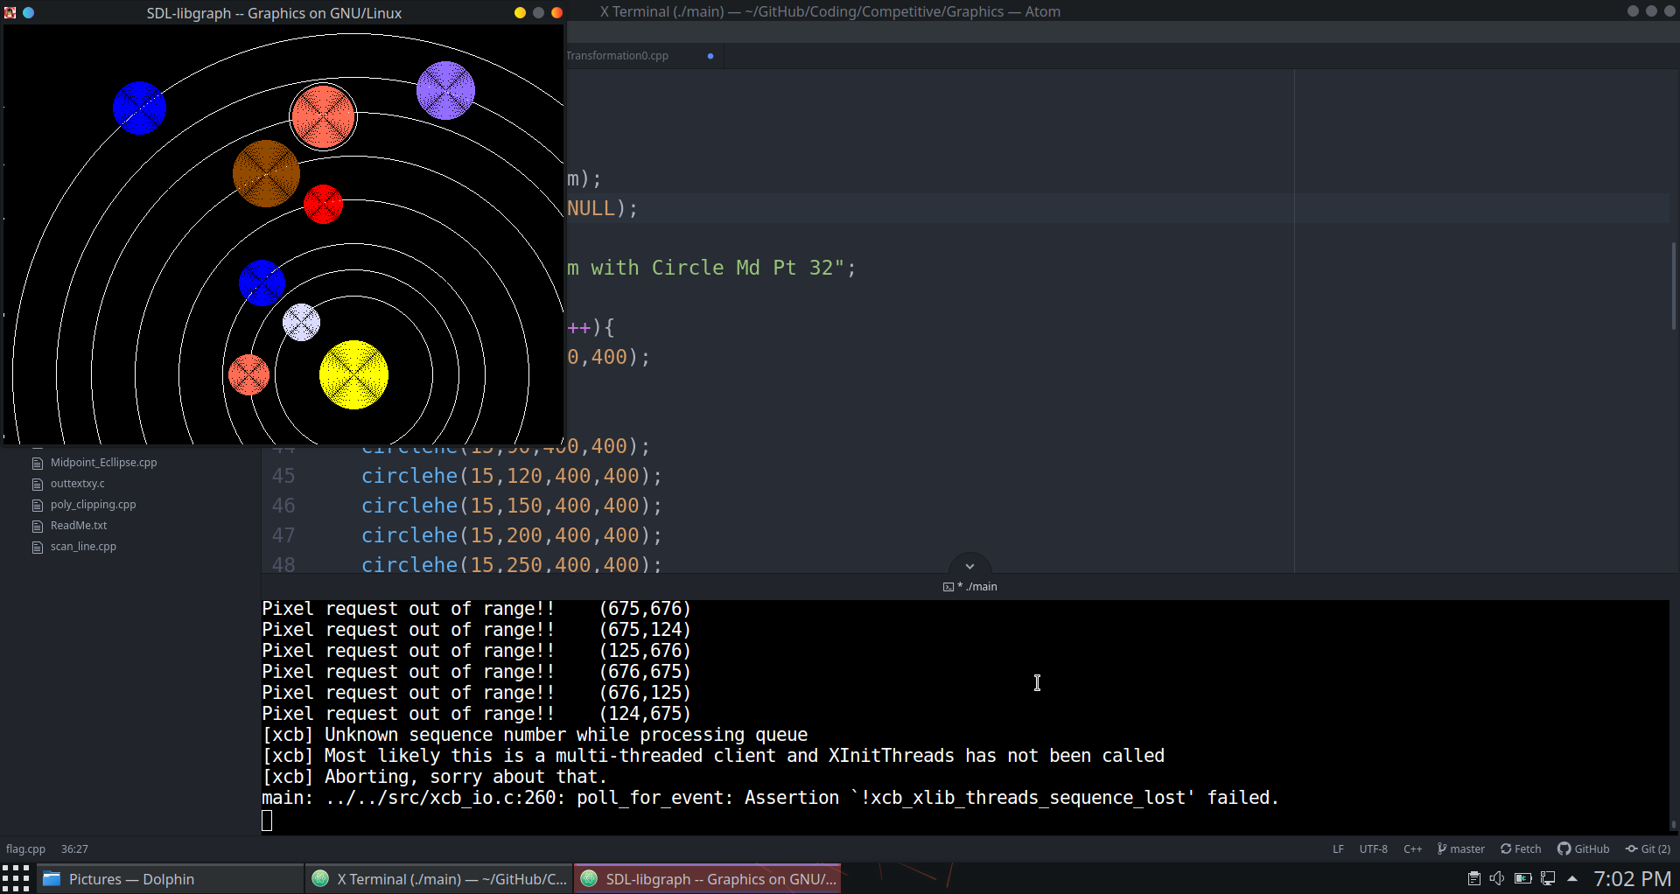

***ASSIGNMENT NO.3***

**Question**

Design a sky consisting of clouds using set of ellipses or circles generated by midpoint ellipse generation algorithm

**Program**

Draw a line using DDA algori

#include<bits/stdc++.h>

#include<graphics.h>

using namespace std;

void sky(){

int x1=20,x2=420;

for(int i=20;i<=420;i++){

int y1,y2;

y1=y2=i;

int dx=x2-x1;

int dy=y2-y1;

int p = 2*dy;

int e = p - dx;

int y =y1;

for(int x=x1;x<=x2;x++){

putpixel(x,y,LIGHTBLUE);

// delay(1);

e+=p;

if(e>=0){

y++;

e-=2*dx;

}

}

}

}

void ellipsehere(float rx,float ry,int e,int f){

float x=0,y=ry;

float d1=(ry*ry) - (rx*rx*ry) + (0.25*rx*rx);

float dy =2*rx*rx*y, dx=2*ry*ry*x;

do{

putpixel(e+x,y+f,WHITE);

putpixel(e-x,y+f,WHITE);

putpixel(e+x,f-y,WHITE);

putpixel(e-x,f-y,WHITE);

if(d1<0){

x=x+1;

dx+=2*ry*ry;

d1=d1+dx+ry*ry;

}

else{

x=x+1;

y=y-1;

dx+=2*ry*ry;

dy-=2*rx*rx;

d1=d1+dx-dy+ry*ry;

}

} while(dx<dy);

float d2= ((ry * ry) * ((x + 0.5) * (x + 0.5))) + ((rx * rx) * ((y - 1) * (y - 1))) - (rx * rx * ry * ry);

do{

putpixel(e+x,y+f,WHITE);

putpixel(e-x,y+f,WHITE);

putpixel(e+x,-y+f,WHITE);

putpixel(e-x,-y+f,WHITE);

if(d2>0){

y=y-1;

dy-=2*rx*rx;

d2=d2-dy+rx*rx;

}

else{

x=x+1;

y=y-1;

dx+=2*ry*ry;

dy-=2*rx*rx;

d2=d2+dx-dy+rx*rx;

}

} while(y>0);

}

void circlehe(int c,int r,int e,int f){

int x=0,y;

float d;

y = r ; d = 1.25 -r;

do

{

putpixel(e+x,f+y,c);

putpixel(e+x,f-y,c);

putpixel(e-x,f+y,c);

putpixel(e-x,f-y,c);

putpixel(e+y,f+x,c);

putpixel(e+y,f-x,c);

putpixel(e-y,f+x,c);

putpixel(e-y,f-x,c);

if(d<0)

{

x++;

y= y;

d= d+2*x+2;

}

else

{

x++;

y--;

d = d+2*x-2*y+1;

}

}while(x<y);

}

int main(){

int gd=DETECT,gm;

detectgraph(&gd,&gm);

initgraph(&gd,&gm,NULL);

sky();

cout<<"Clouds with Circle and Ellipse Md Pt 32";

//cloud 1

for(int i=0;i<20;i++){

circlehe(15,i,100,85);

}

for(int i=0;i<15;i++){

circlehe(15,i,135,90);

}

for(int i=0;i<15;i++){

circlehe(15,i,65,90);

}

int i=60,j=20;

for(;i>=0&&j>=0;i--,j--)

ellipsehere(i,j,100,100);

//cloud 2

for(int i=0;i<20;i++){

circlehe(15,i,200,175);

}

for(int i=0;i<20;i++){

circlehe(15,i,160,185);

}

for(int i=0;i<20;i++){

circlehe(15,i,240,185);

}

i=80,j=30;

for(;i>=0&&j>=0;i--,j--)

ellipsehere(i,j,200,200);

//cloud 3

for(int i=0;i<15;i++){

circlehe(15,i,350,130);

}

i=40,j=20;

for(;i>=0&&j>=0;i--,j--)

ellipsehere(i,j,350,150);

getch();

return 0;

}

**Output**

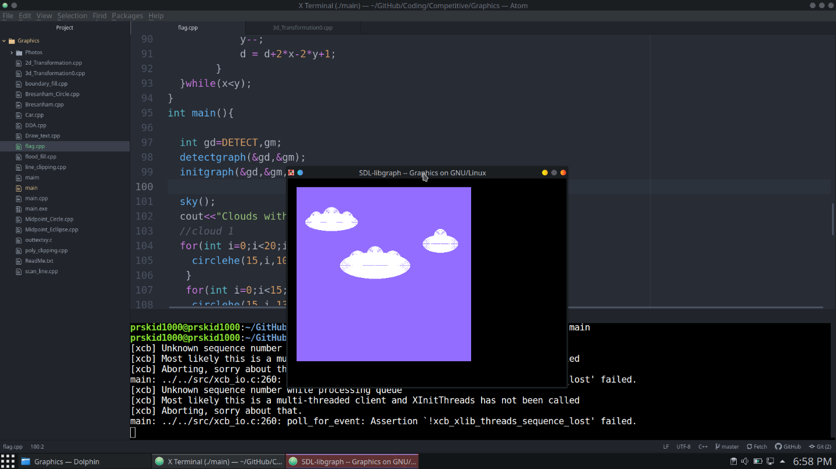

***ASSIGNMENT NO.4***

**Question**

Draw 3 clouds by using graphics functions and fill the 3 clouds with saphron, white and green colors by using flood fill Algorithm.

**Program**

#include<bits/stdc++.h>

#include<graphics.h>

using namespace std;

void floodfillalgo(int x,int y,int c)

{

if(getpixel(x,y)==c)

return;

putpixel(x,y,c);

floodfillalgo(x+1,y,c);

floodfillalgo(x-1,y,c);

floodfillalgo(x,y+1,c);

floodfillalgo(x,y-1,c);

}

int main()

{

int gd=DETECT,gm;

detectgraph(&gd,&gm);

initgraph(&gd,&gm,NULL);

//Saffron Cloud

setcolor(12);

circle(100,85,20);

ellipse(100, 100, 0, 360, 50, 25);

floodfillalgo(90,80,12);

floodfillalgo(90,70,12);

floodfillalgo(80,106,12);

//White Cloud

setcolor(15);

circle(205,85,20);

ellipse(205,100,0,360,50,25);

floodfillalgo(205,80,15);

floodfillalgo(205,70,15);

floodfillalgo(205,106,15);

//Green Cloud

setcolor(GREEN);

circle(310,85,20);

ellipse(310,100,0,360,50,25);

floodfillalgo(310,80,GREEN);

floodfillalgo(310,70,GREEN);

floodfillalgo(310,106,GREEN);

getch();

closegraph();

return 0;

}

**Output**

***ASSIGNMENT NO.5***

**Question**

Draw our national flag by using graphics functions and fill appropriate colors by using boundary fill algorithm

**Program**

#include<bits/stdc++.h>

#include<graphics.h>

using namespace std;

void boundaryfill(int x,int y,int boundarycolor,int newcolor)

{

if(getpixel(x,y)==boundarycolor || getpixel(x,y)==newcolor) return;

putpixel(x,y,newcolor);

boundaryfill(x+1,y,boundarycolor,newcolor);

boundaryfill(x-1,y,boundarycolor,newcolor);

boundaryfill(x,y+1,boundarycolor,newcolor);

boundaryfill(x,y-1,boundarycolor,newcolor);

}

int main()

{

int gd=DETECT,gm;

detectgraph(&gd,&gm);

initgraph(&gd,&gm,NULL);

setcolor(LIGHTRED);

rectangle(40,20,300,60);

boundaryfill(41,21,LIGHTRED,LIGHTRED);

setcolor(WHITE);

rectangle(40,61,300,100);

boundaryfill(41,62,WHITE,WHITE);

setcolor(BLUE);

circle(170,80,20);

float a=170; //center

float b=79; //center

int r=21; //radius

float PI = 3.14;

for(int i=0;i<=360;i=i+15)

{

int x=r*cos(i*PI/180);

int y=r*sin(i*PI/180);

line(a,b,a+x,b-y);

}

setcolor(GREEN);

rectangle(40,101,300,140);

boundaryfill(41,102,GREEN,GREEN);

getch();

closegraph();

return 0;

}

**Output**

***ASSIGNMENT NO.6***

**Question**

Draw a Mickey Mouse shape by using DDA, circle generation algorithm

**Program**

#include<bits/stdc++.h>

#include<graphics.h>

using namespace std;

void boundaryfill(int x,int y,int boundarycolor,int newcolor){

if(getpixel(x,y)==boundarycolor || getpixel(x,y)==newcolor) return;

putpixel(x,y,newcolor);

boundaryfill(x+1,y,boundarycolor,newcolor);

boundaryfill(x-1,y,boundarycolor,newcolor);

boundaryfill(x,y+1,boundarycolor,newcolor);

boundaryfill(x,y-1,boundarycolor,newcolor);

}

void background(){

int x1=20,x2=600;

for(int i=20;i<600;i++){

int y1,y2;

y1=y2=i;

int dx=x2-x1;

int dy=y2-y1;

int steps;

if(abs(dx)>abs(dy)) steps = abs(dx);

else steps = abs(dy);

int xinc = dx/steps;

int yinc = dy/steps;

int x=0,y=i;

x+=xinc;

y+=yinc;

for(int i=0;i<steps;i++){

putpixel(x,y,WHITE);

//delay(1);

x+=xinc;

y+=yinc;

}

}

}

void ellipsehere(float rx,float ry,int e,int f,int color){

float x=0,y=ry;

float d1=(ry*ry) - (rx*rx*ry) + (0.25*rx*rx);

float dy =2*rx*rx*y, dx=2*ry*ry*x;

do{

putpixel(e+x,y+f,color);

putpixel(e-x,y+f,color);

putpixel(e+x,f-y,color);

putpixel(e-x,f-y,color);

if(d1<0){

x=x+1;

dx+=2*ry*ry;

d1=d1+dx+ry*ry;

}

else{

x=x+1;

y=y-1;

dx+=2*ry*ry;

dy-=2*rx*rx;

d1=d1+dx-dy+ry*ry;

}

} while(dx<dy);

float d2= ((ry * ry) * ((x + 0.5) * (x + 0.5))) + ((rx * rx) * ((y - 1) * (y - 1))) - (rx * rx * ry * ry);

do{

putpixel(e+x,y+f,color);

putpixel(e-x,y+f,color);

putpixel(e+x,-y+f,color);

putpixel(e-x,-y+f,color);

if(d2>0){

y=y-1;

dy-=2*rx*rx;

d2=d2-dy+rx*rx;

}

else{

x=x+1;

y=y-1;

dx+=2*ry*ry;

dy-=2*rx*rx;

d2=d2+dx-dy+rx*rx;

}

} while(y>0);

}

void circlehe(int r,int e,int f,int c){

int x=0,y;

float d;

y = r ; d = 1.5 -r;

do

{

putpixel(e+x,f+y,c);

putpixel(e+x,f-y,c);

putpixel(e-x,f+y,c);

putpixel(e-x,f-y,c);

putpixel(e+y,f+x,c);

putpixel(e+y,f-x,c);

putpixel(e-y,f+x,c);

putpixel(e-y,f-x,c);

if(d<0)

{

x++;

y= y;

d= d+2*x+2;

}

else

{

x++;

y--;

d = d+2*x-2*y+1;

}

}while(x<y);

}

int main(){

int gd=DETECT,gm;

detectgraph(&gd,&gm);

initgraph(&gd,&gm,NULL);

background();

circlehe(60,100,100,BLACK);

boundaryfill(80,80,BLACK,BLACK);

circlehe(60,300,100,BLACK);

boundaryfill(280,80,BLACK,BLACK);

circlehe(120,200,200,BLACK);

boundaryfill(180,180,BLACK,BLACK);

delay(100);

getch();

return 0;

}

**Output**