**PRACTICAL NO. 1**

**PROJECT: QUIZADDA**

1. **TITLE OF THE PROJECT**

QUIZADDA

1. **Introduction:**

A quiz is a form of [game](https://en.wikipedia.org/wiki/Game) or [mind sport](https://en.wikipedia.org/wiki/Mind_sport), in which the players (as individuals or in teams) attempt to answer questions correctly. It is a game to test your knowledge about a certain subject. In some countries, a quiz is also a brief [assessment](https://en.wikipedia.org/wiki/Educational_assessment) used in education and similar fields to measure growth in knowledge, abilities, and/or skills.

Quizzes are usually scored in points and many quizzes are designed to determine a winner from a group of participants – usually the participant with the highest score.

In an educational context, a quiz is usually a form of a student assessment, but often has fewer questions of lesser difficulty and requires less time for completion than a [test](https://en.wikipedia.org/wiki/Test_(student_assessment)). This use is typically found in the United States, Canada, the [Philippines](https://en.wikipedia.org/wiki/Philippines), and some colleges in India. For instance, in a mathematics classroom, a quiz may check comprehension of a type of [mathematical exercise](https://en.wikipedia.org/wiki/Mathematical_exercise). Some instructors schedule a daily or weekly quiz ranging from five to thirty relatively easy questions for the purpose of having the students review their previous lessons before attending the next class. A "pop quiz" is a quiz that students are given no time to prepare for; they are simply surprised with it in class.

The online quiz is a web application for to take online test in an efficient manner and no time wasting for checking the paper. The main objective of ONLINE QUIZ is to efficiently evaluate the candidate thoroughly through a fully automated system that not only saves lot of time but also gives fast results. For students they give papers according to their convenience and time and there is no need of using extra thing like paper, pen etc. This can be used in educational institutions as well as in corporate world. Can be used anywhere any time as it is a web based application (user location doesn’t matter). No restriction that examiner has to be present when the candidate takes the test.

1. **Features of the project:**

**The objectives of this application include:**

1. **Knowledge**

Learners must be able to recall and remember information. Memorize, show, pick, spell, list, quote, recall, repeat, catalogue, cite, state, relate, record, name.

1. **Comprehension**

Learners must be able to understand the information. Explain, restate, alter, outline, discuss, expand, identify, locate, report, express, recognize, discuss, qualify, covert, review, infer.

1. **Application**

Learners must be able to use the information they have learned at the same or different contexts. Translate, interpret, explain, practice, illustrate, operate, demonstrate, dramatize, sketch, put into action, complete, model, utilize, experiment, schedule, use.

1. **Analysis**

Learners must be able to analyze the information, by identifying its different components. Distinguish, differentiate, separate, take apart, appraise, calculate, criticize, compare, contrast, examine, test, relate, search, classify, experiment.

1. **Synthesis**

Learners must be able to create something new using different chunks of the information they have already mastered. Decide, appraise, revise, score, recommend, select, measure, argue, value, estimate, choose, discuss, rate, assess, think.

1. **Evaluation.**

Learners must be able to present opinions, justify decisions, and make judgments about the information presented, based on previously acquired knowledge. Compose, plan, propose, produce, predict, design, assemble, prepare, formulate, organize, manage, construct, generate, imagine, set-up.

1. **Requirements**

**5.1) Software Specification:**

Operating system : Windows 10

Programming Language : JDK

Database Tool : Microsoft SQL Server

IDE tool : Netbeans 8.1 or Above

External jar file : My-Sql connector.jar

**5.2) Hardware specification:**

Processor : Intel i3

RAM:4GB

HardDisk :500 GB

1. **Software Planning**

|  |  |  |
| --- | --- | --- |
| Sno. | Activity | Date of completion |
| 1. | Requirement analysis | 15-07-2019 |
| 2. | Design | 22-07-2019 |
| 3. | Coding | 08-08-2019 |
| 4. | Implementation and testing | 06-09-2019 |
| 5. | Documentation | 07-10-2019 |

1. **Developer:- GARBHIT GOEL Signature:**

### PRACTICAL - 2

### SOFTWARE REQUIREMENT SPECIFICATION DOCUMENT

**DATA REQUIREMENTS**

Data requirements are prescribed directives or consensual agreements that define the content and/or structure that constitute high quality data instances and values. Data requirements can thereby be stated by several different individuals or groups of individuals. These include manual data entry for registration, login, update, change. It is self-manageable.

#### **FUNCTIONAL REQUIREMENTS**

Functional requirements may be calculations, technical details, data manipulation and processing and other specific functionality that define what a system is supposed to accomplish.

#### **PERFORMANCE REQUIREMENTS**

Performance requirements define how well the system performs certain functions under specific conditions. The service levels comprising performance requirements are often based on supporting end-user tasks. Like most quality attributes, performance requirements are key elements when designing and testing the product.

**RESPONSE TIME**

0.1 second is about the limit for having the user feel that the system is reacting instantaneously, meaning that no special feedback is necessary except to display the result. 1.0 second is about the limit for the user’s flow of thought to stay uninterrupted, even though the user will notice the delay. Normally, no special feedback is necessary during delays of more than 0.1 but less than 1.0 second, but the user does lose the feeling of operating directly on the data. 10 seconds is about the limit for keeping the user’s attention focused on the dialogue.

**SCALABILITY**

The scalability required is often driven by the lifespan and the maturity of the system. For example, a new (and hence immature) system could suffer an unexpected growth in popularity and suffer from a significant increase in workload as it becomes popular with new users. The response time requirements should still be meet as the workload scales

#### **DEPENDABILITY REQUIREMENTS**

The dependability of a system reflects the user's degree of trust in that system. It reflects the extent of the user's confidence that it will operate as users expect and that it will not 'fail' in normal use. Dependability covers the related systems attributes of reliability, availability and security. These are all inter-dependent. System failures may have widespread effects with large numbers of people affected by the failure. Systems that are not dependable and are unreliable, unsafe or insecure may be rejected by their users. Causes of failure:

##### **Hardware failure**

Hardware fails because of design and manufacturing errors or because components have reached the end of their natural life. EDU Lane is designed in such a way that it does not require any plugin from client side and is compatible with all browsers.

##### **Software failure**

Software fails due to errors in its specification, design or implementation. The system is created with our vision so as the system will grow, other user requirements will become more clear and thus can be added or modified.

##### **Operational failure**

Human operators make mistakes. Now perhaps the largest single cause of system failures in socio-technical systems. The system may fail under certain conditions including:

When user enters wrong login id and password.

If a trainer wants to add a topic but has not yet added any subject in his subject list.

If a trainer wants to add a lecture but has not yet added any Topic in his subject list.

If a user has selected a file of extension other than .jpeg or .png or .jpg while uploading a profile picture. To handle these failures, proper validations are added in the system.

#### **SECURITY REQUIREMENTS**

There are various client users. The security requires that they need to remember their unique UserId because there is no way to retrieve UserId.

#### **LOOK AND FEEL REQUIREMENTS**

The look and feel requirements describe the intended spirit, the mood, or the style of the product's appearance. These requirements specify the intention of the appearance, and are not a detailed design of an interface. The system QuizAdda targets population from various age groups and occupations so the interface required is vibrant yet subtle, simple and easy to use.

**PRACTICAL - 3: DATA FLOW DIAGRAMS**

Data flow diagram (DFD) represents the flows of data between different processes in a business. It is a graphical technique that depicts information flow and the transforms that are applied as data move form input to output. It provides a simple, intuitive method for describing business processes without focusing on the details of computer systems. DFDs are attractive technique because they provide what users do rather than what computers do.

**Representation of Components**

DFDs only involve four symbols. They are:

* Process
* Data Object
* Data Store
* External entity

**Level 0:**

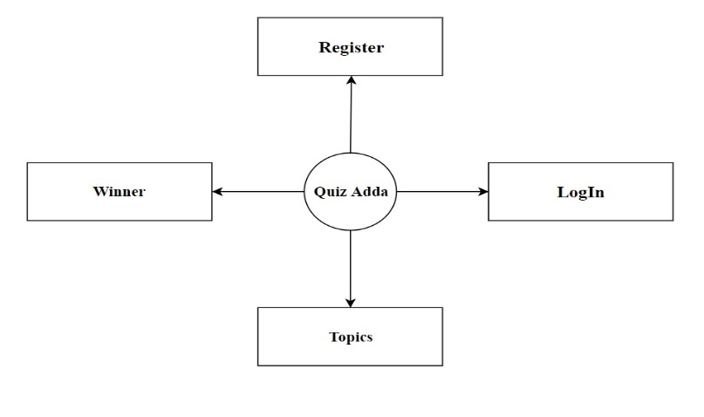

**Level 1:**

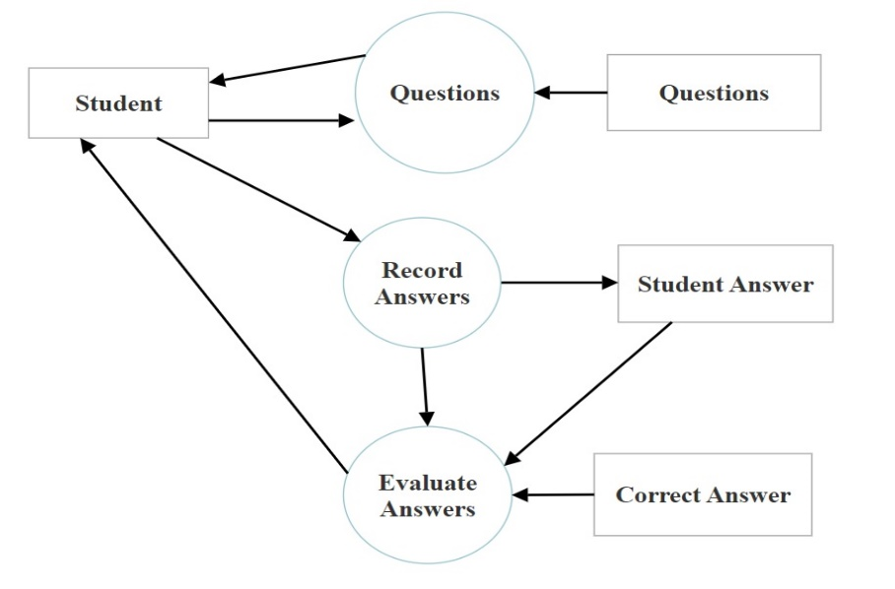

**Level 2:**

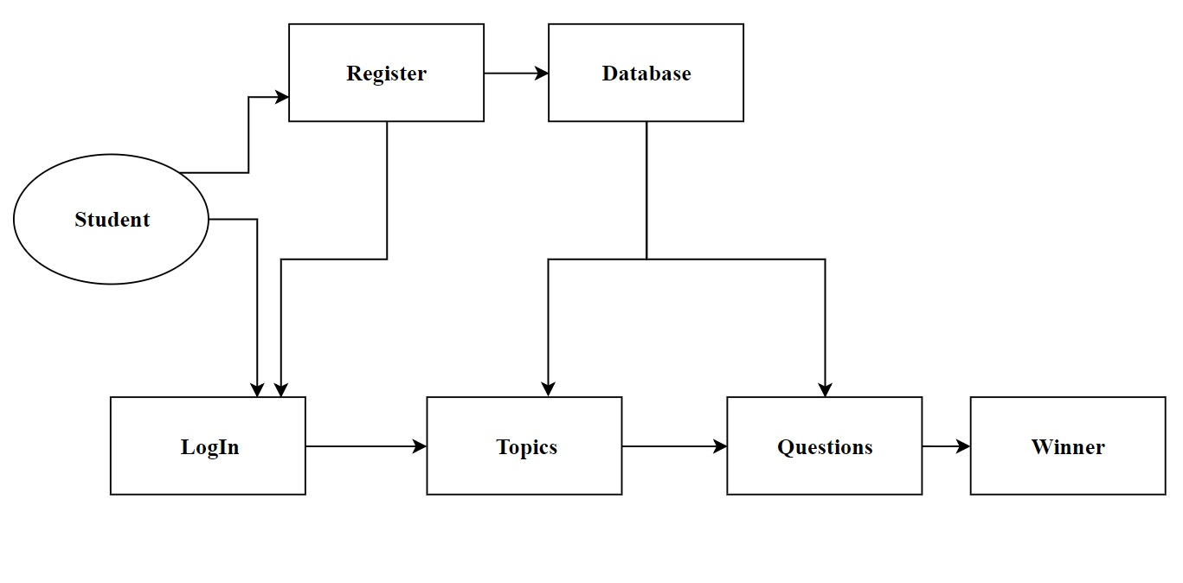

**PRACTICAL - 4: FEASIBILITY STUDY**

After analyzing all the existing or required functionalities of the system, the next task in the development of Employee Management Solution is to do the feasibility study. Feasibility study includes consideration of all the possible ways to provide a solution to given problem.

The proposed solution will satisfy all the user requirements and will be flexible enough so that future changes can be easily done based on future demands of organization.

**1. ECONOMIC FEASIBILITY**

The project has shown the economic feasibility by the study of the fact that by using this software the increased number of the consumers can be given service effectively and efficiently and can save a lot time and saving time means saving money. The economic feasibility is nothing but judging whether the possible benefit of solving the problems is worthwhile or not.

This is a very important aspect to be considered while developing a project. The minimum possible cost factor are:

1. All hardware and software cost has to be decided according to organization’s wealth.
2. Overall from the estimated values the benefits the organization is going to receive from the proposed system will surely overcome the initial costs and the later on the running cost for system.

**2. TECHNICAL FEASIBILITY**

Technical feasibility is concerned with the availability of hardware and software required for the development of the system, to see compatibility and maturity of the technology proposed to be used and to see the availability of the required technical team to develop the system. Technical feasibility centers on the existing computer system (Hardware, Software etc) and to what extent it supports the existing system.

After the study we came to the conclusion that which tools and development environment will be perfect for the developing this system. The study includes function, performance and constraints that may affect the ability to achieve an acceptable system. For this feasibility study, i studied complete functionality to be provided in the system, as described in the system requirement part. Various environments has been finalized for frontend and backend.

**3. OPERATIONAL FEASIBILITY**

Operational feasibility is all about problems that may arise during operations. As the proposed system is fully GUI based that is very user friendly and all inputs to be taken all self-explanatory. A proper training must be conduct to let employee know the essence of the system to the users so that they feel comfortable with new system. The main objective of this feasibility study is to make sure that the developed must be according to client’s requirements and client must get all the system documentation so that they can work in the user friendly environment by accessing all the functionalities according to their role in the organization.

**4. BEHAVIORAL FEASIBILITY**

It includes how strong the reaction of staff will be towards the development of new system that involves computer's use in their daily work. The working staff members are also interested in this project, as it will help them to do work with ease and efficiently without complexity, so they supported the development of this project with full enthusiasm. This shows the behavioral feasibility of the project.

**5.TIME FEASIBILITY**

A time feasibility study will take into account the period in which the project is going to take upto its completion. A project will fail if it takes too long to be completed before it is useful. It is the determination of whether a proposed project can be implemented fully within stipulated time frame. The project was decided to be done in three months and was thought to be feasible enough.

**6. MARKETING STRATEGY**

This feasibility study provides a high level description of how the organization will market its product or service. In order to be successful, this system must differentiate itself from competitors in order to appeal to customers in the online marketplace. It is important to note that this system’s current marketing and sales staff will require training in online marketing and sales practices. This training will need to be contracted to a training provider as part of our startup costs and schedule.

**PRACTICAL-5: CODING AND IMPLEMENTATION**

The following figures depict the output of the system:

**FIRST FORM TO APPEAR:**

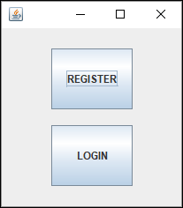

**LOGIN:**

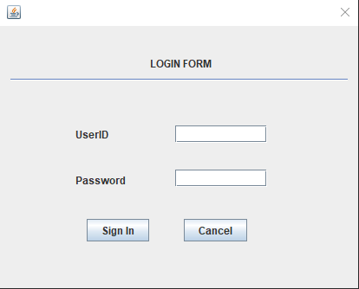

**REGISTRATION :**

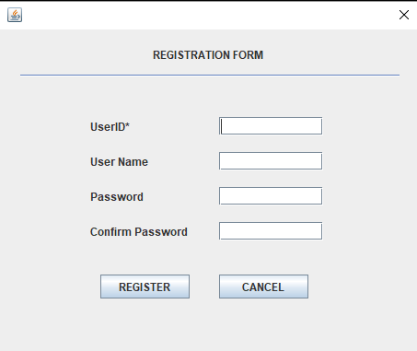

**WELCOME FORM:**

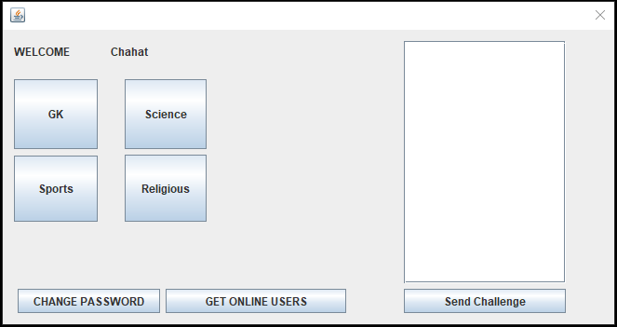

**CHALLENGE FORM:**

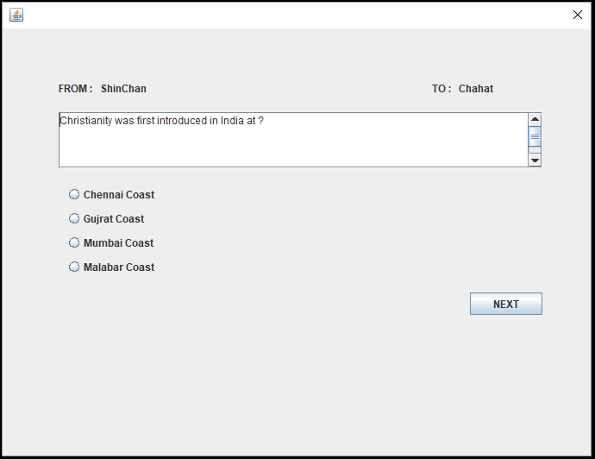

**RESULT FORM:**

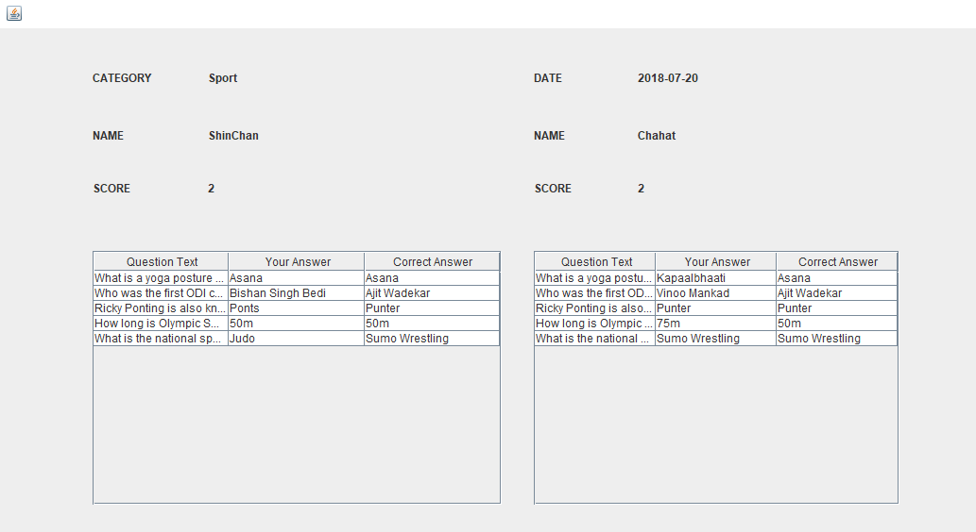

The following database tables are being used by QuizAdda to store the data:

**USERS**

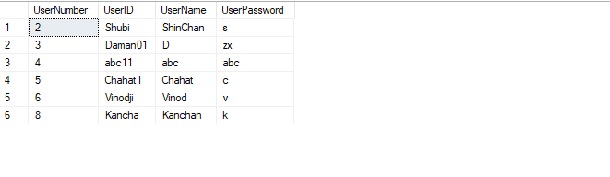

**CATEGORIES**

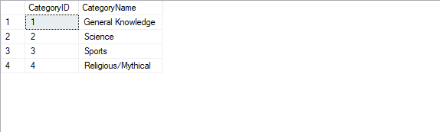

**QUESTIONS**

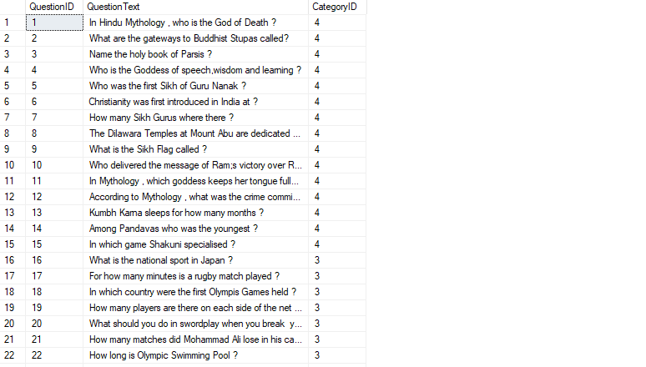

**OPTIONS**

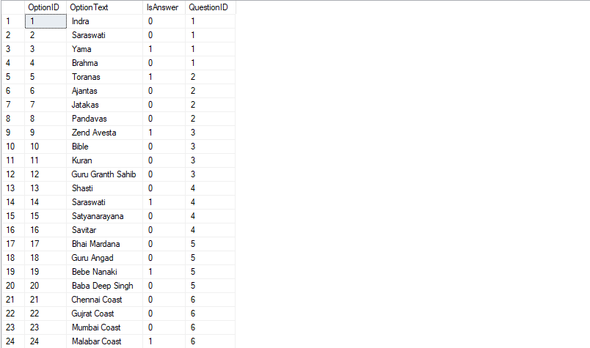

**CHALLENGES**

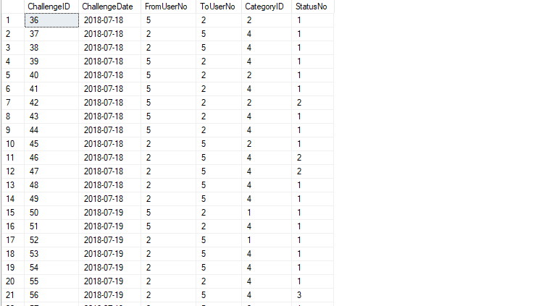

**ATTEMPTED QUESTIONS**

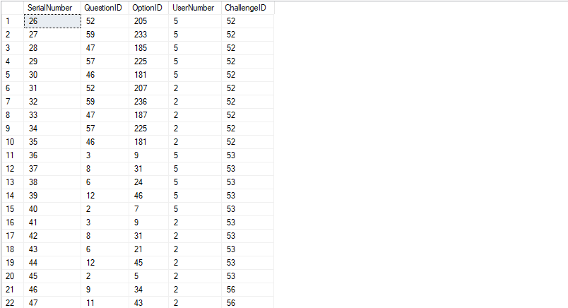

**PRACTICAL-6: TESTING**

**INTRODUCTION**:

Testing is the process of running a system with the intention of finding errors. Testing enhances the integrity of a system by detecting deviations in design and errors in the system. Testing aims at detecting error-prone areas. This helps in the prevention of errors in a system. Testing also adds value to the product by confirming to the user requirements.

The main purpose of testing is to detect errors and error-prone areas in a system. Testing must be thorough and well-planned. A partially tested system is as bad as an untested system. And the price of an untested and under-tested system is high.

The implementation is the final and important phase. It involves user-training, system testing in order to ensure successful running of the proposed system. The user tests the system and changes are made according to their needs. The testing involves the testing of the developed system using various kinds of data. While testing, errors are noted and correctness is the mode.

**OBJECTIVES OF TESTING**

Testing is a process of executing a program with the intent of finding errors. A Successful test case is one that uncovers an as- yet-undiscovered error

System testing is a stage of implementation, which is aimed at ensuring that the system works accurately and efficiently as per the user need, before the live operation commences. As stated before, testing is vital to the success of a system. System testing makes a logical assumption that if all parts of the as system are correct, the goal will be successfully achieved. A series of tests are performed before the system is ready often the user acceptance test.

**TESTING METHODS**

System testing is the stage of implementation. This is to check whether the system works accurately and efficiently before live operation commences. Testing is vital to the success of the system. The candidate system is subject to a variety of tests: on line response, volume, stress, recovery, security and usability tests. A series of tests are performed for the proposed system is ready for user acceptance testing.

The Testing Steps are:

1. **UNIT TESTING:** Unit testing focuses efforts on the smallest unit of software design. This is known as module testing. The modules are tested separately. The test is carried out during programming stage itself. In this step, each module is found to be working satisfactory as regards to the expected output from the module
2. **INTEGRATION TESTING:** Data can be lost across an interface. One module can have an adverse effect on another, sub functions, when combined, may not be linked in desired manner in major functions. Integration testing is a systematic approach for constructing the program structure, while at the same time conducting test to uncover errors associated within the interface. The objective is to take unit tested modules and builds program structure. All the modules are combined and tested as a whole.
3. **VALIDATION:** At the culmination of the integration testing, Software is completely assembled as a package. Interfacing errors have been uncovered and corrected and a final series of software test begin in validation testing. Validation testing can be defined in many ways, but a simple definition is that the validation succeeds when the software functions in a manner that is expected by the customer. After validation test has been conducted, one of the three possible conditions exists.
4. **OUTPUT TESTING:** After performing the validation testing, the next step is output testing of the proposed system, since no system could be useful if it does not produce the required output in a specific format. The output format on the screen is found to be correct, The format was designed in the system design time according to the user needs. For the hard copy also; the output comes as per the specified requirements by the user. Hence output testing did not result in any correction for the system.
5. **USER ACCEPTANCE TESTING:** User acceptance of a system is the key factor for the success of any system. The system under consideration is tested for the user acceptance by constantly keeping in touch with the prospective system users at the time of developing and making changes whenever required.

**TEST CASE:**

|  |  |
| --- | --- |
| **Tested by:** | Mr. Vinod Arora |
| **Test type:** | Unit testing |
| **Test case number:** | 1 |
| **Test case name:** | Login |
| **Test case description** | The user should give any username and password |
| **Item(s) to be tested** | |
| **1** | Verification of Login |
| **Specifications** | |
| **Input** | **Expected output/Result** |
| 1. Type the username and password 2. Logout | 1. Successful user login in the profile. 2. Page exits |