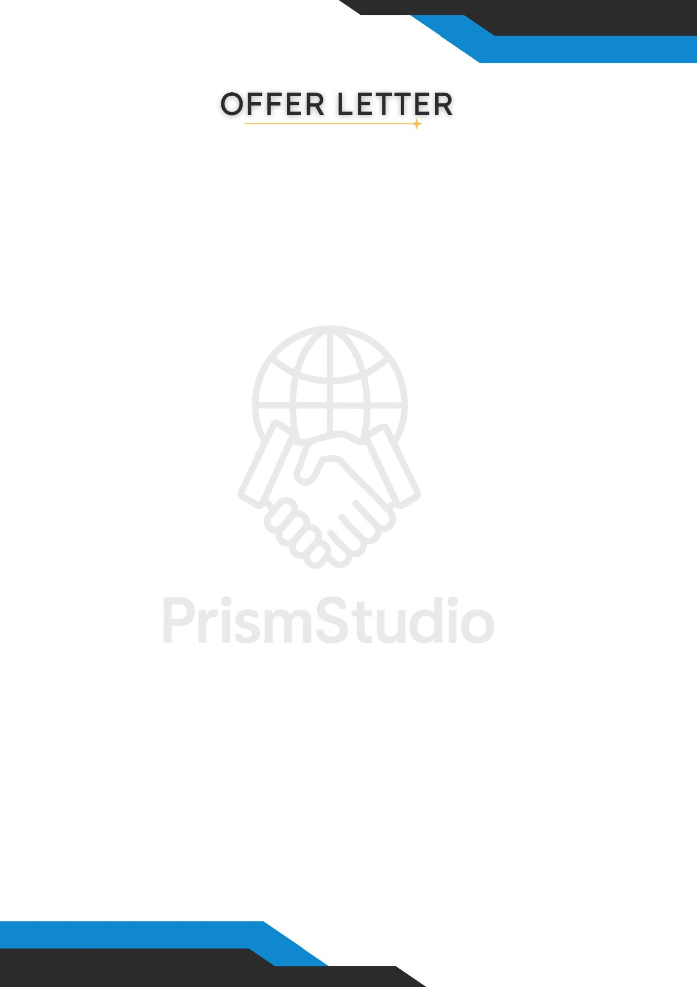

Dear {{Name}}, Date: {{DATE}}

We are excited to welcome you to Prism Studio as a {{Domain}} Intern under our Summer Internship Cohort.
After reviewing your application, we believe your enthusiasm and willingness to learn align perfectly with the spirit of our team. Across the 30-day journey, you’ll work on practical tasks and a real project based on your domain. You'll gain hands-on exposure to real tools, workflows, and team practices — the kind that truly prepare you for the industry.
- Position: {{Domain}} Intern
- Selection ID: {{InternId}}
- Location: Remote
- Duration: 1 month
- Start Date: {{DATE+2days}}
- Stipend: This is an unpaid internship. However, what you learn and build here will hold greater long-term value than any short-term compensation.
What You’ll Work On:
- Structured tasks and a hands-on project relevant to your domain with predefined schedules and breaks.
- You’ll get practical experience working with common tools and workflows used in real-world tech teams.
- Every task and project is designed to enhance your portfolio and sharpen your critical thinking.
- Regular feedback will help you improve, and we’ll actively check in to hear your thoughts and track your progress.
Official Recognition & Academic Use:
This internship is officially issued by Prism Studio, a tech collective focused on innovation, design, and practical upskilling.
The certificate reflects real-world learning and outcomes, making it a strong addition to your academic records, portfolio, or future applications.

We’re excited to see what you’ll create. Let’s make this journey count.
Warm regards,
Team Prism Studio

prismstudio.co.in | team@prismstudio.co.in

