German Credit Data Exploration_2

Dr. Prashant Mishra

3/26/2018

# 1. Import the Clean data

We already have a clean file “german_credit_full.csv” to import.

credit_dataset <- read.csv("german_credit_full.csv",stringsAsFactors = TRUE)  
str(credit_dataset)

## 'data.frame': 1000 obs. of 21 variables:  
## $ Class : Factor w/ 2 levels "Bad","Good": 2 1 2 2 1 2 2 2 2 1 ...  
## $ CheckingAccountStatus : Factor w/ 4 levels "0.to.200","gt.200",..: 3 1 4 3 3 4 4 1 4 1 ...  
## $ Duration : int 6 48 12 42 24 36 24 36 12 30 ...  
## $ CreditHistory : Factor w/ 5 levels "Critical","Delay",..: 1 4 1 4 2 4 4 4 4 1 ...  
## $ Purpose : Factor w/ 10 levels "Business","DomesticAppliance",..: 7 7 3 4 5 3 4 10 7 5 ...  
## $ Amount : int 1169 5951 2096 7882 4870 9055 2835 6948 3059 5234 ...  
## $ SavingsAccountBonds : Factor w/ 5 levels "100.to.500","500.to.1000",..: 5 4 4 4 4 5 2 4 3 4 ...  
## $ EmploymentDuration : Factor w/ 5 levels "0.to.1","1.to.4",..: 4 2 3 3 2 2 4 2 3 5 ...  
## $ InstallmentRatePercentage: int 4 2 2 2 3 2 3 2 2 4 ...  
## $ Personal : Factor w/ 4 levels "Female.NotSingle",..: 4 1 4 4 4 4 4 4 2 3 ...  
## $ OtherDebtorsGuarantors : Factor w/ 3 levels "CoApplicant",..: 3 3 3 2 3 3 3 3 3 3 ...  
## $ ResidenceDuration : int 4 2 3 4 4 4 4 2 4 2 ...  
## $ Property : Factor w/ 4 levels "CarOther","Insurance",..: 3 3 3 2 4 4 2 1 3 1 ...  
## $ Age : int 67 22 49 45 53 35 53 35 61 28 ...  
## $ OtherInstallmentPlans : Factor w/ 3 levels "Bank","None",..: 2 2 2 2 2 2 2 2 2 2 ...  
## $ Housing : Factor w/ 3 levels "ForFree","Own",..: 2 2 2 1 1 1 2 3 2 2 ...  
## $ NumberExistingCredits : int 2 1 1 1 2 1 1 1 1 2 ...  
## $ Job : Factor w/ 4 levels "Management.SelfEmp.HighlyQualified",..: 2 2 4 2 2 4 2 1 4 1 ...  
## $ NumberPeopleMaintenance : int 1 1 2 2 2 2 1 1 1 1 ...  
## $ Telephone : int 1 0 0 0 0 1 0 1 0 0 ...  
## $ ForeignWorker : int 1 1 1 1 1 1 1 1 1 1 ...

colnames(credit_dataset)

## [1] "Class" "CheckingAccountStatus"   
## [3] "Duration" "CreditHistory"   
## [5] "Purpose" "Amount"   
## [7] "SavingsAccountBonds" "EmploymentDuration"   
## [9] "InstallmentRatePercentage" "Personal"   
## [11] "OtherDebtorsGuarantors" "ResidenceDuration"   
## [13] "Property" "Age"   
## [15] "OtherInstallmentPlans" "Housing"   
## [17] "NumberExistingCredits" "Job"   
## [19] "NumberPeopleMaintenance" "Telephone"   
## [21] "ForeignWorker"

# 2. Explore Class vs Checking Account Status, Credit History and Employment Duration

library(gmodels)  
CrossTable(credit_dataset$CheckingAccountStatus, credit_dataset$Class)

##   
##   
## Cell Contents  
## |-------------------------|  
## | N |  
## | Chi-square contribution |  
## | N / Row Total |  
## | N / Col Total |  
## | N / Table Total |  
## |-------------------------|  
##   
##   
## Total Observations in Table: 1000   
##   
##   
## | credit_dataset$Class   
## credit_dataset$CheckingAccountStatus | Bad | Good | Row Total |   
## -------------------------------------|-----------|-----------|-----------|  
## 0.to.200 | 105 | 164 | 269 |   
## | 7.317 | 3.136 | |   
## | 0.390 | 0.610 | 0.269 |   
## | 0.350 | 0.234 | |   
## | 0.105 | 0.164 | |   
## -------------------------------------|-----------|-----------|-----------|  
## gt.200 | 14 | 49 | 63 |   
## | 1.270 | 0.544 | |   
## | 0.222 | 0.778 | 0.063 |   
## | 0.047 | 0.070 | |   
## | 0.014 | 0.049 | |   
## -------------------------------------|-----------|-----------|-----------|  
## lt.0 | 135 | 139 | 274 |   
## | 33.915 | 14.535 | |   
## | 0.493 | 0.507 | 0.274 |   
## | 0.450 | 0.199 | |   
## | 0.135 | 0.139 | |   
## -------------------------------------|-----------|-----------|-----------|  
## none | 46 | 348 | 394 |   
## | 44.102 | 18.901 | |   
## | 0.117 | 0.883 | 0.394 |   
## | 0.153 | 0.497 | |   
## | 0.046 | 0.348 | |   
## -------------------------------------|-----------|-----------|-----------|  
## Column Total | 300 | 700 | 1000 |   
## | 0.300 | 0.700 | |   
## -------------------------------------|-----------|-----------|-----------|  
##   
##

library(ggplot2)  
pl1 = ggplot(credit_dataset, aes(x = CheckingAccountStatus, fill = Class));  
pl2 = pl1 + geom_bar()  
pl2 + theme(axis.text.x = element_text(angle = 90, hjust = 1))

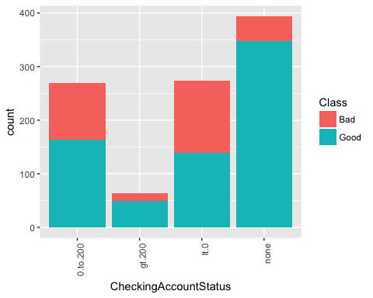

pl3 = pl1 + geom_bar(position = "fill") + ylab("proportion")  
pl3+ theme(axis.text.x = element_text(angle = 90, hjust = 1))

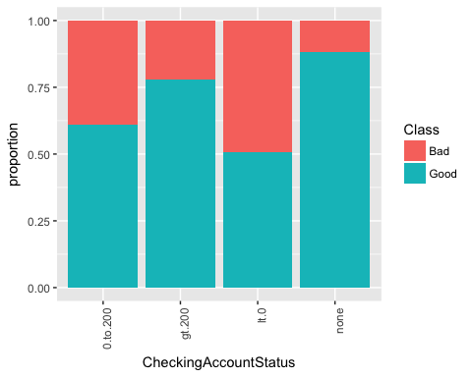 Two points:

1. It seems people who have Checking Account but only get amount between 0-200 DM are more likely to be a bad loan profile.
2. People who don’t have a checking account might have account else where (other banks).

pl1 = ggplot(credit_dataset, aes(x = CheckingAccountStatus, fill = EmploymentDuration));  
pl2 = pl1 + geom_bar()+facet_grid(~Class)  
pl2+ theme(axis.text.x = element_text(angle = 90, hjust = 1))

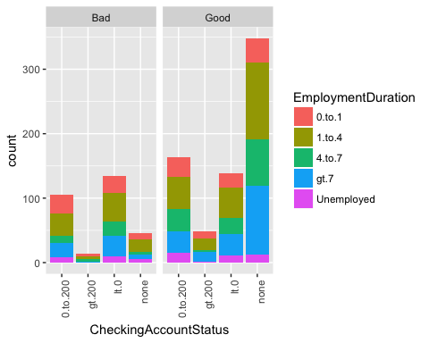

pl2 = pl1 + geom_bar(position = "fill") + ylab("proportion")+facet_grid(~Class)  
pl2 + theme(axis.text.x = element_text(angle = 90, hjust = 1))

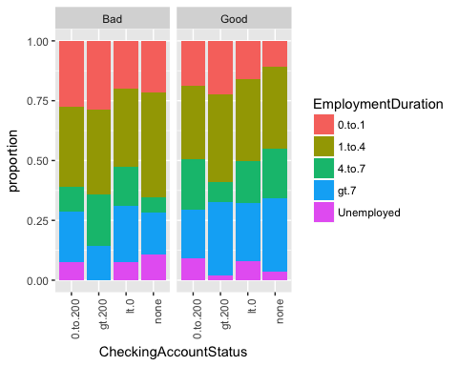

pl1 = ggplot(credit_dataset, aes(x = CheckingAccountStatus, fill = CreditHistory));  
pl2 = pl1 + geom_bar()+facet_grid(~Class)  
pl2+ theme(axis.text.x = element_text(angle = 90, hjust = 1))

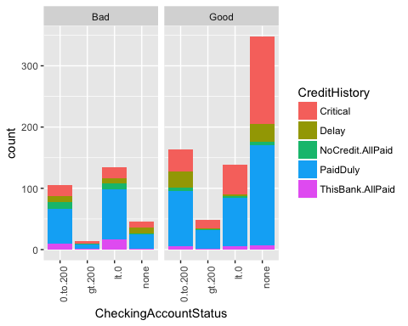

pl2 = pl1 + geom_bar(position = "fill") + ylab("proportion")+facet_grid(~Class)  
pl2 + theme(axis.text.x = element_text(angle = 90, hjust = 1))

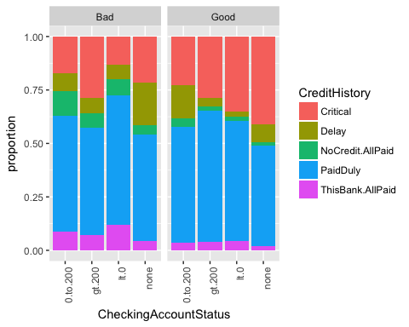

# 2. Explore Class vs Purpose, Personal and Property

CrossTable(credit_dataset$Purpose,credit_dataset$Class)

##   
##   
## Cell Contents  
## |-------------------------|  
## | N |  
## | Chi-square contribution |  
## | N / Row Total |  
## | N / Col Total |  
## | N / Table Total |  
## |-------------------------|  
##   
##   
## Total Observations in Table: 1000   
##   
##   
## | credit_dataset$Class   
## credit_dataset$Purpose | Bad | Good | Row Total |   
## -----------------------|-----------|-----------|-----------|  
## Business | 34 | 63 | 97 |   
## | 0.825 | 0.354 | |   
## | 0.351 | 0.649 | 0.097 |   
## | 0.113 | 0.090 | |   
## | 0.034 | 0.063 | |   
## -----------------------|-----------|-----------|-----------|  
## DomesticAppliance | 4 | 8 | 12 |   
## | 0.044 | 0.019 | |   
## | 0.333 | 0.667 | 0.012 |   
## | 0.013 | 0.011 | |   
## | 0.004 | 0.008 | |   
## -----------------------|-----------|-----------|-----------|  
## Education | 22 | 28 | 50 |   
## | 3.267 | 1.400 | |   
## | 0.440 | 0.560 | 0.050 |   
## | 0.073 | 0.040 | |   
## | 0.022 | 0.028 | |   
## -----------------------|-----------|-----------|-----------|  
## Furniture.Equipment | 58 | 123 | 181 |   
## | 0.252 | 0.108 | |   
## | 0.320 | 0.680 | 0.181 |   
## | 0.193 | 0.176 | |   
## | 0.058 | 0.123 | |   
## -----------------------|-----------|-----------|-----------|  
## NewCar | 89 | 145 | 234 |   
## | 5.035 | 2.158 | |   
## | 0.380 | 0.620 | 0.234 |   
## | 0.297 | 0.207 | |   
## | 0.089 | 0.145 | |   
## -----------------------|-----------|-----------|-----------|  
## Others | 5 | 7 | 12 |   
## | 0.544 | 0.233 | |   
## | 0.417 | 0.583 | 0.012 |   
## | 0.017 | 0.010 | |   
## | 0.005 | 0.007 | |   
## -----------------------|-----------|-----------|-----------|  
## Radio.Television | 62 | 218 | 280 |   
## | 5.762 | 2.469 | |   
## | 0.221 | 0.779 | 0.280 |   
## | 0.207 | 0.311 | |   
## | 0.062 | 0.218 | |   
## -----------------------|-----------|-----------|-----------|  
## Repairs | 8 | 14 | 22 |   
## | 0.297 | 0.127 | |   
## | 0.364 | 0.636 | 0.022 |   
## | 0.027 | 0.020 | |   
## | 0.008 | 0.014 | |   
## -----------------------|-----------|-----------|-----------|  
## Retraining | 1 | 8 | 9 |   
## | 1.070 | 0.459 | |   
## | 0.111 | 0.889 | 0.009 |   
## | 0.003 | 0.011 | |   
## | 0.001 | 0.008 | |   
## -----------------------|-----------|-----------|-----------|  
## UsedCar | 17 | 86 | 103 |   
## | 6.253 | 2.680 | |   
## | 0.165 | 0.835 | 0.103 |   
## | 0.057 | 0.123 | |   
## | 0.017 | 0.086 | |   
## -----------------------|-----------|-----------|-----------|  
## Column Total | 300 | 700 | 1000 |   
## | 0.300 | 0.700 | |   
## -----------------------|-----------|-----------|-----------|  
##   
##

CrossTable(credit_dataset$Personal,credit_dataset$Class)

##   
##   
## Cell Contents  
## |-------------------------|  
## | N |  
## | Chi-square contribution |  
## | N / Row Total |  
## | N / Col Total |  
## | N / Table Total |  
## |-------------------------|  
##   
##   
## Total Observations in Table: 1000   
##   
##   
## | credit_dataset$Class   
## credit_dataset$Personal | Bad | Good | Row Total |   
## ------------------------|-----------|-----------|-----------|  
## Female.NotSingle | 109 | 201 | 310 |   
## | 2.753 | 1.180 | |   
## | 0.352 | 0.648 | 0.310 |   
## | 0.363 | 0.287 | |   
## | 0.109 | 0.201 | |   
## ------------------------|-----------|-----------|-----------|  
## Male.Divorced.Seperated | 20 | 30 | 50 |   
## | 1.667 | 0.714 | |   
## | 0.400 | 0.600 | 0.050 |   
## | 0.067 | 0.043 | |   
## | 0.020 | 0.030 | |   
## ------------------------|-----------|-----------|-----------|  
## Male.Married.Widowed | 25 | 67 | 92 |   
## | 0.245 | 0.105 | |   
## | 0.272 | 0.728 | 0.092 |   
## | 0.083 | 0.096 | |   
## | 0.025 | 0.067 | |   
## ------------------------|-----------|-----------|-----------|  
## Male.Single | 146 | 402 | 548 |   
## | 2.059 | 0.883 | |   
## | 0.266 | 0.734 | 0.548 |   
## | 0.487 | 0.574 | |   
## | 0.146 | 0.402 | |   
## ------------------------|-----------|-----------|-----------|  
## Column Total | 300 | 700 | 1000 |   
## | 0.300 | 0.700 | |   
## ------------------------|-----------|-----------|-----------|  
##   
##

CrossTable(credit_dataset$Property,credit_dataset$Class)

##   
##   
## Cell Contents  
## |-------------------------|  
## | N |  
## | Chi-square contribution |  
## | N / Row Total |  
## | N / Col Total |  
## | N / Table Total |  
## |-------------------------|  
##   
##   
## Total Observations in Table: 1000   
##   
##   
## | credit_dataset$Class   
## credit_dataset$Property | Bad | Good | Row Total |   
## ------------------------|-----------|-----------|-----------|  
## CarOther | 102 | 230 | 332 |   
## | 0.058 | 0.025 | |   
## | 0.307 | 0.693 | 0.332 |   
## | 0.340 | 0.329 | |   
## | 0.102 | 0.230 | |   
## ------------------------|-----------|-----------|-----------|  
## Insurance | 71 | 161 | 232 |   
## | 0.028 | 0.012 | |   
## | 0.306 | 0.694 | 0.232 |   
## | 0.237 | 0.230 | |   
## | 0.071 | 0.161 | |   
## ------------------------|-----------|-----------|-----------|  
## RealEstate | 60 | 222 | 282 |   
## | 7.153 | 3.066 | |   
## | 0.213 | 0.787 | 0.282 |   
## | 0.200 | 0.317 | |   
## | 0.060 | 0.222 | |   
## ------------------------|-----------|-----------|-----------|  
## Unknown | 67 | 87 | 154 |   
## | 9.365 | 4.013 | |   
## | 0.435 | 0.565 | 0.154 |   
## | 0.223 | 0.124 | |   
## | 0.067 | 0.087 | |   
## ------------------------|-----------|-----------|-----------|  
## Column Total | 300 | 700 | 1000 |   
## | 0.300 | 0.700 | |   
## ------------------------|-----------|-----------|-----------|  
##   
##

pl1 = ggplot(credit_dataset, aes(x = Purpose, fill = Class));  
pl1 + geom_bar()+ theme(axis.text.x = element_text(angle = 90, hjust = 1))

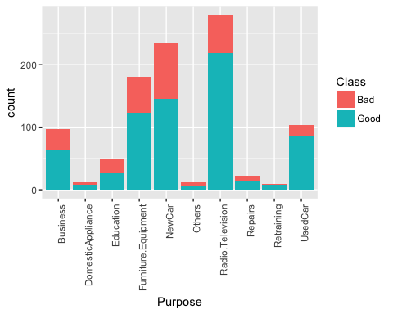

pl1 + geom_bar(position = "fill") + ylab("proportion")+ theme(axis.text.x = element_text(angle = 90, hjust = 1))

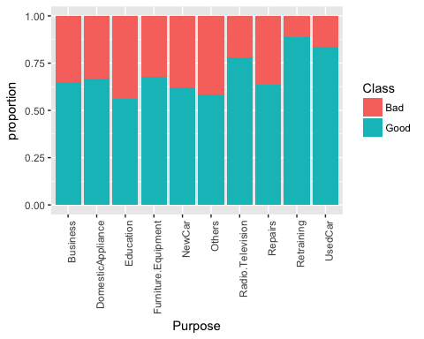

pl1 = ggplot(credit_dataset, aes(x = Purpose, fill = Personal));  
pl2 = pl1 + geom_bar()+facet_grid(~Class)  
pl2+ theme(axis.text.x = element_text(angle = 90, hjust = 1))

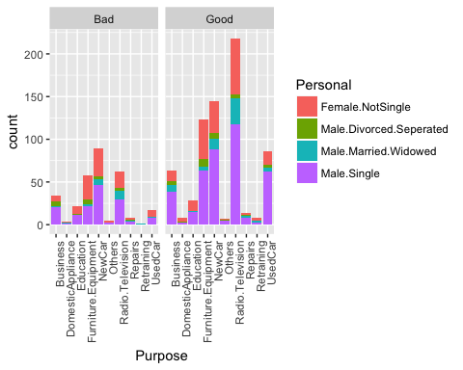

pl2 = pl1 + geom_bar(position = "fill") +ylab("proportion")+facet_grid(~Class)  
pl2 + theme(axis.text.x = element_text(angle = 90, hjust = 1))

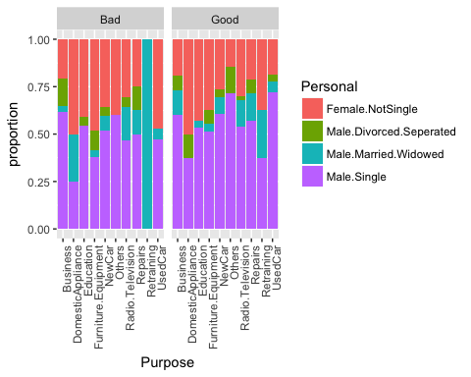

pl1 = ggplot(credit_dataset, aes(x = Purpose, fill = Property));  
pl2 = pl1 + geom_bar()+facet_grid(~Class)  
pl2+ theme(axis.text.x = element_text(angle = 90, hjust = 1))

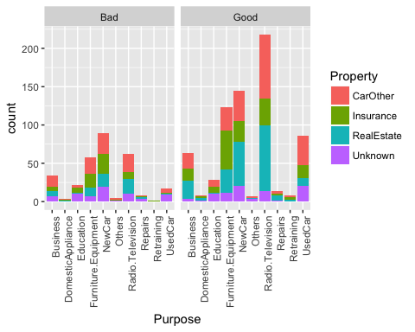

pl2 = pl1 + geom_bar(position = "fill") + ylab("proportion")+facet_grid(~Class)  
pl2 + theme(axis.text.x = element_text(angle = 90, hjust = 1))

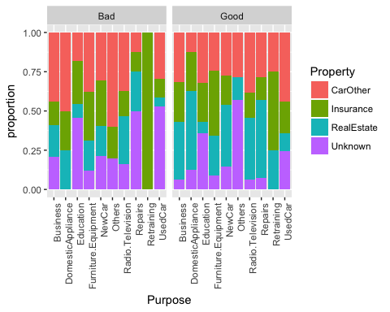

1. New Car loan seems to be worse than used car loans and any other loan.
2. Property doesn’t seem to play a huge role as a deciding factor.

pl1 = ggplot(credit_dataset, aes(x = Purpose, y = Amount, color=Purpose));  
pl2 = pl1 + geom_boxplot()+facet_grid(~Class)  
pl2 + theme(axis.text.x = element_text(angle = 90, hjust = 1))

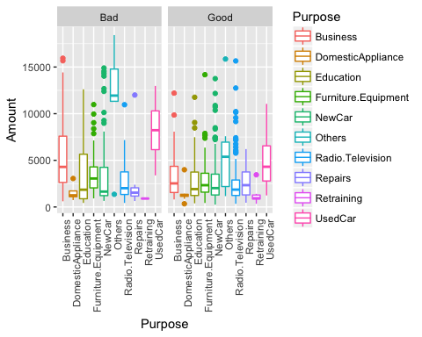

pl1 = ggplot(credit_dataset, aes(x = Personal, y = Amount, color=Personal));  
pl2 = pl1 + geom_boxplot()+facet_grid(~Class)  
pl2 + theme(axis.text.x = element_text(angle = 90, hjust = 1))

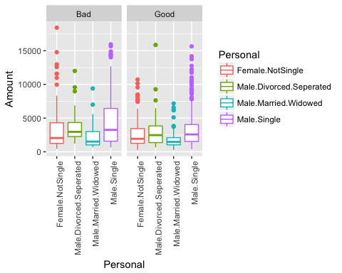

pl1 = ggplot(credit_dataset, aes(x = Job, y = Amount, color=Job));  
pl2 = pl1 + geom_boxplot()+facet_wrap(~Class,ncol = 2)  
pl2 + theme(axis.text.x = element_text(angle = 90, hjust = 1))

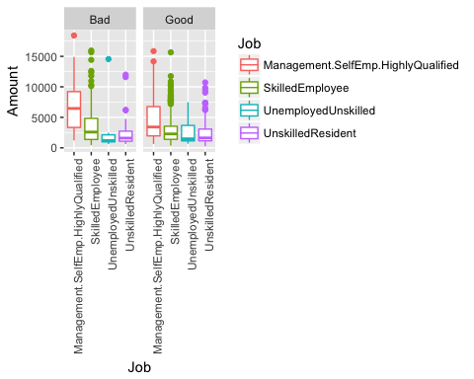

pl1 = ggplot(credit_dataset, aes(x = Housing, y = Amount, color=Class));  
pl2 = pl1 + geom_boxplot()+facet_wrap(~Personal,ncol=2)  
pl2 + theme(axis.text.x = element_text(angle = 90, hjust = 1))

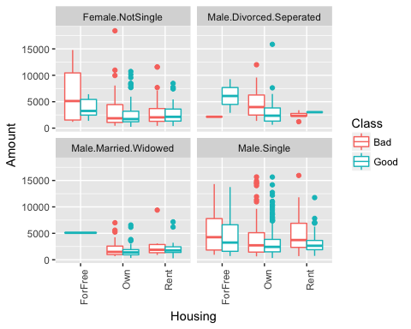

pl1 = ggplot(credit_dataset, aes(x = Purpose, y = Duration, color=Class));  
pl2 = pl1 + geom_boxplot()+facet_wrap(~Personal,ncol=2)  
pl2 + theme(axis.text.x = element_text(angle = 90, hjust = 1))

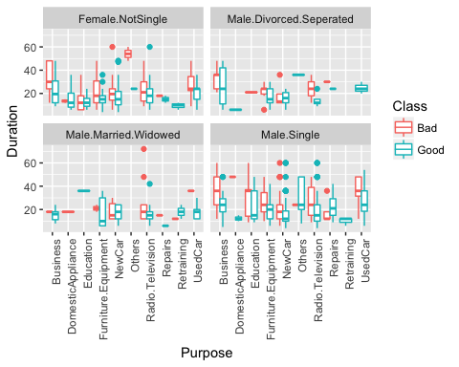

pl1 = ggplot(credit_dataset, aes(x = Personal, y = Amount, color=Class));  
pl2 = pl1 + geom_boxplot()+facet_wrap(~Purpose, ncol = 5)  
pl2 + theme(axis.text.x = element_text(angle = 90, hjust = 1))

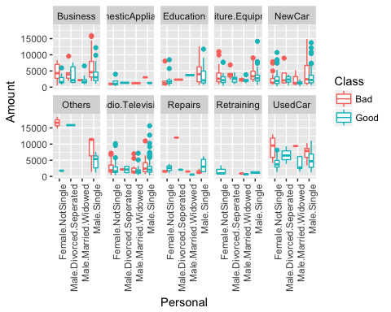

1. Used car data show that that Female.NotSingle tend to take higher loan for Used car, and are more likely bad loans.
2. Unsual data for Others, we might need to get more data on that.

pl1 = ggplot(credit_dataset, aes(x = Personal, y = Amount, color=Class));  
pl2 = pl1 + geom_boxplot()+facet_wrap(~Job,ncol=2)  
pl2 + theme(axis.text.x = element_text(angle = 90, hjust = 1))

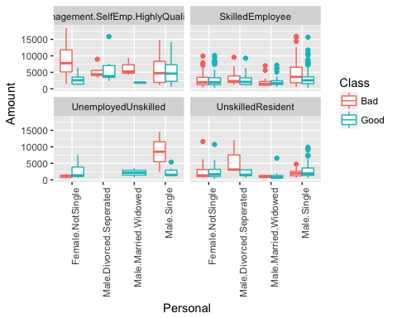 1. Male single, Unemployed and Unskilled— high risk 2. Female Not Single — Also high risk 3. Male Divored/Separated Unskilled Resident – high risk

pl1 = ggplot(credit_dataset, aes(x = Personal, y = Amount, color=Class));  
pl2 = pl1 + geom_boxplot()+facet_wrap(~CheckingAccountStatus,ncol=2)  
pl2 + theme(axis.text.x = element_text(angle = 90, hjust = 1))

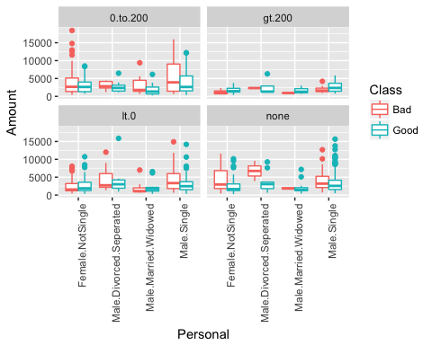

pl1 = ggplot(credit_dataset, aes(x = Personal, y = Amount, color=Class));  
pl2 = pl1 + geom_boxplot()+facet_wrap(~CreditHistory,ncol=3)  
pl2 + theme(axis.text.x = element_text(angle = 90, hjust = 1))

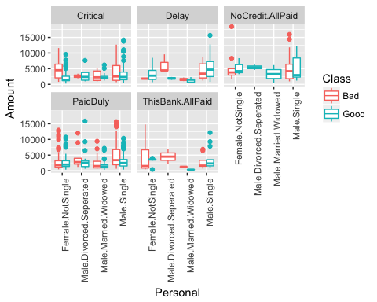 Just some detective skill: We can see the outlier in NoCredit.AllPaid, Female.NotSingle. Some one from Highskilled, management or self employed category with checking account status between 0 to 200 took the loan for others category.