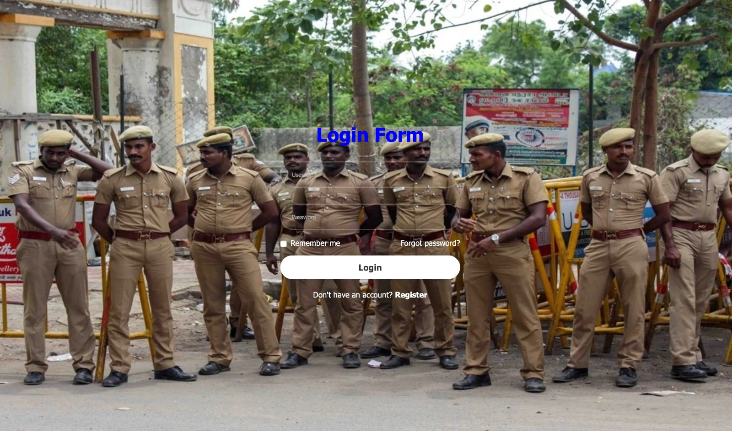

This is just create a sample login page with a logic function of username and password

