Declaration of an interface starts with the access modifier followed by keyword interface which is in turn followed by its name or identifier that is followed by a block of statements; these statements contain declarations of variables and abstract methods. The variables defined in interfaces are implicitly public, static, and final. They are initialized at the time of declaration. The methods declared in an interface are public by default. An illustration of declaration of an interface is given.

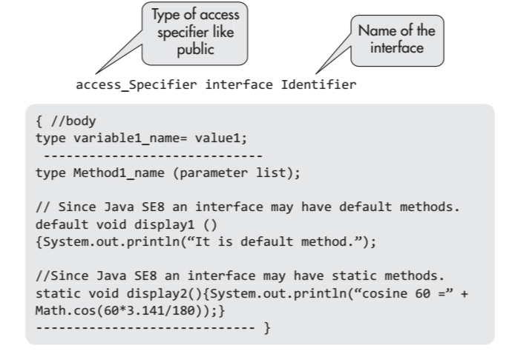

**Interface Modifiers**

Access modifiers for an interface are generally public or no access modifier is used. By declaring it as public, interface can be used in any package and in any class.

**Members of Interface**

The members of an interface comprise the following:

1. The members declared in the body of the interface.

2. The members inherited from any super interface that it extends.

3. The methods declared in the interface are implicitly public abstract member methods.

4. The field variables defined in interfaces are implicitly public, static, and final. However, the specification of these modifiers does not create a compile-type error.

5. The field variables declared in an interface must be initialized; otherwise, compile-type error occurs.

6. Since Java SE8, static and default methods with full definition can also be members of interface.

**Implementation of Interface**

The interfaces are implemented by classes. An illustration of declaration of class that implements an interface

A class implementing an interface must provide implementation for all its methods unless it is an abstract class.