Strings are treated differently in Java when compared to C programming language; in the latter case, it represents an array of characters terminated by null character. In Java, a string is an object of a class, and therefore, there is no automatic appending of null character by the system. In Java, there are three classes that can create strings and process them with nearly similar methods. These classes are as follows:

1. class String

2. class StringBuffer

3. class StringBuilder

All the three classes are part of java.lang package.

Storage of Strings

The objects of class String have a special storage facility, which is not available to objects of other two String classes or to objects of any other class.

The memory allocated to a Java program is divided into two segments: 1. Stack 2. Heap

1. The variables are stored on heap,
2. whereas the program is stored on stack.
3. Within the heap, there is a memory segment called ‘String constant pool’.

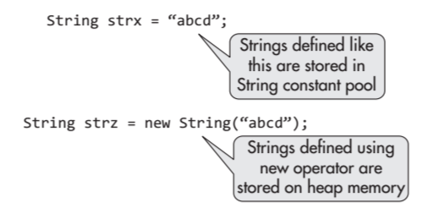

The strings that are defined like String strx are stored in the String constant pool, whereas the strings that are defined by operator new like String strz are stored on the heap; however, they are stored outside the String constant pool, where the objects of other classes are also stored.

Example Program

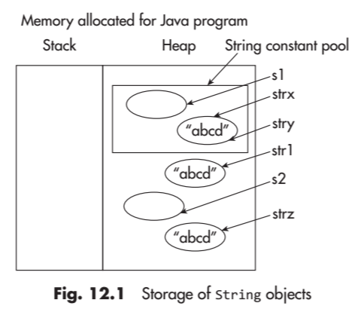

public class StringTest

{

public static void main(String[] args)

{

String strx = "abcd"; //object stored in pool

String stry = "abcd"; //only one "abcd" exists in pool

String strz = new String("abcd"); //new object

String str1 = new String ("abcd");// new object

String s2 = new String();// empty string

String s1 = "";// empty string

System.out.println("Are references of strx and stry same? " + (strx==stry));

System.out.println("Are references of strx and strz same? " + (strx==strz));

System.out.println("Are references of str1 and strz same? " + (str1==strz));

System.out.println("Are references of s1 and s2 same? " + (s1==s2));

System.out.println("Are strx and strz equal? " + strx.equals(strz));

}

}

Class StringBuffer

The class StringBuffer defines the strings that can be modified as well as the number of characters that may be changed, replaced by another, a string that may be appended, etc. The strings are also thread safe.

Class StringBuilder

The StringBuilder class is the subclass of Object in java.lang package. This class is used for creating and modifying strings. Its declaration is as follows:

public final class StringBuilder extends Object implements Serializable, CharSequence

The class is similar to class StringBuffer; however, it is useful where a single thread of execution is used because it is not thread safe; further, performance-wise, it is better than StringBuffer class.